Academic Timetable Guide

Note for 2020/21 academic year – Covid-19 has had a significant impact on the timetable. The Draft semester one timetable is available from September 11th 2020, with timetable details subject to change. Semester two is under review, and is very much subject to change.
Please follow the guide below in conjunction with the documentation on how much time students should expect to be on campus, which is available at: https://www.maynoothuniversity.ie/coronavirus/students.

The Timetable Viewer has the following ‘views’ of the timetable.
1) Lectures - allows you to search by course e.g. ARTS Year 1
2) Venues – allows you to search to see what’s in a room at a given time
3) Departments – allows you to see every activity i.e. both Lectures and Tutorials for the Department
4) Students – this is a personalised timetable that you need to log in to view. This is only visible after you have registered to your modules, and will not be available until closer the start of term on 28th September 2020.
There are guides and useful information available at the bottom of the page.

In general tutorials and practicals are not displayed on the timetable. This is to avoid confusion as there may be multiple offerings of tutorials but each student may only need to attend one. The relevant Department can advise you in relation to both tutorials and practicals.

How to view your Timetable
Prior to Registration the best way to view your timetable for the year is to click on “Lectures”.
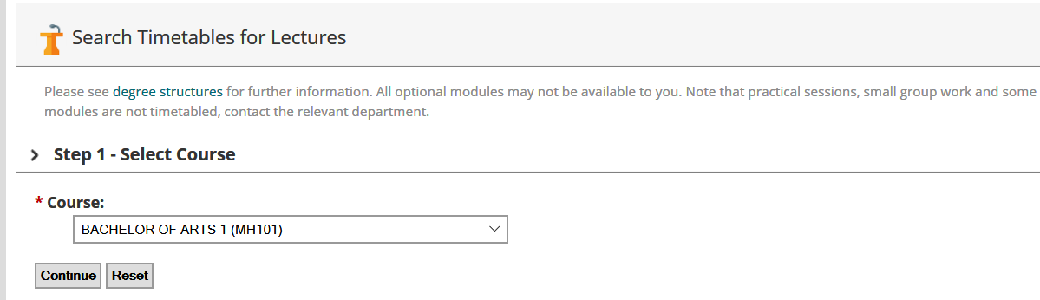

STEP 1: Select Course
Click on the arrow to the right of the box to display a list of courses and select the course you are interested in then click “Continue”.
Note: “Course” refers to a general container for programmes of study, for example BA ACOUNTING AND FINANCE 1 (MH403) refers to the Bachelor in Arts (BA) for the course Accounting and Finance for first year (1). The CAO code is included in brackets at the end.

STEP 2: Select Programme
Each “Course” may contain a number of “Programmes”. Click on the course of interest and click continue.

STEP 3: Select Semester

Click continue to show both semesters. You can also just select a single semester. Please note that while semester two is visible, it is currently under review and is subject to change.
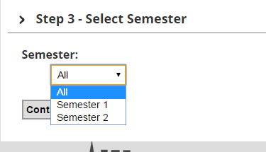

STEP 4: Select Modules
Click “Continue” to select all modules.
You can also use the “Ctrl” key if you only want to display particular modules.
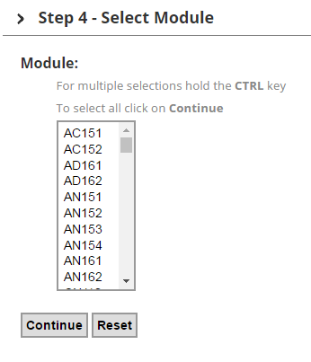

Step 5: Timetable Display
The timetable will now be displayed as below, showing module code and venue.
For example, on Tuesday at 9am EC101 takes place in JHL1
“EC101” is a module code, to get further information about the module, click on it and you will be brought to a page which will give more information about the module. [JHL1] is the venue. If you click on the venue you will be brought to a link with more information
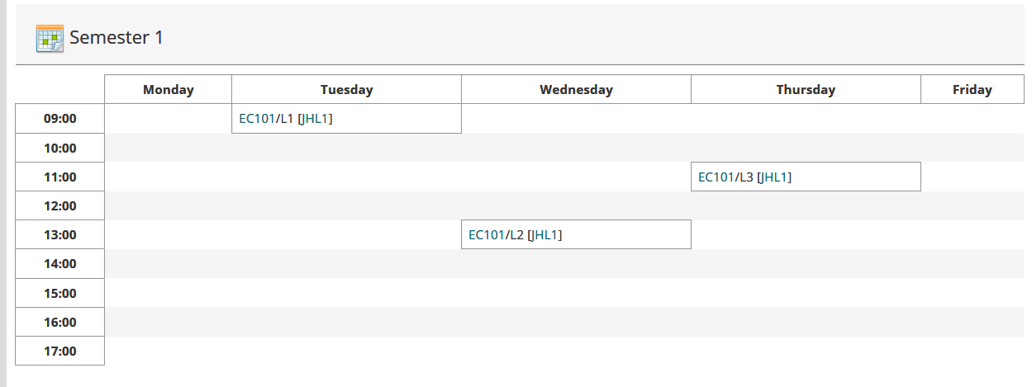

Changing your selections: All of the selections you have made in each of the steps above are shown towards the top of the screen. If you wish to change the Course/ Programme/Semester or Module Information displayed you can click the “Change” link, this means you don’t have to go all the way back to the beginning.

Reading the timetable
- L1/L2/L3, etc. refer to Lecture 1, Lecture 2, Lecture 3. Students typically need to attend all of these, but in 2020, departments may make arrangements to have some students attend on a rota basis. Information will be provided by the relevant academic department, but in the meantime, guidance information is available in the Time on Campus guides for students.
- T1/T2 or TUT1, TUT 2 refers to tutorials. (In general students do not need to attend all of these – see your academic department for further information)
- P1, P2, P3 refers to practicals. These are managed by the relevant academic department.
- Where /A or /B or /C appears after the Module code, that means the module is delivered more than once, e.g. MN151. You will be allocated to one of the groups, and will attend either A or B for each lecture.
- Allocation depends on your other modules, when they are timetabled, the department’s requirements and the available capacity in each group.
- You will only see the classgroups relevant to you on your personalised timetable.
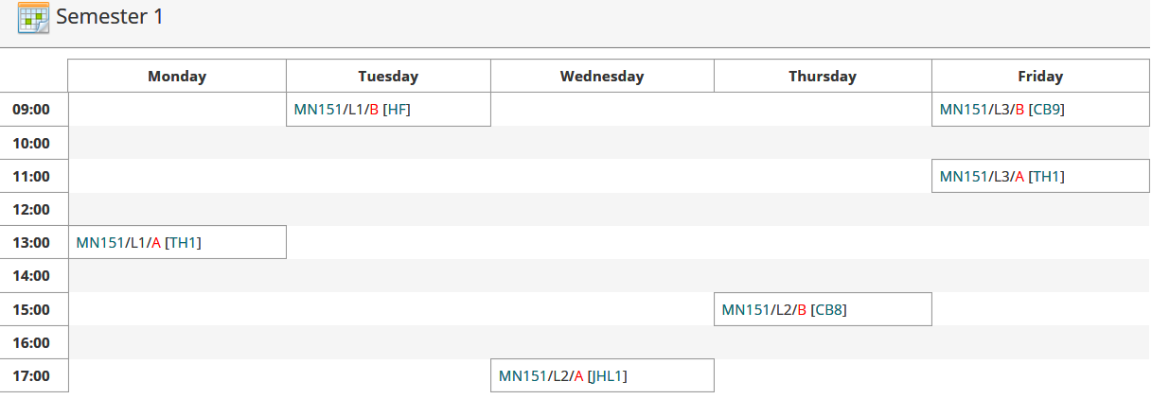

- This classgroup allocation feeds into Moodle, the University’s Virtual Learning environment, within a couple of working days.
- Changing module choices may result in changes to classgroups.

Printing:
Click on the ‘Print’ icon 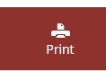 and this will open a new web page and the print dialogue box will automatically appear, you can change printers, adjust size etc. here before printing

To view your personalised Timetable
Note: Personalised student timetables are only available after registration, are not available to most postgraduates, and will not be available until later in September, closer to the start of term. In 2020/21, they will likely not display a complete or detailed picture to students of their timetable commitments.
- Select the Student Tab
- Enter your student number and password
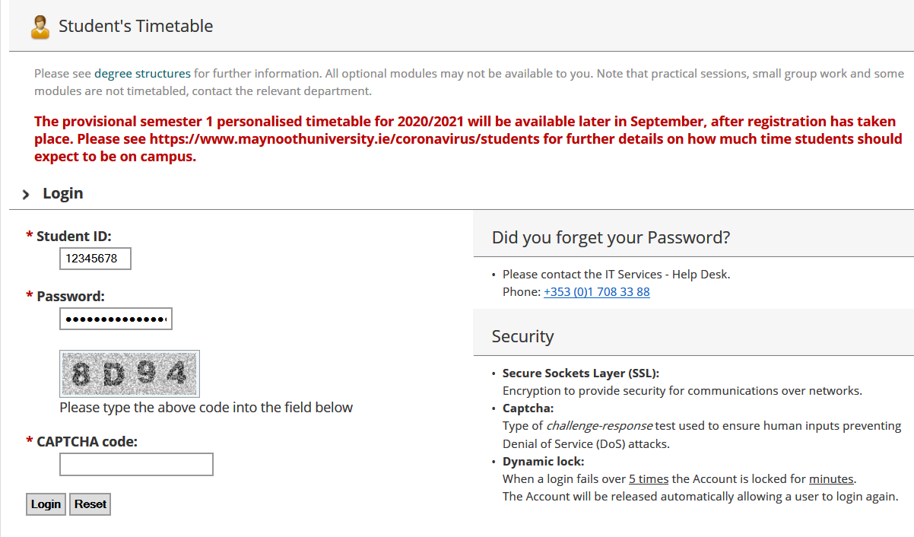

- Enter the code as you see it in the grey box

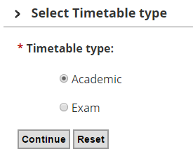
Choose ‘Academic’ and press Continue
You will then be brought to your personalised Timetable.
Please be aware that practicals and tutorials are not generally shown on the personalised timetable and you will need to contact the relevant Academic Department in relation to these.

Further questions?
If you have questions that are not answered above, Email Timetable@mu.ie with a clear query and please include your student number in all correspondence. While we will do our best to answer queries, we will not have detailed information in relation to lecture rotations and may need to refer some queries onto academic departments.

