National University OF Ireland, Maynooth
DEPARTMENT OF HISTORY

FLYERS FOR OPTIONAL MODULES

II ARTS SEMESTER 2 2022-23

PLEASE NOTE

Flyers provide information supplementary to that available in module descriptors, which may be viewed on the university database at www.maynoothuniversity.ie/courses.

Students are expected to consult both flyers and module descriptors, as well as the academic timetable, in advance of registration.

national university of ireland, maynooth
department of history
second arts, 2022-23
Second Semester
Module Co-ordinator  DR MICHAEL POTTERTON | Module code  HY 224 | Credits  5 | Lecture hours per week  Two

Module title:
SETTLEMENT AND SOCIETY IN IRELAND

Module content
Ireland boasts one of the most abundant archaeological and historical landscapes in the world. It is especially rich and varied for the Middle Ages – from the advent of Christianity in the fifth century to the dissolution of the monasteries over a millennium later in the 1530s and 1540s. The fifth century also marks the beginning of writing in Ireland and the start of our documented history. Combining the evidence of written sources with what we know from archaeology and the visible physical remains of the past we can recreate a vivid picture of life in medieval Ireland. We can start to understand, for example, where and how people lived, what their daily lives were like, what they ate and drank, how society was structured, how they practised religion, how they dealt with death, and much more.

Module aim
The core aim of this module is to familiarise students with aspects of settlement and society across the island of Ireland from the beginning of recorded history in the early medieval period to the end of the Middle Ages. Illustrated lectures will guide participants on a virtual tour of the sites, monuments and landscapes of medieval Ireland. Using specific examples, we will examine when, why and how they were constructed, who was responsible, what it was like to live, work and die during that time and what significance this has in the twenty-first century. Upon successful completion of the module, students will
- be familiar with major developments in Ireland in the period c.AD400–1600;
- be aware of where and how people lived during this time;
- be able to recognise Irish medieval archaeological monuments and landscapes;
- understand the significance of the medieval past in the modern world.
Form of assessment
There are two parts to the assessment for this module:
a. one mid-term assignment (1,000 words; 25% of module marks)
b. one illustrated project (3,000 words; due 8 May 2023; 65% of module marks)
c. participation in class (10% of module marks)

Special requirements
Some of the classes will take place at medieval sites in and near Maynooth. There will also be one Saturday field trip; we will travel via coach from Maynooth and visit a number of sites in north Leinster. The trip will cost students €20 each. All participants in the module are expected to attend all classes and the field trip. Further details will be provided in class and on Moodle.
national university of ireland, maynooth
department of history
second arts, 2022-23

Second Semester
Lecturer  DR DYMPNA MC LOUGHLIN | Module code HY 230 | Credits  5 | Lecture hours per week  Two

Module title
HISTORY OF HEALTH AND MEDICINE A

Overview

This module introduces the history of medicine. The following themes will be covered:
- the structure and function of the medical profession, including doctors, surgeons, and apothecaries.
- Quack and quackery.
- The professionalization of nursing.
- the main medical institutions of the nineteenth century, including the hospital
- the dispensary- a local model of healthcare.
- the adulteration of food and its consequences on human health
- the complex issue of mental health and the treatment of the vulnerable in asylums.
- Tuberculosis and its impact of the stigma of tuberculosis on sufferers and their family in twentieth century Ireland.
- The Contagious Diseases Acts and the feminisation of venereal disease.
- Eugenics.

Aim
The aim of this module is to introduce students to the developing area of medical history

Form of Assessment

Two-hour end of semester examination

national university of ireland, maynooth
department of history
second arts, 2022-23
Second Semester
Lecturer  DR RORY FINEGAN | Module code HY 257 | Credits  5 | Lecture hours per week  Two

Module title
Twentieth-century Ireland political:
THE NORTHERN IRELAND TROUBLES

Module content: in Ireland, history weighs heavily on the minds of the people. The prolonged and often bloody conflict witnessed in Northern Ireland between 1969 and the Good Friday (Belfast) Agreement [GFA] (1998) has often been euphemistically refereed to as the ‘Troubles’ and witnessed a period of intense violence and political turmoil unequalled in its intensity and ferocity in the history of Western Europe since the Second World War; until the advent of the linked Civil Wars in the former Yugoslavia of the early 1990s. The often-visceral sectarian nature of the conflict which pitted Protestant unionist/loyalist and Catholic nationalist/republican had its roots in the settler-native confrontations of the 17th century plantations. The Troubles were the most recent phase of a conflict that can be traced to the partition of Ireland and the formation of a separate Northern statelet in the 1920s. The resonance of these echoes of history have been evoked by a current series of consecutive centenary commemorations of late which has allowed a degree of critical revisionism in being brought to bear from an historical perspective. These debates have become intertwined with ongoing controversies related to Brexit linked to changing demographics which has brought to the fore constitutional issues not just on the island of Ireland but within the British Isles as a whole.

Module aim: the raison d’etre of this bespoke module is to introduce students to the history of the Troubles from a conflict resolution perspective, to examine the underlying political, economic, sociological and military contexts which fuelled this internecine conflict, which claimed some 3,700 lives (McKittrick et. al., 1999, Lost Lives). Northern Ireland as such has gone through the spectrum of violent conflict and conflict resolution (ongoing) to a ‘relatively’ successful peace process predicated on the GFA (1998). But critically at the heart of this module will be an exploration in that additionally what made the Troubles in Northern Ireland unique was the way in which at the time the violence was portrayed “as indelibly ethnic or tribal” and somewhat out of sync with the then wider Cold War political confrontations between West and East. Indeed, this analysis of Northern Ireland of been “a place apart” has being challenged particularly as ethnic-identity disputes erupted after the end of the Cold War in 1991. Therefore, while Northern Ireland may not portray definitive or absolute answers as to the ethnic/nationalist conflicts in the modern era, there is nonetheless a strong argument that as a core case study it provides valuable lessons that can be rigorously analysed and interpreted that will both contribute to and enhance the academic jigsaw on this topic.

Assessment
Mid-term assignment, presentation (Individual) based on assigned topic 15%
Essay of 4,000 words based on primary research and on a topic from assigned
essay list. Submission deadline Monday, 8 May 2023 80%
Class Participation 5%
national university of ireland, maynooth
department of history
second arts, 2022-23
Second Semester
Lecturer  DR JONATHAN WRIGHT | Module code HY 272 | Credits  5 | Lecture hours per week  Two

Module title
MODERN BRITISH ELECTIVE
SLAVERY AND ANTI-SLAVERY IN THE BRITISH WORLD, c. 1750-1833
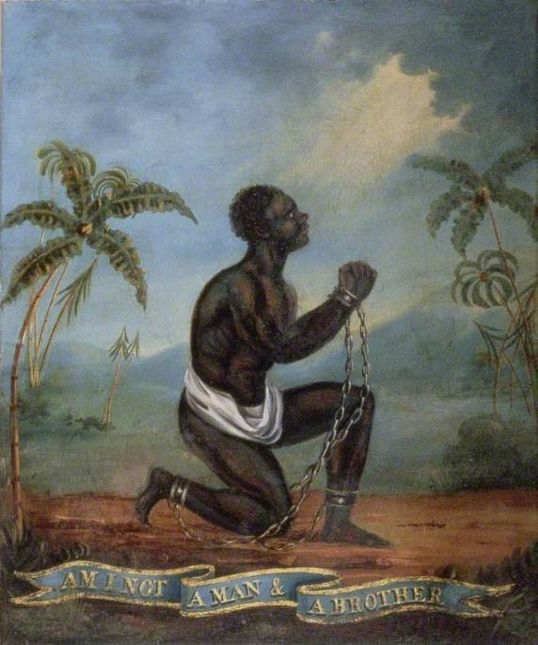
Module content
In 1562, John Hawkins captured 300 Africans from Sierra Leone, inaugurating British involvement in ‘the largest forced migration in history’ – the Atlantic slave-trade. By the mid-eighteenth century, Britain had become a leading player in the trade of enslaved people, and slavery had become central to the Atlantic economy. Forcibly transported to the British colonies in America and the West Indies, enslaved African produced sugar, tobacco and, above all, profits. Vast fortunes were made on the back of the slave trade and transatlantic slavery impacted British society in multiple ways. Yet, by 1807 the trade in enslaved people had been prohibited by parliament, and while slavery persisted as an institution in Britain’s colonies, this too was abolished in 1833.

This module will explore the character of British involvement in the slave trade, and will examine the reasons for its abolition and its long–term consequences. Situating Britain within the wider ‘Atlantic world’, the module will stress that slavery was not just something that happened ‘over there’, in the colonies, but something that had real and tangible consequences ‘at home’ in Britain, and will address a range of themes, including: the middle passage and the triangular trade; plantation life and slave rebellion; consumption and the cultural impact of slavery; abolition; and the continuing legacies of slavery.

Module aim
Having completed this module you will have engaged with key historiographical debates relating both to slavery and the ‘Atlantic World’, and will have developed a nuanced understanding of the multifaceted nature of British involvement in the slave trade and an appreciation of its on-going significance. In addition, you will have used a range of traditional and online archival resources, and will have been given an opportunity to develop your written presentation skills by completing assignments.

Assessment:
1,250 word assignment 25%
1,250 word assignment 25%
2,500 word essay 50% (deadline Monday 8 May, 2023
national university of ireland, maynooth
department of history
Second arts, 2022-23
Second Semester
Lecturer  DR ALISON FITZGERALD | Module code HY 278 | Credits  5 | Lecture hours per week  Two

Module title
DOMESTIC WORLDS: THE GEORGIANS AT HOME
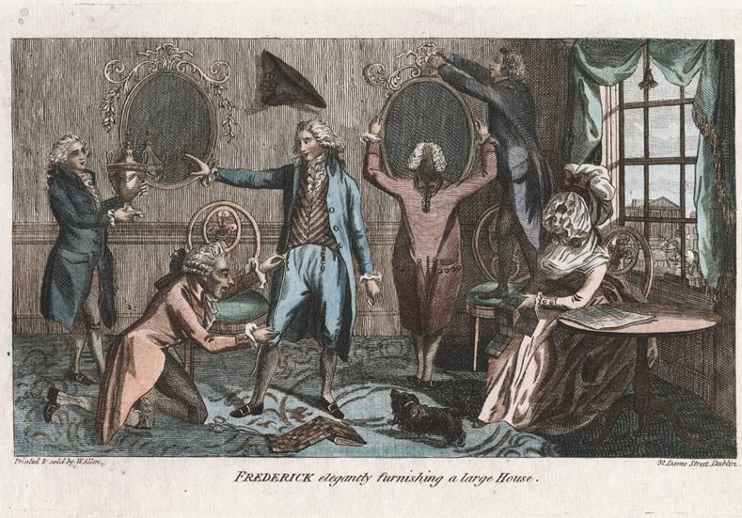
Module content
Centuries before the concept of online shopping was dreamt up, catalogue shopping, must- have products, product branding and the widespread use of advertising, became staple features of the consumer culture of Georgian Britain and Ireland. An unprecedented range of new commodities, from exotic imported porcelain and textiles, to ingenious mechanical furniture, fuelled fashions which were quickly, widely, and mercilessly commented on. Depending on the author, and on his or her biases, luxury and the impulse to keep up fashionable appearances, was celebrated or censored. Fashion victims were fair game in the world of satirical print. What was new? Who lead taste? How did new technology transform the sort of goods that people bought, used and coveted? Was there a clear distinction along gender lines in terms of fashionable commodities? Using a wide range of primary sources from diaries and letters, to account books and inventories (with excellent online databases of printed primary sources available via MU library) this module will consider the material culture of the Georgians at home.

No previous knowledge of the History of Art or design is required to take this module.

Assessment
Participation 10%
In-class assessment 25%
Essay (3,000 words) 65%
Deadline for submission of essay: 8 May 2023
national university of ireland, maynooth
department of history
second arts, 2022-23

Second Semester
Lecturer  To be confirmed | Module code HY 282 | Credits  5 | Lecture hours per week  Two

Module content
How have emotions changed over time and how can we study them? To what extent are emotions culturally constructed and understood? Do love and fear mean the same today as they did in the past? And what role have emotions played in history? These are just some of the questions posed by researchers working in the field of emotions history.
This module will provide a thematic introduction to the history of emotions. It will consider both the universality and cultural specificity of how people feel, both as individuals and as groups. Emotions can bring people together, but they can also tear communities apart. Participants will consider how feelings are created, taught and transmitted, how they change over time and how they have impacted upon major political events, social movements and economic conjunctures throughout time.

Module aim
This module familiarizes participants with theoretical and interdisciplinary tools used by historians to understand how emotions worked in the past, from cultural anthropology, cognitive psychology and the neuro-sciences. Participants will encounter a range of different primary sources and examine the various methods of analysis that have been used by researchers in this field.

Assessment
Short assignments 30%
Class Participation 10%
Essay of approximately 3,000 words 60%
Essay deadline: Monday, 8 May 2023

national university of ireland, maynooth
department of history
Second arts, 2022-23
Second Semester
Lecturer  PROFESSOR MARIAN LYONS | Module code  HY 283 | Credits  5 | Lecture hours per week  Two
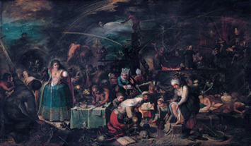

Module title
Early modern Europe – culture:
WITCHCRAFT IN EUROPE, c.1450-c.1650

Module content
This module explores the phenomenon of witchcraft in Europe during the era of the Renaissance, the Reformations and the Scientific Revolution when thousands of people (the majority of them women) were executed for witchcraft. We explores how major social, political, and cultural changes of the period (notably state formation, Christian Humanism, Protestant and Catholic Reformations, New science, and skepticism) shaped belief in and practice of witchcraft at all levels of society. We examine contemporaries’ beliefs about different types of magic, supernatural forces and reported experiences of bewitchment and witch sabbaths. Witchcraft was regarded, indeed feared, as an exceptional crime, during this period. Many members of Europe’s learned elite published highly influential works on witchcraft and its eradication, including the German Dominican inquisitor, Heinrich Kramer and the French jurist and political philosopher, Jean Bodin: their ideas are explored in-class through examination of extracts from their most important texts. Europe’s experience of witch hunting is explored through case studies of hunts in selected localities across Europe, notably in Germany, France, Scotland, England and Ireland for which we analyse contemporary printed and visual sources. The module concludes by investigating the reasons for the decline in witchcraft and witch hunting during the late seventeenth century.

Assessment
Research project (4,500 words approx.) on topic agreed in advance with lecturer 80%
Primary source analysis (750 words approx.) submission mid-term 10%
Participation 10%
Deadline for submission of essay: Monday 8 May 2023

Reading
Brian Levack, The witch-hunt in early modern Europe (4th edn., London, 2015) available in MU bookstore and MU library (133.4094 LEV)
Brian Levack, The witchcraft sourcebook (London, 2004 edn. EBook full text online via MU library)
Brian Levack, The Oxford handbook of witchcraft in early modern Europe and colonial America (Oxford, 2013), available in MU library (133.430903 LEV)
national university of ireland, maynooth
department of history
Second arts, 2022-23
Second Semester
Lecturer  PROFESSOR IAN SPELLER | Module code HY 2001 | Credits  5 | Lecture hours per week  Two

Module title
INTRODUCTION TO MILITARY HISTORY AND WAR STUDIES

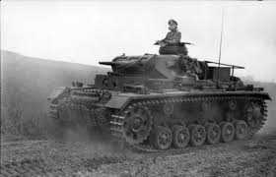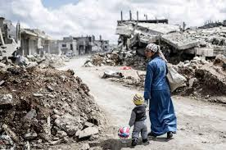

The module will provide an introduction to the study of war in the past and in the present. It will draw on methodologies of military history and strategic studies to explore alternative ideas as to the causes, conduct and impact of war. It will include an exploration of the economic, political, societal impact of war, including engagement with ideas about race, gender and war. In addition, a range of battles and campaigns will be examined in order to foster an understanding of evolution in the theory and practice of war over the course of the last century.

Form of Assessment:
- Essay: maximum 3,000 words (excluding footnotes/bibliography) chosen from list provided by the lecturer. Deadline Monday 8 May 2023 (70%)
- Participation with weekly Blog via Moodle Forum (10%)
- 10 minute Podcast. Completed during Semester (20%)

Module Structure
The module consists of 2 x one hour classes each week, in addition to preparatory reading that students will complete in their own time. Students are expected to attend all classes and will be expected to prepare appropriately and thus be able to contribute to in-class discussion and debate.

Learning Outcomes
On completion of this modules students will be able to:

- Identify appropriate methodologies for military history
- Critique alternative explanations for the causes of war and conflict
- Demonstrate understanding of changes in the conduct of war over the past century.
- Explore the impact of war on society, and of society on war.
- Examine key debates on current security issues
- Present their ideas in a convincing manner, with reference to relevant history
national university of ireland, maynooth
department of history
second arts, 2022-23

Second Semester
Lecturer | Module code SG254 | Credits  5 | Lecture hours per week

Module title
HISTORY 2 - LAW, SOCIETY AND LEARNED CLASSES IN EARLY IRELAND

Information as per Course Finder, August 2022

Overview
The early Irish law books, often known as the ‘Brehon laws’ provide a wealth of information about numerous aspects of medieval Irish society. This module studies aspects of these law books, the learned classes that created them and the social institutions and practices they illuminate.

Form of assessment

Continuous assessment (one essay) 100%

Please note that SG254 is timetabled by Early Irish (Sean-Ghaeilge) and may clash with core lectures in other subjects.

national university of ireland, maynooth
department of history
second arts, 2022-23

Second Semester
Co-ordinator | Module code GC224 | Credits  5

Module title
UNDERSTANDING THUCYDIDES: THE FLOWERING OF GREEK HISTORIOGRAPHY

Information as per Course Finder, August 2022
Overview
Towards the end of the fifth-century BC the Greek world became embroiled in a conflict which lasted with little interruption for 27 years. This module examines this conflict – the Peloponnesian War – and the parts played by the principal adversaries, Athens and Sparta. Central to it is a close study of the Greek historian Thucydides’ account of this war. In particular, we examine the principles of historiography that he employed. On account of his methodology, Thucydides would acquire a reputation as the first scientific historian of the western world, a claim the module scrutinizes. We also, briefly, makes use of other perspectives, such as those provided by the comic playwright Aristophanes, who enriches the picture, adding a cultural dimension by examining the impact that the war had on the general population, male and female, citizen and slave. The module closes with an assessment of the legacy of Thucydides and his place in the Greek historiographical tradition.

Form of assessment

Continuous assessment (essay): 40%
Examination (90 minutes) 60%

Teaching & learning methods
18 lectures, 3 labs/practicals

For further information please contact Ancient Classics Department

Please note that GC224 is timetabled by Ancient Classics and may clash with core lectures in other subjects.

