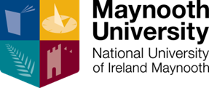

Maynooth University
Department of Law

invites you to a
Criminology Taster Day

Saturday, 27 March 2021 10.45 a.m. to 1.30 p.m.
On Zoom (Please register to join us)

Order of Events (details subject to change)
10.45 | Informal Hello – share a tea/coffee* with us before the event (*bring your own beverage!) | Dr Fergus Ryan, Director of Undergraduate Studies, Department of Law
11.00 a.m. | Welcome Address  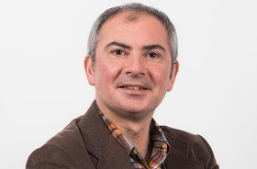 | Professor Michael Doherty, Head of Maynooth University Department of Law
11.10 a.m. | Keynote Address | TBC
11.25 a.m. | A brief guide to our programmes and University Life | Dr Fergus Ryan, Director of Undergraduate Studies, Department of Law
11.35 a.m. | 'Some interesting (and perhaps counterintuitive) facts about crime and punishment' | Professor Claire Hamilton Maynooth University Department of Law
11.55 a.m. | Break
12.00 noon | What are the Police?  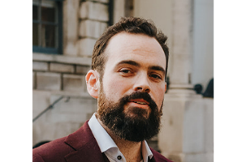 | Dr Cian Ó Concubhair, Maynooth University Department of Law
12.20 p.m. | Religious homes as sites of punishment in Ireland | Dr Lynsey Black, Maynooth University Department of Law
12.40 p.m.-1 p.m. | Q & A Panel | Current and past Maynooth University Students across Criminology Programmes

