Index

How to Access the JDE report Link Pages 2 - 3

Which Reports to Run Pages 4 - 6

How to Run the Summary Reports Pages 7 - 14

View & Download the Summary Report Pages 15 - 18

How to Interpret the Summary Reports Pages 19 - 20

View and Download the Non-Interactive Report Pages 21 - 27

How to Interpret the Transaction Report Pages 28 - 29

Glossary of Finance & JDE Terms Pages 30 - 32

`

How to Access the JDE report Link:
The link is located on the Bursar’s webpage https://www.maynoothuniversity.ie/bursar/finance-projects

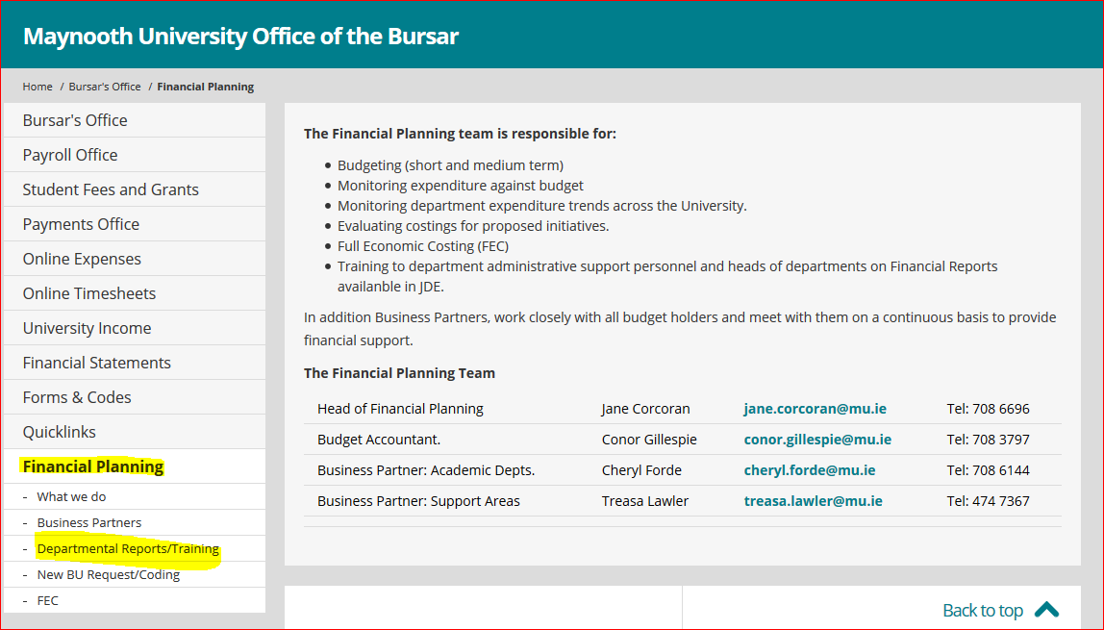

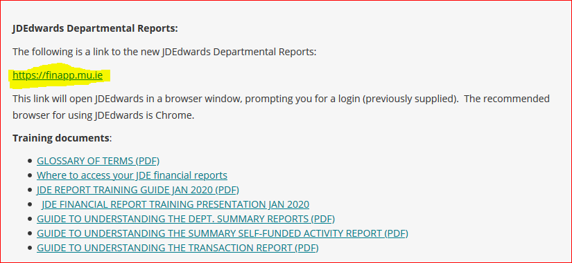

Finance recommend using Firefox for the purposes of running the JDE Financial Reports.
Settings: Turn off popup blocker for JDE
Firefox: http://usc.custhelp.com/app/answers/detail/a_id/1206/~/how-do-i-disable-the-pop-up-blocker-in-mozilla-firefox%3F

What report to choose?
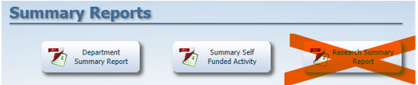

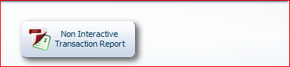
Please note the BU types:
Department Summary Report | When to use
Recurrent Academic | RC
Recurrent Non-Academic | RN
Recurrent Academic Services | RA
Self-Funded Activity Report | When to use
Other Academic | PN
Non-Academic | NA
Ancillary | AN
Scholarships | PS

HINT: Please note that BU Types RS and GR are part of the Research ledger. You use the Research Summary report for these BU types. Please contact the Research Development Office (RDO).
- If your Department is funded by the University - these are called Recurrent Business Units (BUs) – You need to run the Department Summary Report
- If you have been assigned a BU to run a Self-Funded project e.g. Conference or a course funded by the HEA etc. These are normally funded solely or partially by external sources of income – you need to run the Summary-Self Funded Activity.

HINT: Knowing which report to run for the above BU types is very important. If you run the incorrect report, you will not be able to interpret the data correctly.
A list of BUs’ can be provided on request by either the Business partner or staff in the RDO

NAVIGATION FROM SCREEN TO SCREEN IN JDE:

To navigate through the various screens within JDE and in order to get back to the main menu, you need to click on the X symbol located on the LHS of the screen you are currently in.
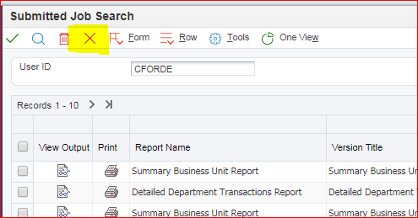

How to Run the Summary Reports.
The below instructions are the same for either the Department Summary Report or the Summary Self-Funded Activity options.
To run the Summary Reports:
- Click on Department Summary Report or Summary Self-Funded Activity, as per below based on the BU type described on page 7

- Tick the box (Data Selection) and click ‘Submit’.

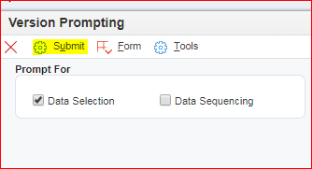

- Click on the drop-down menu in the BLANK field:
Department Summary Report View
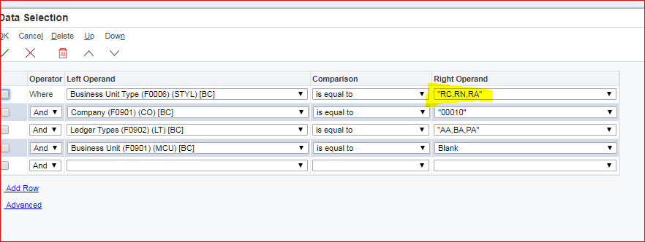

Summary Self- Funded Activity View
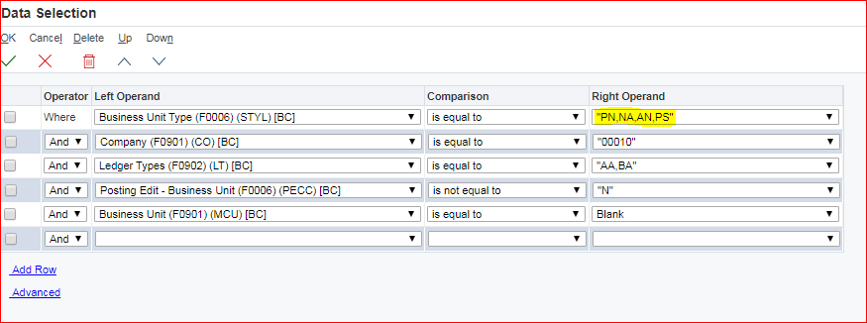

- When the drop-down menu appears – Choose ‘Literal’.

There are 3 Tabs to Choose from: SINGLE/RANGE/LIST

1 Single Value
If you want to run the report for one BU, select the ‘Single Value’ tab.
- Enter the BU Number in the Literal value field.

- Click OK on LHS
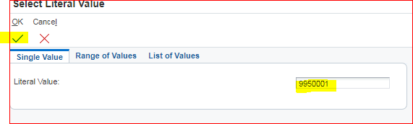
- When this screen appears:
Click OK on the LHS
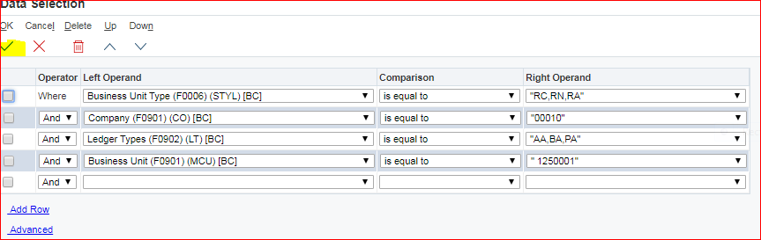
To select the Time Period

On the next page, you can select the month & year (parameters).

- Enter 12 (for month 12 – Oct to Sept) in the Period Number field
- Enter 18 (for 2018), in the Fiscal Year field.
Hint: Always insert 12 in the Period as this will run the most current data: In the Financial/Fiscal Year: Period 1 = Oct, Period 2= Nov……….. Period 12= Sept.
Financial/Fiscal Year: 18 = 2018/19 : FY19: 2019/20
The report below will run from 01 Oct 18 to 30 Sept 19
- When you enter your parameters - Click OK

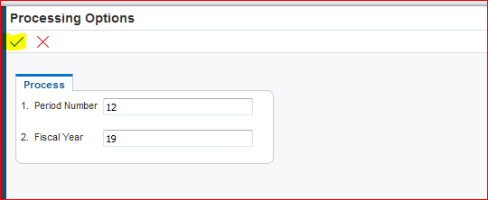

HINT: Fiscal Year = Financial Year for Maynooth University (01 October to the 30 September)

Or
2) Range of Values
To run the report for a range of BUs, select the ‘Range of Values’ tab. Useful when you want to run all the summary reports within your Dept for either Recurrent or Self- Funded.
  - Department Summary Report: all Recurrent BUs you set up in the range
  - Summary Self- Funded Activity Report: all self-funded BU s you set up in the range

- Enter the first BU number in the field: Literal Value From
- Enter the last BU number in the field: Literal Value To.
- Click Ok on LHS
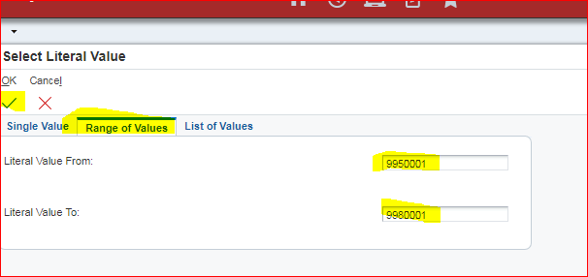

You will be returned to the ‘Data Selection’ page, showing your selection, see page 11.
- To proceed click OK

Or
3) List of Values
To run a list of BU summaries together: that are not in a range. Useful for when you have a list of BU Numbers you want to run.
- Department Summary Report: output all Recurrent BUs you set up in the list
- Summary Self- Funded Activity Report: output all self-funded BU s you set up in the list
- In the ‘Literal Value to Add’ field, enter the first one BU number in the list and hit return. The BU appears in the Box below.
- Enter next BU number & hit return again etc... until your list is complete
- When complete click OK

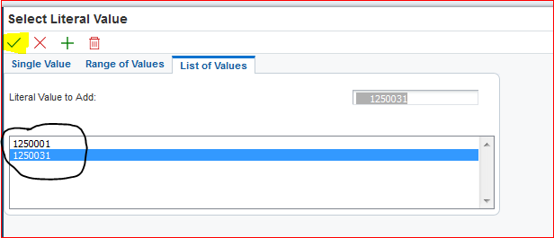

At the next screen you will see the BU’s that yiou have selected to run the reports for:
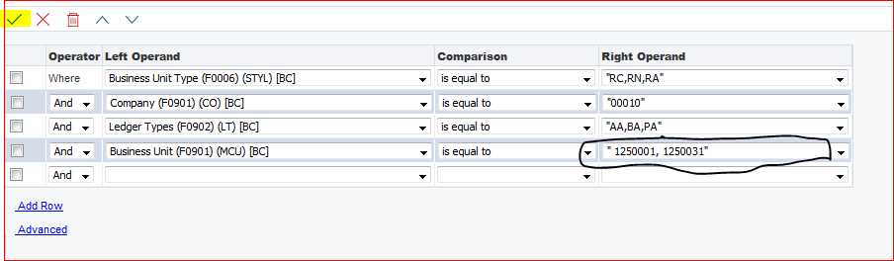
- To proceed click OK
You will be returned to the ‘Processing Options’ page, showing your selection, see page 11.
To select All BUs (either Recurrent or Self-funded)
This is another way to run either your Recurrent/Self-Funded BUs.
- Tick the 4th box and click Delete button.
This removes the line, which is ticked.
Department Summary Report view.
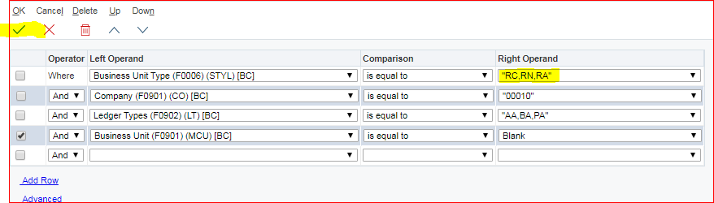

- Click OK on the LHS
Summary Self-Funded Activity view
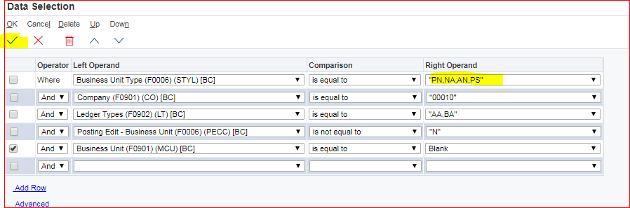
- Click OK on the LHS

HINT: Do not worry the next time you login and run a query the system will revert to the original set up.
View & Download the Summary Report
PDF or Excel?
PDF is just a picture view – Hint: Handy if the HOD/Head of Support Area wishes to see in soft copy all the Recurrent BU Summaries Or all the Self-Funded Summaries. You will need to run two lists
Excel – Allows the user to write on the report and format it.

The Submit Report Definition screen will appear as below, and it will automatically tick the PDF format. Select one or both options, depending on the view type you want to view.

- Tick the Output Format Option(s) and click Ok : LHS

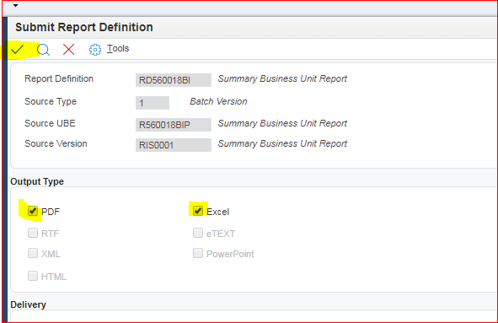

- At the next screen click submit
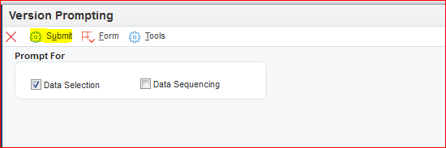
View Reports you have Run
- Click the ‘Recent Reports icon’ and a drop-down menu will appear.

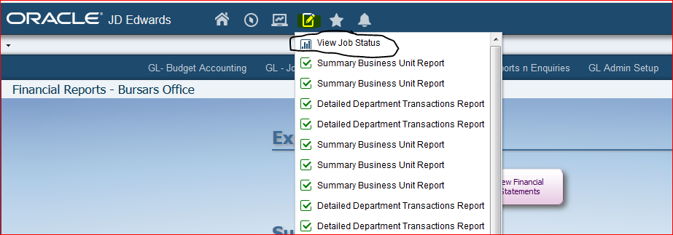

- Click View Job Status and a drop-down menu with a list of all the reports you have ran in the past will be shown.

From the list, you will be looking for the most recent one: Your report will be first on the list.

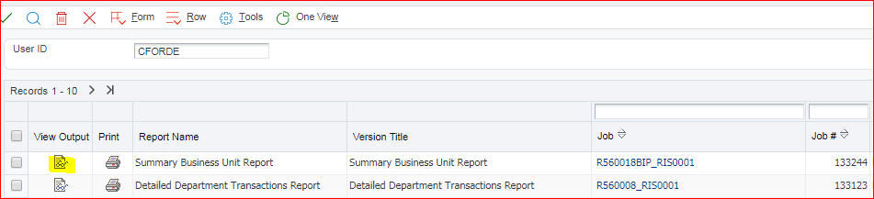

- Click on View Output – Glasses Icon
If you selected both the PDF and Excel, both will appear as options to open.
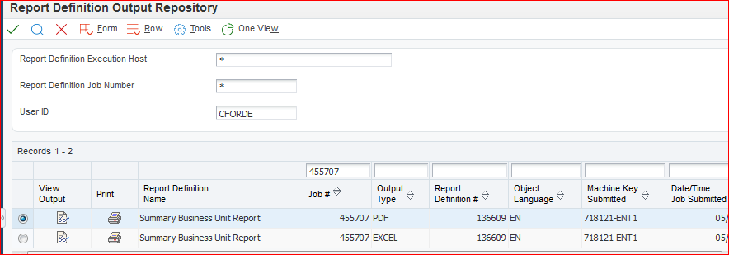

- Choose either Excel or PDF option: depending on what format you want to view the report.

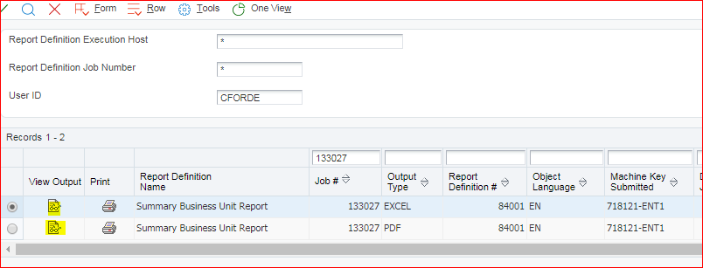

- Click on View Output –Glasses Icon.

HINT: The Report will pop up on the Bottom left hand corner of your screen:

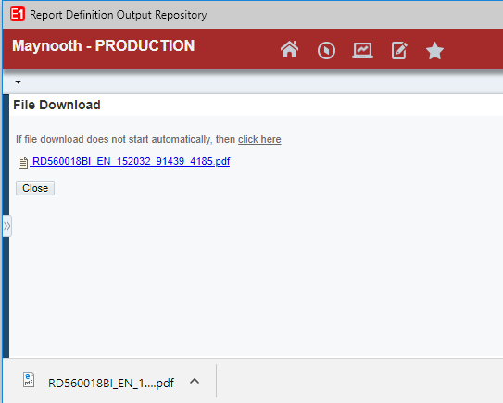

or under the
arrow down icon on top RHS, depending on the browser you are using.

This is an example of a Department Summary Report

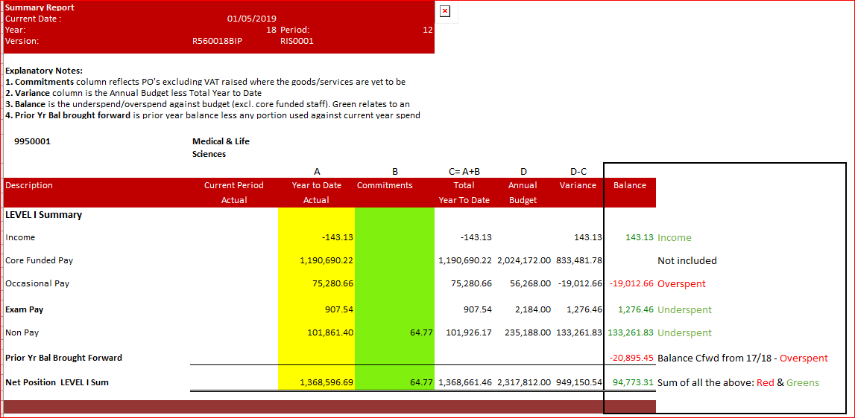

A = Total Year to Date = the total transactions posted for the period: 01 Oct 18 up until 30 Sept 19
B = Commitments – Purchase Orders (PO’s) raised. Once the PO is receipted, the figure becomes an actual in the Transaction report and moves into Col A.
Note: Income is shown as a minus (-). Spend is shown as a positive (+)

BALANCE: What you have left to spend now. Most Important Figure you need to know.
HINT: Keep on top of your “Receipting” as it keeps the Commitments figures low.
This is an example of a Summary Self- Funded Activity Report
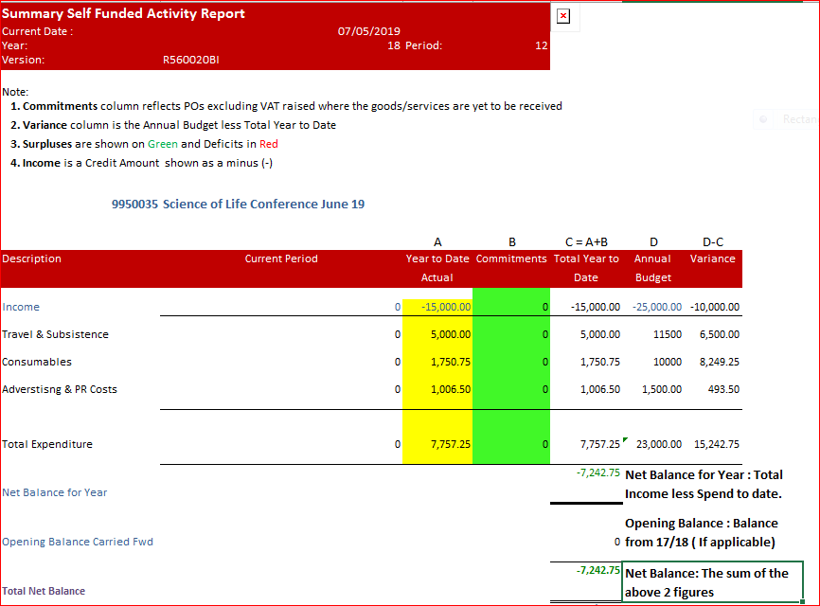
A = Total Year to Date = the total transactions posted for the period: 01 Oct 18 up until 30 Sept 19
B = Commitments – Purchase Orders (PO’s) raised. Once the PO is receipted, the figure becomes an actual in the Transaction report and moves into Col A.
Note: Income is shown as a minus (-). Spend is shown as a positive (+)
Total Net Balance: What you have left to spend now. This figure will change as you received more income and spent against the forecasted budget. It should never end up in the red once the activity is complete.
HINT: Keep on top of your “Receipting” as it keeps the Commitments figures low. Commitments become an actual only when the goods are “Receipted”. The System does not send out reminders.
How to Run the Non – Interactive Transaction Report:
What is it? This is a list of all transactions for the current Financial Year (Oct 18-Sept 19). It shows all income and expenditure transactions posted to the BU – balances forward are not shown.
The Transaction report can be run for all BU types - Department (Recurrent) or the Self-Funded Activity BU types.
Select the Non-Interactive Transaction Report

- Tick Data Selection and click Submit

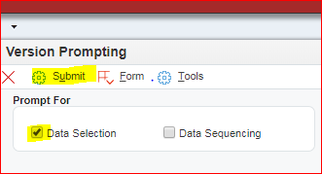

To select BUs
- Click on the drop-down menu in the BU field:
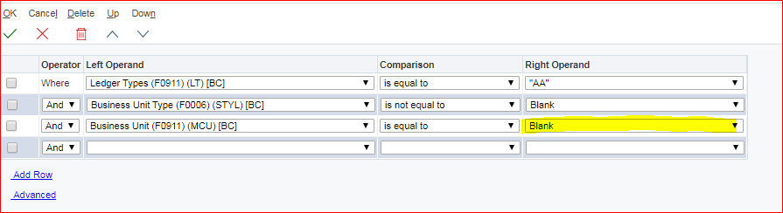

- When the drop-down menu appears – Choose ‘Literal’.

There are 3 Tabs to choose from: SINGLE/RANGE/LIST
Single Value
If you want to run the report for one BU, select the ‘Single Value’ tab.
- Enter the BU Number in the open field.

- Click OK on LHS

To select the Time Period & Format
- In Period box enter 12, for month 12 (Sept)
- In Fiscal Year box enter 18, for Fiscal/Financial year 2018/19, FY 19: 2019/2020
- In the Output Order Format enter either 1 or 0

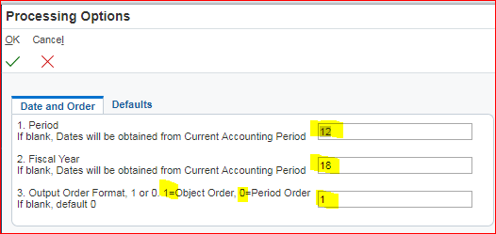

Output Order Format: 1: shows the transactions by Object/Expenditure Type e.g. Travel, consumables etc…
Output Order Format: 0: shows the Expenditure by Month
The report above will run in Financial/Fiscal 2017/18 from Oct 17 to Sept 18 by Object type.

- Click Ok on LHS
This screen will appear next.
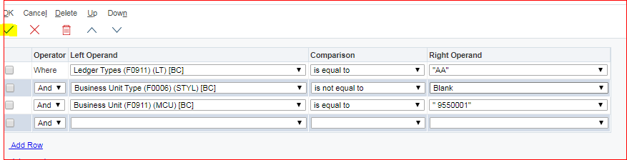

- Click Ok on LHS

View & Download the Non- Interactive Report
PDF or Excel Format or both:
- Select one or both in the Output Type and click OK: on the green tick

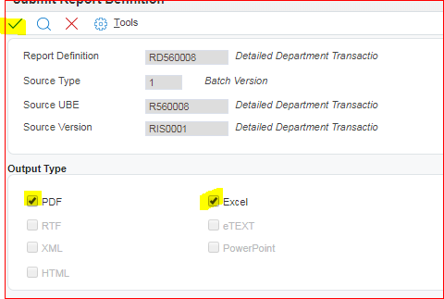

You can now proceed and pick up your report that you have just run.
- Click the ‘Recent Reports icon’ and a drop-down menu will appear.

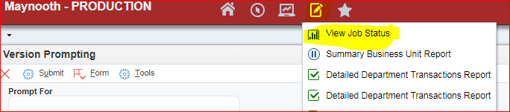

- Click on your most recent report, the one on top of your list:

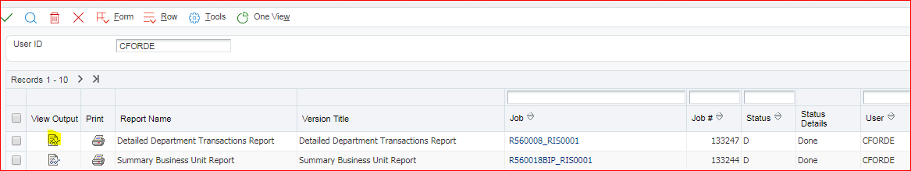

- Choose either Excel or PDF option: depending on what format you want to view the report.
- Click on the View Output Icon – Glasses Icon

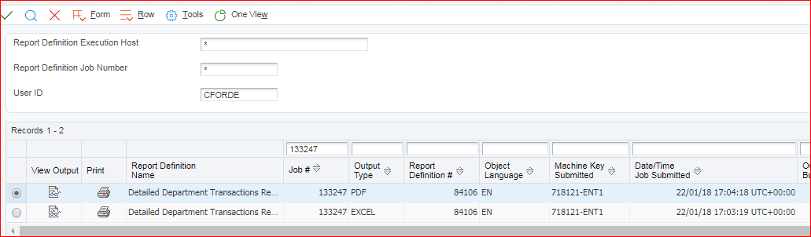
The report will pop up in your screen in the bottom left hand corner or in the top RHC depending on which browser you are using. See page 18.

Transaction Report
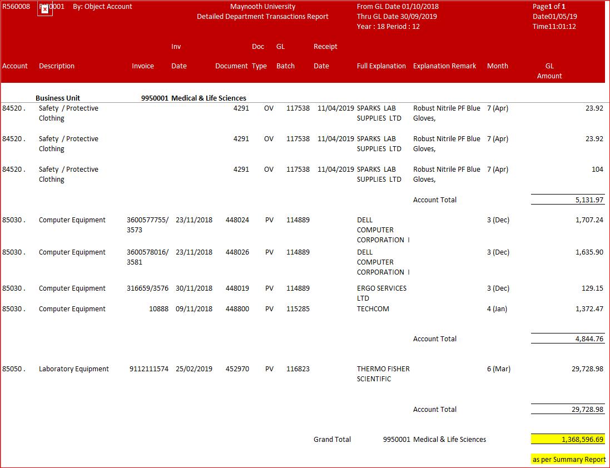
Total Transactions as per yellow = Total Year to Date Col A in Department Summary Report.
The transaction report explained:
- This is a list, for example in the current financial year (2018/19), of all income and expenditure transactions posts – balances forward are not shown. In this example it is all transaction posted to BU 9950001 from 01/10/18 to 30/09/19.

- It does not show commitments. It only shows actual costs.
- The Transaction report can be run for either the Department (Recurrent) or the Self-Funded Activity BU types – used for all BU types.
- Income is shown as a minus (-) on the report
- Spend is shown as a plus (+) on the report
- The transaction list can be run by either spend type (object: option 1) or by period (month: option 0))
- Depending on the parameters – assume you are running it to period 12, it will show you the list of transactions to date in the current Fiscal/Financial year – 18 = 2018/19 (01 Oct 18 to 30 Sept 19)

Glossary of Finance & JDE Terms

JDE REPORTS AND FINANCE TERMINOLOGY
Doc: Type | Description | Explanation
BUSINESS UNITS
BU | Business Unit | Unique 7-digit code assigned within JDE Financial Reports, which shows the area of spend e.g. Department recurrent, Support Areas, Conference etc.
RC/RN/RA | Recurrent BUs | Academic Department and Support Area BUs whose annual budget is funded by the University (State Grant: fees etc.).  - RC: Recurrent  - RN: Recurrent Non-Academic  - RA: Recurrent Academic Support
PN/NA/PS/AN | Self-funded BU’s | PN: Academic Departments with self-funded activities e.g. conferences.  NA: Non-academic areas with self-funded activities e.g. HEA funding initiatives for disadvantaged students.  PS: University Student Scholarships  - Internal: John Hume scheme/Doctoral Scholarships  - External sources.  AN: Ancillary areas that generate commercial income: rental income from apartments
TERMINOLOGY
OBJECT CODES | Income/Expense types (Operating Cost Codes) | Breaks down and helps identify the type of expense/income which allows one to identify the key cost drivers/trends in an area. Examples include Travel and Subsistence, Consumables, Recruitment costs, Conference income, Other Income…
FISCAL YEAR (FY) | The University Financial Year | The University Financial Year runs from 01 October through to the 30 Sept annually. The Financial Reports in JDE refers to this as the Fiscal year.
PERIOD NUMBER | The Periods in the University Financial Year | There are 12 periods, which are defined by month in the University Financial Year. Period 1 is Oct; Period 2 is Nov…..all the way through to period 12, which is Sept.
BALANCE | Term used when referring to funds left to spend in Recurrent BUs | What is left to spend at a given point in time within the current  University Financial Year for Recurrent BUs (RC/RN/RA). It excludes the Core Pay budget.
NET BALANCE | Term used to refer to the balance in Self-Funded BUs | Total Income minus total expenditure in the current Financial year plus the opening balance if applicable from the previous Financial Year.
VARIANCE | Variance is used in all BU types. | The difference between what you have spent to date versus the budget in the Summary reports in Recurrent and Self-funded BUs (PN/NA)
CUT-OFF | A period of time where 2 Financial years overlap. | The period between the end of one University Financial Year and the start of another Financial Year. The cut-off window is the period just after period 12 (Sept) and at the start of period 1 (Oct).
ACCRUALS | Accrued Expenditure | Invoices dated Sept (period 12) in the old University Financial year but not received until the new Financial year (on or after period 1).
PREPAYMENT | Prepaid Expenditure | Invoices received and paid by in period 12 (Sept) the old University Financial Year, which relates to the new Financial year period 1 (Oct) e.g. subscriptions, equipment, expenses paid in advance
ACCRUED INCOME | Income owed | Income owed at period 12 (Sept) the Old University Financial Year, which will not be received until the new Financial year, during or after period 1 (Oct).
DEFERRED INCOME | Advance Income | Income paid upfront/in advance by period 12 (Sept) the Old University Financial year, which belongs to the new Financial Year post period post 1 (Oct) e.g. advances/student field trip fee income.

TRANSACTION CODES
Doc: Type | Description | Explanation
RI | Income | Invoiced Income through AR/The Income Office
X6 | Income | Income not invoiced
X5 | Payment | Direct transfer to a Supplier
JE | General Journal | Finance Office general journal used to correct miscoded costs.
JP | Payroll Journal | Finance journal used to upload monthly pay from Core Pay
CC | Core Correction Journal | Finance journal used to correct miscoded pay costs
JC | Core Expenses Journal | Finance journal used to upload expenses from Core Pay into JDE
CE | Core Expenses Correction Journal | Finance journal used to correct miscoded core expenses
JF | ITS Fees Journal | Finance Journal used to upload Fee charges from ITS into JDE
CF | ITS Fees Correction Journal | Finance journal used to correct miscoded fees
IT | Internal Trade Journal | Finance journal used to transfer income between Departments
RD | Recurring Bill Journal | Finance journal used to charge recurring bills e.g. Vodafone
UP | Petty Cash Journal | Finance petty used to charge cash Journal to a BU
RJ | Research Journal | Research Journals completed by the Research Development Office (RDO).
OV | PO + Goods Receipted | Requisitioner/Buyer/Approver: Purchase Order (PO) where the goods have been received (receipted) from the Supplier.
PV | Invoice | Relates to purchases currently outside the scope of POP – Hotel Bookings, Club travel, Postage
PC | Purchase Credit | Refund from a supplier (PV)
UI | JDE Expense Claim | Expenses processed through JDE – Academic travel, non-staff travel expenses (visitors).
PR | Student Stipend | Monthly Stipend payments to students.

