Irish Residence Permit (IRP) Card

With effect from March 1st 2022 a new version of the Irish Residence Permit (IRP) card, example below, will commence to issue to all non-EEA nationals registered to live/work/study in Ireland.

The new IRP card will be compliant with the updated EU common format specifications and will include additional security features for validation. The IRP will also include a signature of the cardholder.

New IRP Design
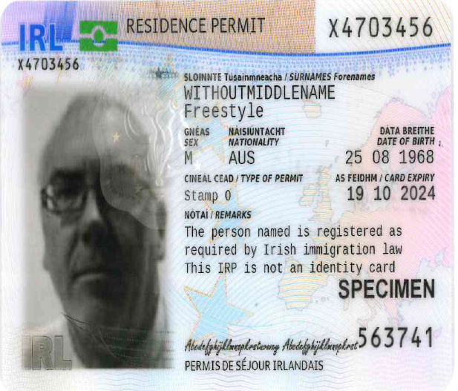 | 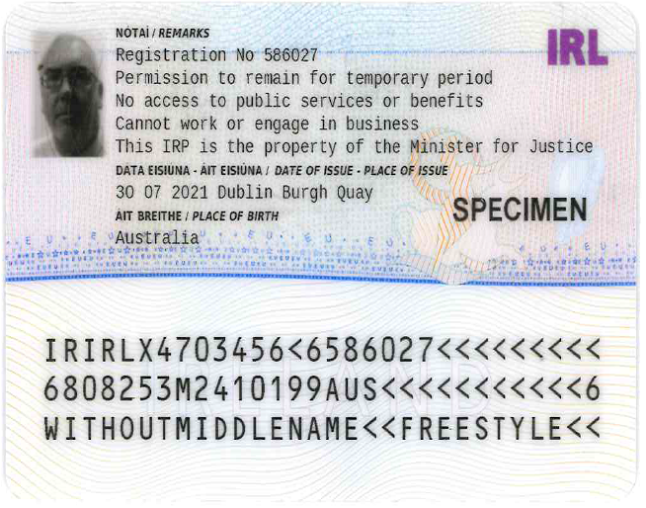
New IRP Card front | New IRP Card reverse

In date versions of the old design, example below, will remain valid to the stated expiry date printed on the IRP card or 31 May 2022, in line with the Minister’s general extension of permissions provided during the Covid pandemic, whichever is the later.

Old IRP Design
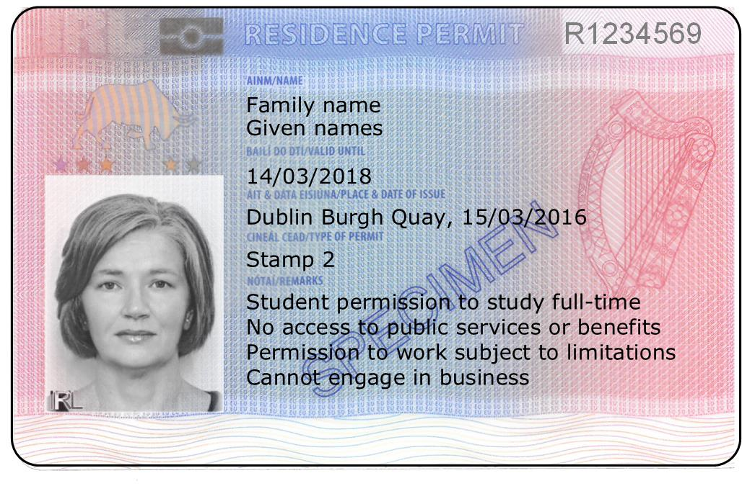 | 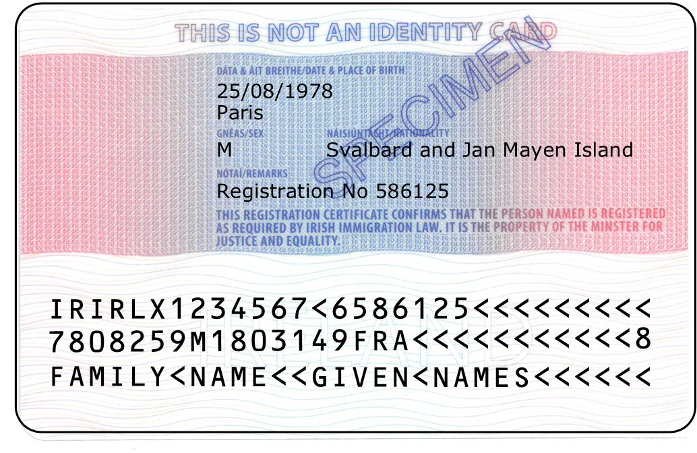
Old IRP Card front | Old IRP Card reverse

Immigration Service Delivery
Department of Justice

25 February 2022

