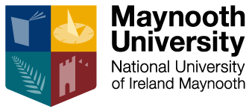

HISTORY DEPARTMENT RESEARCH SEMINAR 2022-2023 (SEMESTER I)

Venue: Room 1.33, Iontas Building

6 October at 6pm
Catherine Corless
Tuam Mother & Baby Home - Exposing the Truth
(chaired by Dr Jennifer Redmond)
Venue: John Hume Lecture Theatre 1, North Campus)

20 October at 6pm
Avishek Ray (National Institute of Technology Silchar)
Roma Historiography and Its Sticky Association with India

17 November at 6pm
Dr Olga Byrska (European University Institute)
Interregnum, or: Poland’s unachieved revolution, 1944-48

24 November at 6.30 pm
Professor Michael Geary (Norwegian University of Science and Technology)
Waving goodbye to neutrality? Navigating Irish foreign policy inside the European Union from membership to Maastricht

15 December at 6.30 pm
Ruth Canning (Liverpool Hope University)
Power, Politics, and Personality in Sixteenth-Century Ireland: A Case Study of Christopher Nugent, Baron of Delvin

