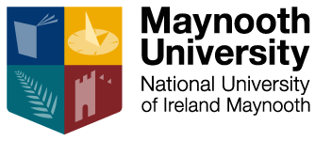

HISTORY DEPARTMENT RESEARCH SEMINAR 2021-2022 (SEMESTER II)
Time: 6pm – 7.30pm (GMT)

Venue: Online in February and then JHL 2)
All are welcome to attend

3 February (online)
Aisling Shalvey (German National Academy of Science, Leopoldina)
‘Paediatrics under German Occupation, 1941-1944’

3 March
Lewis Defrates (Maynooth University)
‘The Newspapers, the Telegraph Wires, the Cables”: Race, Infrastructure and the Global Production of American Culture, 1865-1914’

10 March
6.30pm - Hussam Ahmed (Maynooth University)
‘Hassanein Heikal's al-Ahram: Journalism vs. the University in Nasser’s Egypt’

24 March
Laura Brown (Maynooth University)
‘True crime and the historian’

14 April
Justin Dolan Stover (Idaho State University)
'Reconsidering "Active Service" during the Irish Revolution'

28 April
6.30pm - Sarah Roddy (Maynooth University)
'A grateful client of St Gabriel': an introduction to the PARISH church inscriptions project’

5 May
Doina Anca Cretu (Masaryk Institute, Prague)
‘Humanitarian Containment: Austria-Hungary and the Origins of Modern Refugee Camps in the Era of the First World War’

