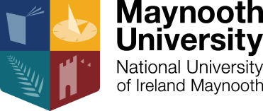

NEW PHD OPPORTUNITY AT THE HAMILTON INSTITUTE, MAYNOOTH UNIVERSITY, KILDARE, IRELAND

The Hamilton Institute at Maynooth University are seeking to recruit a new funded PhD studentship supervised by Professor Andrew Parnell and Dr Keefe Murphy in the area of ‘Missing data analysis in statistical and machine learning’. The project involves working on large data sets with missing data mechanisms that act on both multivariate target and feature variables, in the context of tree-based ensemble prediction methods. The project is funded through the national Science Foundation Ireland Insight Centre for Data Analytics.

The Hamilton Institute is dedicated to providing a bridge between mathematics and its applications in ICT, biology, and other disciplines. Founded in 2001 with support from Science Foundation Ireland, the Hamilton Institute has been internationally recognized for its work across communication networks, machine learning, mathematical biology, and fundamental mathematics.

The student will join a team of researchers working in areas including: Bayesian inference, extreme value theory, machine learning, bioinformatics, anomaly detection, and closed-loop control theory.

All applicants must have
- Relevant 2:1 degree (or higher) in Statistics, Machine Learning, Computer Science, Data Science, Mathematics, Engineering, Physics, or similar qualification
- Ability to code in one or more of R, Python, C, or Matlab
- Strong linear algebra and calculus skills
- Experience with Bayesian Statistics and MCMC methods
- Excellent written and verbal communication and presentation skills in English

The studentships are for 48 months and include a tax-free stipend of €18,500 p.a. and the payment of academic fees up to a maximum of €5,500 per annum, as well as a computer and travel allowance.

Application Procedure: send a curriculum vitae and a cover letter to hamilton@mu.ie with PHD Parnell in the subject.

Closing Date: applications must be received before 30th September 2020

Interview: Interviews will be held as applications arrive.

Starting date: October 2020 (or on acceptance)

