Core Expenses – Staff Manual
Entering and Managing Expense Trips

Table of Contents
Details | Page Number
Login | 2
Entering an expense trip | 3
Receipts information | 5
Entering a Non euro Expense item | 7
Error with Non-Euro Expense item | 9
Submitting an expense trip for approval | 10
Managing previously created expense trips | 11
Remittance Advices | 12
Rejected claims and additional information | 13
Policies | 14

Login
Navigate to the Core Portal Login page by adding below to your browser:
https://www.maynoothuniversity.ie/ess
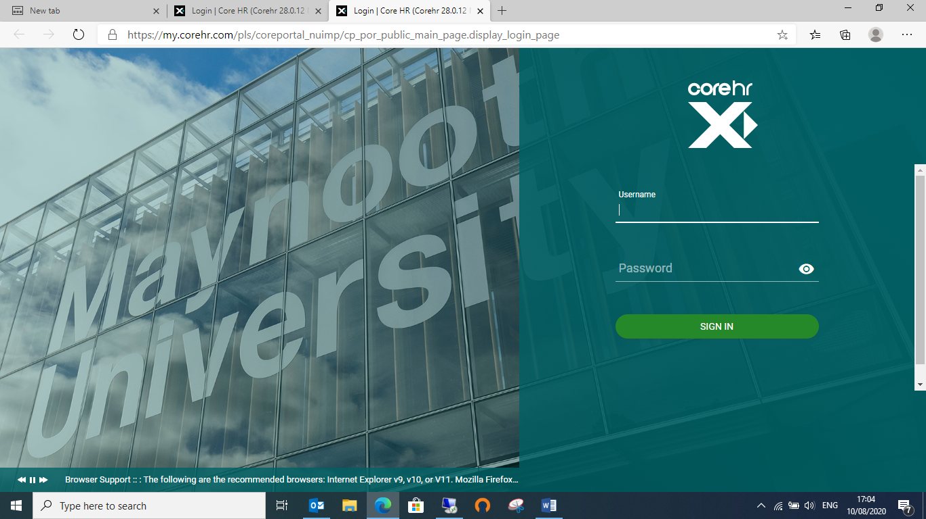
To login, enter your system username and password in the corresponding fields and press enter on your keyboard or click on Sign in

Entering an Expense Trip

Click on the “Expenses” Widget on the left hand side of the screen
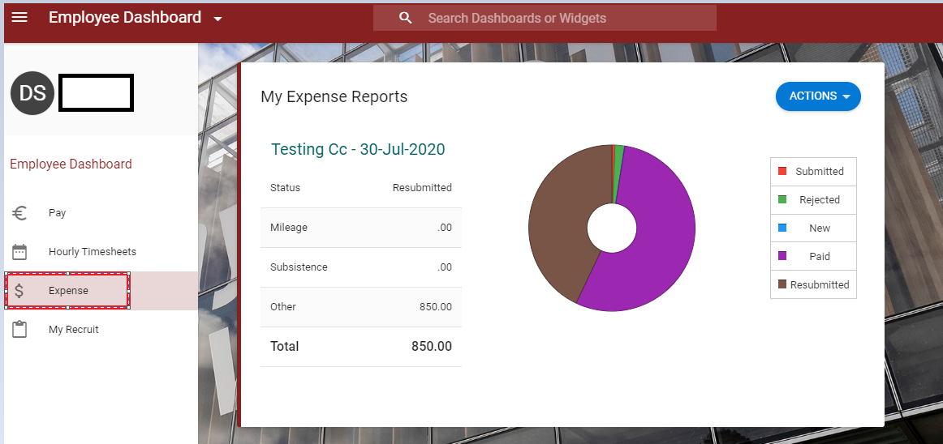

Click actions and new expense report
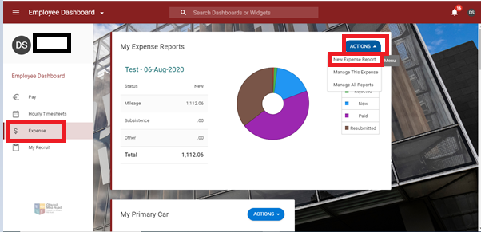

The following pop up box will appear.
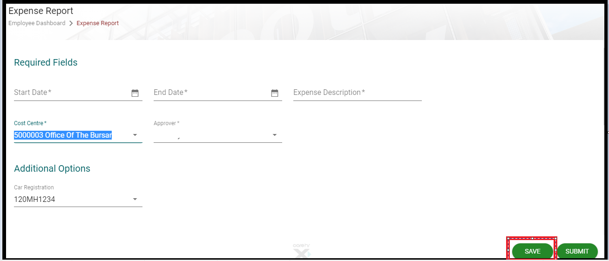
- Enter in your start date and end date
- Expense description – please give as much information as you can, further information for each expense thereafter can be given further on in the claim.
- Cost centre – this will be automatically populated with your ‘home’ cost centre, if you wish to change this just start typing the cost centre you want and when you see it on the drop down list click on it.
- Approver – This will also be set to your departments set approver 1, if you have more than one name on your list please check with your department who you should choose.
- When you have completed the above hit save, you have now created your trip.

Scroll down the page and click on ‘new expense item’
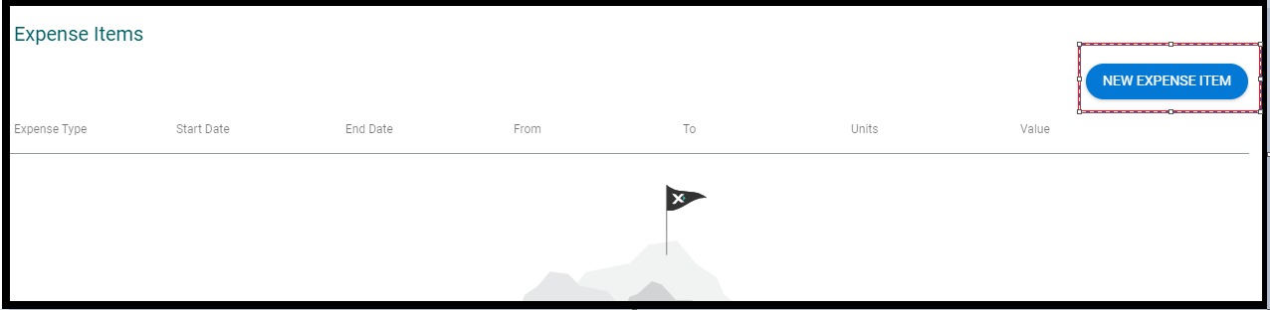

The following pop up will appear (Please note the below is only relevant if you are claiming Euro expense items, if your receipt is not in Euro please see the section on ‘Entering a Foreign Expense Trip’.
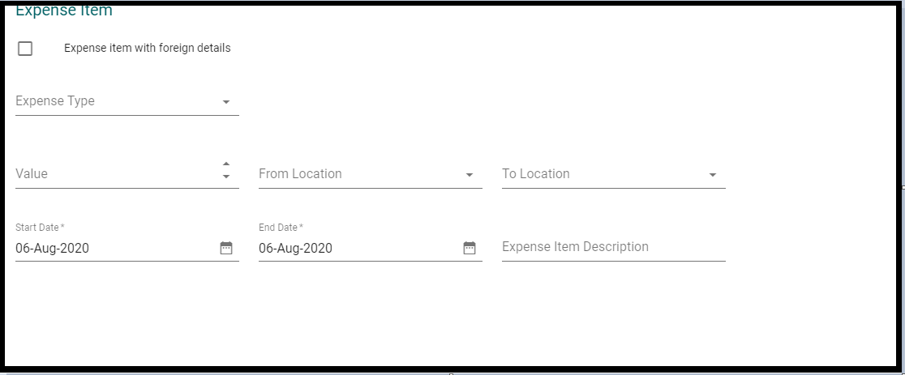
Click on the drop menu of the expense type and you will see the list of expense items you can choose from (43)
Fill in all the other information as below
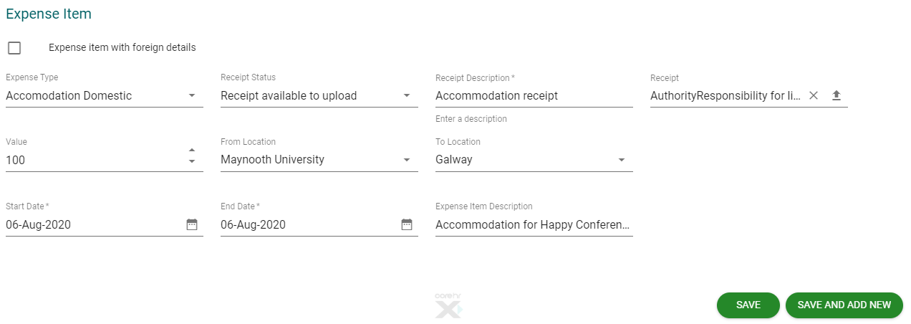
- Receipt status – if you choose “receipt available to upload” please complete the next 2 boxes’
- For receipt description please just write a brief description as above
- Receipt – please upload the expense item receipt.

- Receipt status – if you choose “no receipt available”
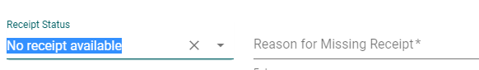
Please give the reason for the missing receipt
- Receipt status – If you choose “submit paper separately to your expense administrator”, please note expenses will not be processed until the receipts have been viewed by your department and then received by finance to be viewed.

- Value – This is the value you are claiming for, if your receipt is in a different currency please see the section on ‘Entering a Foreign Expense Trip’ and if you are not claiming the full receipt value please give a reason in the description box. EG alcohol of €15.00 has been removed from the claim.

- From Location – Usually Maynooth University
- To location – Wherever your conference/meeting was held (Dublin, Galway etc)

- Start date – The date the trip started and or the date on the receipt for non-travel items.

- End date – The date the trip finished and or the date on the receipt for non-travel items.

- Expense item description – Please give the full University business purpose e.g. the name of the conference, or the person you were meeting etc.

You can then press “save” or “save and new” if you wish to add another expense item.
Entering a Non-Euro receipt expense item
You create your ‘expense trip’ as above then when you scroll down to add your expense type
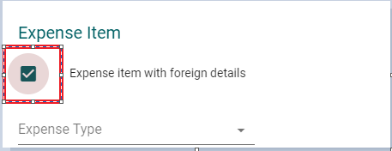
You tick the box that states ‘expense item with foreign details’
You complete all the details as above however the ‘from location and to location’ is very important this is what drives the rate you receive.
E.g. If I wish to claim for sterling expenses, I would put the claim in as per below
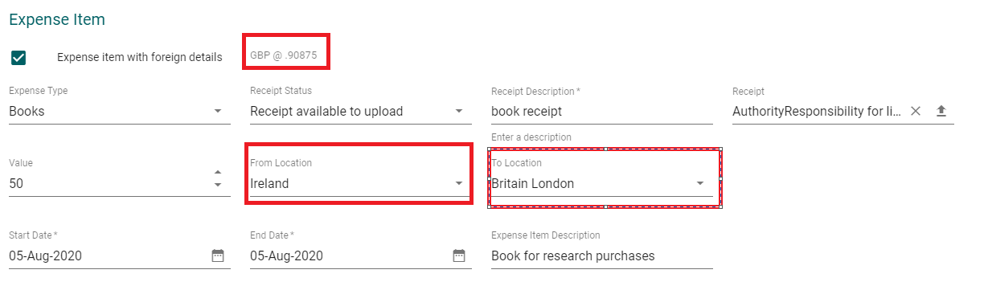

Just to note in the value, you put in the sterling value.
You then press save

You will see your claim has been converted.
Using your credit card rate
If you wish to use your own rate (from your credit card) you can do so by changing the rate.
At the top click on actions and then currency detail
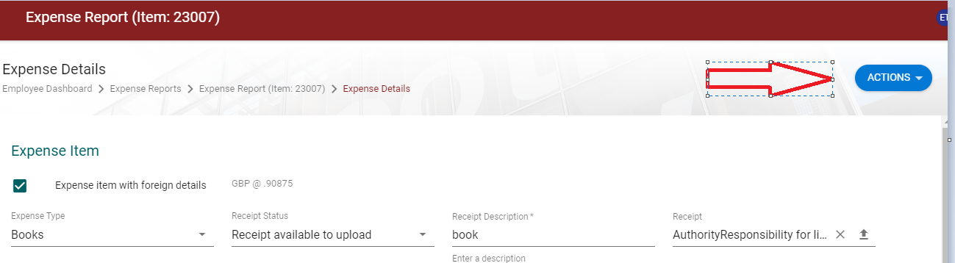

You will get this pop up
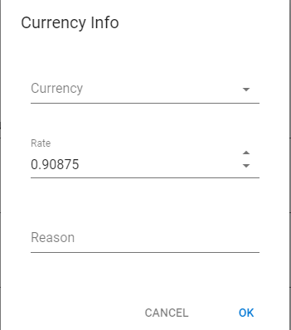

Enter in the rate you received (you must provide proof of this) and hit ok.
If you receive an error when inputting your non-Euro claim
If when you choose your location, you get a zero rate of currency or an error as below
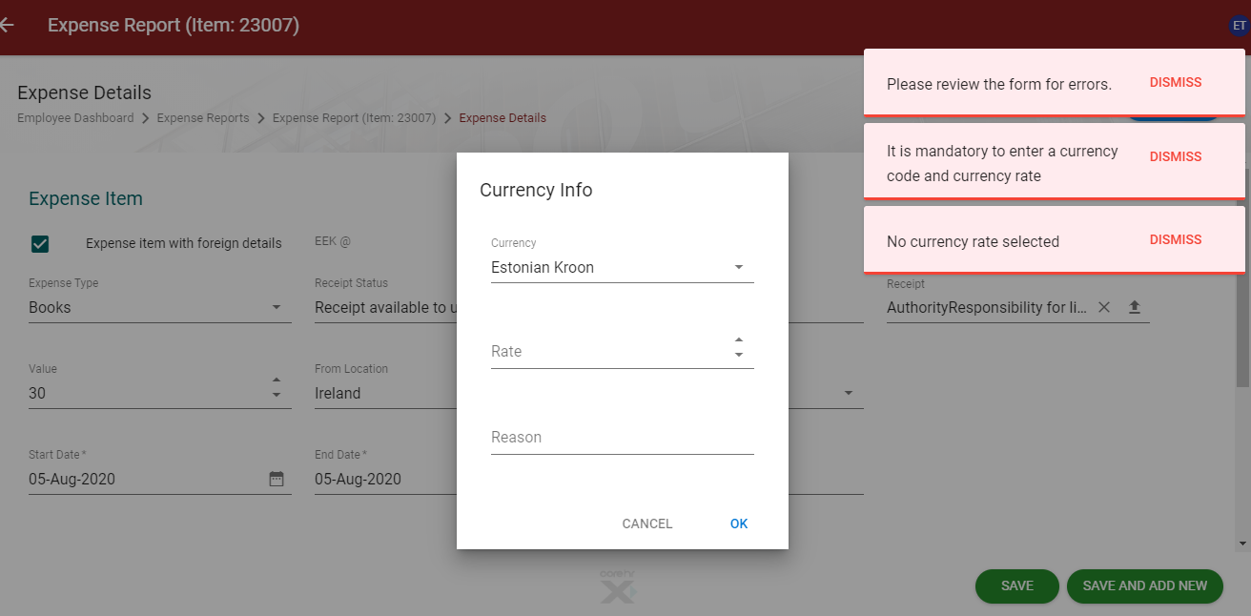

This is because the rate you have chosen is not available on our system as it is not available through the upload from central bank.
Click dismiss on the errors and enter in the rate you have received (please show proof of this by uploading a credit card statement with the rate charged) and hit ok.
Make sure you are happy with the converted Euro rate after you have entered the conversion rate.

Submitting your claim for approval
Once all expense items have been entered press the submit button. This will send the expense trip to the selected approver.

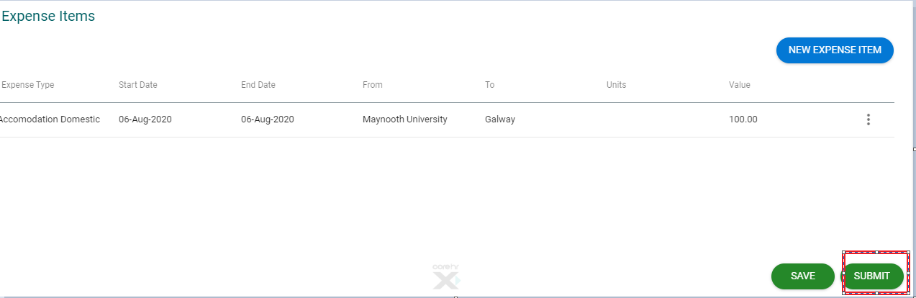
You will see the following pop up
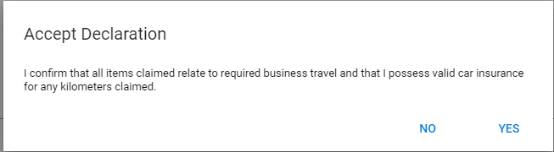
If yes, then your claim is now submitted to your approver 1 to review.

Managing previously created expense trips
Should you wish to make any changes to the expense report, on the home screen, click actions and manage all expense reports
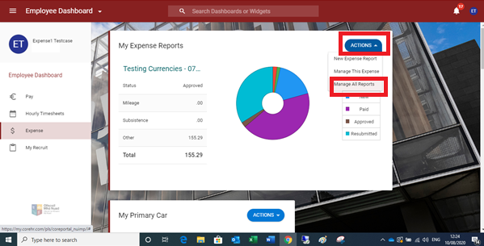
Here you can view the status of your trip Id, approver and the status of your claim
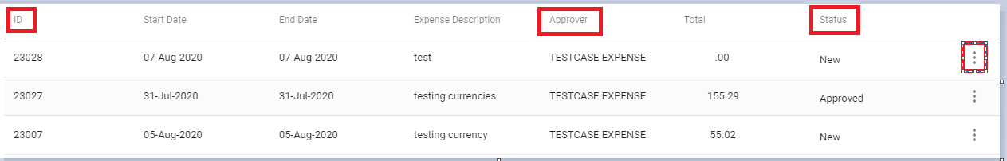
When you click on the 3 dots you can then make the changes you wish.

Remittances
Recent remittance advices are available on the Employee Screen (dashboard) just scroll down until you see remittances.
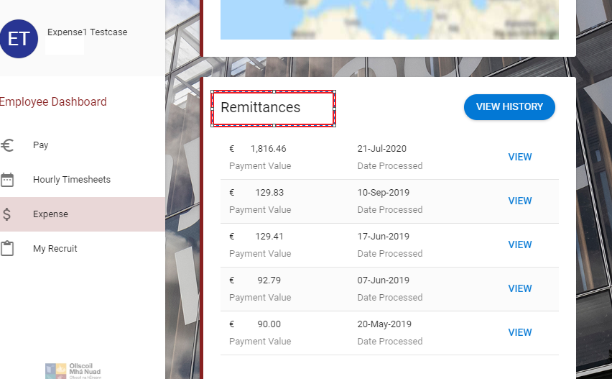

Rejected claims
On the home screen click on the actions, manage all reports

You will see your rejected claim here

You can see the reason at a claim or when you click on the 3 dots click view rejected reason. If your claim was rejected by finance an email will also be sent to you within 24hours of rejection with reason for rejection and notification of additional information that may be required.
You can then click the 3 dots again and make any changes that are required and re-submit your claim.

Additional information

- When creating an expense trip, it can only range within one Calendar year e.g. 1st October 2019-30th September 2020, if you wish to make an additional claim outside of this you must create a new expense report for this.
- All claims must be in line with the policies and procedures manual (available on the finance webpage).
- All research claims must also be in line with their own research procedures (please check with the PI or with the research office)
- All claims must be in line with the subsistence travel rates (available on the finance webpage).

