Core Expenses – Staff Manual
Car Manual

Table of Contents

Details | Page Number
Login | 2
Creating your Car | 3
Editing/updating your car | 7
Kilometres expense item error | 8
Making a Kilometres claim | 9

Login
Navigate to the Core Portal Login page by adding below to your browser:
https://www.maynoothuniversity.ie/ess
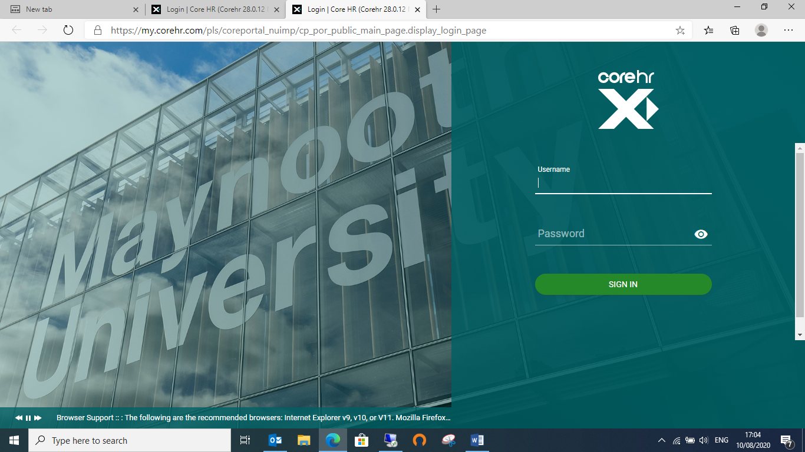
To login, enter your system username and password in the corresponding fields and press enter on your keyboard or click on Sign in

Click on the “Expenses” Widget on the left side of the screen
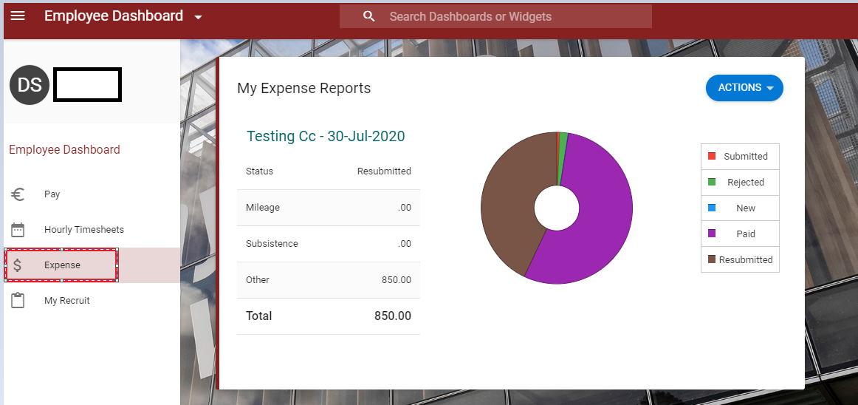

Creating your Car
Scroll down to my primary car and click on actions
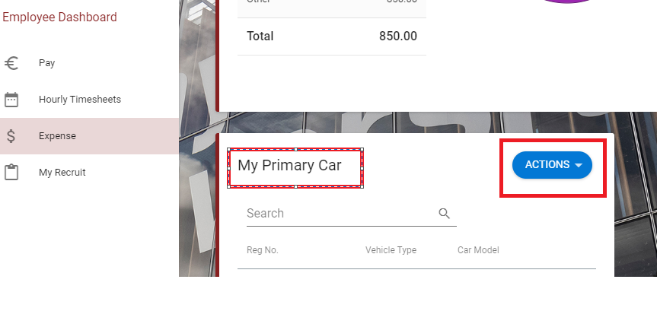

In actions click on ‘create car’ – you will see the below pop up.
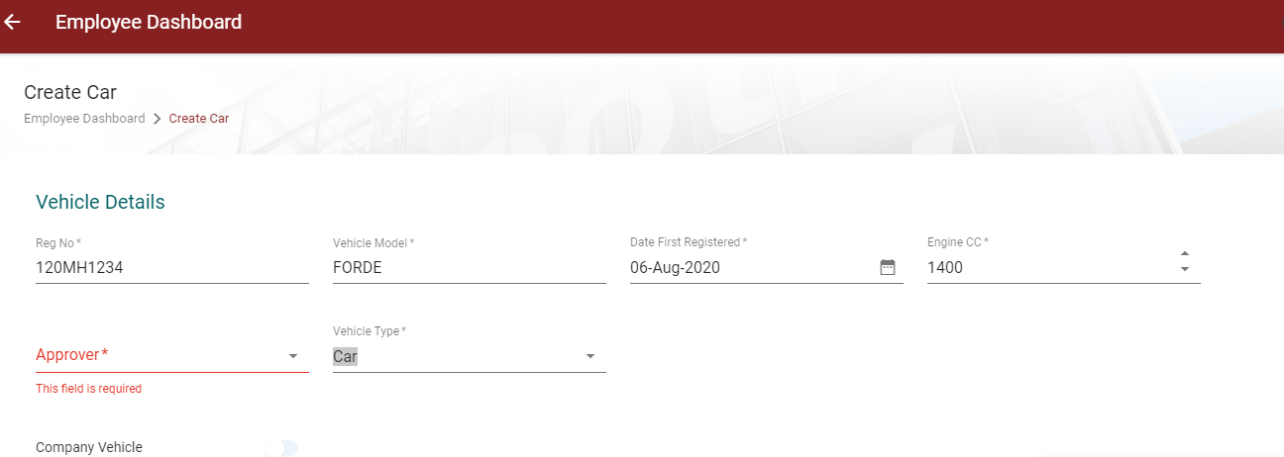

Reg No – Full registration details here.
Make/Model – E.g. Audi, Ford etc….
Date First Reg: If you do not know this, please put in todays date.
Engine CC – Check your logbook registration details if you are unsure, as this information is vital to your kilometres and drives the rate you will receive (please see https://www.maynoothuniversity.ie/bursar/online-expenses/finance-circulars for further details
Approver – Please select the name provided (it may be already populated)
Type – This is the vehicle you are registering e.g. car, motorcycle etc.

Scroll down further to your insurance details as highlighted. Your insurance details are mandatory, you will be unable to make a kilometre claim without completing this.

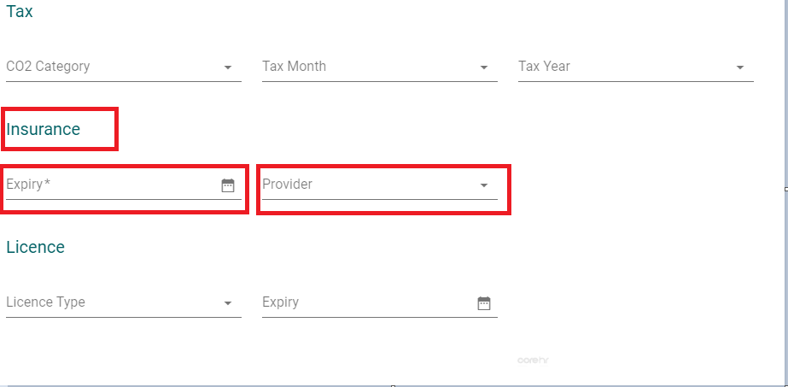

Once you complete all of the above, please tick the ‘ I confirm’ button and hit save.
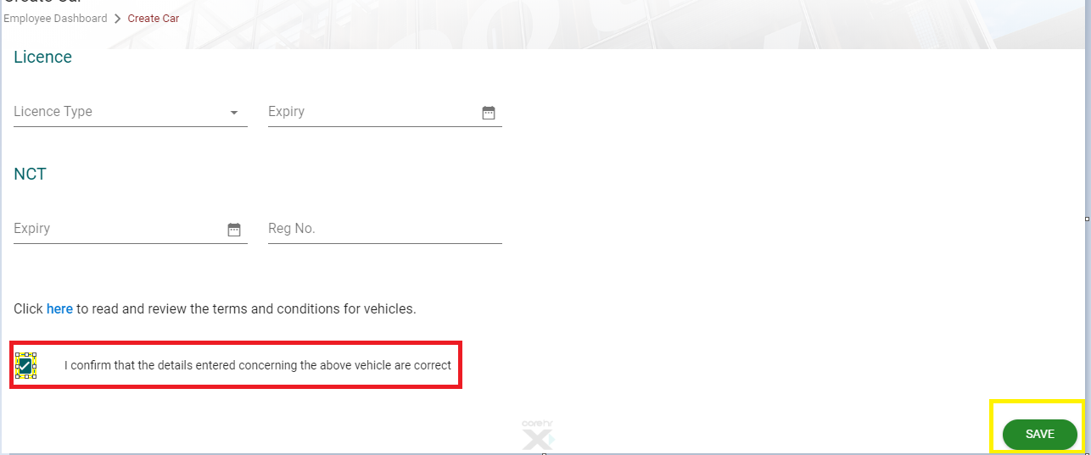

Your car is now sent to your approver 1 for approval. You cannot make a claim until your car is approved.
*note – each time you create/update an item, it must be approved.

Editing/updating your car
To edit your car or make a car your primary vehicle if you have more than one car please click on the 3 dots.

Here you can edit your car and or make a car your primary vehicle if you have more than one car
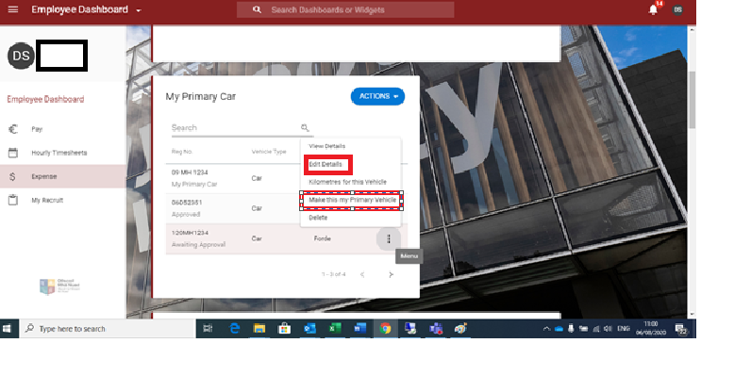
*Please remember – each time you create/update an item, it must be approved.

I am trying to input Kilometres but I am getting an error?

- Please check that your insurance is in date as you cannot claim with out of date insurance, if it is your insurance you should receive the following error when making your claim
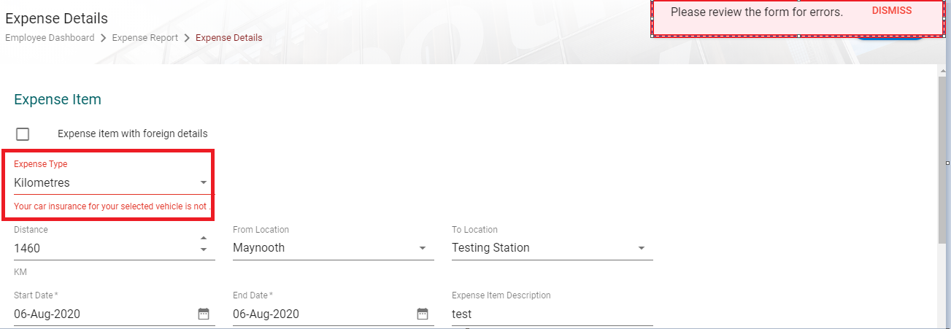
- Once you update your details they will be sent for approval, you will not be able to make a claim until they are approved.
- Please check that the system has picked up your car reg as per below, if it is blank please select your car from drop down and press save. If you have more than one car please choose the appropriate car from the list.
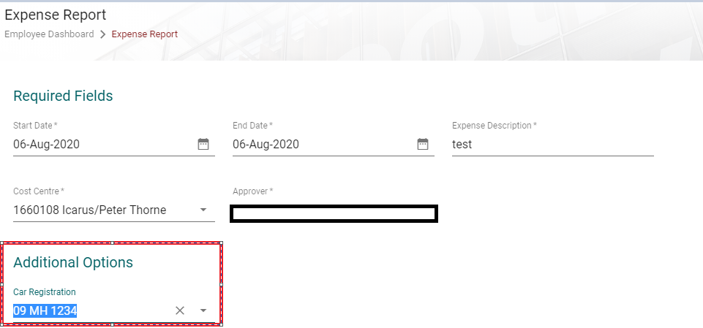
- If none of the above work please email expenses@mu.ie and we will revert back to you.

Making a kilometres claim
Once you have your car set up and your car is approved you can make your kilometres claim.
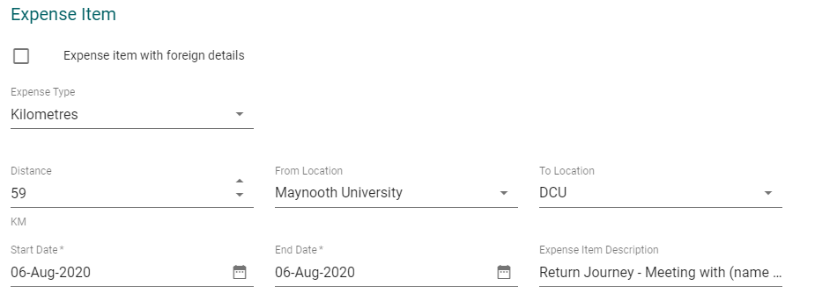
- Expense type – you choose kilometres from the drop down list
- Distance – put in the total return journey km’s example (59km is the total return journey from Maynooth University to DCU)
- From Location – this will normally be Maynooth University (please see the policies and procedures manual for details on this)
- To location – this is your end journey
- Start date – this is the day in which you took the trip
- End date – this is the day in which you returned
- Expense item description – please give the full University Business purpose for this. E.g. Return journey for meeting with (name of person) in DCU.

Once completed press Save or Save and add new if you wish to add another trip and or expense item.
The system will calculate your kilometres, this is based off your engine CC and your year to date mileage.
