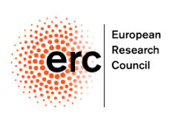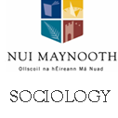

Can Social Investment save Social Europe?
Special Seminar hosted by the
Department of Sociology/ NIRSA
Political Economy and Work Cluster - New Deals in the New Economy
9.30-13.30, Thursday 29th May 2014
Phoenix Building, North Campus, NUI Maynooth

Keynotes: Prof Anton Hemerijck, VU University Amsterdam and Prof Brian Nolan, UCD
Roundtable Discussion: Rossella Ciccia (NUIM), Tom Healy (NERI), Mary Murphy (NUIM), Rory O’Donnell (NESC)
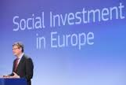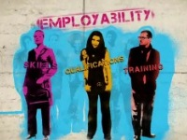
‘Social Investment’ focuses on investing in people’s skills and capacities and supporting them to participate fully in employment and social life (EU Commission). Does ‘social investment’ lead to a renewal or an erosion of the welfare state? Will ‘social investment’ support economic and social recovery? Join us for a discussion with leading figures in the debate.

At 13:30 Joan Burton, Minister for Social Protection will launch a new NUIM MA Sociology: Work, Labour Markets and Employment (MAWLE).
(To commence September 2014 subject to approval of the Academic Council)

Please register for seminar by emailing newdeals@nuim.ie before May 26th, 2014
Details of transport available at: https://www.nuim.ie/location

Schedule of Events
9.30 Registration/ Coffee
10.00-11.40 Keynote Presentations
“Affordable Social Investment after the Crisis: A Reply to Critics”
Prof. Anton Hemerijck, VU University Amsterdam
"What Use is 'Social Investment'?"
Professor Brian Nolan, UCD
Discussion, chaired by Prof. Seán Ó Riain, NUI Maynooth
11.40 Coffee
12.00-1.15 Panel Discussion and Conclusion
Dr. Rossella Ciccia, NUI Maynooth
Dr. Tom Healy, Nevin Institute
Prof. Rory O’Donnell, NESC
Chaired by Dr. Mary Murphy, NUI Maynooth
1.30 Launch
Minister Joan Burton, Minister for Social Protection, launches the Department of Sociology’s MA in Sociology: Work, Labour Markets and Employment

