WoW Bags Catalogue 2014

WoW Bags began in August 2006 as a way of providing a sustainable livelihood to woman living in the Philippines. WoW stands for Wonders of Waste…. Reflecting our sense of the wonder that it is possible to create beautiful bags and also an income from something which is thrown away.

Presently 16 people are receiving a regular fair trade income from the project. By using 100% recycled drinks pouches and lots of imagination combined with hard work the project aims to encourage care for the earth while also providing regular income to poor families. The women involved collect or sew pouches at their own pace, receive just payment and social security benefit. An enhanced saving scheme enables them to save a percentage of their income and plan for their future. Some have added extensions to their home or upgraded their sewing machines. They work from home and can combine earning a regular income with their responsibilities as parents. In almost every case they are the sole providers of a regular income within their household.

Below you will find the full range of WoW products. They have all been designed by the sewers.
Our recycled bags have a 4 stage quality control check (twice on the quality of the pouches & twice on the finished goods). The handles of each bag are reinforced and we believe you will get many years of use from your WoW Bag. Unfortunately it is not possible to respond to requests for bags in specific pouches or colours as we have to work with whatever pouches are available and these dictate the colours we use.

We hope you will enjoy looking at the amazing fruits of the Philippines and that our colorful bags will send some sunshine your way. The children of the sewers modeled some of our bags in their local school.

Thank you so much for your interest and your support which is making a small difference to our planet and a large difference to the lives of all the people involved with WoW.
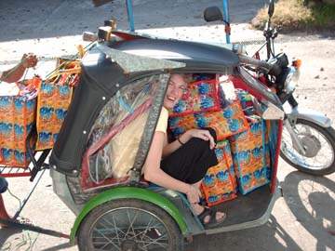
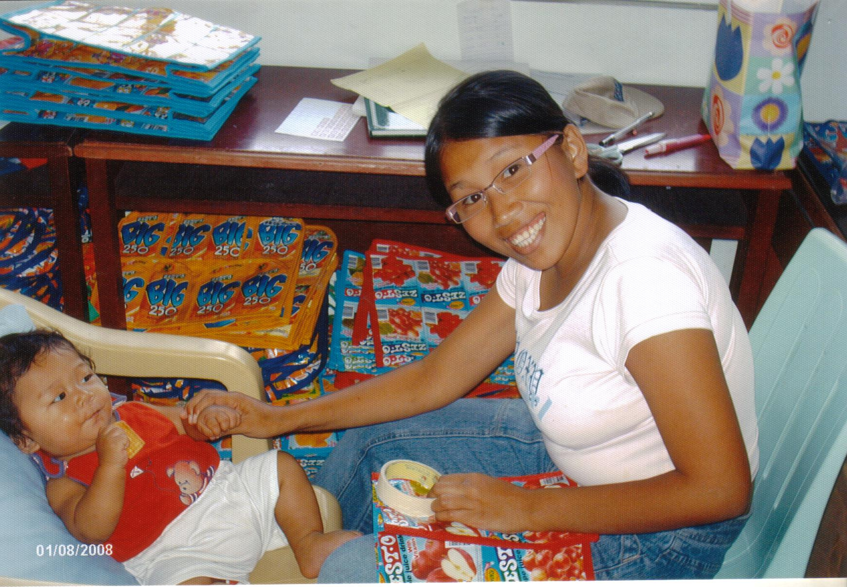

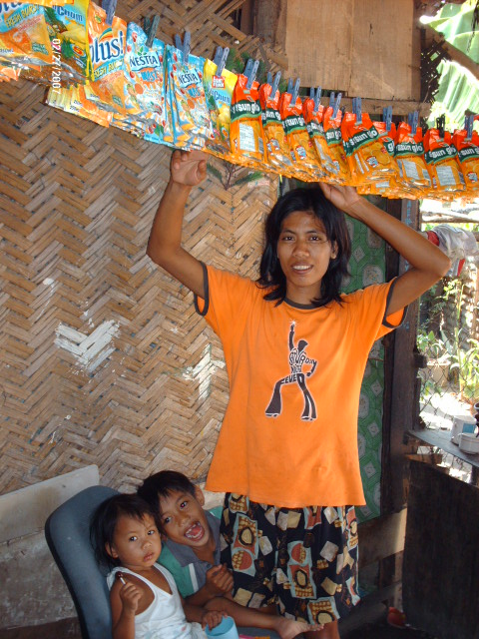

Eco-friendly delivery system.
Quality check with a smile.

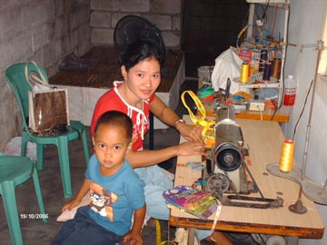

Vilma hanging out the washing!
Remy making beautiful bags.

All measurements are in cm
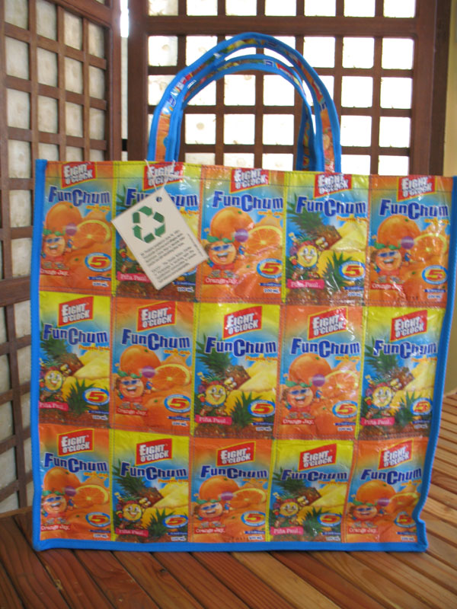 | Bag Code 01 Giant Market  Environmental impact 56 packs recycled  Cost €13.00  Description  Our biggest bag. Suitable for use at the beach, pool or supermarket. It has a small inside pocket.  Measurements in cm
  Height | Width | Depth
  43 | 45 | 19
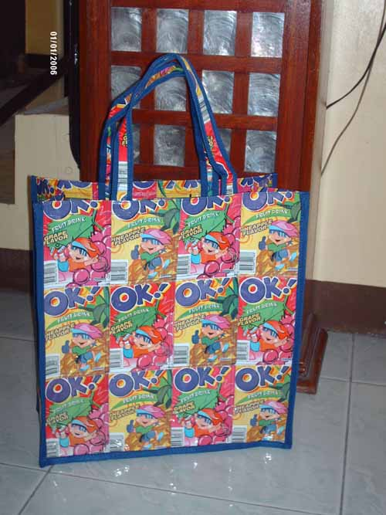 | Bag Code 02 Large Market  Environmental impact 51 packs recycled  Cost €11.00  Description  A slightly smaller shopping bag suitable for everyday use.  Measurements in cm
  Height | Width | Depth
  39 | 36 | 15
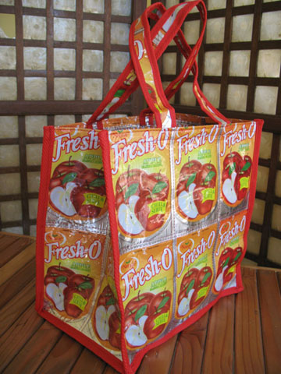 | Bag Code 03 Medium Market  Environmental impact 27 packs recycled  Cost €9.00  Description  A small square useful bag for smaller amounts of shopping.  Measurements in cm
  Height | Width | Depth
  29 | 28 | 19
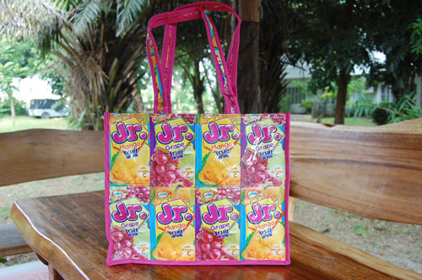 | Bag Code 04 Small Market  Environmental impact 27 packs recycled  Cost €6.00  Description  Made with junior juice packs this neat bag is a perfect fit for an I-pad.  Measurements in cm
  Height | Width | Depth
  25.5 | 29.5 | 8
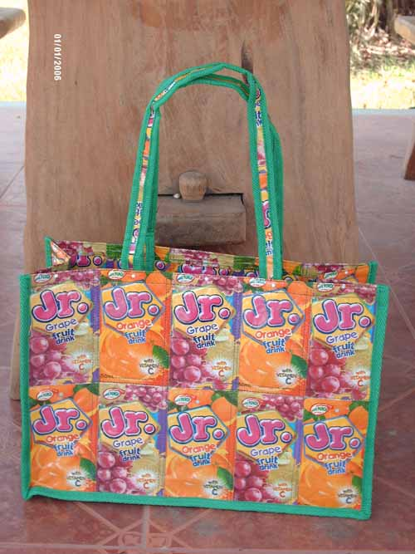 | Bag Code 05 Rectangular Market  Environmental impact 40 packs recycled  Cost €9.00  Description  A handy sized bag which will hold A4 size folders, books etc comfortably.  Measurements in cm
  Height | Width | Depth
  2 | 36 | 15
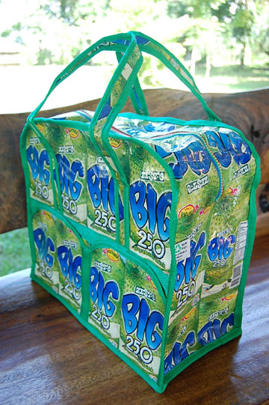 | Bag Code 06 Gym Bag  Environmental impact 42 packs recycled  Cost €13.00  Description  Look smart at the gym, the swimming pool or while going away over night. This bag comes with a sturdy zip and 2 outside pockets.  Measurements in cm
  Height | Width | Depth
  32.5 | 37 | 18.5
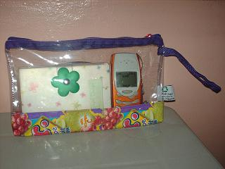 | Bag Code 07 Clear Zipped Bag  Environmental impact 2 packs recycled  Cost €2.00  Description  A small neat bag which could double as a toilet bag or a handbag wallet. Allows you to see everything at a glance.  Measurements in cm
  Height | Width | Depth
  15 | 25 | 2
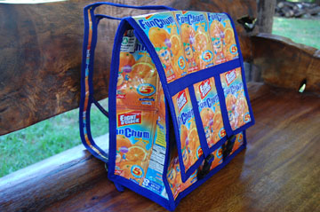 | Bag Code 08 Large Backpack  Environmental impact 42 packs recycled  Cost €12.00  Description  A fully lined back pack with adjustable straps and easy to close front fastenings. This pack comes with an inbuilt pencil case and inside pocket.  Measurements in cm
  Height | Width | Depth
  30 | 28 | 15.5
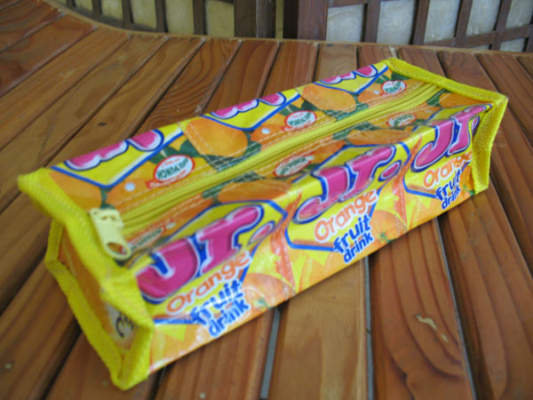 | Bag Code 09 Pencil Case  Environmental impact 7 packs recycled  Cost €4.00  Description  A smart rectangular shaped pencil case with zip also useful for make up brushes.  Measurements in cm
  Height | Width | Depth
  5.5 | 22 | 8
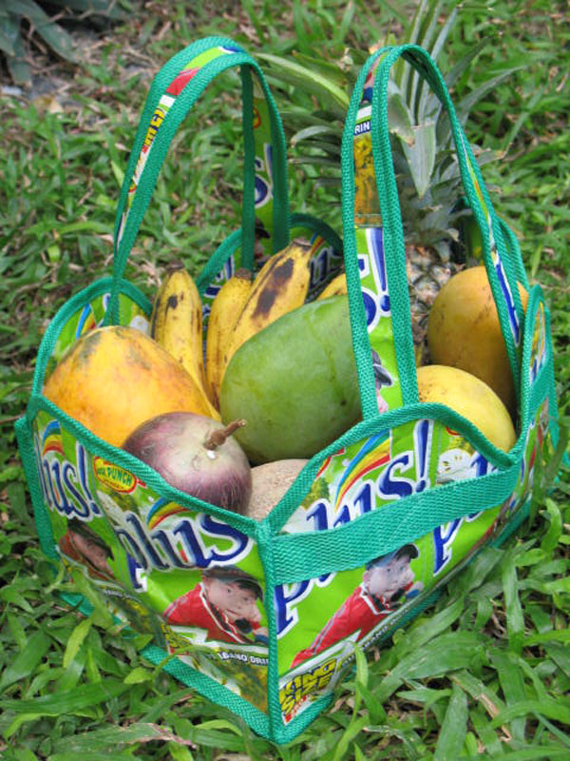 | Bag Code 10 Fruit Basket  Environmental impact 17 packs recycled  Cost €5.00  Description  Ideal for holding fruit, small plants or toiletries (perfect size for 6 loo rolls!!) this colourful basket will brighten up your home.  Sorry we can’t include the fruit!!!  Measurements in cm
  Height | Width | Depth
  17 | 29 | 19
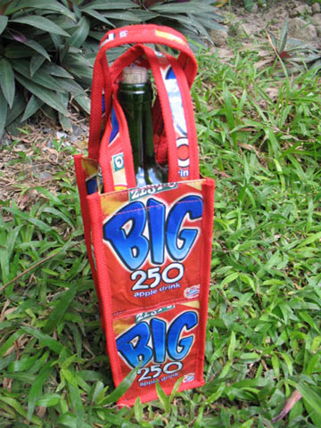 | Bag Code 11 Wine bag  Environmental impact 12 packs recycled  Cost €3.00  Description  A wine bag with a difference.  Measurements in cm
  Height | Width | Depth
  28.5 | 10 | 10
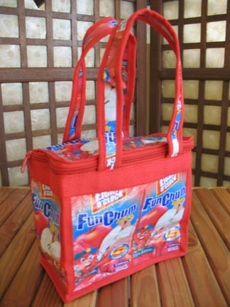 | Bag Code 12 Lunch bag  Environmental impact 18 packs recycled  Cost €8.00  Description  This small bag is fully lined with plastic and has an inside pocket. It can serve as a lunch bag, a bag for cosmetics or an attractive bag for small toys.  Measurements in cm
  Height | Width | Depth
  16 | 19.5 | 10
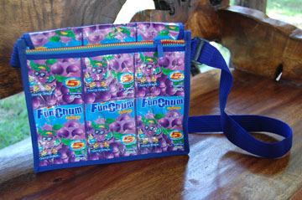  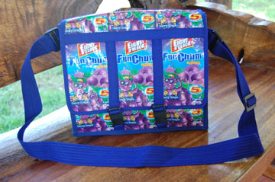 | Bag Code 13 Nida Bag  Environmental impact 37 packs recycled  Cost €12.00  Description  A shoulder bag with adjustable strap, 2 inside compartments & key holder. It also has a zipped outside pocket and safety clip fasteners. Ideal for traveling.  Measurements in cm
  Height | Width | Depth
  25.5 | 29.5 | 8
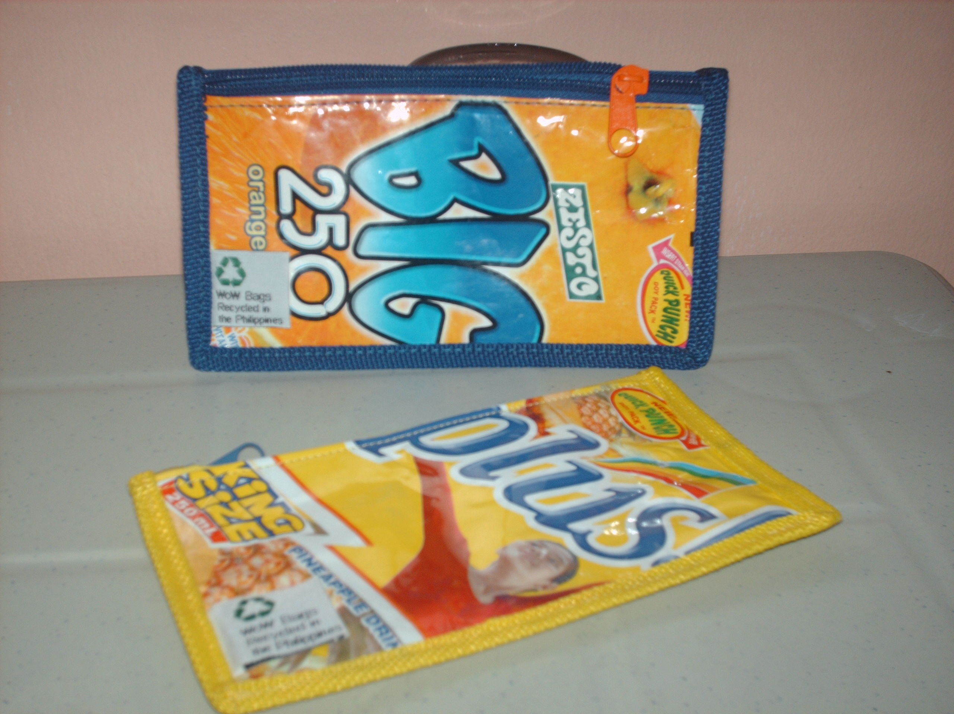 | Bag Code 14 Pouch purse  Environmental impact 2 packs recycled  Cost €2.00  Description  Small purse showing both sides of a juice pack, suitable for change, jewelllery, keys etc  Measurements in cm
  Height | Width | Depth
  10 | 17 | n/a
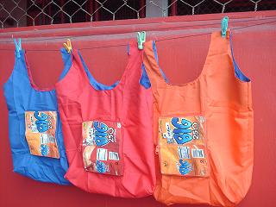 | Bag Code 15 Gina Zipped Bag  Environmental impact 2 packs recycled  Cost €4.00  Description  A lightweight & compact extra bag made of strong gina silk. Folds into its own carry purse.  Measurements in cm
  Height | Width | Depth
  35 | 46 | 11
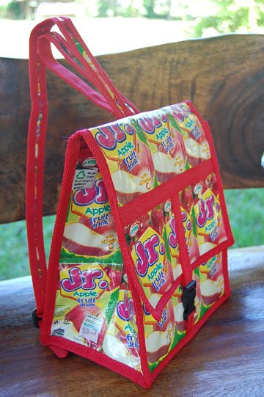 | Bag Code 16 Small Backpack  Environmental impact 38 packs recycled  Cost €9.00  Description  A fully lined back pack with adjustable straps and easy to close front fastenings. This pack comes with an inbuilt pencil case.  Measurements in cm
  Height | Width | Depth
  26.5 | 22 | 8
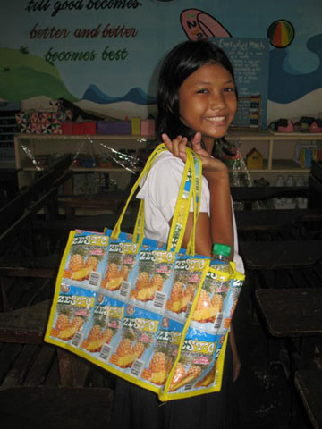  Jamella uses bag 17 for all her books and school needs – there is even space for her bottle of water. | Bag Code 17 Rectangular Organizer Bag  Environmental impact 51 packs recycled  Cost €15.00  Description  A place for everything and everything in its place. This bag has 2 inside pockets, one with a secure fastening making it suitable for items like wallets and phones. It also has a key holder and a coin purse attached. Pockets on the ends of the bag are suitable for a folding umbrella, car park tickets etc.  Measurements in cm
  Height | Width | Depth
  25 | 36 | 15
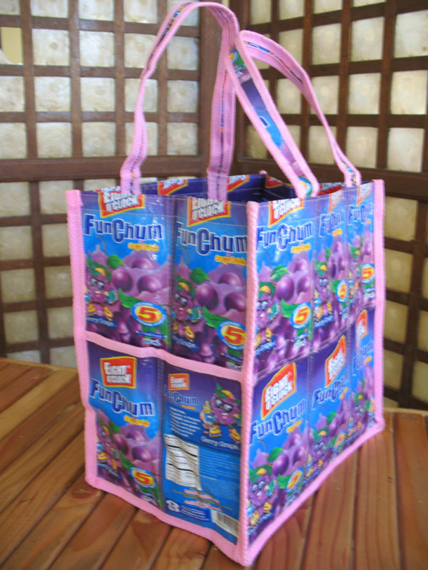 | Bag Code 18 Medium Organizer Bag  Environmental impact 38 packs recycled  Cost €11.00  Description  A useful bag with pockets on each end and a small inside pocket.  Measurements in cm
  Height | Width | Depth
  29 | 28 | 19
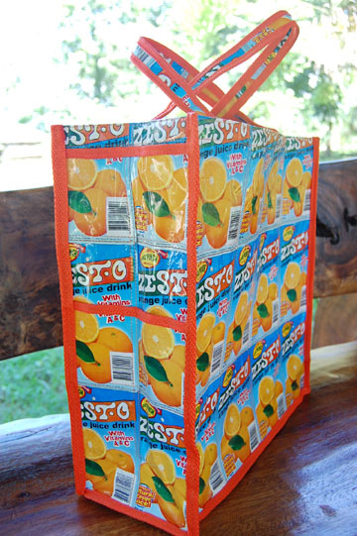 | Bag Code 19 Large Organizer Bag  Environmental impact 79 packs recycled  Cost €15.00  Description  Featuring 2 pockets incorporated into each end, a deep internal pocket and another suitable for a wallet or phone this bag is ideal for shopping.  Measurements in cm
  Height | Width | Depth
  39 | 36 | 15
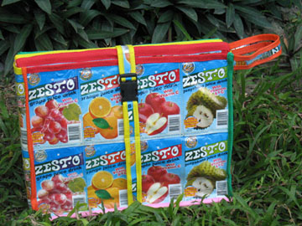  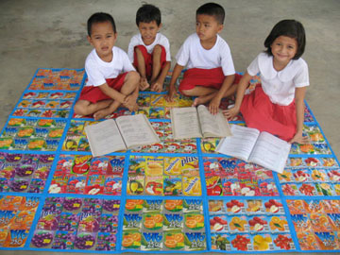  Renren, Alex, Daniel & Aira wait for their teacher | Bag Code 20 Picnic / Playmat  Environmental impact 226 packs recycled  Cost €36.00  Description  A beautiful colourful mat suitable for beach, garden or park. It also makes a great baby play mat, it is easily cleaned and folds into an attractive carry case.  Measurements in cm folded  Measurements in cm opened
  Height | Width | Depth
  28 | 37 | 10
  Height | Width | Depth
  142 | 182.5 | N/A
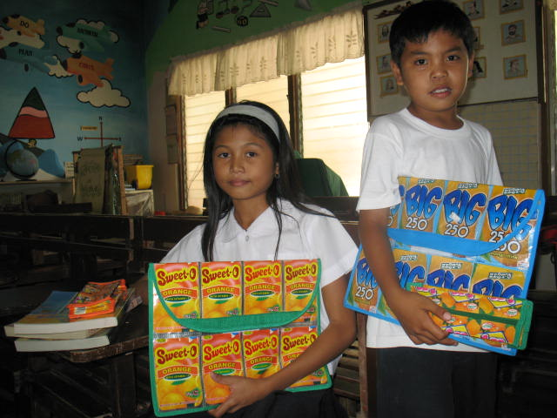  Joyce & Amir carry their lesson plans in WoW folders. | Bag Code 21 Envelope Document Bag  Environmental impact 24 packs recycled  Cost €7.00  Description  Keep your papers neat and add colour to meetings, this bag comes with a built in pencil case.  Measurements in cm
  Height | Width | Depth
  27.5 | 37 | N/A
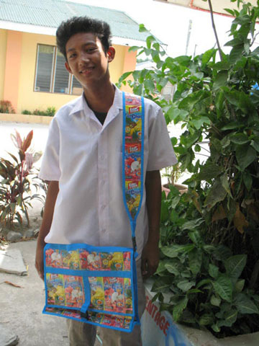  Jonel is ready for college | Bag Code 22 Record Bag  Environmental impact 49 packs recycled  Cost € 13.00  Description  Designed to hold a lap top computer, folders and books this bag has a key holder, a adjustable shoulder strap, a hand carry strap and safety fasteners.  Measurements in cm
  Height | Width | Depth
  32 | 40 | 10
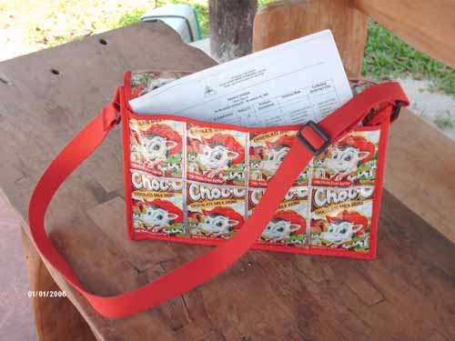  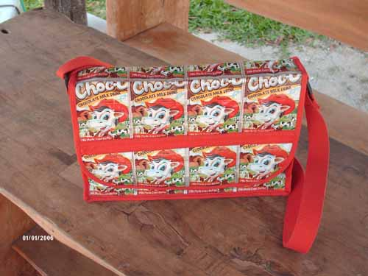 | Bag Code 23 Satchel Bag  Environmental impact 39 packs recycled  Cost €12.00  Description  A rectangular bag suitable for books/ folders. It has an adjustable shoulder strap, an outside pocket, a key holder and coin purse. Velcro closing ensures the safety of your possessions  Measurements in cm
  Height | Width | Depth
  26.5 | 35.5 | 8
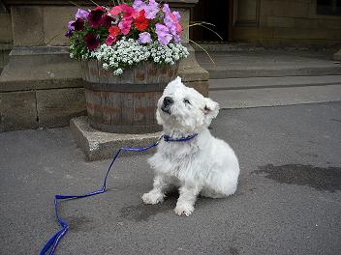 | Bag Code 24 Dog collar and lead  Environmental impact 10 packs recycled  Cost €4.50  Description  For the environmentally conscious pet in your life. These sets come trimmed in green, royal blue or red only. The collar is 38 extendable to 53.5. The lead is 80 cm. Hamish who lives in Lancashire UK is the perfect model.
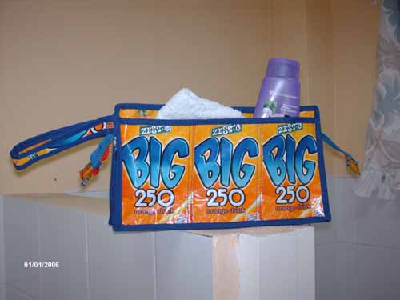  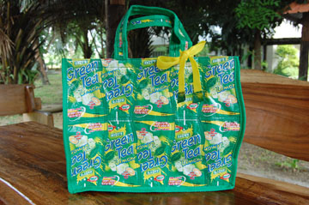 | Bag Code 25 Toilet Bag  Environmental impact 13 packs recycled  Cost €8.00  Description  Our unisex toilet bag has a chunky zip, an outside pocket and a side carry strap. (comes in Red, Green and Royal Blue trim only)  Measurements in cm
  Height | Width | Depth
  16.5 | 28 | 10
Bag Code 26 Bheng Bag
Environmental impact 33 packs recycled
Cost €9.00
Description
An attractive hand carry bag with curved sides it features a removable contrasting bow on one handle.

Measurements in cm
Height | Width | Depth
28.5 | 36.5 | 14

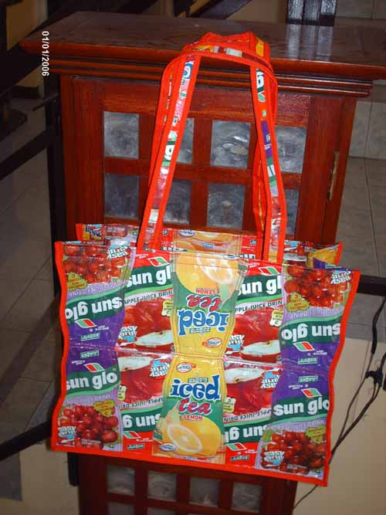 | Bag Code 27 Rina Bag  Environmental impact 40 packs recycled  Cost €9.50  Description  Made in patchwork style with slightly ‘wavey’ sides reflecting the contours of the pouches used this large shoulder bag will brighten up your day.  Measurements in cm
  Height | Width | Depth
  30 | 36 | 15.5
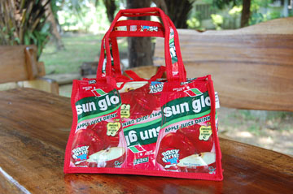 | Bag Code 28 Gift Bag  Environmental impact 12 packs recycled  Cost €4.00  Description  Designed as an alternative to wrapping paper our tiniest bag has also been popular with younger customers as a handbag.  Measurements in cm
  Height | Width | Depth
  14 | 21 | 7.5
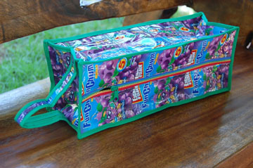 | Bag Code 29 Shoe Bag  Environmental impact 42 packs recycled  Cost €9.00  Description  Originally designed as a shoe bag, this smart bag with a chunky zip and carry strap has been used for a variety of items.  Measurements in cm
  Height | Width | Depth
  12.5 | 38.5 | 12.5

Prices held until Jan 16 2015

.

