National University of Ireland, Maynooth
DEPARTMENT OF HISTORY

FLYERS FOR OPTIONAL MODULES

III ARTS SEMESTER 2 2024-25

PLEASE NOTE

Flyers provide information supplementary to that available in module descriptors, which may be viewed on the university database at www.maynoothuniversity.ie/courses.

Students are expected to consult both flyers and module descriptors, as well as the academic timetable, in advance of registration.

national university of ireland, maynooth
department of history
third arts, 2024-25
Second Semester
Lecturer  DR ALISON FITZGERALD | Module code HY313 | Credits  5 | Lecture hours per week  Two
Module title:
ART, DESIGN AND SOCIETY IN SEVENTEENTH-CENTURY EUROPE

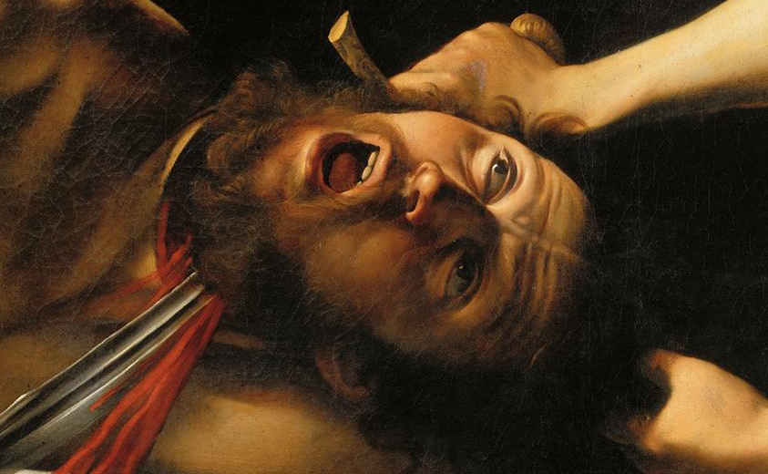

Module Content:
Why was Italian painter Caravaggio such an influential artist in seventeenth-century Europe? How did the sculptor Bernini dazzle his patrons and his rivals in seventeenth-century Rome? Why is the seventeenth century known as the Golden Age of Dutch painting? How did seventeenth-century artists use emblem books to communicate ideas that crossed geographic and linguistic boundaries? This module considers artistic developments in seventeenth-century Europe. It investigates the ways in which the socio-political and cultural background of the period shaped the production of art. From nepotistic papal patronage to the secular tastes of the Dutch bourgeoisie, it examines the context in which artists like Bernini, Caravaggio and Rembrandt worked, and locates their art in a historical and stylistic context using seventeenth-century city guides, artists’ biographies and Counter-Reformation literature. The module will include a seminar in the Russell Library providing an opportunity to explore primary sources on campus.

No previous knowledge of the History of Art is required to take this module.

Form of Assessment:
In-class test: 35%
Essay: 3,500 words: 65%
Deadline for submission of essay: Monday, 12 May 2025
national university of ireland, maynooth
department of history
Third arts, 2024-25

Second Semester
Lecturer  PROFESSOR FILIPE RIBEIRO DE MENESES | Module code HY 314 | Credits  5 | Lecture hours per week  Two

Module title

Hitler’s Europe, 1939-1945 (A)

Module Content
This module is dedicated to investigating German rule over occupied Europe during the Second World War. Its specific focus is on Nazi plans for the future of Europe once a German military victory had been secured, and how these evolved during the conflict. As such it considers the often contradictory political, economic and racial aims of the Nazis and how they proposed to bring them to fruition. Special attention is paid to the origins and implementation of the Final Solution and its relationship with the course of the war.

Module Aim and Objectives:
Aim:
- To acquire a deeper understanding of the nature of Nazi plans for the future of Europe, enabling students to discuss this period with greater certainty and clarity.
Objectives:
- To familiarize students with the historiography of the period 1939-1945, including that of the Final Solution;
- To deepen students’ ability to engage critically with key primary and secondary sources relating to a crucial period of contemporary European history;
- To stimulate and reward students’ willingness to participate in class discussion

Module Structure:
This module will be seminar-based, with an emphasis on the reading, and discussion, of primary documents and key secondary texts.

Form of assessment
This module is entirely based on continuous assessment, including a short oral presentation, a review and an essay. Great importance is placed on class participation as well as critical engagement with sources, with students having to complete a weekly reading worksheet.
Essay deadline: Monday, 12 May 2025

national university of ireland, maynooth
department of history
third arts, 2024-25

Second Semester
Lecturer  DR DAVID LEDERER | Module code HY 354 | Credits  5 | Lecture hours per week  Two

Module title
THE HOLY ROMAN EMPIRE, 1648-1806

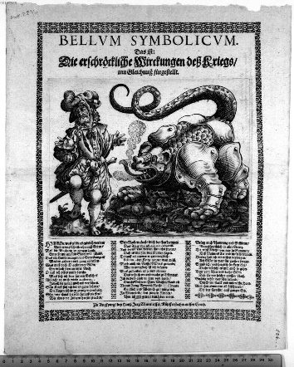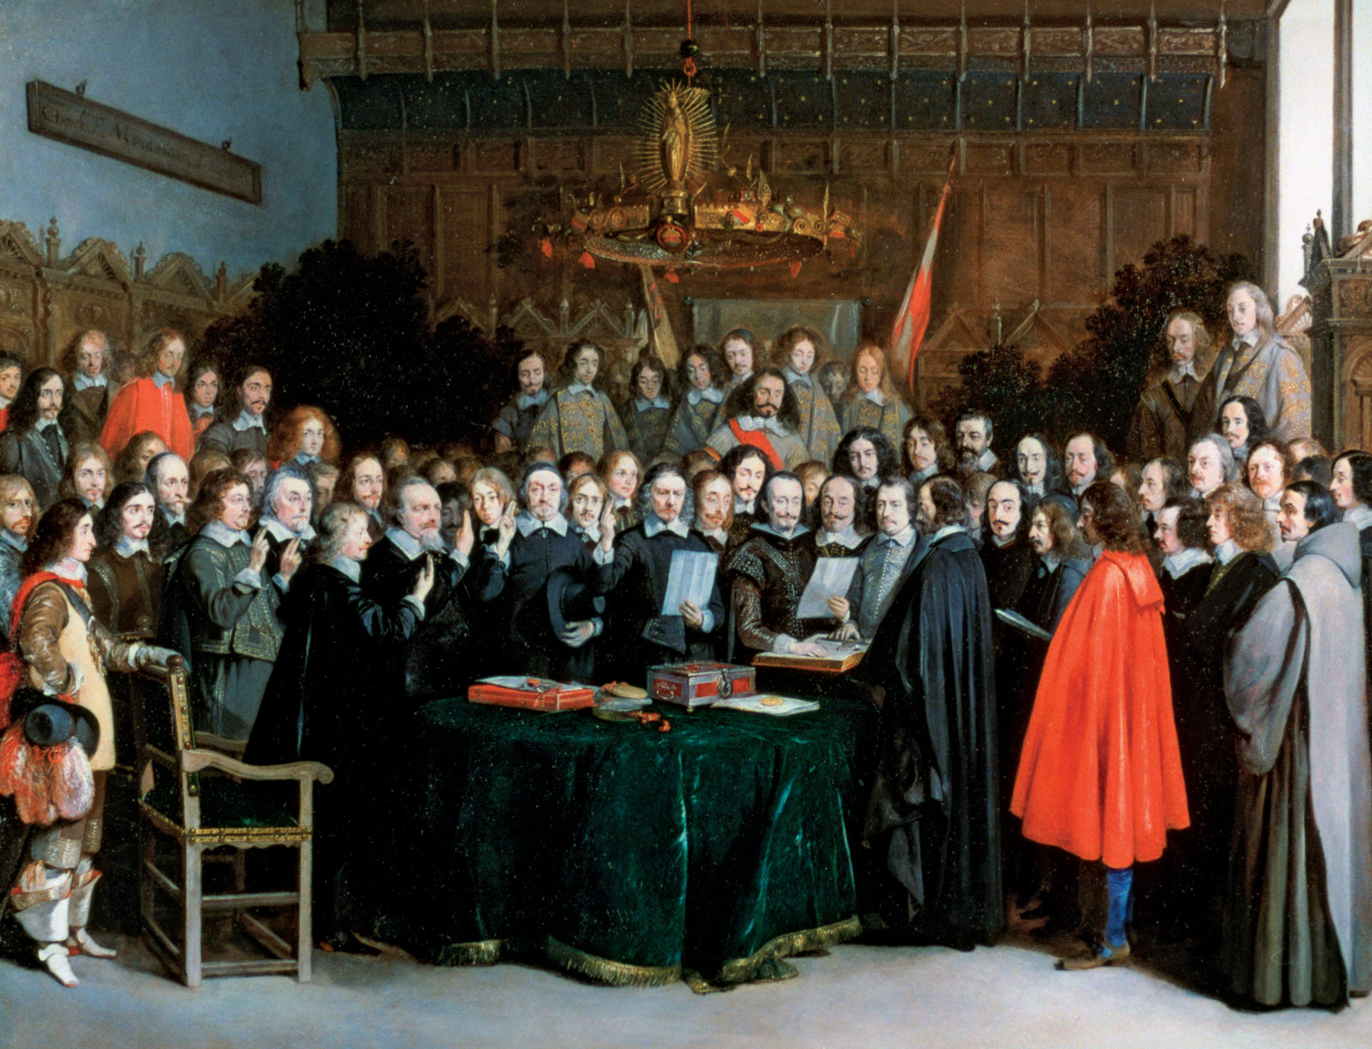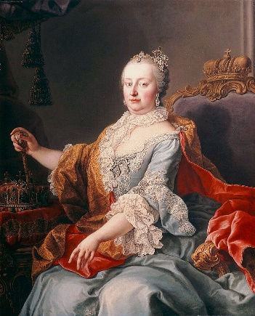

MODULE CONTENT

This is part two of the Holy Roman Empire super-elective, which follows on from HY353 in the first semester. However, attendance at HY 353 is not a prerequisite to taking this course. It begins with an extended analysis of the Thirty Years War from political and social perspectives and the impact of the Peace of Westphalia on Europe. Subsequently, we examine mounting tension between Prussia and Austria and events leading to the final dissolution of the Empire in 1806. Finally, students are introduced to differing historical interpretations of the Empire from German, European and Global perspectives. Students participate actively in a series of in-class discussions, presentations of historical documents and oral book reviews, posting to a group website and composing an essay for submission at the end of the semester.

Form of Assessment

3,000 word essay 60%
In-class assignments/tests 40%
Deadline for submission of essay is Monday, 12 May 2025

national university of ireland, maynooth
department of history
third arts, 2024-25
Second Semester
Lecturer  DR ALISON FITZGERALD | Module code HY 3022 | Credits  5 | Lecture hours per week  Two

Module title
GEORGIANS REVEALED: THE DOMESTIC WORLD OF THE LONG EIGHTEENTH CENTURY

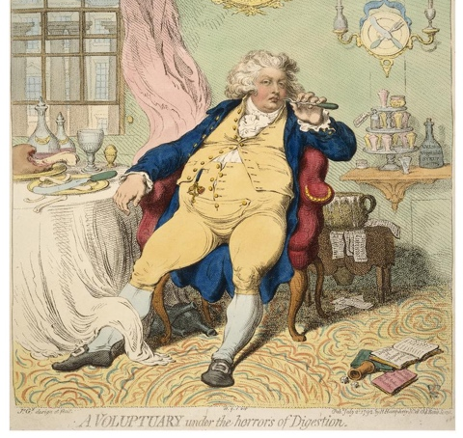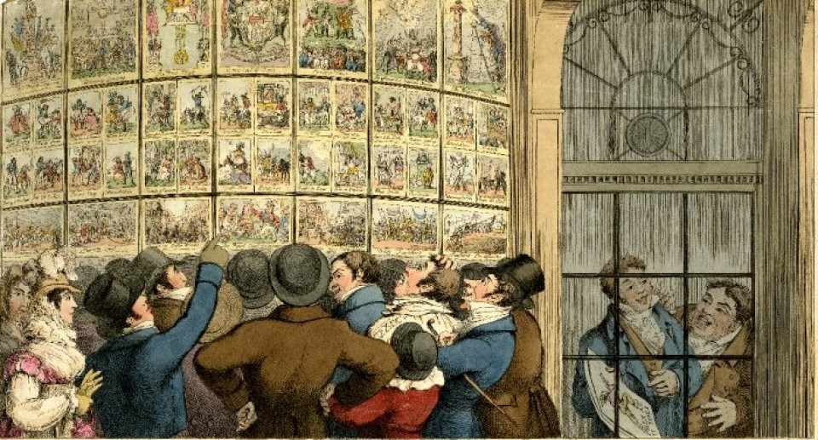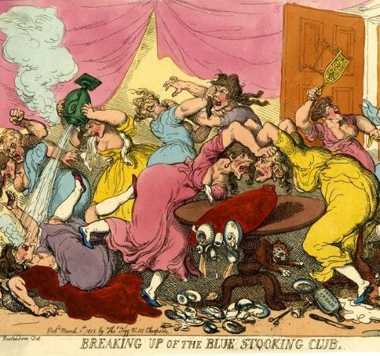

Module content
This module explores the ways in which travel, trade with the East, and new technologies contributed to a consumer boom that transformed the Georgian home (1714–1830). Using a wide range of primary sources from diaries and letters to account books and inventories, the module considers the impact of this consumer revolution. What was new? Who led fashions? How did satirical print make fun of what was new or fashionable? The module will examine the competitive culture of keeping up appearances, during a period of great innovation.

Module objectives
- Identify and interpret key themes that facilitate comprehension of the Domestic world of the Georgians
- Assess the factors that contributed to the success of leading entrepreneurs
- Develop skills in evaluating digital resources, including Eighteenth Century Collections Online (ECCO) and museum databases as rich repositories of primary sources
- Interrogate different types of historical evidence, to construct effective arguments.
Please note students who have taken the module HY278 cannot also take HY3022.

Form of Assessment
This project uses online resources to develop a short exhibition proposal, based around individual student’s interests and linked to the module themes /essay assignment. Clear guidance will be provided at the outset of the module. Exhibition Proposal: 40%
Essay/project (3,000 words approx..) 60%
Deadline for submission of research project: Monday, 12 May 2025
national university of ireland, maynooth
department of history
third arts, 2024-25
Second Semester
Lecturer  PROFESSOR DEJAN DJOKIĆ |  | Module code  HY 3025 | Credits  5 | Lecture hours per week  Two
Module title

EUROPE IN THE AGE OF REVOLUTION AND NATION, 1789-1878

Module content
Historians have traditionally approached the age of revolution in 19th century Europe from a western-centric perspective, but this module looks at both eastern and western Europe. The broader context of European (France and the Napoleonic wars) and Middle Eastern (Ottoman Egypt and Syria) revolutionary upheavals of the late 18th and early 19th century helps explain the fragmentation of the Ottoman political space and the outbreak of Serb and Greek ‘revolutions’. The students will also explore the (failed) 1830 Polish revolution; the impact of the 1848 revolutions on East-Central Europe; the wider, pan European significance of Italian and German unification movements; and the Ottoman, Habsburg and Russian rivalry during the ‘Great Eastern Crisis’ of the 1870s.

Assessment

Class attendance/participation 10%
In-class assignment 25%
3,000-word essay 65%
Deadline for submission of essay: Monday, 12 May 2025
national university of ireland, maynooth
department of history
third arts, 2024-25
Second Semester
Lecturer  DR OKSANA VYNNYK |  | Module code  HY 3026 | Credits  5 | Lecture hours per week  Two
Module title

EASTERN EUROPE IN THE MODERN WORLD

UKRAINE: IMPERIAL, SOVIET, INDEPENDENT

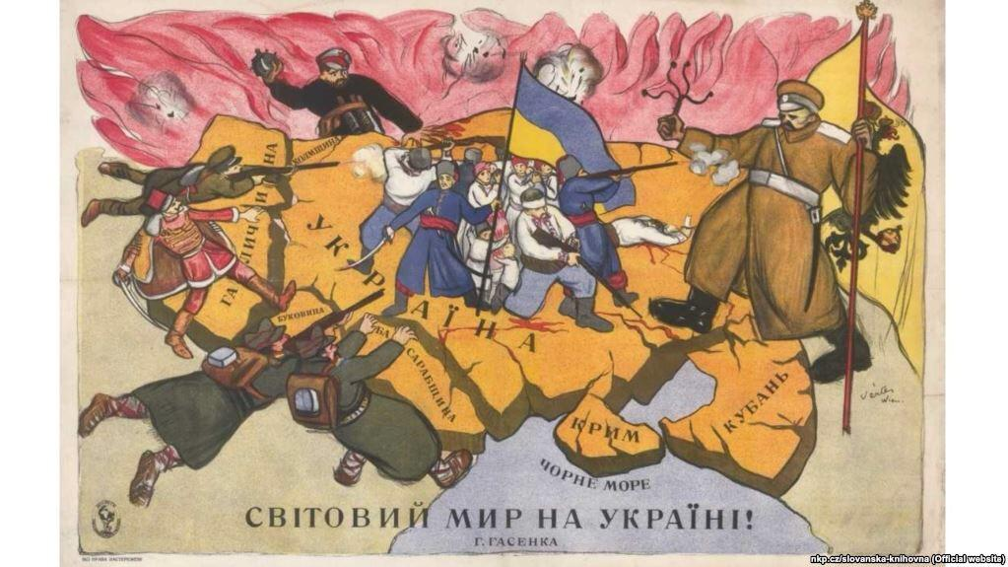

Module content
After the full-scale Russian invasion, Ukraine has become the centre of a military conflict that challenges the global balance of power. The complex history, the variety of memory narratives and the attempts of Russia to hold the dominant position among post-Soviet countries have resulted in the bloodiest war in Europe since 1945. We will look at the imperial and Soviet legacies that shaped historical narratives used to contest contemporary Ukraine’s borders. This module explores Ukrainian history in a broader European context from the early nineteenth century to the present day. It will focus on the process of nation-building and the factors that influenced the construction and transformation of Ukrainian national identity(ies). The module will show how national identities are shaped and transformed under empires, communist rule, national independence, and in war and peace.

Assessment
Continuous assessment during semester: 40%
3,000-word essay 60%
Deadline for submission of essay: Monday, 12 May 2025
NATIONAL UNIVERSITY OF IRELAND MAYNOOTH
DEPARTMENT OF HISTORY
THIRD ARTS 2024-25

Second Semester
Lecturer | Module code SG354 | Credits  5 | Lecture hours per week

Module title
HISTORY 5 – THE VIKING WORLD II: IRELAND

as per Course Finder, July 2024

Overview
Vikings occupy an important place in the modern cultural imagination, but who exactly were they and what impact did they have in Ireland? This module explores representations of the Vikings in medieval sources and popular culture, shedding light on their origins, their first raids on Ireland from the late eighth century and their later settlements on the island. This module will explore questions of ethnic identity, immigration, gender, urbanisation and the cultural legacy of Vikings in Ireland and the wider medieval world. The historical reality of the Vikings will be contrasted with their representation in films and TV shows in the modern era.

24 lecture hours

Form of assessment
Assessment type | Weighting | Duration
Continuous Assessment | 50%
University scheduled written examination | 50% | 60 minutes

Please note that SG354 is timetabled by the Department of Early Irish (Sean-Ghaeilge) and may clash with core lectures in other subjects.
NATIONAL UNIVERSITY OF IRELAND MAYNOOTH
DEPARTMENT OF HISTORY
THIRD ARTS 2024-25

First Semester
Lecturer | Module code GC316 | Credits  5 | Lecture hours per week

Module title
A WORLD FULL OF GODS: RELIGIOUS LIFE IN THE ROMAN EMPIRE

Information as per Course Finder, July 2024

Overview
"The various modes of worship, which prevailed in the Roman world, were all considered by the people as equally true; by the philosopher, as equally false; and by the magistrate, as equally useful.” Edward Gibbon’s famous statement points to the complexity of religious life in the Roman world, where religion was inseparable from all aspects of life: this was indeed “a world full of gods.”
This module offers a wide-ranging study of religion in the Roman world, from early to late. We begin with religion in the Republic, as it was intimately bound up with the family, the state, and ultimately the conquest of the Mediterranean, bringing about the formation of a pantheon of “all” the gods. We turn then to religion under the Empire, examining how practices such as emperor worship, gladiatorial spectacles, and voluntary associations often served to consolidate imperial authority. Finally, we will look at later periods of the Empire, as religious enthusiasm was often used to bolster political unity while at the same time it posed challenges to the Roman order itself, most notably in the cases of Judaism and Christianity. Throughout, attention will be given to primary sources in historiography, literature, art, philosophy, graffiti and other material culture, as well as modern sociological approaches to religious phenomena.

18 lecture hours, 3 workshops

Form of assessment
Assessment type | Weighting | Duration
Continuous Assessment | 40%
University scheduled written examination | 60% | 90 minutes

Please note that GC316 is timetabled by the Department of Ancient Classics and may clash with core lectures in other subjects.

