National University of Ireland, Maynooth

DEPARTMENT OF HISTORY

FLYERS FOR OPTIONAL MODULES

III ARTS SEMESTER 1 2019-20

PLEASE NOTE

Flyers provide information supplementary to that available in module descriptors, which may be viewed on the university database at www.maynoothuniversity.ie/courses.

Students are expected to consult both flyers and module descriptors in advance of registration.

national university of ireland, maynooth
department of history
third arts, 2019-20
First Semester
Lecturer  DR LILI ZÁCH | Module code HY 302 | Credits  5 | Lecture hours per week  Two

Module title
EUROPE 1770-1870

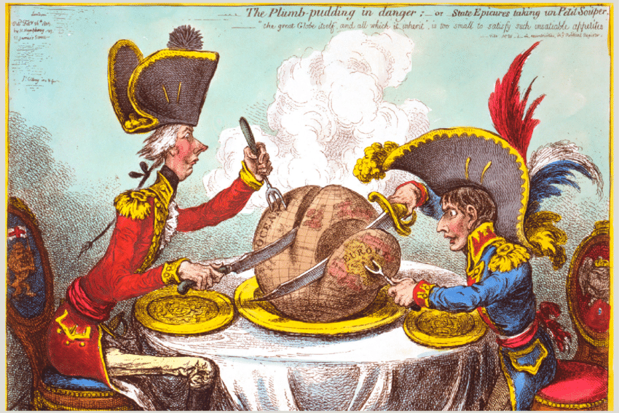

Module content
This module explores the interconnections between European and Irish history from the days of the French revolution through the ‘springtime of peoples’ in 1848 until the eve of the Great War. Through interpreting primary sources with the help of secondary sources, we will investigate the political, socio-economic and cultural transformation of Europe focusing on topics and themes such as nationalism, liberalism, industrialisation, modernity, socialism, social changes, and imperialism. The main goal of the course is to highlight changes and continuity in European political, social, and economic history as shaped by global events. Developing a critical approach will be crucial in order to interpret a variety of historical sources and acquire a grasp of the narrative of modern European history before the outbreak of the First World War.

Form of Assessment:
1,500 word analysis of primary source 30%
3,500 word essay 70%
Deadline for submission of essay: Tuesday, 7 January 2020

Module conditions apply. See relevant descriptor at www.maynoothuniversity.ie/courses .

national university of ireland, maynooth
department of history
third arts, 2019-20

First Semester
Lecturer  DR JOANNE MANCINI | Module code HY 305 | Credits  5 | Lecture hours per week  Two

Module title
ENVIRONMENT AND CULTURE IN AMERICAN HISTORY

Content

This module explores the relationship between people and the natural world as an aspect of American history. Drawing on environmental, cultural, political, and social history, it will examine how this relationship, and conceptions of it, have changed over time.

Form of Assessment
Participation: 10%
Continuous assessment portfolio: 20%
Essay (3500 words) 70%

Deadline for submission of essay is Tuesday, 7 January 2020
Module conditions apply. See relevant descriptor at www.maynoothuniversity.ie/courses.

Special requirements (e.g., field trips inc. cost; special sessions; books)
Required text, McKibben, ed., American Earth.

national university of ireland, maynooth
department of history
third arts, 2019-20
First Semester
Lecturer  DR ALISON FITZGERALD | Module code HY313 | Credits  5 | Lecture hours per week  Two
Module title:
ART, DESIGN AND SOCIETY IN SEVENTEENTH-CENTURY EUROPE

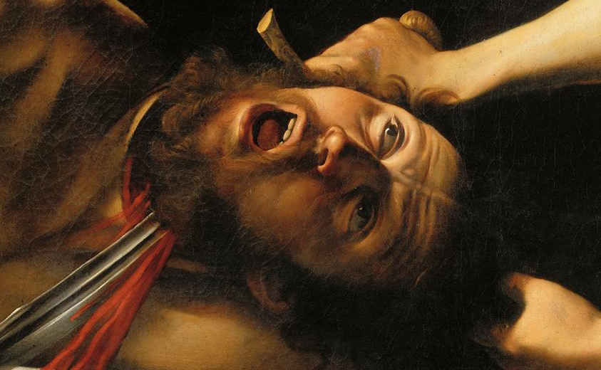

Module Content:
Why was Italian painter Caravaggio such an influential artist in seventeenth-century Europe? How did the sculptor Bernini dazzle his patrons and his rivals in seventeenth-century Rome? Why is the seventeenth century known as the Golden Age of Dutch painting? This module considers artistic developments in seventeenth-century Europe. It investigates the ways in which the socio-political and cultural background of the period shaped the production of art. From nepotistic papal patronage to the secular tastes of the Dutch bourgeoisie, it examines the context in which artists like Bernini, Caravaggio and Rembrandt worked, and locates their art in a historical and stylistic context using seventeenth-century city guides, artists’ biographies and Counter-Reformation literature. The module will include a seminar in the Russell Library to explore primary sources for this module on campus and a visit to the National Gallery. No previous knowledge of the History of Art is required.

Form of Assessment:
In-class assessment: 30%
Essay: 3,500 words: 70%
Deadline for submission of essay: Tuesday, 7 January 2020
Module conditions apply. See relevant descriptor at www.maynoothuniversity.ie/courses.

Special requirements (e.g. field trips inc. costs, special sessions)
There will be one site visit to the National Gallery which will take place on a Friday afternoon and will replace the on-campus classes for HY313 that week. The date for this will be circulated at the beginning of the semester.
national university of ireland, maynooth
department of history
third arts, 2019-20

First Semester
Lecturer  DR DAVID LEDERER | Module code HY 353 | Credits  5 | Lecture hours per week  Two

Module title
THE HOLY ROMAN EMPIRE, 1495 TO 1618

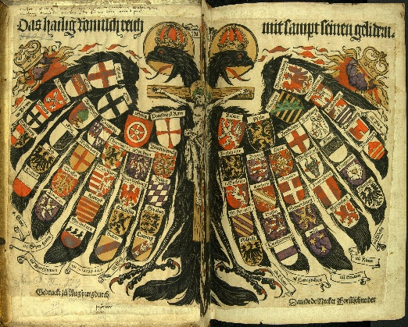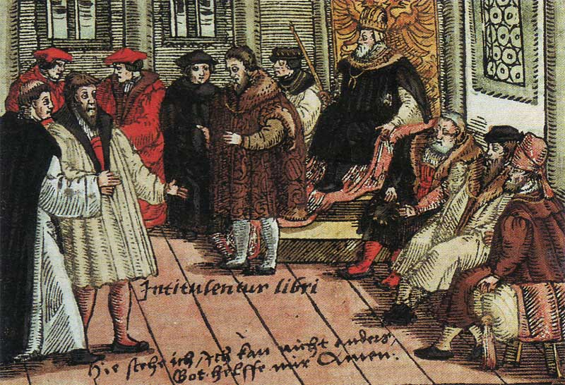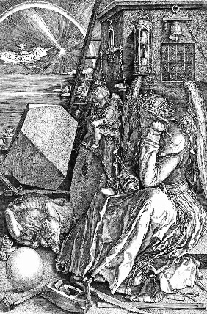

MODULE CONTENT
Voltaire jokingly disparaged this loose conglomeration of particularistic interests as ‘... neither holy, nor Roman, nor an empire". In 1848, intellectual revolutionaries debated Greater- and Lesser-German solutions to replace it. Nazi propagandists drew historical parallels between the first Reich (which lasted over 1,000 years) and their short-lived racist vision of an Aryan Third Reich. Post-War Austrian historian Friedrich Heer promoted the ethnically diverse Empire as a traditional model of European integration. In the 1990s, debate raged over Germany’s ‘special path’ (Sonderweg) from Martin Luther to unification under Bismarck and, ultimately, two world wars. Was the Holy Roman Empire a failed state? Or the direct antecedent of the Danubian Monarchy? Or Imperial Germany? the EU? the Holocaust? Or is it simply an arbitrary construct open to any multiplicity of interpretations?

HY353 introduces students to this enigmatic Empire from its earliest medieval origins. We analyse its political constitution set out in the Golden Bull and subsequent imperial reforms. Ultimately, our focus shifts onto the Protestant Reformation, the German Peasants’ War, crime and punishment, and social disciplining during the Confessional Age. Students participate actively in a series of in-class symposia, a role-play of the Diet of Worms, panel discussions of key historical documents and individual oral book reviews, composing a short critical essay for submission at the end of the semester.

Form of Assessment
3,000 word essay 60%
In-class assignments/tests 40%
Deadline for submission of essay is Tuesday, 7 January 2020
Module conditions apply. See relevant descriptor at www.maynoothuniversity.ie/courses.
NATIONAL UNIVERSITY OF IRELAND, MAYNOOTH
DEPARTMENT OF HISTORY
THIRD ARTS, 2019-20

First Semester
Module Co-ordinator  DR DYMPNA MC LOUGHLIN | Module code  HY 390 | Credits  5 | Lecture hours per week  Two

Module title:

SOCIAL HISTORY OF HEALTH IN NINETEENTH AND TWENTIETH CENTURY IRELAND

Overview
The module will introduce students to the key aspects of the social history of medicine in nineteenth century Ireland. It will document the journeys of ordinary Irish men, women and children through ill health, and in particular, how they negotiated their way through various medical institutions. The medical profession will also be documented, as well as how the profession understood and treated various illness and diseases.

Course Themes
The nineteenth century medical world
Medical Institutions in the nineteenth century.
Illness with stigmas attached to them such as Aids, tuberculosis and syphilis.
Smallpox in Ireland and attempts to vaccinate against it.
Cholera and the two major epidemics in 1832 and 1847-52.
Lunacy and the Implications of the Dangerous Lunatics Act
Epilepsy and bromide therapy
The adulteration of Alcohol- case studies of whiskey, poteen and ether.

Form of Assessment

Template – brief analysis of a primary source (1000 words) 20%
Essay of 4,000 words on primary source 80%
Deadline for submission of essay is Tuesday, 7 January 2020
Module conditions apply. See relevant descriptor at www.maynoothuniversity.ie/courses.

Special requirements (e.g. field trips incl. cost; special sessions; books)

national university of ireland, maynooth
department of history
third arts, 2019-20
First Semester
Lecturer  DR DENISE DUNNE | Module code HY 392 | Credits  5 | Lecture hours per week  Two

THE RELUCTANT EUROPEAN: BRITAIN AND EUROPEAN INTEGRATION, 1945 - 1975
Module over view
British policy on European integration has been the subject of intensely divisive political and public debate for decades. The current debates on Brexit have deep historical roots, which this module explores. This is a documents based module. Students will examine a range of primary source documents on Britain’s policy on European integration with a view to objectively assessing the causes and consequences of that policy focussing on the period from 1945-1975.
The early lectures will contextualise British policy on European integration by briefly looking at the British response to attempts to promote European integration in the inter-war period before moving on to analyse the policy of ‘limited liability’, which dominated British thinking on European co-operation in the period from 1947-1955. As assessment of the rationale behind this policy is essential in order to understand the British response to the Marshall Plan and the OEEC and to the proposals for the Council of Europe, the European Coal and Steel Community (ECSC), the European Defence Community (EDC), and the European Political Community (EPC). Despite pressure from both Europe of the Six and the United States, Britain clung steadfastly to ‘limited liability’ refusing to ‘go beyond the point of no return’ in Europe. It is therefore not surprising that Britain quickly earned the label of the ‘reluctant European’.
External factors and international foreign policy goals were a key influence on British policy on European integration, most notably Britain’s ‘special’ relationship with the US. Throughout this module we will pay particular attention to the American influence on the formulation of British policy on European integration under the Truman, Eisenhower, Kennedy, and Johnson Administrations. Although never the intention of the US, the Anglo-American ‘special relationship’ arguably slowed down Britain’s gradual turn to Europe, effectively stunting the evolution of British policy on European integration. Even in the wake of the Suez crisis, Britain did not initially prioritise Europe. Why? Was it ‘wrong’ for Britain not to join the EEC 1958? We will carefully examine the perceived advantages and disadvantages of British participation in the process of European integration. We will look at the Treasury and Foreign Office assessments of the costs and benefits of joining the EEC versus remaining outside. The module will examine why Harold Macmillan initiated such a dramatic U-turn in British foreign policy by applying for membership of the EEC in 1961 and also why he failed in his objective to get Britain ‘in’.
The latter part of the module examines whether or not British policy on European integration truly evolved between the governments of Macmillan, Wilson and Heath. Heath finally got Britain into the European Economic Community in 1973 but as recent events so clearly demonstrate, this did not mean that Britain was no longer a ‘reluctant European’.
Form of Assessment:
5,000 word essay, which must incorporate a range of primary source documents
Deadline for submission of essay is Tuesday, 7 January 2020
Module conditions apply. See relevant descriptor at www.maynoothuniversity.ie/courses.
Special requirements: Please note that students are expected to be familiar with key events in the history of European integration prior to undertaking this module. If you have not previously studied the history of European integration you must be prepared to take the initiative and read on the subject by way of preparation for this module. Students will also be expected to discuss the primary source documents, which will be posted weekly on Moodle.
national university of ireland, maynooth
department of history
third arts, 2019-20
First Semester
Lecturer  PROFESSOR MARIAN LYONS | Module code HY 393 | Credits  5 | Lecture hours per week  Two

Module title
IRISH MIGRANTS IN THE EARLY MODERN WORLD

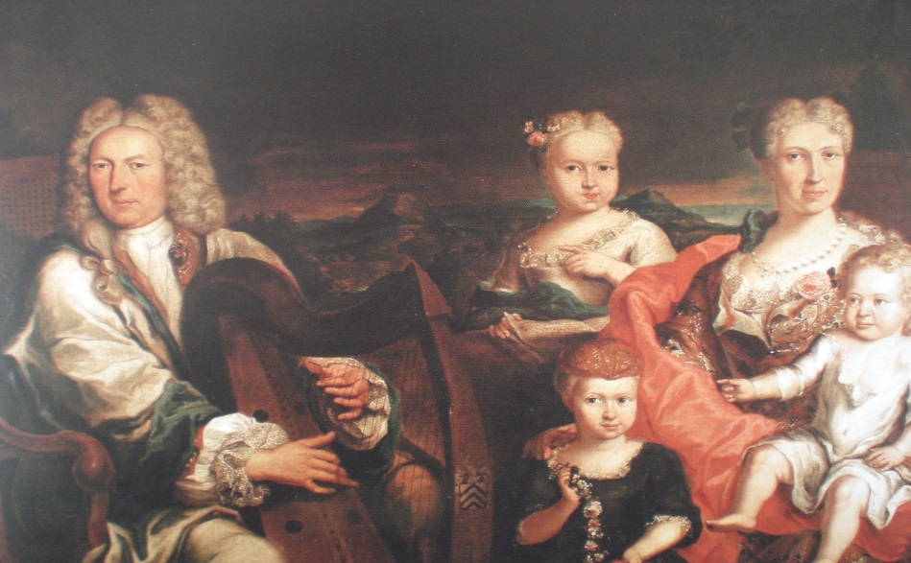

Module content
Between c.1600 and c.1820, a great variety of motives caused men and women to leave Ireland for Continental Europe and further afield. The lure of education, employment, prosperity and religious tolerance was especially strong, but so too was the desire for adventure and change, and a dislike of the isolation associated with living at the extreme periphery of Europe. By the mid-seventeenth century, the Irish had achieved unprecedented visibility on the Continent: on the battlefields, in the docks of major ports, in the university lecture halls, in royal courts, on the streets and even in the hospitals, prisons and galley ships. Between c.1600 and c.1820 many Irish made significant contributions to their host societies in Europe and through service in the overseas colonial administrations of Europe’s major powers, especially in the realms of war, politics, diplomacy, medicine, and trade (including slavery and the East India Company). This module explores their diverse experiences in various parts of Europe and as far afield as the Caribbean.

Form of Assessment
Research project (4,500 words approx.), topic to be agreed upon in advance with lecturer 90%
Primary source analysis (500 words approx.) 10%
Deadline for submission of research project: Tuesday, 7 January 2020
Module conditions apply. See relevant descriptor at www.maynoothuniversity.ie/courses.

NATIONAL UNIVERSITY OF IRELAND MAYNOOTH
DEPARTMENT OF HISTORY
THIRD ARTS 2019-20

First Semester
Lecturer  TBC | Module code SG354 | Credits  5 | Lecture hours per week  Two

Module title
THE VIKING WORLD II - IRELAND

Module content

The Vikings were a major factor in the history of Europe from the late eighth century until the eleventh. This module studies the Viking impact in Britain, Continental Europe and the North Atlantic.

Form of assessment
100% continuous assessment

Special requirements (e.g. field trips inc. costs, special sessions)
None

Please note that SG354 is timetabled by the School of Irish and may clash with core lectures in other subjects.

