Department of History

Third Year Special Topics - Semester 2

2022-23

[5 credits: two hours per week]

Students select one of the following modules in the second semester.

HY384 THE GREAT WAR, 1914-18
Dr David Murphy

HY3010 THE GLOBAL COLD WAR
Dr Conor Tobin

HY3014 RELIGION AND SOCIETY IN IRELAND SINCE 1800
Dr Sarah Roddy

national university of ireland, maynooth
department of history
Third Arts, 2022-2023

Second Semester
Lecturer  DR DAVID MURPHY | Module code HY384 | Credits  5 | Lecture hours per week  Two

Module title

THE GREAT WAR, 1914-18

Module Content
This elective will focus on the origins and conduct of the “Great War” of 1914-18. Lectures and seminars will examine the campaign on the Western Front and also events in the Eastern and Middle Eastern theatres. There will be some reference to the impact of the war on Ireland and the effect of the global conflict on the civilian population of the belligerent powers. The naval and airpower aspects of this war will also be discussed. There will be some discussion of developments in military technology. This is an operational military history elective focusing on the conduct of the war and the gradual development of technology and tactics during this period. There will be some discussion of legacy issues and the impact of the war on military thinking during the 1920s and 1930s.

Objectives:
This elective will provide participating students with an understanding of the strategic and operational history of the “Great War” of 1914-18.

Form of assessment
Two-hour examination at end of semester: 100%

Key Texts
John Keegan, The First World War (1999)
Hew Strachen (ed), The Oxford Illustrated History of the First World War (2nd edition, 2014)
BBC TV Series, The Great War (available as a boxed set through the MU library)

national university of ireland, maynooth
department of history
Third Arts, 2022-2023

Second Semester
Lecturer  DR CONOR TOBIN | Module code HY3010 | Credits  5 | Lecture hours per week  Two

Module title

THE GLOBAL COLD WAR

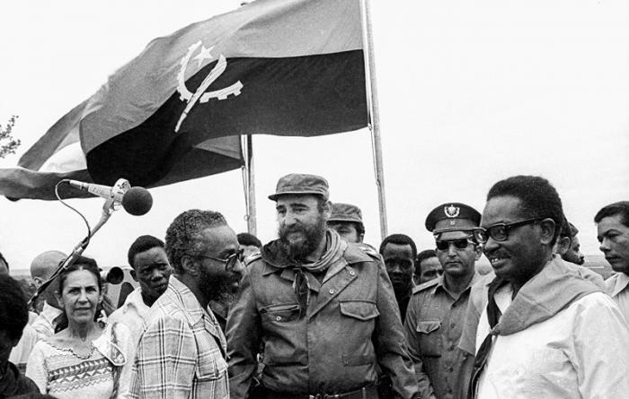
Fidel Castro with Angolan President Agostinho Neto (right) and Celia Sánchez (left)
during a 1977 visit to Angola
Module Content
The second half of the twentieth century was dominated by the Cold War. This module provides a global introduction to the history of the Cold War and to the ways in which it has shaped the world in which we now live. Going beyond the Great Power confrontation, this module explores the impact of Cold War on East Central Europe, Africa, Latin America, and Asia, often under-represented in traditional bipolar histories of the period. A chronological approach will be combined with an exploration of broader themes, such as the impact of the Cold War on decolonization, the contest for cultural supremacy between the US and the Soviet Union, conflict in the Middle East, social and cultural histories of the Cold War. Drawing on both classic and recent historiography, this module will explore the role of ideology and political ideas, the links between the Cold War and parallel histories of decolonisation, international development, globalisation, and European integration, and the ways in which the conflict shaped understandings of society, science and culture.
Module Structure
This module will be lecture-based, although time will be allotted for discussion of key primary and secondary sources.

Form of assessment
Two-hour examination at end of semester: 100%
national university of ireland, maynooth
department of history
Third Arts, 2022-2023

Second Semester
Lecturer  DR SARAH RODDY | Module code HY3014 | Credits  5 | Lecture hours per week  Two

Module title

RELIGION AND SOCIETY IN IRELAND SINCE 1800

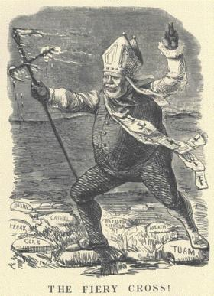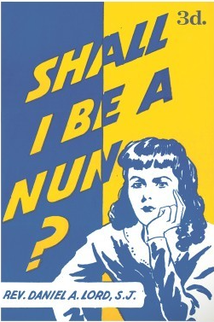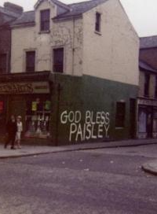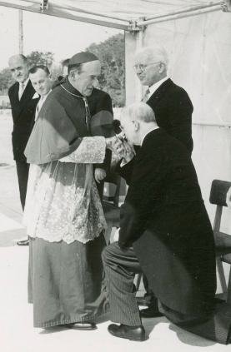

Overview

Religion has been a powerful force in the history of modern Ireland and religious legacies remain significant in Ireland today. This module will interrogate how that came to be the case. It will do so through a series of lectures focused on religious developments in the nineteenth and twentieth centuries, in Ireland north and south, and in Protestant, Catholic and other minority denominations.

Issues covered in relation to the nineteenth century will include the campaign for Catholic Emancipation, the growth of evangelicalism, the role of women in religious life, and the social, economic and political influence of the churches. For the twentieth century, we will discuss the position of religious majorities and minorities in the two new states created by partition and independence, the continued religious involvement in welfare and institutions, the growth of Irish missionary activity overseas and the religious background to the Northern Irish Troubles. We will end the module by asking what role religion, including non-Christian faiths, plays in Irish society today.

This module will be lecture-based.

Form of assessment
Two-hour examination at end of semester: 100%

