National University of Ireland, Maynooth  Maynooth, Co. Kildare, Ireland  Ollscoil na hÉireann, mÁ nuad  School of Modern Languages, Literatures and Cultures  Scoil na Nua-Theangacha, na Litríochtaí agus na gCultúr | 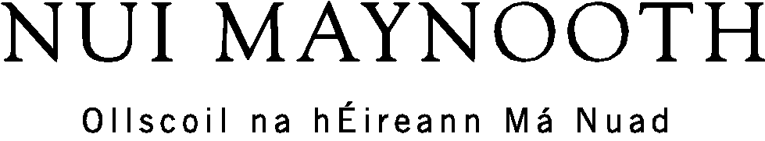

TEACHING ASSISTANTSHIP REPORT

The following report must be completed and submitted to the relevant department on return from your assistantship if you wish to be considered for the BA International Degree.

Answer each question in the target language (i.e. French, German or Spanish) and not in English. The total report should not exceed 1,500 words. Please type up your report.

Provide the following details on a cover sheet to accompany your report.

- Student name and number:
- Language Department (NUIM):
- Address of School abroad:
- Dates of Assistantship:
____________________________________________________________________________________

Teaching and Learning Experience:

Answer all four questions

- Describe briefly the school that you worked in and your weekly duties. (200 words)

- Compare and contrast two language lessons that you designed and delivered during your assistantship. (700 words)

- Review your own language acquisition during your time abroad. To what extent do you feel your language skills have improved and how? What measures did you take to ensure sufficient progress? What were the main challenges of the linguistic experience? (300 words)

- Provide evidence of personal cultural immersion during your assistantship. How did you improve your knowledge of this particular country/society? (300 words)

Also provide a copy of the English Language Assistantship Attestation Form, available under NUIM German Dept Handbooks and Forms, signed by the school principal. (You may also receive a similar form in French from the school principal in any case).

