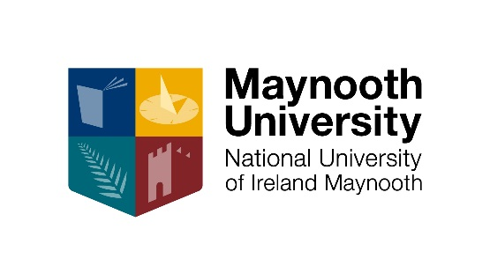
Supporting Supervisors for Research Students

In the academic year 2017-18, the Graduate School coordinated four Supervisory Training workshops for the benefit of academic staff seeking to refresh their skills and understanding of policy as well as to engage in dialogue about best supervision practices with peers.
The programme was modelled on a framework developed by the National Academy for the Integration of Research, Teaching and Learning (NAIRTL)
The workshops proved very informative and the issues raised will give rise to:
- Review of the admissions process for research students
- Review of the role of the internal examiner after the Viva
- Review of career advice to research students

To commence our supervisory training for 2018-19, GS is hosting an interactive workshop during Research Work, which will explore best practices for research supervisors as they support and advise PhD students on the skills and attributes that they will acquire and develop during their doctoral journey.

Date: 9 October 2018
Title: Research Supervision: Exploring Career Paths for PhDs
Time: 10am - 11.30am
Venue: John Hume Boardroom

The supervisory series includes:
- The Supervisor and the Institution
(co-ordinated with the Research Development Office) 10 October 2018
- Preparing to Supervise: Recruitment and Induction 22 November 2018
- Making Progress Spring 2019
- Progress to completion: the Viva and beyond Spring 2019

Full details are listed below:

Workshop one: The supervisor and the Institution
Workshop one is delivered, with the Research Development Office. This focusses on the relationship between the supervisor and MU, in terms of explaining the various layers of regulatory framework (e.g., local, institutional, national and perhaps international) within which supervisors and students operate.
In addition, this workshop should provide supervisors with an overview of the institutional supports in place for research students.
This workshop is particularly relevant to supervisors who are new to the institution, or who are supervising their first student.
Learning outcomes
- Outline the policy issues nationally and internationally which inform local guidelines.
- Recognise the general nature of, and be able to access details on, the key institutional regulations and processes governing postgraduate education.
- Identify who, other than the supervisor, provides support and training for students.

Workshop Two: Preparing to supervise and optimising quality student recruitment
The first stage of the student life-cycle concerns the key question of how to find the best student and preparation by the supervisor for receipt of the student. Many supervisors will testify that careful selection of students in the first instance optimises the chances of a successful process and outcome. Understanding the processes of recruitment within MU and implementing key quality processes (such as interviewing, written material analysis, general assessment of proficiency in language of study), are important first measures in framing the PhD candidature.
Learning outcomes
- Approach recruitment of research students in a manner which maximises the likelihood of selecting the best student for a position.
- Assess a potential student who presents with a research idea in terms of their suitability for postgraduate research.
- Navigate the MU’s procedures involved in recruitment and commencement of a research student.
- Identify potential sources of funding for research students, and institutional sources of advice and expertise on such matters.

Workshop 3: Making progress
The objective of this workshop is to support supervisors during the “making progress” part of the supervision life cycle and to provide them with relevant resources.

Learning outcomes
- Know the institutional policies and procedures governing this stage, including reporting requirements and processes
- Identify their own role as supervisor, the role of co-supervisors and offices and committees of the institution relevant to this stage
- Recognise relevant policies on health and safety, research ethics and intellectual property management as they pertain to supervision
- Be equipped with planning and project management approaches to facilitate their supervision of students
- Be capable of carrying out a training needs analysis with their students
- Provide guidance and direction to students on academic writing
- Help students disseminate their research through publication and conference presentations as appropriate, and identify suitable routes for such dissemination

Workshop 4: Progress to completion and the Viva and beyond
This workshop aims to support supervisors during the “progress to completion” part of the supervision life cycle and to provide them with relevant information and resources but also in providing opportunities or advice, following the viva, for student acculturation into the academic community or, increasingly, preparation for non-academic careers. The rationale for this final workshop is to provide a forum where supervisors from across disciplines meet to discuss how to best support students through and beyond the viva.

Learning outcomes
- Advise and assist students on structuring and managing the work associated with the later phases of a research project, including completing data collection/experimentation and commencing write-up
- Be knowledgeable on formal policies and procedures governing this stage
- Have an awareness of challenges that can accompany this stage and have developed potential approaches to manage them
- Support students with relevant information on research careers, including funding sources and signposting to relevant resources
- Demystify the viva process both for themselves and for their students

