Academic Timetable Guide
There are four options for viewing your Academic Timetable
1) Lectures - allows you to search by course e.g. ARTS Year 1
2) Venues – allows you to search to see what’s in a room at a given time
3) Departments – allows you to see every activity i.e. both Lectures and Tutorials for the Department
4) Students – this is a personalised timetable that you need to log in to view.
PLEASE BE AWARE THE “STUDENTS” OPTION IS ONLY AVAILABLE FOLLLOWING REGISTRATION.

There are guides and useful information available at the bottom of the page.

In general tutorials and practicals are not displayed on the timetable. This is to avoid confusion as there may be multiple offerings of tutorials but each student may only need to attend one. The relevant Department can advise you in relation to both tutorials and practicals.
Sometimes lectures are split into different classgroups. When you view the timetable via “Lectures” or “Departments” you will see all offerings of all of the classgroups. Once you have registered you will be assigned a classgroup based on availability in terms of viability and capacity. You will only see the classgroups relevant to you on your personalised timetable.

How to view your Timetable
Prior to Registration the best way to view your timetable for the year is to click on “Lectures”.
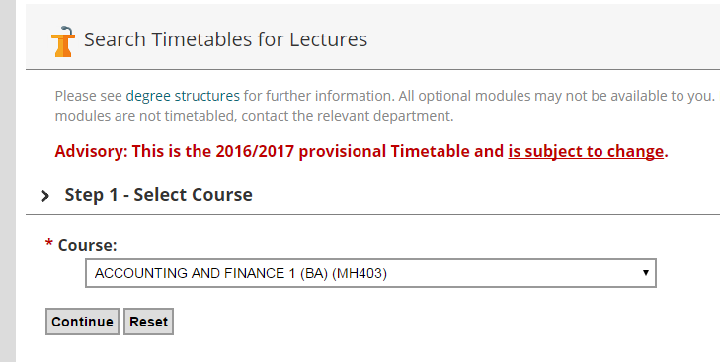

STEP 1: Select Course
Click on the arrow to the right of the box to display a list of courses and select the course you are interested in then click “Continue”.
Note: “Course” refers to a general container for programmes of study, for example ACOUNTING AND FINANCE 1 (BA) (MH403) refers to the Bachelor in Arts (BA) for the course Accounting and Finance for first year (1). The CAO code is included in brackets at the end.

STEP 2: Select Programme
Each “Course” may contain a number of “Programmes”. Click on the course of interest and click continue.

STEP 3: Select Semester

Click continue to show both semesters. You can also just select a single semester.
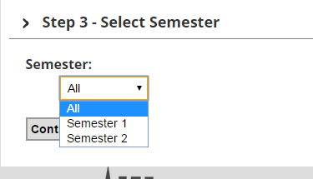

STEP 4: Select Modules
Click “Continue” to select all modules.
You can also use the “Ctrl” key if you only want to display particular modules.
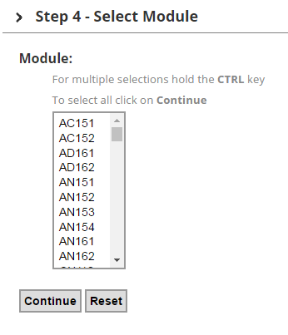

Step 5: Timetable Display
The timetable will now be displayed as below, showing module code and venue.
For example, on Thursday at 9am CS171 takes place in TH2
“CS171” is a module code, to get further information about the module, click on it and you will be brought to a page which will give more information about the module. “TH2” is the venue. If you click on the venue you will be brought to a link with more information
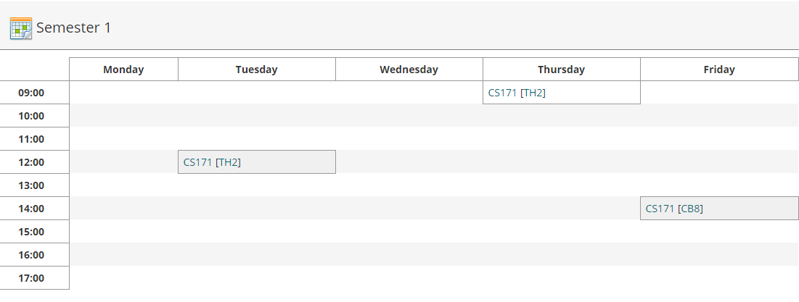
Changing your selections: All of the selections you have made in each of the steps above are shown towards the top of the screen. If you wish to change the Course/ Programme/Semester or Module Information displayed you can click the “Change” link, this means you don’t have to go all the way back to the beginning.

Printing: Click on the ‘Print’ icon 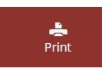 and this will open a new web page and the print dialogue box will automatically appear, you can change printers, adjust size etc. here before printing

To view your personalised Examination Timetable do the following;
- Select the Student Tab
- Enter your student number and password – this is how you currently log in to PCs in NUIM

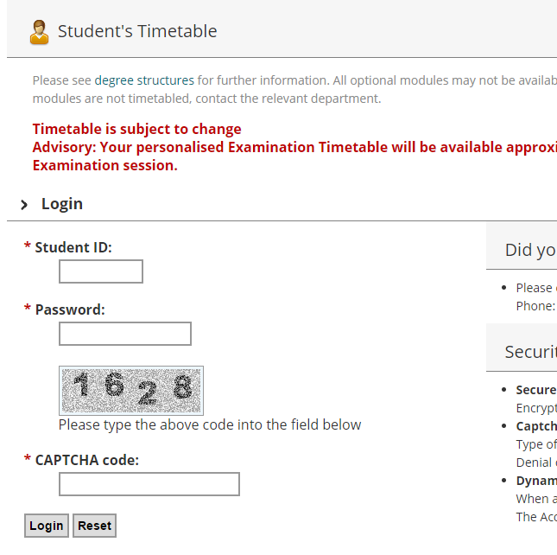

- Enter the code as you see it in the grey box

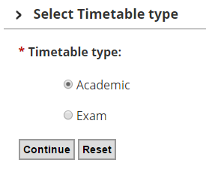
Choose ‘Academic’ and press Continue
You will then be brought to your personalised Timetable.
Please be aware that Practicals and Tutorials are not generally shown on the personalised timetable and you will need to contact the relevant Academic Department in relation to this.

