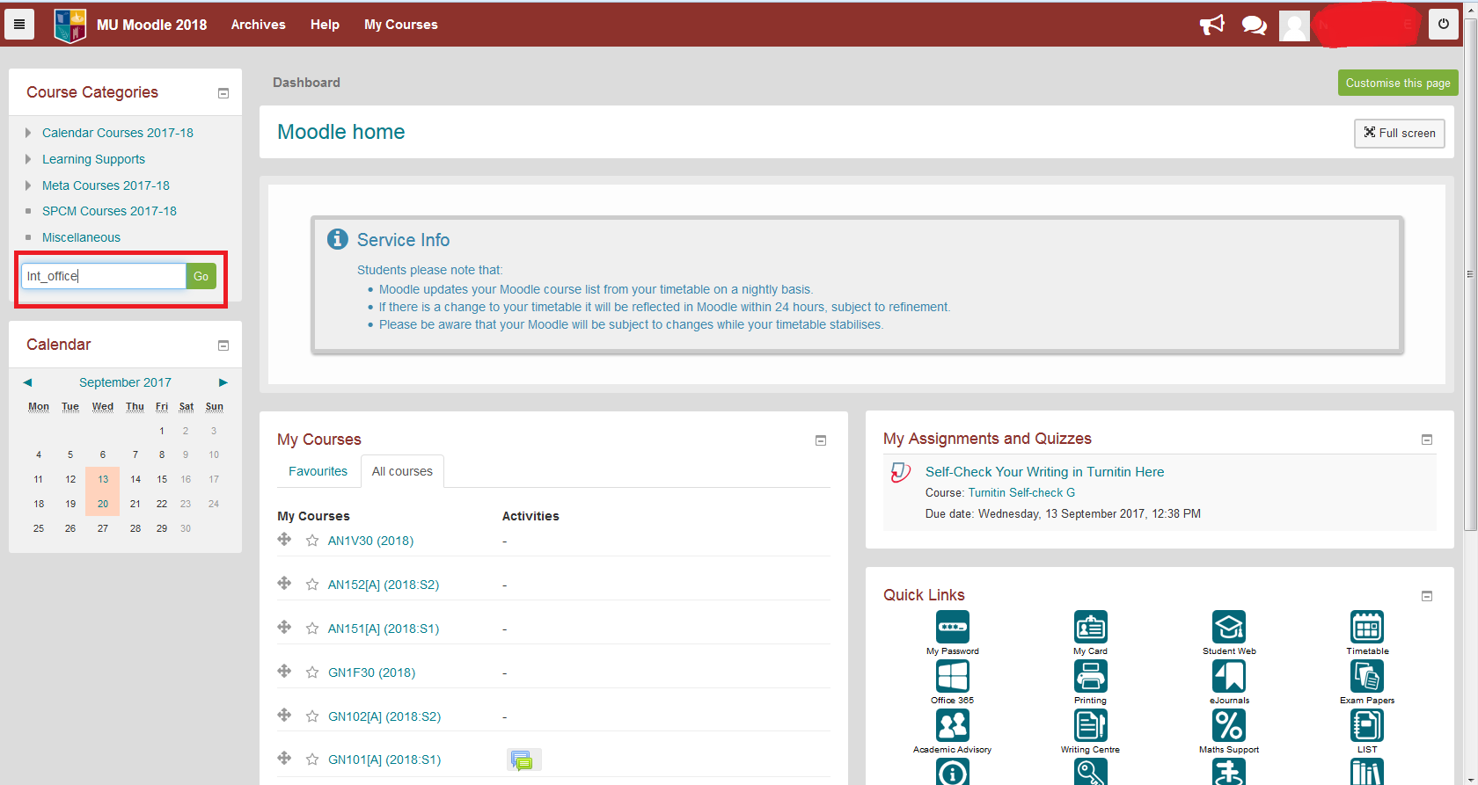
Log into Moodle
Look up International Office in search bar

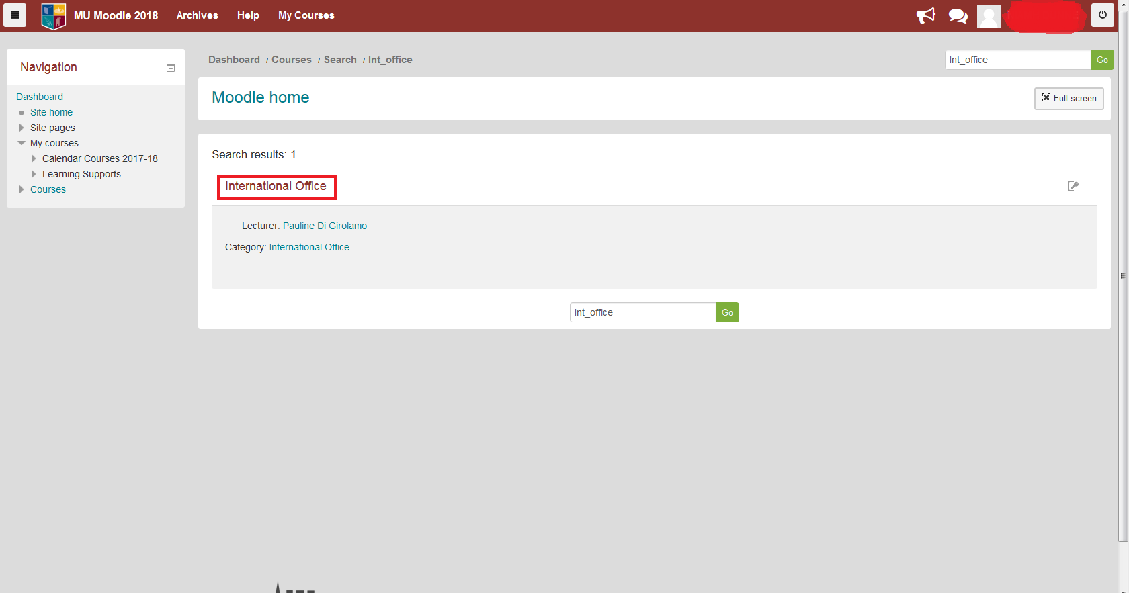

Click on International Office

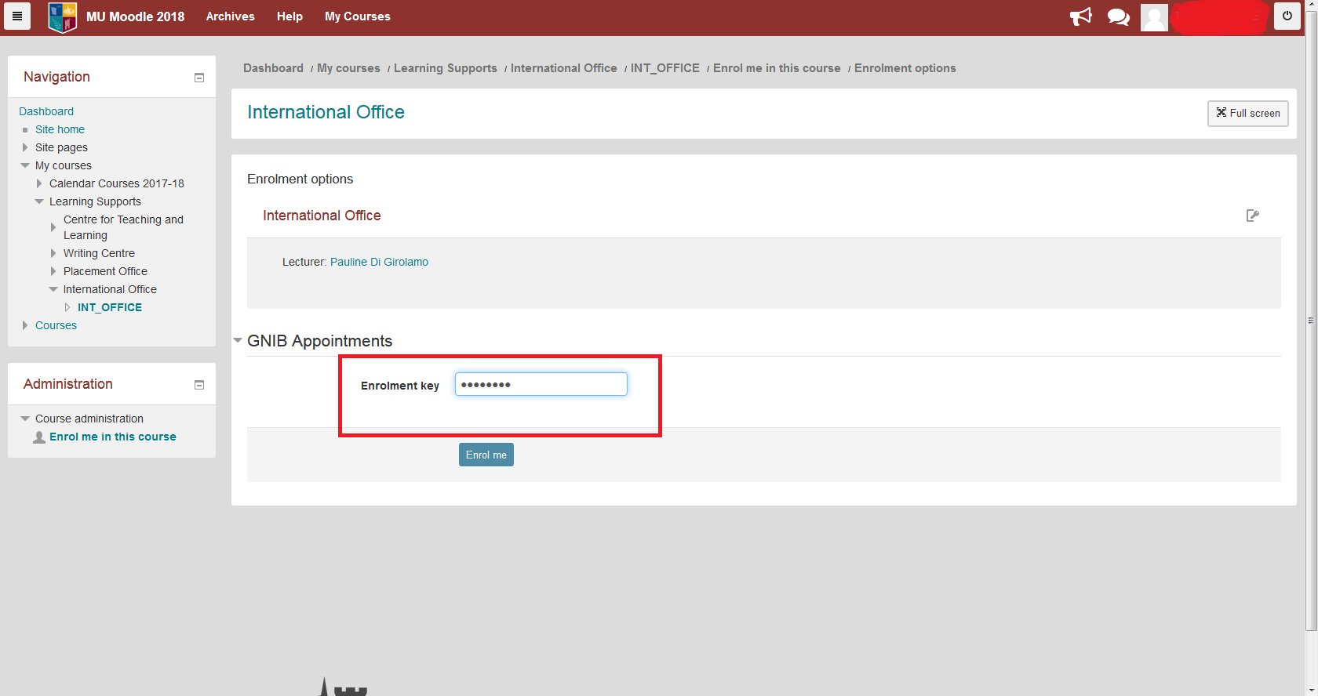

Enter Enrolement Key: gnib2018
Click on Enrol me
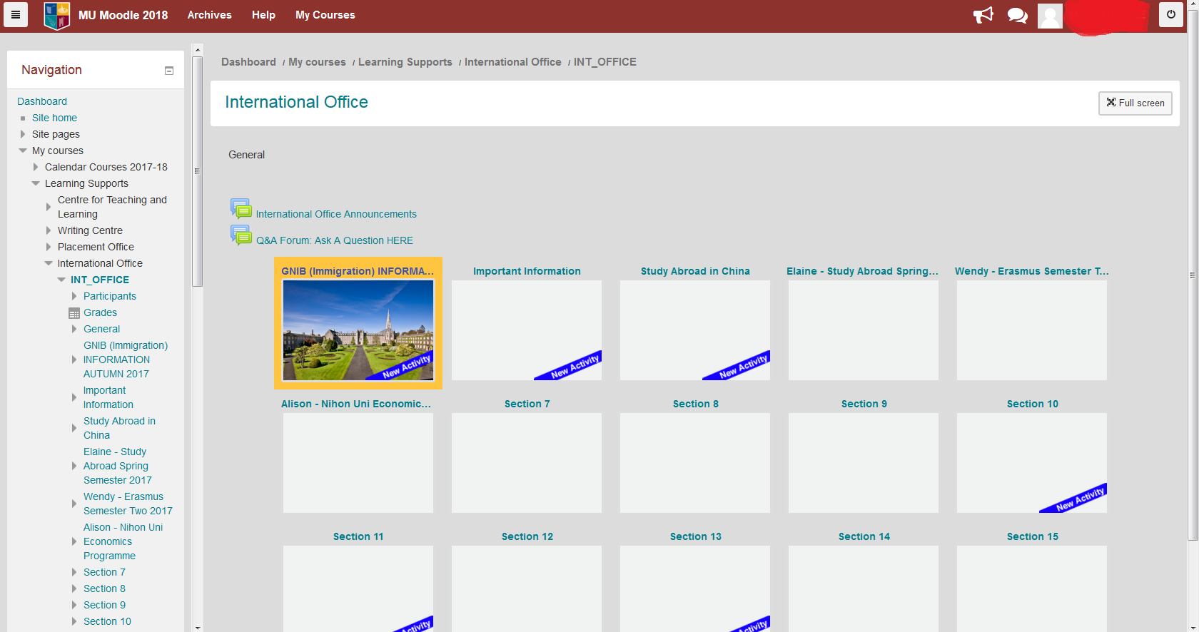

You now have access to the International Moodle Page

