Step 5: Manage Profile

Tools
The Manage Profile page allows you develop your profile and publish it to the University website and create CVs which can be downloaded as word documents. A great deal is customisable for the user, and that can be done here.
Please note the contact details and the photograph section shown in the published profile preview will not be published to your departmental profile. This section is managed by the Communications Office.
Information given here will be downloaded to your word document CVs.
There are six categories which you may or may not select in order to build up your profile. These are: Biography, Research, Publications, Professional, Teaching and Collaborators. The Biography section is shown by default. All other sections must be changed to show all at the users and discipline’s preference and custom.
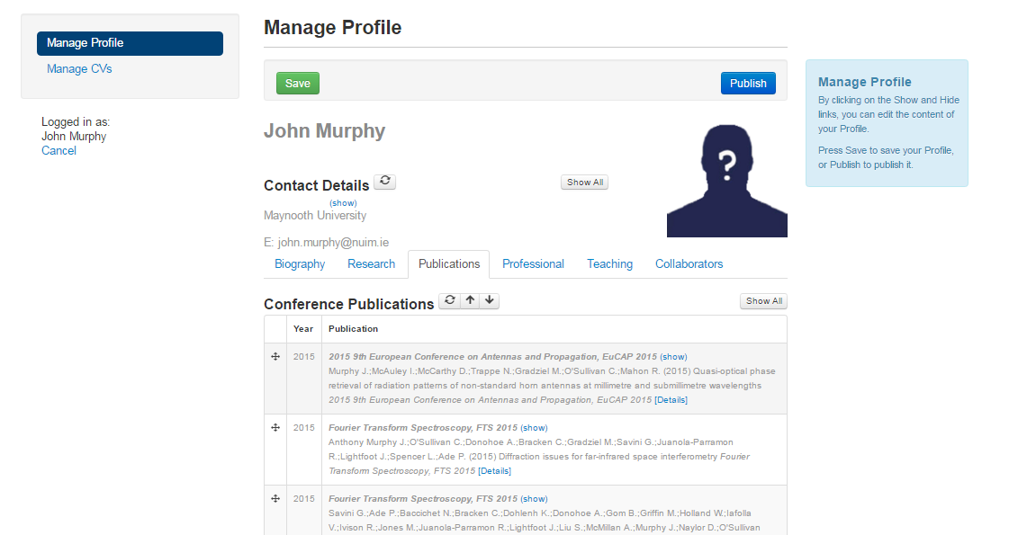
1
3
1
2
1
1
1
4
Figure 15 Manage Profile
- Contact Details and Profile Picture
Your System User and primary Contact Details are imported from another System, and cannot be changed in RIS. Please note the contact details and the photograph section shown in the published profile preview will not be published in your departmental profile. Information given here will be downloaded to your word document CVs.

- Editing profile details
- . To include information, click on the show link. Alternatively, click on the hide link to add information to your Profile.
- You can only add or remove items from your Profile in this section. To edit the contents of each category, you must do so in their respective sections (earlier in this document).
- When you are managing your Profile, you can order the information which you see on screen by clicking on the following links (similar to Moodle):
The Move icon allows you to re-order your list items (eg. Books above book chapters etc). Please note: when new entries are added, the order of your list items may change.
The Up Arrow allows you to move a sub-section up.
The Down Arrow allows you to move a sub-section down.
The Refresh icon will check the system to see if any publications relating to you have been added.
The Show All icon will add all the information in this sub-section to your Profile.
The Hide All icons will hide all the information in this sub-section to your Profile.
- Save
REMEMBER When you are finished with your Profile, click on Save to save it to the system. Otherwise your changes will be lost.
- Publish
If you want to publish your Profile to your institute’s website, click on Publish. This will be live after May 11 2016. But prior to that date, you will see a near approximation.

Figure 16 Manage Profiles

- Publish Profile to the Website
Please follow these exact steps:
- Click on the Save and Publish my Profile to Web
- Accept that you comply with MU policies
- Click on Review your Published Profile to ensure the accuracy of your profile
- If your profile is incorrect, press return to Manage Profile and amend your profile. Please remember to Save any changes before clicking the Publish button
- Repeat I-III

