Step 4: Publications
This section contains your bibliography of published work, and is used to populate your web profile. All your previously recorded publications in the old system have been migrated from InfoEd. In the new Publications section, RIS searches for your publications, you can search manually (by ISBN, DOI etc) or even bulk upload from Google scholar. You will be able to:
- Review publications uploaded to your profile
- Claim references which the system has matched against your name
- Manually add references to your profile
- Import references from personal bibliographic databases such as BibTex, Endnote etc. and export references from your profile to personal bibliographic databases
- Upload the full text of your publications to your university institutional repository (optional).

Review your Publications Uploaded to your Profile
Before entering any new publications, you need to record your Author Name and Keywords in the User Preference. (See above)
Publications from InFoEd have been migrated to your profile. These publications are identified as “migrated”.
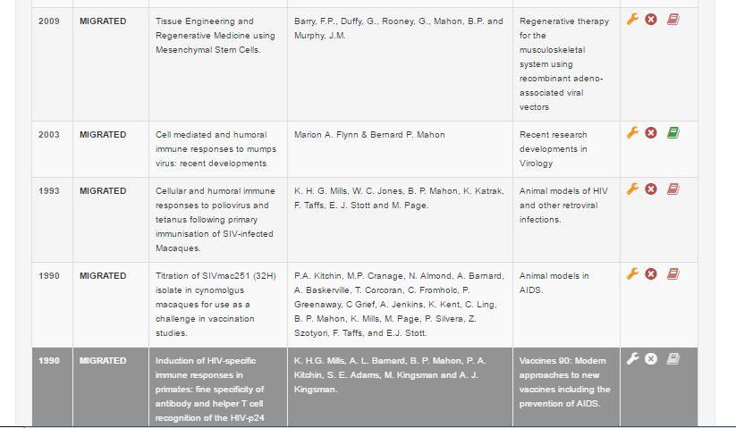
Figure 10 Migrated data

On your first use of the RIS system (or shortly afterwards) please review all publications that were uploaded against your profile to ensure that the right information is in the right fields.
These publications are categorised into the following publication types:
- Books
- Book Chapters
- Books Edited
- Peer Reviewed Journals
- Other Journals
- Conference Publications
- Conference Contributions
- Published Reports
- Other Publications

You can navigate through these sections to review works that have been pre-populated to your profile. This may time on your first visit while you verify publications/remove duplicates etc.

Claim References which the System Has Matched Against your Name
The system automatically shows all the latest publications associated your name from online sources such as Scopus. The system attempts to match publications to your profile based on the publishing alias mentioned earlier, but you must still claim those publications to verify they are yours. You can claim publications here, but a Claim Publications box also appears on the homepage and shows all publications that you have not claimed or rejected yet. The latter function is a shortcut to assist you when you are using the system regularly, to save time working through multiple pages etc.

To claim a publication
Click on the checkbox at the right of the entry, and then click on the “Claim Publications” button at the bottom of the page.
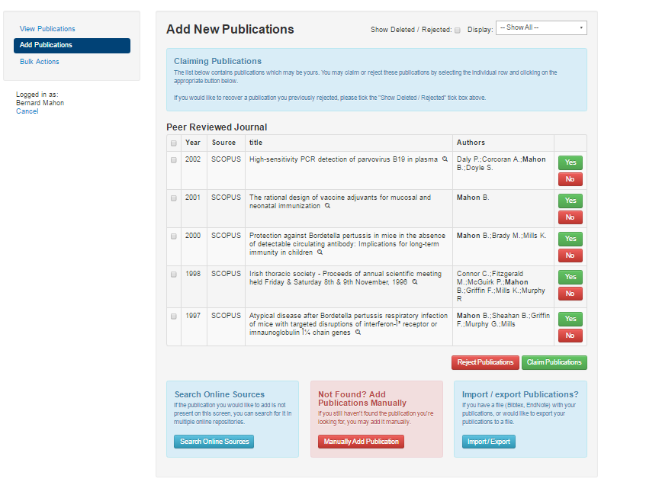
Figure 11 Claiming Publications from External Databases

For Initial Start Up
- We recommend you accept all your publications from external databases on your first visit and then delete duplicates.
- If you discover duplicates, in the example below you see two entries referring to the same publication:
  - Migrated from InFoEd
  - Imported for external database
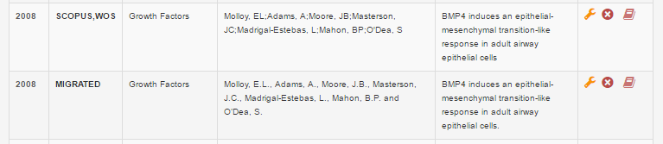
Figure 12 Image of Duplicated Entries

We recommend you accept the imported database entry (e.g. SCOPUS) and reject/delete the migrated version (pressing the red circle with the cross). Imported citations typically have few transcription errors, more metadata etc.

To disclaim a publication
If there are publications shown which are not yours (for example, publications from others with your surname from online databases), you can disclaim/reject them by clicking the checkbox at the right of the entry, and then clicking on the Reject Publications button at the bottom of the page.

Disclaimed a publication in error?
If you had previously disclaimed a publication in error, tick the box labelled “Bulk Actions”. From here you can view all rejected publications. Please indicate publications that you wish to reclaim and press Reclaim Deleted Publications.
Institutional repository
- Links to your published work in the institutional repository appear as a green book icon.
- If links to your published work in the institutional repository break in transfer to the new RIS. This will be fixed centrally in May 2016- you need take no action. After the training sessions are complete, the Eprints link to migrated data will be mapped via the DOI to the accepted database entry. In other words, the Eprints link to the deleted migrated entry will be automatically added to the imported database entry for you.
Please do not try to upload the entry again into the repository.

Adding New Publications –Online Sources
The blue button at the bottom of the page allows authors to claim from other online databases e.g. by ISBN, by DOI (digital object identifier) or via other searches. This feature is recommended if the system has not found your publication and suggested it to you as above.

Adding New Publications Manually
If you know an ISBN number, DOI number etc or can perform an online search we recommend the method above (Adding New Publications –Online Sources. If you still cannot discover a publication that you have authored.
You can add new publications manually in two ways:
- Bulk Action. By uploading them from your existing personal bibliographic database (see below Publication import/export), (e.g. BIBTEX, EndNote & RIS.) Whatever the type of personal bibliographic database you use, you must provide your entries in one of the three compatible formats: EndNote-XML, BIBTEX, or RIS. All known personal bibliographic databases are capable of saving your entries in one of these forms, and you must do this before uploading them.

Endnote
Click on Import Publications from EndNote xml format file and then click on Browse to select your .xml file of entries from your computer disk. Note: you must already have saved the entries from EndNote, ProCite, Reference Manager, or other system into EndNote-

BIBTEX
Users of LATEX, ConTEX t, and other TEX systems using BIBTEX: click on Import Publications from BIBTeX and then click on Browse to select your .bib file. Click on Import to upload and import the entries. You may need to tidy entries after import.

RIS
The RIS format (Research Information Systems) can be used as an export and import format by most personal bibliographic database systems. Click on Browse to select your .ris file. Click on Import to upload and import the entries.
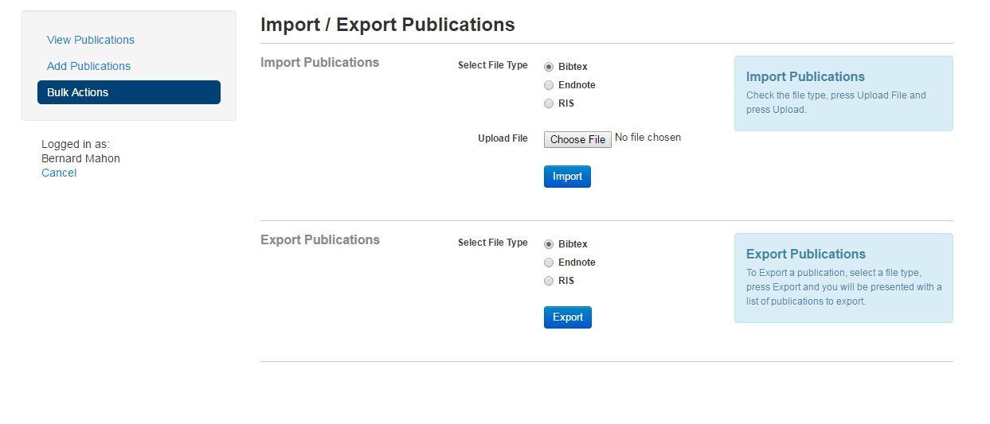Figure 13 Import/Export Publications

- By clicking on one of the links under ‘Add a new publication’ at the foot of the page for the relevant type of publication and adding the entry in the form provided. The publication categories are as follows:
- Book
- Book Chapters
- Books Edited
- Peer Reviewed Journal
- Other Journal
- Conference Publication
- Published Report
- Other Publications

The Other Publications link provides access to a drop-down submenu in the form with dozens of other publication types not shown here for reasons of space. If a specific type of publication that you need is not shown, please email RDO office to ask for it to be added.

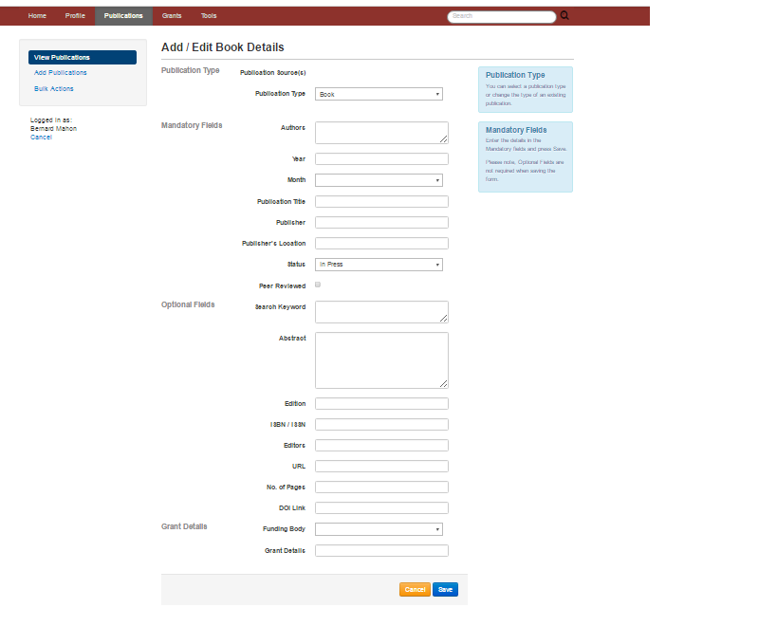
Figure 14 Manually adding a publication
The ‘new publications’ form is slightly different depending on the type of publication because each has different requirements: Most of the fields are self-explanatory, but a few require foreknowledge, which is noted in the list below:

All types
- Author and Editor Names: Enter in the name in the format: Surname First name Middle name. Multiple authors must be separated by a semicolon.
- Month is currently compulsory; if you do not know the month please select “unknown”.
- Titles must be given in full and without enclosing quotes.
    - "Laughter and Language in 'Romeo and Juliet'"
    - Laughter and Language in 'Romeo and Juliet'
- Embedded quotes around cited titles should remain. There is no provision for italics, bold, or equations (TEX mark-up can be used for mathematics).

Books
See the general comments in All types above.

Book chapters
If your chapter is untitled, please assign a notional chapter number.

Books edited
See the general comments in All types above.

Peer-reviewed journals
The list of journal titles is held separately in an Authority list maintained by the Systems Administrator. If the title of your peer-reviewed journal is not shown, email ris@nuim.ie and ask for it to be added.

Other journals
For these journals, give the full journal name.

Conference publications
This type is for papers published in a volume of Proceedings. Other forms of conference presentation which have been published can be loaded in the ‘Conference Contribution’ type under ‘More Publications’. Conference presentations and other contributions which have not been published go in the ‘Professional’ section under ‘Conference Contribution’.

More publications
This section provides access to a much longer menu of more publication type. If there is a further type of publication you need which is not in the list, please e-mail the Research office and ask for it to be added. The grouping ‘More publications’ is only used here to save menu space because the list is very long. When your profile is published to the web, each publication type is presented separately under the specific type, and the heading ‘More Publications’ is not used.

Uploading Publication to Institutional Repository
You can now send your publications from the RIS to the University Institutional Repository. When you have your publication data completed, simply attach your publication and click on the red book icon to begin the process.
In the Actions column of the table, you have the following options:
- Click on the Spanner icon to edit an entry.
- Click on the X to delete an entry.
- This icon means that the publication has yet to be uploaded to the repository.
- This icon means that you have started the uploading but not yet sent the document
- This icon means that the publication has started the upload to repository process. At this point your publication is being checked by library staff for submission
- This icon means that the publication is in the repository.
To provide further information and to alert you to copyright policies, we ask that you answer some questions. If you are unsure you can tick the button that you feel is most representative. The library will perform copyright checks prior to making material available in the IR and can contact you if there are any issues:
Have you checked copyright?
Yes I've checked and I have permission to archive in an open access repository.
No I haven't, please check for me.
You can leave further details in the "Any other comments" text box.
Remember – the Library will always work to ensure no publication will be made available in contravention to your wishes or copyright policies
Please indicate the version you are submitting (different publishers have different policies regarding Open Access repositories. You can normally find this information on your signed Copyright Transfer Agreement or the publisher website however the library will not make material live until we have performed a check)
- Draft (Early version circulated as work in progress)
- Submitted Version (The version that has been submitted to a journal for peer review)
- Published Version (The publisher-created published version)
- Updated Version (A version updated since publication)
Confirm License Agreement
You should read and agree to the stated deposit agreement. Please refer to the MU Policy on Open Access Research.
Where possible it is recommended that all MU faculty and researchers deposit their publications in the institutional repository. The MU open access mandate can be viewed here.
Although submission via the RIS is now the recommended method of deposit to the Institutional Repository, you can still submit directly and your work will be linked to your RIS profile.

Finally, items which you have already deposited, but have the red book icon next to the entry may be broken links from the transfer of information into the new RIS. Please do not deposit an item again. This will be resolved by the technical team and you need take no action. Depositing again will only create unnecessary work for this team.

