Step 3: Profile

General Information
The General Information section allows you scope to change some of your Profile details. Please note contact information and the photograph uploaded will not be published to your departmental profile, but information given here can be used by RIS to help you create a downloadable word document CV and in future may be used to directly populate some funding applications (e.g. SFI format CVs).
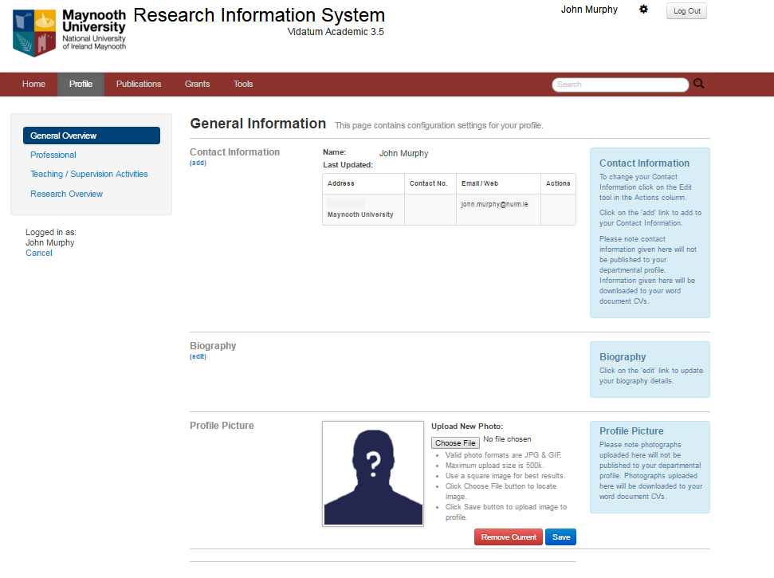
1
1
1
2
1
3
Figure 5 General Information
- Contact Information
The contact information and the photograph uploaded will not be published to your departmental profile. Information given here will be downloaded to your word document CVs.
- Biography
The Biography section, on the General Information page gives you a summary of your biography. To edit it, press the Edit link and you are brought to the screen below. You can cut and paste information from Word processing applications or update and format your details with the text editor and press Save.
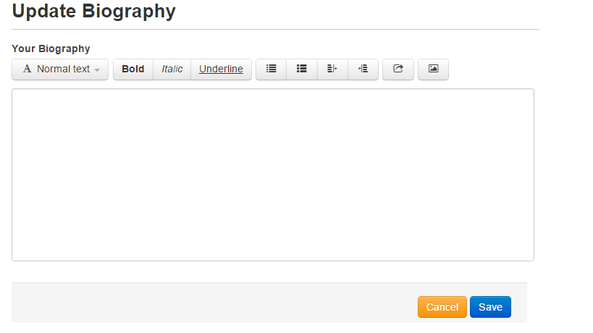
Figure 6 Update Biography

- Profile Picture
The photograph uploaded will not be published to your departmental profile. Information given here will be downloaded to your word document CVs.

Professional & Qualifications
The Professional & Qualifications section contains eleven categories which cover most areas of your professional life and is used to build CVs and/or feed your web profile. To help you, we have imported information from our previous system (InfoED), you should check/update/edit as necessary
The areas are:
1 | Honours & Awards | Directly extracted from InFoEd, editable content.
2 | Professional Associations | Directly extracted from InFoEd, editable content. This section should be populated if you are a member of a professional association. It is possible to record the function within the association, but this should only be used if the function does not fit into a committee structure, otherwise please use the Committee section.
3 | Patents & Licensing | This field is not editable. Content will be pulled directly from Commercialisation Office.
4 | Committees | Directly extracted from InFoEd, editable content. Please check relevance, accuracy.
5 | Employment | Directly extracted from InFoEd, editable content.
6 | Education and Professional Development | Directly extracted from InFoEd, editable content.
7 | Languages | Directly extracted from InFoEd, editable content.
8 | Consultancy | Directly extracted from InFoEd, editable content. This section refers to expertise/services/consulting which are activities within your area of professional academic expertise that advance or communicate that expertise through interaction with Government state bodies, industry and the community/public. This section can be used by the Research & Commercialisation Offices to direct enquiries for partnership to academics. Leave blank if not applicable
9 | Public Engagement/Outreach Activity | Directly extracted from InFoEd, editable content. This refers to research-related initiatives directed to the general public, rather than academic peers. The goal of this activity is to create awareness among the general public about the research work performed in MU and its impact. It assists Maynooth in capturing the many outreach activities which might otherwise go unnoticed.
10 | Editorial/Academic Reviews | Directly extracted from InFoEd, editable content. Information entered here describes your role as a Journal editor or similar not published outputs (i.e. not edited books etc). Any published outputs should be entered in the publication section.
11 | Other Professional Activity | Optional. Directly extracted from InfoEd, editable content. This section applies to any other non academic professional activities which arise from your academic position.

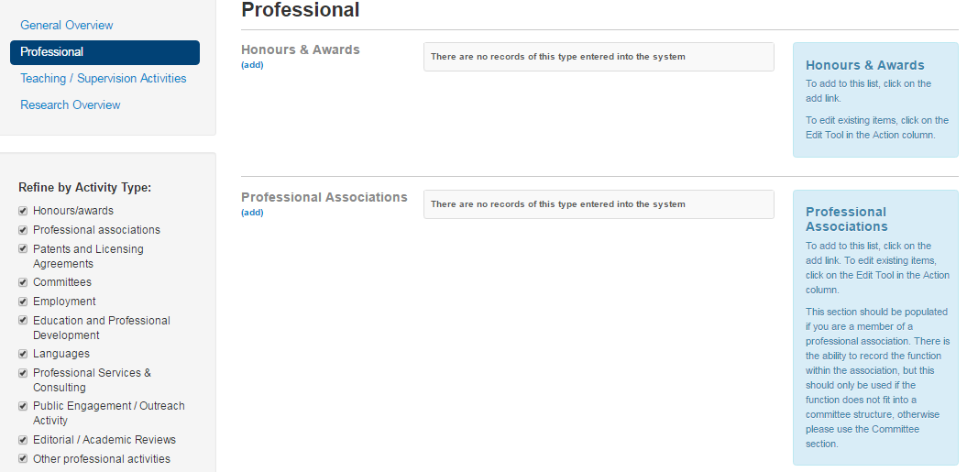
Figure 7 Professional & Qualifications

Teaching
This section is optional. The Teaching section contains four categories which cover your teaching and supervision activities, and was included following feedback from users. It is especially suitable for researchers who research teaching approaches in their discipline and wish to showcase their practice.
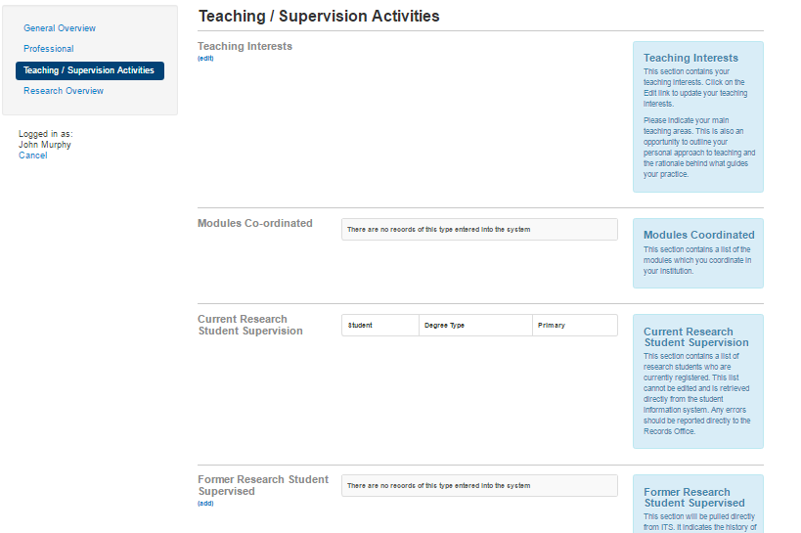
1
4
1
3
1
1
1
2
Figure 8 Teaching Activities
- Teaching Interests
To update your teaching interests and opportunity to outline your personal approach to teaching and the rationale behind what guides your practice.
- Modules coordinated
Content for this will be pulled directly from the Module Database and will not be visible until 2017.
- Current Research Students
This information will be directly populated from the Student Record System and cannot be changed here. It will show your current registered research students. Content will not be visible until 2017.
- Former Research Students Supervised
This section will be pulled directly from it's the student record system. It indicates the history of your research students in Maynooth University. Only students who have completed their research will be displayed on your departmental profile. Any errors should be reported directly to the Records Office. Display of this information will appear later in 2017.

Research Information
The Research Information section contains four categories that populate your staff web profile. They are:
- Research Interests
This section indicates the key areas of your research interest. The system may use this to perform research key word searches to identify researchers for funding opportunities.
- Research Projects
This section is divided into funded and non funded projects. The information for funded projects will be populated automatically from the PT module which will be available in 2017. You will be needed to complete information on any non-funded research manually.
- Post Doctoral Fellows/Research Team
Existing information has been directly populated from InFoEd. Content is editable
- Collaborators
Existing information has been directly populated from InFoEd. Content is editable

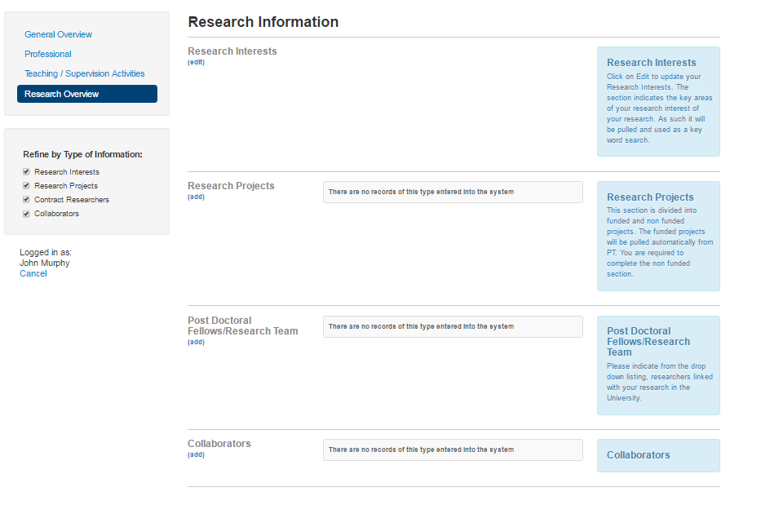
1
2
1
3
1
4
1
1
Figure 9 Research Information

