Step 2: User Preferences
The first time you enter the RIS system before entering any new publications, you need to record your Author Name and Keywords in the User Preference. You can do this by clicking on the “cog” icon at the top right of the webpage, circled in the screenshot below.
Figure 3: User Preferences Login
The User Preference page has three sections which help you to establish your Profile. They are:
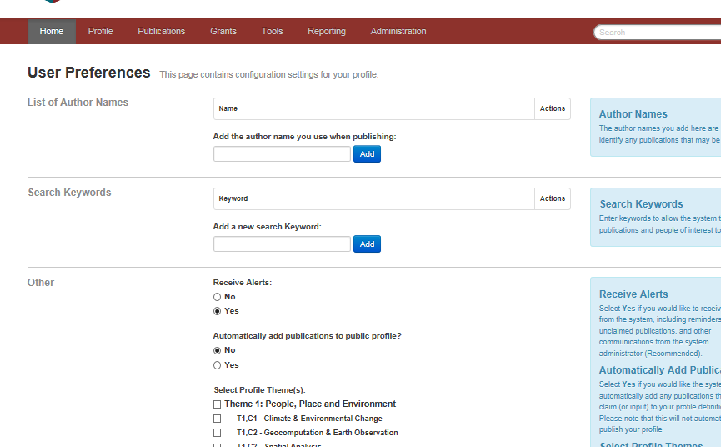
1
3
1
2
1
4
1
1
Figure 4: User Preferences
- List of Author Names
This information defines your publication name for RIS to search external databases. We suggest using your surname followed by a space then your first initial only. Do not add any punctuation. For most users a single entry (e.g. Murphy B) will be sufficient. Click on the Add / Save button to add / save each entry e.g. Murphy B. These settings allow the system to match publications from the Web of Science and PubMed, among others. However, if the result of publications extracted from the SCOPUS, Web of Science does not reflect the number of the publications linked to your profile, you are advised to insert only your surname.
- Search Keywords
Vidatum Academic can track publications and people that may be of interest to you. You may leave this blank or enter keywords. Press Add to add to the list. If you want to remove a name, click on the in the Action column.
- Other
Receive Alerts: Select ‘Yes’ to receive alerts from the system, this allows the system to suggest reminders of unclaimed publications, and other communications from the system administrator. This is the recommended option. Select No only if you are certain you do not want reminders.
- Select Profile Theme (s): Selecting a profile theme will allow your profile to appear on theme-specific departmental and institute listings.

Remember to save your action.

