Step 1: Logging In for the First Time
The current URL (web address) for the system is https://ris.maynoothuniversity.ie/live/. Please log in using your Maynooth University Username and Password. After May 11 2016, when the system is fully live, you will be able to log in to RIS from the Staff workbench on the web.
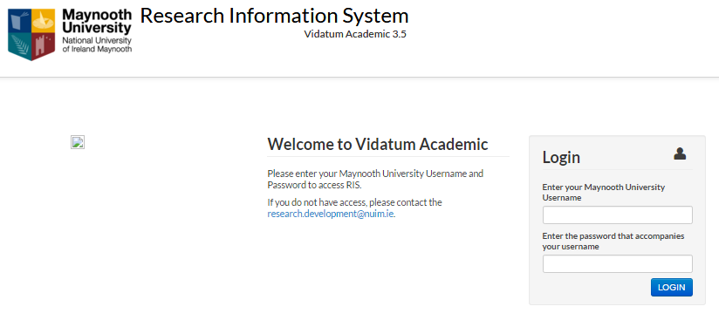
Figure 1: Login Screen

