I'm Glad to Know I'm Not Going Mad!: The Use of Videos of Authentic Classroom Practice to Prompt Collaborative Reflective Practice Among Second Level Modern Foreign Languages Teachers by Celine Healy, Angela Rickard Kevin McDermott and Karen Ruddock in The Digital Learning Revolution in Ireland : Case Studies from the National Learning Resources Service. (Cambridge Scholars Publishing) 2012.
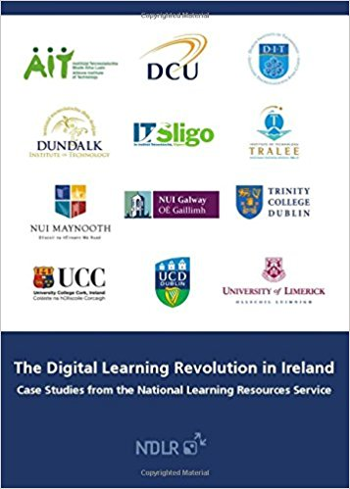
This chapter reports on the a project entitled Video Ideas for Teaching and Learning Languages (VITALL) in which videos were created for and used in the professional development of language teachers. The chapter discusses the opportunities presented by the project to see inside the classrooms of peers and to hear them talk about their practice. This project within a supportive environment, can act as a stimulus to reflect on and discuss the view’s own practice as well as the practice of others.
http://www.cambridgescholars.com/the-digital-learning-revolution-in-ireland-12

Training for Trainers: Challenges, Outcomes, and Principles of In-Service Training across the Irish Education System by Angela Rickard, Françoise Blin and Christine Appel In Teacher Education in CALL Edited by Philip Hubbard and Mike Levy (John Benjamins Publishing) 2006.
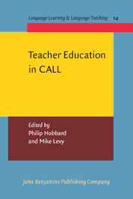
In the Republic of Ireland, the Department of Education and Science oversees the management and evaluation of in-service training for teachers from the primary and post-primary levels. A top-down model of delivery of courses is normally adopted and designed to facilitate the introduction of educational policy or curricular change, and, since the mid-nineties, the use of educational technology in all subjects. In response to an overwhelming demand for in-service support in the area of CALL by language teachers from the primary, secondary and further education sectors, a new model of in-service teacher training programme was created for and with language teachers in Ireland. Aiming to model and to promote good practice in professional development as well as the successful integration of technology into the curriculum of six languages taught in Irish schools, the two-phase programme consisted of training 'trainers' who then delivered in-service courses to their peers according to the principles of learner autonomy, learner-centredness, constructivism and situated learning. Following an overview of the context of in-service teacher training provision in Ireland and of the design and implementation of the programme, this chapter discusses the issues that emerged from its formative evaluation and proposes principles for the organisation of CALL in-service training programmes.
http://web.stanford.edu/~efs/callted/
O’ Grady, G. (2013) 'Towards a more Playful and Politicized Practice of Guidance Counselling'. NCGE Handbook, Autumn Issue, Vol. 42. Dublin: NCGE.

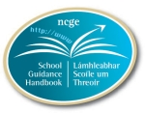
This paper is in the form of a short narrative trail through my developing ideas about identity and my increasing understanding of the power of discourse and language in constructing what we take to be real. It is part of a larger study, which began with a curiosity about how young people in ‘late adolescence’ construct their identities (O’ Grady, 2012). I draw on some of that work in this article to provide a rationale for the need to develop a politicized practice of guidance counselling. A creative approach to research and counselling encourages the expression of multiple truths exposing knowledge as socially constructed (Eisner, 1988) and therefore open to reconstruction. In this way the approach is both playful and political. The second part of the paper attempts to offer some assistance in applying a critical psychology that is artful and politicized to the practice of guidance counselling.

Walsh, T. (2012) Primary Education in Ireland 1897-1990: Curriculum and Context. Bern: Peter Lang International Academic Publishers.

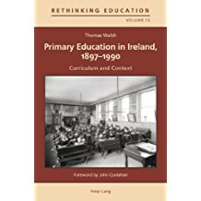

This book critically examines the context, origins, development and implementation of successive primary school curricula in Ireland between 1897 and 1990. It focuses on three particular policy changes during the period: the Revised Programme of Instruction introduced in 1900, the curricular provisions implemented following the achievement of independence in the 1920s and the Primary School Curriculum of 1971. These three eras are distinctive by virtue of their philosophy of education, the content of the curriculum, the methodologies employed and the concept of the child inherent in the curriculum.

Curricular changes are analysed within the complex web of wider educational and societal factors that influenced their devising and implementation. In this way, the book locates curricular developments within the climate of thought from which these policies emerged. The philosophy and ideology underpinning successive curricula are examined, along with the successes and shortcomings of curriculum implementation in each period. This historical analysis of the evolution of the primary curriculum in Ireland has much to offer researchers and policymakers

