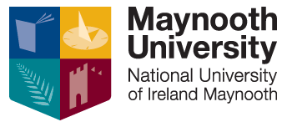 | Ollscoil Mhá Nuad  Maynooth University
Form No. R12
(Version 3, 08 March 2021)

English Language Teaching Assistant registration
This form must be submitted before you leave Ireland to take up your
English Language Teaching Assistant position abroad

Principles: Students who intend their English Language Teaching Assistantship to form part of their final qualification and who wish to graduate with a BA International degree must register for their year aboard via the Student Web.

As with students who go on Erasmus, English Language Teaching Assistantship students are liable for university fees when they register, and are also required to meet academic requirements for satisfactory progress. You should liaise with your department regarding your residence abroad academic obligations.

Note: If you are ‘opting out’ of the BA International programme but still intend working as a English Language Teaching Assistant during the 2021-22 academic year, please remember that you require the explicit permission of your language department to do so. In such circumstances, it is normally possible for a comment confirming your English Language Teaching Assistantship to be included on your academic transcript on your return.

Student Details
First name
Family name
Student number
MU email
Contact number (mobile)

Please tick the appropriate box below
1 | I will be spending the 2021-22 academic year aboard working as an English Language Teaching Assistant as part of the BA International Degree programme. I understand that I must register for my year aboard via the Student Web.
2 | I am opting out of the BA International degree programme option but will be working as an English Language Teaching Assistant during 2021-22 academic year.  (Reminder, permission is required from your language department)

Signature
If sending electronically, you may type your name here, and send this form from your MU email address.
Date

Please submit completed form to:
Student Records Office, Humanity House, South campus, Maynooth University
Or via email to registration@mu.ie

