Dates: Thursday 8th, Friday 9th, Saturday 10th March 2018
Thursday 22nd, Friday 23rd, Saturday 24th March 2018

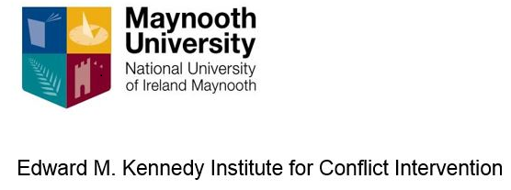

Post Conflict: Challenges of Implementing Peace Agreements
Module MC630 – EQF Level 9

Why do so many peace agreements collapse? This course focuses on creating conditions where successful transitions to peace are possible and explores the political, security and economic challenges entailed in preventing the failure of peace agreements.

The course examines post-conflict healing and reconciliation, how questions of trauma and truth recovery and the search for justice have been handled since the Good Friday Agreement, in addition to comparisons with Bosnia, South Africa and Columbia. Post conflict challenges are also analysed in terms of the EU, UN, third party mediation in disputes, investigating the Middle East Peace Process and Northern Ireland Talks.

Through in-depth discussion and engagement, the course will deliver the necessary knowledge and skills for participants to work in the field of transformative peace-making, teaching transformational interventions that promote methods to reduce and ultimately eliminate violence with a deeper level of understanding of the difficulties in creating post-conflict societies. In addition, the module comprises a combination of seminars as well as guest lectures and speakers as well as Masters Classes with key actors in the Irish Peace Process.

Venue: Kennedy Institute, Maynooth University and Glencree Centre for Peace and Reconciliation, Wicklow, Ireland.
Fee: €1500 which covers course materials, online learning and EQF administration.

HOW TO BOOK:
For more details please phone Dr Roisin Smith: +353 (0) 1 474 7752 or email: roisin.smith@mu.ie Log on to https://www.maynoothuniversity.ie/edward-m-kennedy-institute Limited places available - Closing date 1st March 2018

