Overview
The Home Page
The Homepage of RIS is a summary of your activities and profile. It is the first page which you see when you log into the system.
There are four main sections to the Homepage:
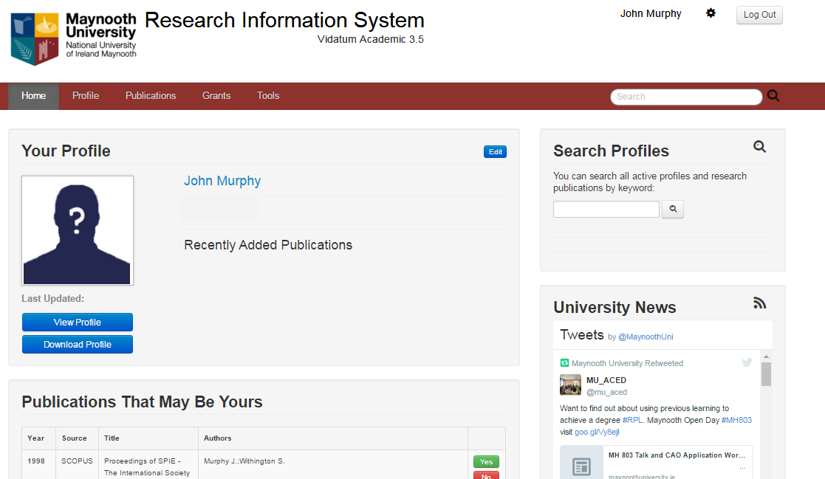
1
3
1
4
1
2
1
1
Figure 2: The Home page
- Your Profile.
This contains the summary information which is kept on the system. By clicking on the Edit link, you are brought to General Information where you can update your profile accordingly. By clicking on View Profile, you will get a preview of what your profile looks like on Maynooth University’s website; by clicking on Download Profile, your profile can be downloaded as a Microsoft Office file.
- Search Profiles.
Allows you to find research collaborators within the University by searching your colleagues’ profiles and / or publications by keyword.
- Publications That May Be Yours.
This section automatically suggests publications which might be authored by your. This feature searches catalogues and databases such as Scopus, for your publications.
- Navigation Menu:
The Main Menu allows you to navigate between all sections in the system.

