Dates: Sunday 20th, Monday 21st, Tuesday 22nd, Wednesday 23rd, Thursday 24th
Thursday, Friday 25th May 2018
2018

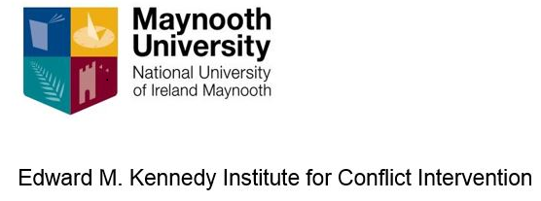

Mediation, Negotiation and Dialogue Skills

Module MC631 – EQF Level 9

Negotiation, mediation and facilitation skills are an essential part of our lives. These skills are needed in our daily work and in all professions. This course provides an opportunity to explore, practice, develop and hone these skills in a safe, supportive and highly mentored learning environment.

The aim of course is to give participants an understanding of mediation and negotiation and allow them acquire a facility to be able to apply these techniques in crisis management and missions. The EU now engages alongside other international actors in complex multi-faceted mediation activities. These insturments are required at all stages of a crisis management operation or mission.

The course will teach individuals to negotiate for themselves and then try to use the mediation process, which includes negotiation, to help other parties to prevent, to manage and to resolve conflict. The content will be highly interactive with a strong emphasis on inter-personal engagement and learning by doing. The programme is comprised of seminars as well as presentations and conversations with guest lecturers This will develop your personal capacity to be more effective in conflict resolution.

Venue: Edward M Kennedy Institute for Conflict Intervention, Maynooth University, Ireland.

Fee: €1500 which covers course materials, online learning and EQF administration. Apply early as places are strictly limited.
HOW TO BOOK:
For more details please phone Dr Róisín Smith: +353 (0) 1 474 7752 or email: roisin.smith@mu.ie Log on to https://www.maynoothuniversity.ie/edward-m-kennedy-institute Limited places available - Closing date 01 May 2018

