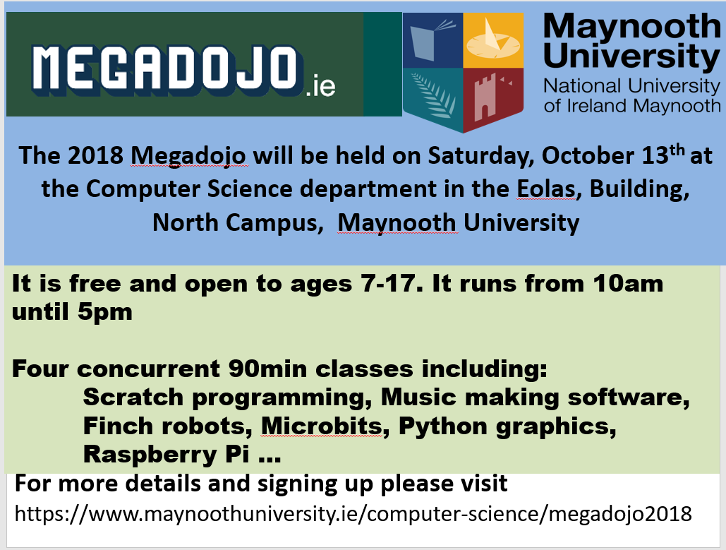

Maynooth University MegaDojo Timetable
Time/Room | Eolas 002 | Eolas 003 | Eolas 004 | Eolas 005 | Eolas 019
10.30 | Beginners Scratch | Python | HTML Web development | Finch robots | Greenfoot
12.00 | Beginners Scratch | Intermediate Scratch | Javascript | Raspberry Pi | Music Software
14.00 | Beginners Scratch | Python | HTML Web development | Raspberry Pi | Music Software
15.30 | Beginners Scratch | Intermediate Scratch | Javascript | Finch robots | Microbit

All rooms have a capacity of 46 places except for Eolas 019 which is 37 places.

