Maynooth University Sport Scholarships

Guide for Applicants

Important information for applicants

Purpose of the Guide is to provide applicants practical information in preparing and submitting an application for Maynooth University Sport Scholarship.

Applicants are required to read carefully the terms and conditions of the scheme and this guide before completing their application.

Eligibility criteria for the scholarship are outlined in the terms and conditions.

Applications that are incomplete or not submitted (i.e. remain as drafts) in the online system after the application deadline will be deemed ineligible.

Where text in the application form exceeds the specified limit, only the text within the limit will be considered. For example, should an applicant submit three pages for a section which is limited to two pages maximum, only first two pages of the text submitted by the applicant will be considered by the evaluators and the rest of the text will be ignored.

Important dates

Deadline for applicants: | 00:00 (GMT), 15th April
Deadline for referees: | 00:00 (GMT), 15th April
Outcome of the competition: | late June 2015

Applicants and referees are strongly encouraged to submit applications/references well in advance of the deadline. Late applications/references cannot be accepted.

How to apply

Applications are online via an online application system accessible from the following link:

https://app.hobsons.co.uk/AYApplicantLogin/fl_ApplicantConnectLogin.asp?id=nuim

Applicants do not have to complete and submit their application in one sitting; they can save the information in the online system and return to their application repeatedly. Please note that once an application is submitted, it is not possible to make any changes.

The application form consists of a number of fields. Many fields are mandatory and if left empty, the system will provide an error message as applicants save their work and progress to another section/check the application before submitting. Some fields are not specified as mandatory in the online system; however applicants still have to ensure that they provide information in fields relevant to their scholarship.

Some fields require text to be entered into a box and some fields require documents to be uploaded into the system.

Where text is to be entered directly into a box, applicants can prepare their text outside of the online application system and simply cut and paste it into the online system once they are happy with it. Please note that the online system does not support any formatting such as bold, underlined or italics.

Where applicants are required to upload a document, they can upload a file in one of the formats supported by the online system: .pdf (preferred file format), .docx, .doc, .rtf, .wpd, .txt, .xlsx, .xls, .jpg, .pict, .gif, .bmp, .tif or .png. The file name must include the appropriate three- or four-letter extension. Important: do not attempt to upload a document that is password protected or contains macros or some other active content; such files cannot be uploaded and the upload process will fail. It is recommended that applicants save their documents as .pdf, selecting “smallest file size” option when they create the .pdf file.

Content of the application
Table below provides applicants with information about the type of information required. Note that the table does not represent an exhaustive list of fields that will be available to applicants in the online system.

Information type | Comments
Applicant’s personal details | Mandatory information. Please note that date of birth is required to ensure that duplicate records can be identified in the online system.
Applicant’s contact details | Self-explanatory. A number of fields are mandatory.
Application Information | Mandatory information. Please note that date of birth is required to ensure that duplicate records can be identified in the online system.
Applicant’s declaration | Applicants must declare their acceptance of the scheme’s terms and conditions.
Information about referees | Terminology used in the online system is “recommendation” for “reference”, and “recommendation provider” for “referee”. Where the online system is open for customization, the terms “referee” and “reference” are used. Applicants enter contact details of 2 referees and indicate for each referee whether they are online or offline referees. This information is mandatory for both referees. A valid email address must be provided for online referees.

Applying “step by step”

Creating account
The first step is to register in the online system and create an account, including user name and password – see a screen snapshot below. To create your account, select the “Create Account” tab. Note instructions regarding password characteristics provided on the bottom of the screen.
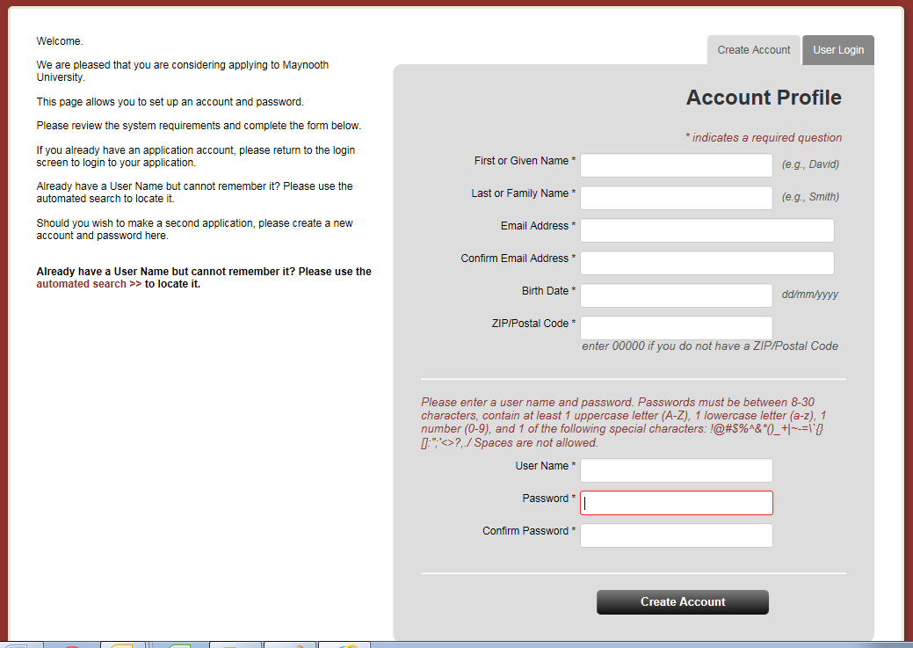

The online system will also send you an email confirming your account details.

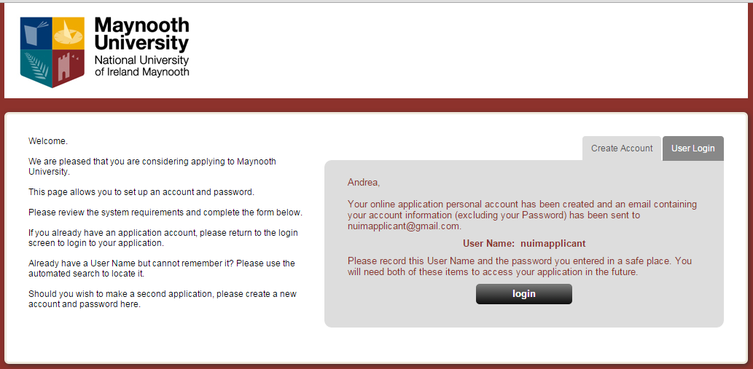

Before you can log into the system for the first time after creating your account, you need to confirm your acceptance of terms and conditions for use of the online system.

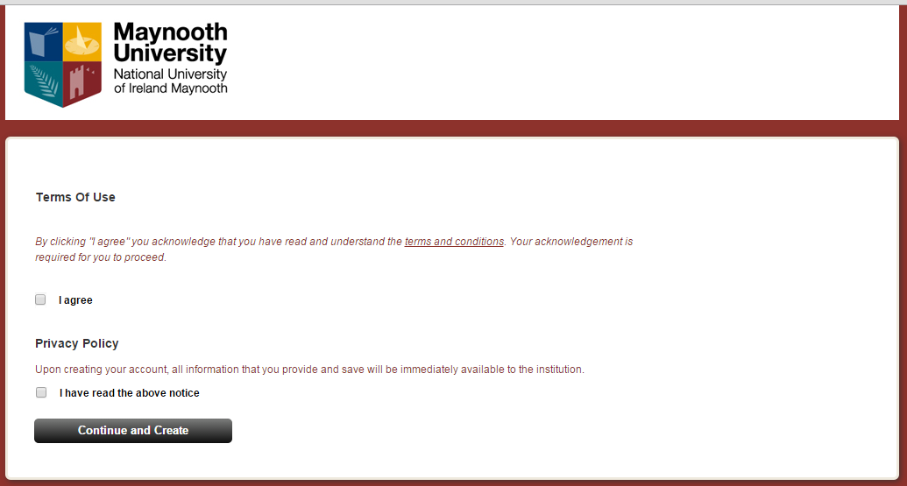

When you need to return to the online system to continue working on your application, you will select the “User Login” tab as highlighted on the screen snapshot below.

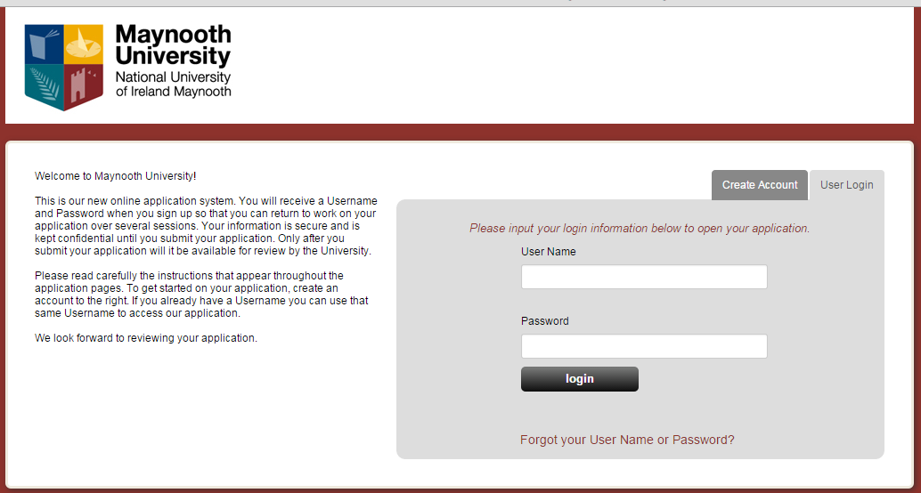

Note: If you forget/misplace your user name or password, click on “Forgot your User Name or Password?” at the bottom of the login screen and follow instructions provided by the system.

Starting application
The University uses the online application system to accept and process not only scholarship applications but also applications for certain type of courses. Applicant’s home screen therefore includes two main areas. “Application for Admission” and “Scholarship Application”. To start your scholarship application, click on the “Start Application” button in the “Scholarship Application” area. See screen snapshot below.

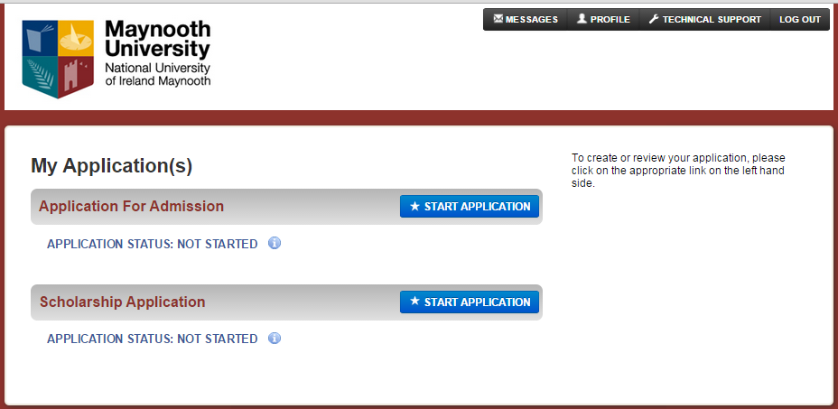

After you click on the relevant “Start application” button, the following screen will be displayed:

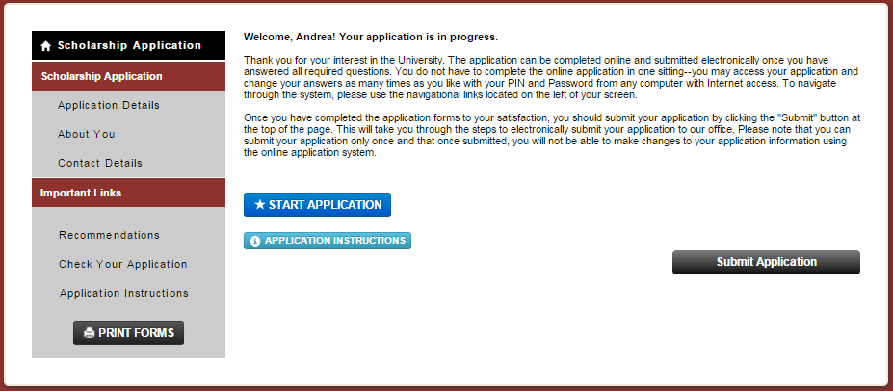

After you click on the “Start Application” button again, you will progress into the first section of the application as such.

“Application details” section
In this section, you will select “Research Scholarship” to indicate which scholarship you wish to apply for. The online system can be used to accept applications for different scholarships depending on schemes currently available at the University. Applicants for John and Pat Hume Scholarship therefore need to ensure that they select “Research Scholarship”. If you select a different scholarship type, your application will NOT be considered as application for John and Pat Hume Scholarship, even if you submit details relevant for Hume scholarship competition.

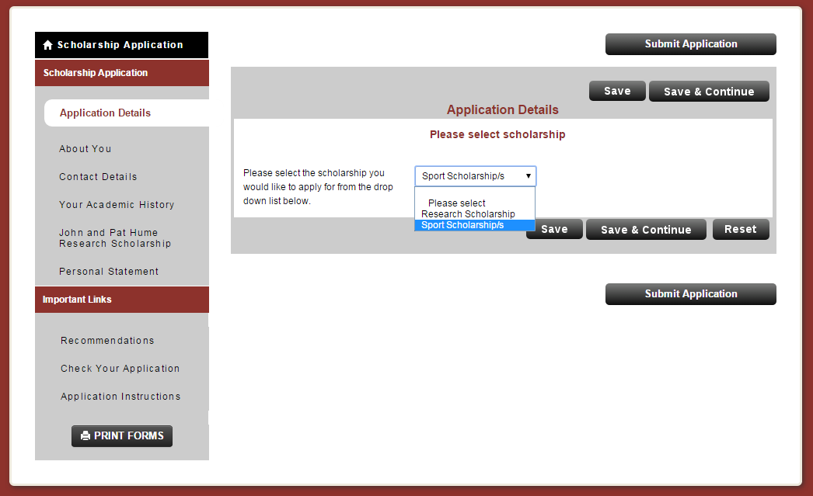

To save your scholarship selection and continue to the next section of your application, click on the “Save & Continue” button.

You can alternatively click on the “Save” button and select a section that you wish to populate from the list of sections available on the left hand side of the screen. Note that the list of sections changes dynamically depending on information saved in the system – you will notice that more sections will become available to you once you save your choice of scholarship.

“About you” section
Ensure that all fields marked with * are completed.
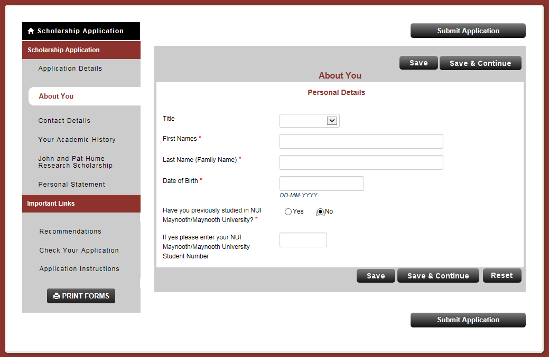

Important: if you do not save details entered before selecting another section from the list of sections on the left hand side of the screen, the data will be lost. Therefore you should always click on either “save” or “save & continue” if you wish to save the information entered.

“Contact details” section
Fields on the screen below are used to capture applicant’s contact details.

Note: “Home phone number” field is mandatory and cannot be left empty. If you are not in the position to provide a home phone number, enter an alternative phone number (work, mobile) instead.

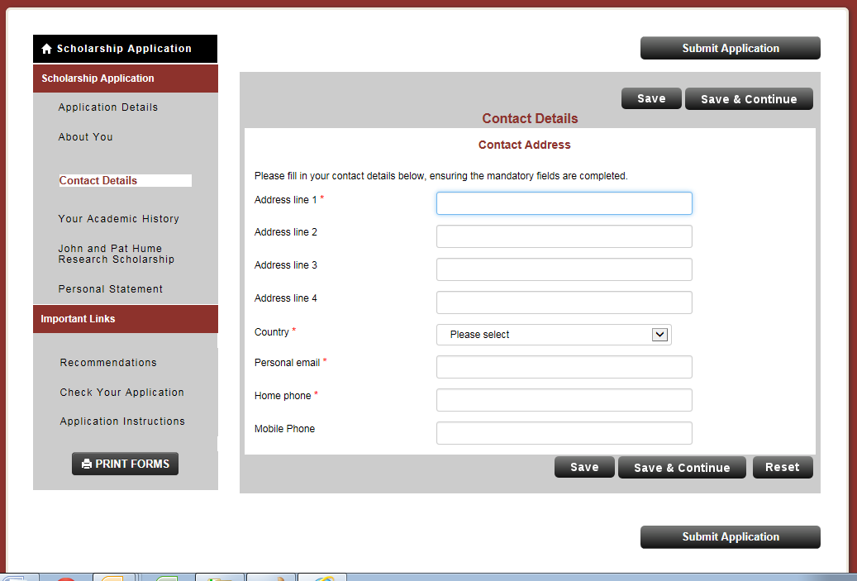

“Sport Scholarships” section
This section allows you to provide a summary of your sporting history to date.
Sport history is very important information for the assessors; therefore applicants are encouraged to complete this section with as much detail as possible.

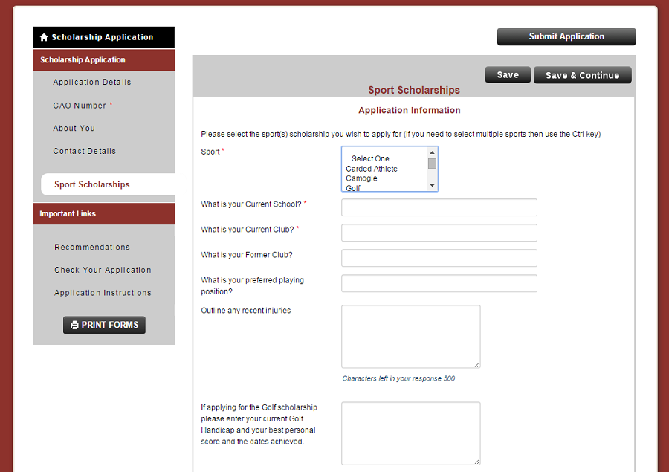

Adding referees
As mentioned previously, terminology used by the online system is “recommendation” for “reference”, and “recommendation provider” for “referee”.

Referees can provide reference either electronically using the online system, or they can submit a reference on paper directly to the Sports Office. Applicants need to agree with each referee in advance whether the referee will submit his/her reference online or on paper.

Both “online” and “paper” references need to be provided on a specified Referee form available for downloading https://www.maynoothuniversity.ie/study-maynooth/undergraduate-studies/scholarships/sport-scholarships.

You will enter details of your two referees into the online system in the section called “Recommendations”, see the following screen snapshot.

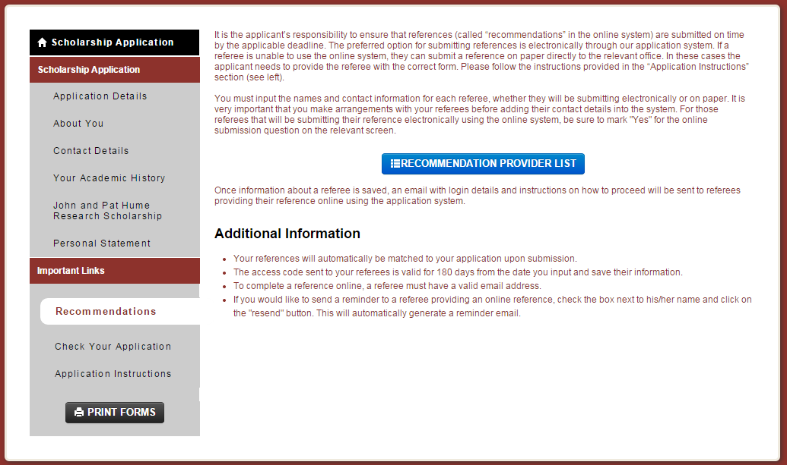

After you click on the “Recommendation Provider List” button, the following screen appears.
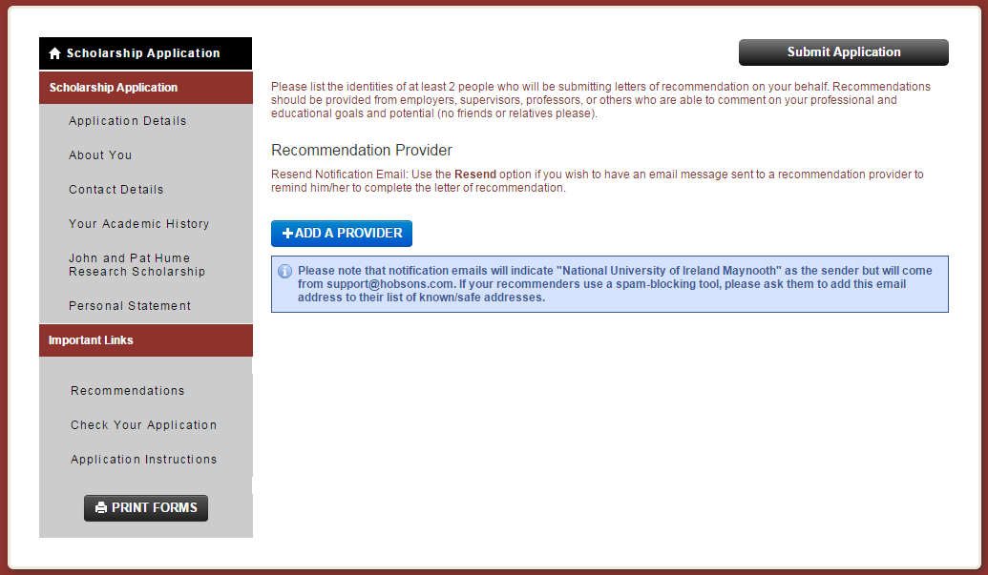

After you click at the “+ Add a Provider” button, the system will present the following screen for entering referee’s details. Each referee’s details will need to be entered separately.

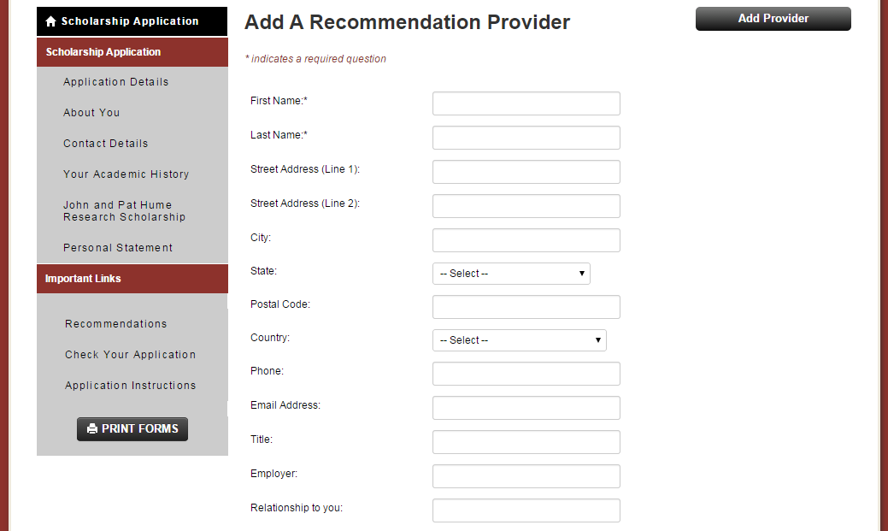
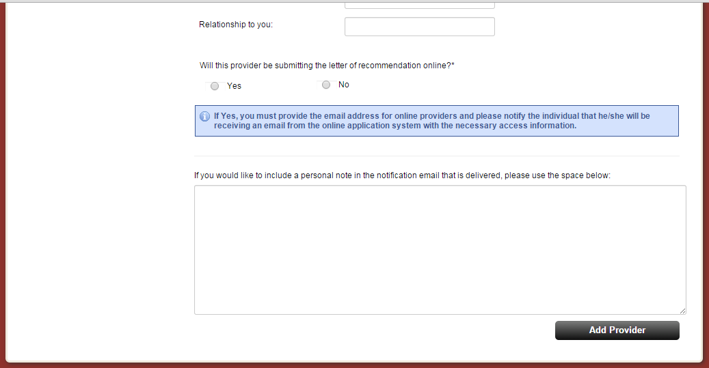

If a referee is designated as providing reference online, you have to enter his/her email address into the relevant screen. You must ensure that the email address is valid and entered into the system correctly. The online system will use the email address you enter to send login details and instructions to the referee.

Once you add your referees’ details into the online system, the system will present you with a summary of your referees as illustrated on the screen snapshot below.

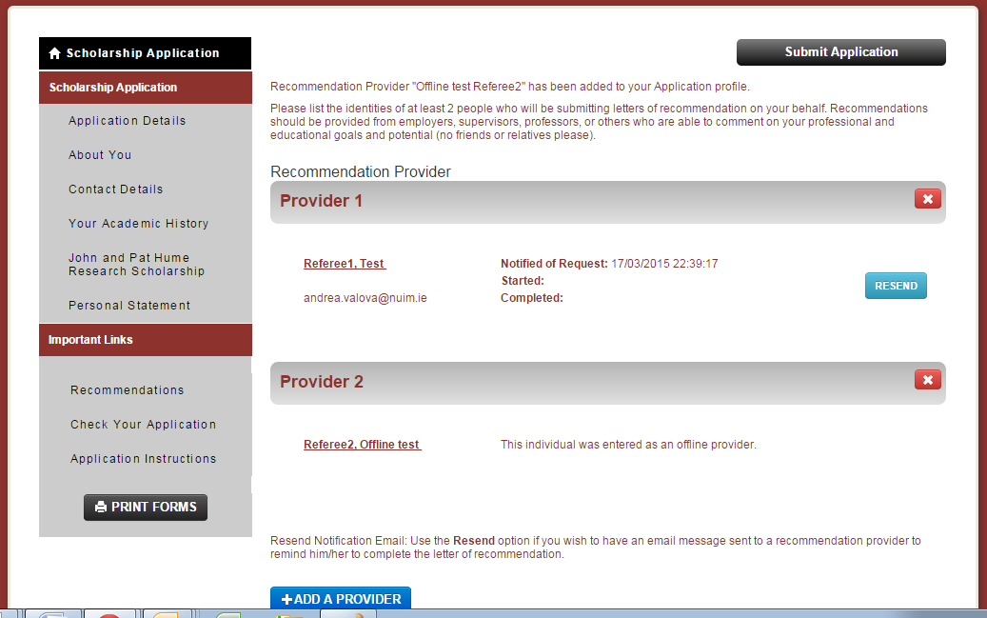

Note that in the screen snapshot above, “Test Referee1” was registered in the online system as providing reference online, and “Offline Test Referee2” was registered as providing a reference on paper/offline.

The applicant is responsible for providing offline referees with the Referee form and for ensuring that the referee has access to the Guide for referees. Important: Referees providing reference on paper (offline referees) will not receive any instructions from the online system.

Applicants can delete a referee and register a new one. This process should also be followed in case a referee registered as providing reference on paper (offline) should be changed as providing reference online and vice versa.

Check application
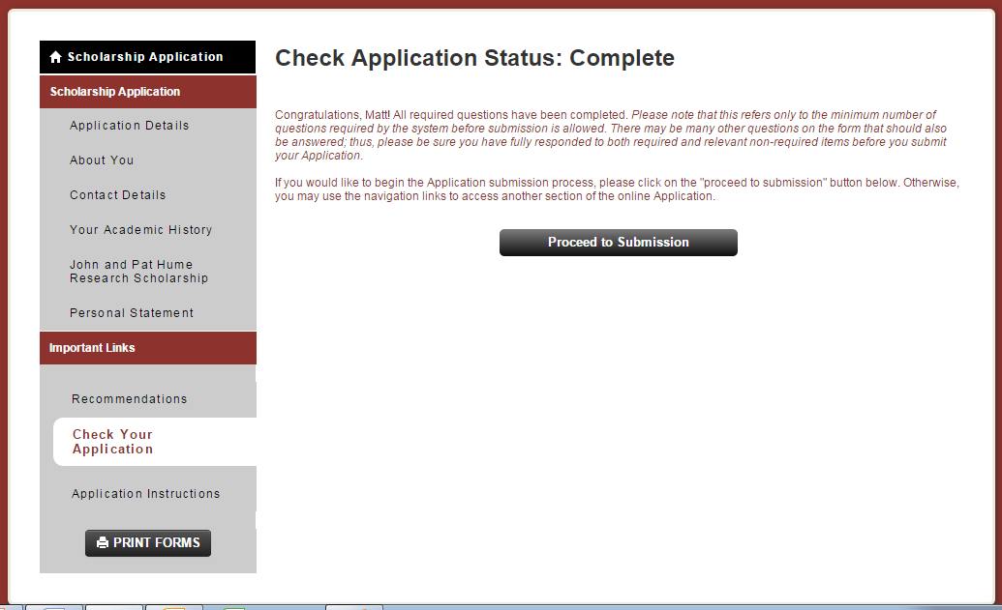

Review application
You can review information entered into the online system by clicking at the “Print Form” button at the bottom of the screen (see the above screen snapshot).

Submit application
Once you are happy with your application, you can proceed to submission. Remember, once you submit your application, it will not be possible to make any amendments in it.

Recommended system requirements for using the online system

Maynooth University uses a third party service, therefore some email addresses and urls used are those of the service provider. All information provided by applicants and referees will only be used by Maynooth University in the process of collecting and processing scholarship applications. No third party will have access to the data.

Supported browsers include Internet Explorer 9 and 11, Firefox, Chrome and Safari.

While the majority of features will work with other browsers, full compatibility is guaranteed and support offered is for the browsers mentioned above.

If you are using one of the supported browsers and are experiencing problems, we encourage you to upgrade to the latest version. If you still experience problems after upgrading, please make sure that your browser is set to accept cookies. Also, make sure the following browser settings are enabled:

JavaScript must be enabled.
Popup blockers must be disabled.
If your browser has a section for trusted sites, please enter these two URLs:

http://rec.hobsons.co.uk
https://rec.hobsons.co.uk
You will need Adobe Reader 6.0 or higher to download, view and print PDF files. While PDF files should work with most other PDF viewers, we can only guarantee full compatibility and support for Adobe Reader 6.0 or higher.

If your email offers a whitelist, please add the following addresses:

support@hobsons.com

Enquiries

If you have any questions regarding the application process please consult documentation for applicants, such as this guide, and Terms and conditions of the scheme.

Should the documents available not answer your question, please email sportscholarship@nuim.ie with “Query & sport name” in subject.

For reasons of transparency and fairness, only email enquiries will be accepted.

