Virtual Reality and Neuroimaging to Investigate the Neuronal Process while Walking
John S. Butler, School of Mathematical Sciences in Technological University Dublin
Falls are the leading cause of reduction in quality of life and life expectancy. There are also many neurological disorders that impact people’s ability to walk, such as Parkinson’s disease. For a long time, walking was considered an automatic process which did not require much cortical processing resources, but this is not the case. To investigate this every day process requires the collaboration of different research expertise such as neuroscience, computer science, mathematics, statistics, data analytics, neurology and electrical engineering. This burgeoning new research is known as Mobile Brain Imaging (MoBI).
In this talk, I will present a series of studies which investigate the neuronal processes of passive movement and walking in healthy young people, older people and people with Parkinson’s disease. These studies employed virtual reality, behavioural experiments and neuroimaging methods to acquire the data, and signal processing techniques and mathematical methods to interpret the data.
The first set of studies investigated the relative contributions of visual and body-motion cues to estimate distance walked. The results were modelled using a leaky integrator ordinary differential equation which showed that participants exhibited a more reliable estimate of distance walked when presented with both cues. Interestingly, the combination of visual and body-motion cues was not predicted solely by the reliability of each cue, but rather more weight was given to the body-motion cue.
In the second set of studies, high-density electroencephalographic (EEG) recordings were used to investigate the neuronal processes associated with passive self-motion and walking. These studies were some of the first of their kind, as EEG experiments have been mainly conducted in electrically shielded rooms with minimal participant movement. The studies outline the practicality and feasibility of conducting these experiments using different virtual reality setups. As well as showing how signal processing methods enabled the separation of signal from the noise to allow for the interpretation of the data. Finally, the results have given insight into the neurophysiological measures of self-motion under a more naturalistic environmental setting and a window into aging and Parkinson’s disease.

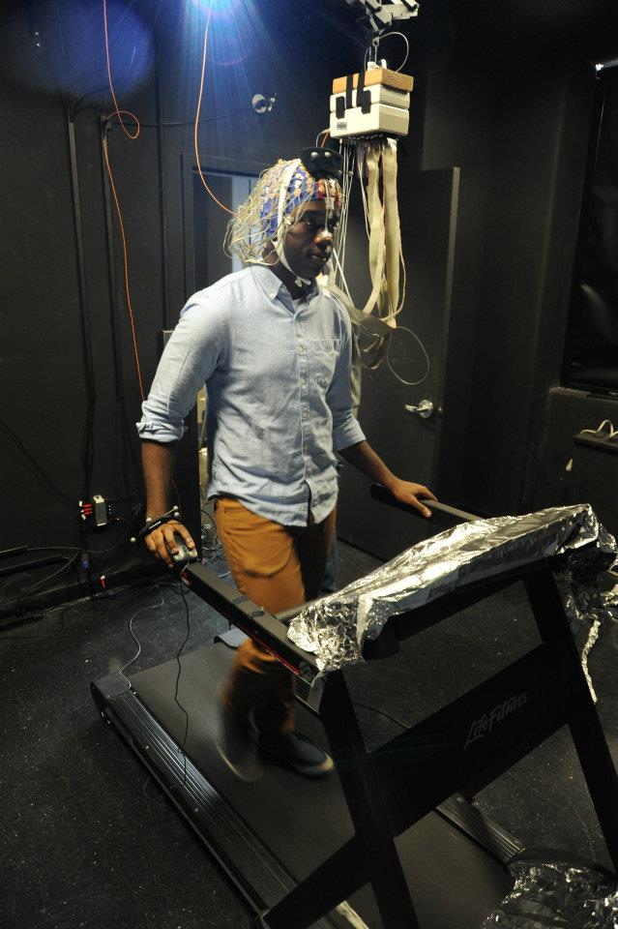
Left, Participant seated on motion platform wearing an EEG electrode cap. Right, Participant walking on treadmill wearing an EEG electrode cap.

