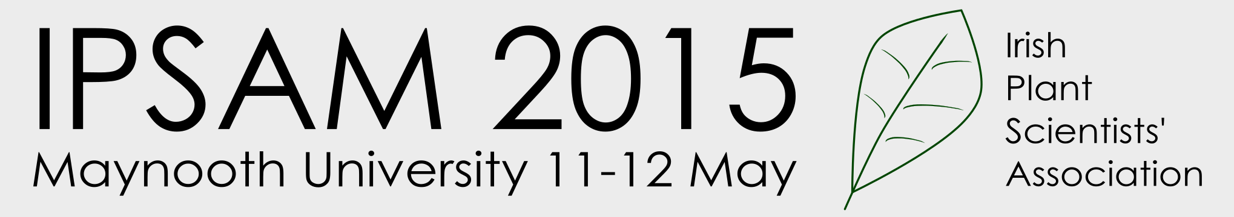

Abstract Submission Form

Please give details of one submitting author here for correspondence

Title:

Name: Type your full name here

Affiliation: e.g. School of BEES, University College Cork

Address: Insert full postal address here

Email:

Thank you for considering submitting an abstract for IPSAM 2015. Please type your abstract in the space provided overleaf (maximum 200 words).

Please indicate whether you would prefer to give a POSTER or ORAL presentation by typing the word poster or oral below

Preferred form of presentation:

Please use the exact format prescribed below. No graphs, tables, photographs, etc. to be inserted in the abstract.

Please save this file (using the format mysurname_IPSAM15.doc/ .docx) and submit by email to IPSAM2015@nuim.ie

Please also submit a (reasonably sized) photograph of the presenting author along with your email. This image will be used in the book of abstracts. Please submit as a .jpg, .jpeg or .png file, with your surname in the file name, to the above email address.

Submission Deadline: 17.00 Sunday 19th April

ABSTRACT

Title: Analysing the distribution of Humulus lupulus in West Cork

Murphy James J¹*, Beamish William R¹, Guinness Arthur P²
¹ Department of Plant Science, University of Leinster, Ireland
² Centre for Biology, Munster Institute of Technology, Ireland

*Presenting author

Abstract
Given the importance of Humulus lupulus to the global economy, a detailed analysis was carried out to establish its distribution across....

- Max 200 words – words beyond this limit will be deleted.
- Do not use references or footnotes in the abstract.
- Ensure you adhere to the style outlined above

