HY212 Early Modern Europe

Lecturer: Professor Marian Lyons

Semester One (2019-20) Tuesdays @ 11am + 1 weekly tutorial

Course description
From the mid-fifteenth century down to the outbreak of the French Revolution (1789), so profound were the changes that convulsed all spheres of European political, social, cultural, and economic life that historians believe it transitioned from medieval to early modern Europe, and its peoples assumed a new place in an emerging world civilization.

This module explores these modernizing impulses, beginning with the invention of printing, the discovery of ‘the new world’ and the emergence of Portuguese and Spanish overseas trade routes, the end of the Hundred Years War between England and France, and the advance of the Ottoman turks on Constantinope and Western Europe. The major cultural and intellectual movements of the era - the Renaissance, Scientific Revolution and Enlightenment - are all explored, as are major religious reform movements, particularly in the dominant Catholic and Protestant traditions.

The sixteenth and seventeenth centuries were notorious for political strife, protracted wars, economic hardship, and vigorous pursuit of deviant individuals, most notably witches: all of these are examined. Major trends in economics and the development of technology are traced; so too is Europe’s evolving relationship with the wider world and its involvement in the East India Companies and lucrative slave trade.

The module ends with outbreak of revolution in France (1789) which heralded a new era in the history of Europe. While much of the focus is on exploring the impact of these major changes across Europe and in European overseas colonies, important religious, ethnic, gender, class and regional differences are also highlighted.

Recommended textbook
Merry E. Wiesner-Hanks, Early modern Europe, 1450-1789 (Cambridge History of Europe series, Cambridge, 2011, sixth printing). Copies available in the University Bookshop.

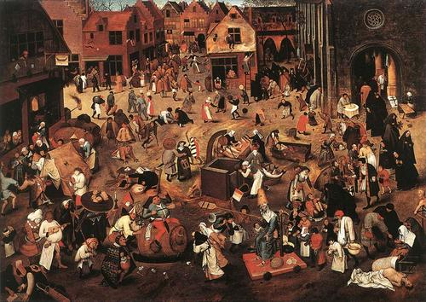
Image title: The Battle of Carnival and Lent, Pieter Bruegel, 1559

