Maynooth University Commercialisation Office | 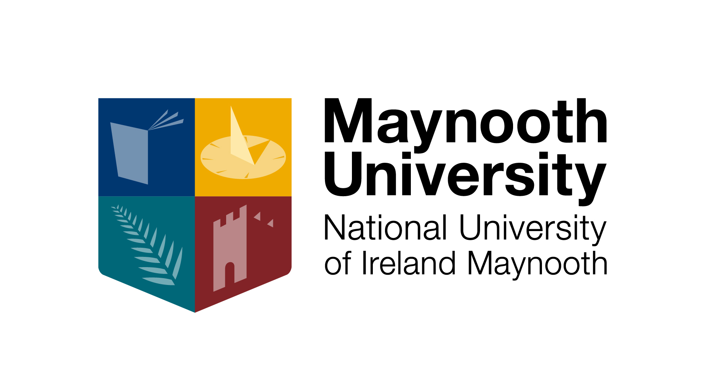

Innovation and Research Commercialisation - GSE2

Strongly Recommended for All Postgraduate students
offered in the first semester of academic year 2017/18

Credit Weighting: 5 ECTS credits

This 24-hour contact generic skills module will be offered in the form of seminars/workshops run over 4 days and includes 86 non contact hours. There is a comprehensive reading list/links provided.
For the 2017-2018 AY the module will run from 10am-5pm on the following dates:
Date: Wednesday, November 1st through Friday, November 3rd 2017 (3 days)
Wednesday, December 6th (1 day)
Venue: Staff Development Training Room, John Hume Building, 3rd Floor, North Campus

www.maynoothuniversity.ie/commercialisation

Registration for this module should be completed at annual registration. Late applications can be accepted depending on availability of places. Attendance on all four days of GSE2 is compulsory.

Module Objective
To equip researchers with the skills required to commercialise the outcome of their research, to provide them with know how to interact with industry and to improve their ability to innovate and act with an entrepreneurial mindset. A team project is an integral part of this module and must be completed.

Section 1 – Introduction to Commercialisation of Research and Hi-Tech Enterprise Development
- To cover: national strategy, hi-tech ecosystems, IP market place, University role, Irish funding agencies, commercialisation office.
- 1 hour direct contact.

Section 2 – Intellectual Property
- To cover: patents, copyright, trade secrets, etc.
- 2 hours direct contact
- 2 assignments (4 hours indirect)
- The following reading list is supplied (5 hours indirect)
  - The Role of the Inventor in the Technology Transfer Process
  - Introduction to IP Issues in the University Setting: A Primer for Scientists
  - How to Start and Keep a Lab Notebook: Policy and Practical Guidelines
  - How to Read a Biotech Patent
    - Assessment (1 hour direct).

Section 3 – Legal Contracts
- To cover: research contracts, licensing contracts, MTA’s and NDA’s, dissection of a legal contract
- 1 hour direct contact
- The following reading list is supplied (4 hours indirect)
- General Legal Overview
  - Workshop (1 hour direct).

Section 4 – Hi-tech spin-offs
- To cover: how to start a company, how to raise money, case study
- 4 hours direct contact
- The following reading list is supplied (4 hours indirect)
- Developing Winning Business Plans
- Approaching, Presenting and Selecting Investors
- Structuring the Funding Transaction
- How to Start a Start-up
  - Workshop (2 hours direct).

Section 5 – Technical Marketing, Product Development
- To cover: market analysis, market drivers, proof of concept / proof of market, product development, channels to market
- 2 hours direct contact
- 1 group assignment / assessment (5 hours indirect)
- The following reading list is supplied (4 hours indirect)
- Achieving Proof of Concept
- An Introduction to Marketing Early Stage Technologies
- Technology Marketing
- Workshop (2 hours direct).

Section 6 – Interacting with Industry
- To cover: anatomy of an industrial organisation, industry needs and drivers, basics of presentation and negotiation
- 1 hour direct contact.

Section 7 - Business Exercise
- Form teams of 4 or 5 students and write a maximum 5 page business plan and a presentation for a new product / company to include: market need, market opportunity, technology, team, go to market plan, sales and revenue plan. This team project must be successfully completed for course credits.
- 6 hours direct
- 60 hours indirect.

Profile of Trainers:
This module is delivered by the Commercialisation Office. The trainers’ biographies follow:

John Scanlan, Director, Commercialisation Office
PhD Plasma Physics, 15 years in industry, former CTO Straatum (sold to Lam Research)
9 granted patents, 5 academic publications, 6 trade journal publications.

Paul Tyndall, Commercialisation Executive
PhD DNA Technology, 15 years industry experience (including roles at Zeneca/Avecia and as Technical Director with start-up company BioBode).

Peter Conlon, Commercialisation Executive
BEng Electronic Systems, CEng Professional Chartered Engineer
20 years industry experience including product development and management roles with Agilent Technologies and MV Technology - a successful Irish start-up company.

Karen Griffin, Commercialisation Executive
PhD in Physiology, Masters in Management (MIM), previous role as Grant Research Manager and Business Development Manager at Centre of BioNano Interactions, UCD.

Owen Laverty, MaynoothWorks Incubation Centre Manager
MSc Bio Eng, 15 years as a product designer (including Philips and own startup venture).

