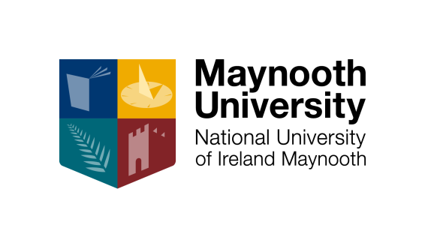

Centre for Teaching and Learning and Access Office

Teaching Fellowships 2015-2016

Call for Applications

Introduction

As part of Maynooth University’s ongoing commitment to developing teaching and enhancing the student learning experience, the Centre for Teaching & Learning is supporting up to six Teaching Fellowships in 2015-2016.

Each Fellowship can attract funding of up to €5,000. One fellowship will be funded by the Access Office for projects which specifically address diversity and inclusive approaches to learning and teaching. The fellowships overall are intended to support the recipients’ professional development and the dissemination of their learning within the University.

Fellowships must be completed within the calendar year 2016 and recipients are required to produce an interim and final report on their projects including details of the impact of the award professionally and on the institution.

The aims of these Fellowships are:

- to recognise and acknowledge individuals or groups who make an outstanding contribution to the student learning experience
- to raise the profile of innovative practices in learning and teaching that have contributed to the student learning experience in Maynooth University
- to disseminate such practices across the university.

We encourage applicants to design fellowship proposals that will address the following:

- the development of strategies that support learning and teaching and that influence, motivate and inspire students to learn
- the development of curricula, resources and learning supports that reflect a command of the field and foster independent learning
- approaches to learning and teaching that put the student at the centre of the learning experience.

CTL Teaching and Learning Fellowship Call

The theme for 2016 Teaching and Learning Fellowships is Enhancing Assessment and Feedback in the Undergraduate Curriculum. Assessment is core to the student learning experience and a key vehicle to supporting and improving student learning.

Five CTL Teaching & Learning Fellowships will be awarded (of up to €5,000 each) to individuals or team based project submissions which address one or more of the following areas:

- Assessment for Learning in the Undergraduate Curriculum
- Peer review and assessment
- E-Assessment: effective and innovative use of learning technologies to support and enhance assessment and feedback practice
- Technology supported feedback approaches in first year
- Innovative assessment to support student engagement with real world challenges and applications
- Assessment design to support the development of Maynooth University graduate attributes and skills
- Integrative and innovative approaches to assessment and feedback at programme levels

Applicants are encouraged to design projects which reflect the above areas and are relevant to the work of the department/discipline. This may involve researching and piloting a specific assessment /feedback approach. Alternatively, it may incorporate developing and/or implementing an assessment resource(s) and evaluating its effects. Proposals leading to outcomes which have the potential for application across a range of disciplines in the University are particularly welcomed.

The Access Office Fellowship Call

Maynooth University is widely recognised as a national leader in both encouraging and attracting mature students, students from disadvantaged socio-economic backgrounds and students with disabilities. At Maynooth University over 27% of the full time undergraduate student population are supported by the Maynooth Access Programme. Further information is available at http://access.nuim.ie. The Access Office Fellowship should address this year’s theme but should specifically address the issues of diversity and inclusiveness.

Eligibility and requirements

- Any Maynooth University staff member who is teaching in the University may make an application.
- The funding is limited to a maximum of €5,000 per project.
- Approved projects must be completed by 16th December 2016.
- The staff member leading the project will be required to present on the project implementation and findings at a CTL event in the summer of 2016 and to submit a report on the project by 1st February 2017.

Award process

Applications will be assessed by a panel consisting of members of the CTL, the Access Office and the Faculty Teaching and Learning Committees. All applications will be assessed with reference to the following criteria:

- reflective of the Fellowship themes
- innovative nature of project
- clarity and viability of project plan
- costing of plan – evidence of an appreciation of value and return on investment
- potential for sustainable implementation/dissemination of project and impact across the University as a whole, with respect to students, the department and the University.

Notes for applicants

- All projects should be endorsed by the Head of Department/Centre and applications signed by this person.
- Projects may be collaborative or inter-disciplinary in nature.
- Project research or evaluation methods may require approval by the University Ethics Committee.

How to apply

Should you wish to apply for a Fellowship, please download and complete an application form from the CTL website, http://ctl.nuim.ie/.

The deadline for completed applications is 6th November 2015.

A hard copy of the completed application form should be sent to:

Dr Úna Crowley
Director
Centre for Teaching and Learning
Education House
Maynooth University

In addition, all applications should be emailed to: ctl@nuim.ie

Applicants will be informed of the outcome of their submission by 13th November 2015 with formal launch of the Fellowships to follow on 25th November 2015.

If you have any queries regarding eligibility of projects for this scheme please contact the Centre for Teaching and Learning on ctl@nuim.ie or on ext. 6770.

