Dates: Thursday 22nd, Friday 23rd, Saturday 24th Feb 2018
Thursday 1st, Friday 2nd, Saturday 3rd March 2018
(One overnight in Northern Ireland as part of Module)

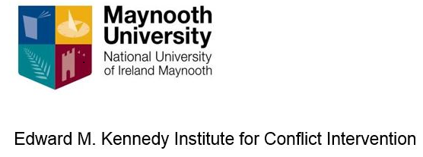

Conflict Resolution: Resolving Protracted Conflict

Module MC629 – EQF Level 9

This six-day module delivers the necessary knowledge and skills for students to work in the field of transformative peace making. This module addresses through in class presentation, discussion and film analysis, the knowledge and skill base of dialogue processes, principles of multi-track diplomacy, conflict resolution at track two level, official and unofficial approaches at track one level, political dialogue workshops, calling a truce and agreement.

The module teaches transformational interventions that promote methods to reduce and ultimately eliminate violence; interventions that foster structures that maximise participation of people in decisions that affect them. Students are taught process knowledge and conflict intervention skills for practice as a peacemaker drawing from the work of scholar practitioners in the field such as Lederach and others.

The programme is comprised of seminars as well as presentations and conversations with guest lecturers. Students develop a plan for a practical project in peace making. A visit to Northern Ireland enables students to hear directly the lessons of the Northern Ireland Peace Process.

Venue: Kennedy Institute, Maynooth University, Ireland with field trip to Northern Ireland
Fee: €1500 which covers course materials, online learning and EQF administration.

HOW TO BOOK:
For more details please phone Dr Roisin Smith: +353 (0) 1 474 7752 or email: roisin.smith@mu.ie Log on to https://www.maynoothuniversity.ie/edward-m-kennedy-institute Limited places available - Closing date 12th February 2018

