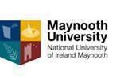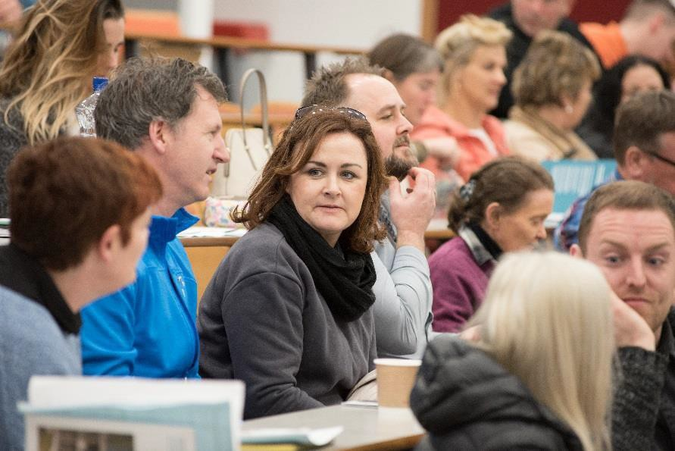
NUI CERTIFICATE IN ADDICTION STUDIES

Level 7 (20 ECTS)

The aim of this course is to provide participants with a broad overview of key theoretical frameworks in relation to substance misuse and dependence, and to enable them to develop basic helping and intervention skills. This course focuses on introducing participants to current debates on addiction. On completion, participants will have become familiar with contemporary addiction theory as well as prevention and treatment strategies. They will have explored associated issues such as public policy, factual information on substance misuse, gender issues and community drug prevention issues among others. The course will provide participants with adequate knowledge and skills to respond effectively and positively to addiction-related issues as they arise at work or in the community.

WHO IS THIS QUALIFICATION FOR?
This course is aimed at people already working or seeking to work in the area of drug and alcohol services or related areas:
- Community and Youth workers, Gardaí, Teachers,
- Social and Health Care workers including doctors and nurses, care centre managers,
- Counsellors and psychotherapists. Policy makers.
- Project or outreach workers in various services that deal with people experiencing problems with Drugs and Alcohol or homelessness.

OVERVIEW
Duration of the course is 100 hours, part-time one evening per week plus 3 or 4 Saturdays
throughout the year.

COVID 19 CHANGES:__________________________________________________
Given the current situation with the Covid 19 Pandemic we hope to be able to run the courses as closely as possible to the way we have always run them. This being the case we are looking at the university guidelines for face to face classrooms and this means having small classes in large class rooms in order for us to observe physical distancing rules. However, we will need to be flexible in our approach and therefore we are also preparing for Blended delivery of courses. This will mean that depending on the advice from the government regarding tightening or loosening the control measures of lockdown we might have to switch to Teams, Video or Moodle classes at short notice. As a consequence people who are thinking of applying for our certificate courses for 2022-2023 will need access to a PC or Laptop to take part in distance learning. We will do our utmost to give you the best learning experience that circumstances allow and hope to be able to continue with our preferred face to face classroom based teaching for as long as possible and it is safe to do so.

DATES, VENUES AND FEES
This course will commence:

Bluebell/Inchcore Dublin Commences Wednesday 5th October 6 6.00-9.00pm
Maynooth University Campus Commences Tuesday 4th October 7.00-10.00pm
A Fee Easy Payment Plan is available once you register.
Part time students who are on courses at levels 6 to 10 on the framework of qualifications may be eligible to for the Student Assistance Fund (SAF) to help with the associated costs of attending a university course such as Travel, Childcare, Utilities, Materials etc. You should first consult: SAF Guidelines to see if you qualify and then e-mail student.budget@mu.ie to make further enquiries.

CPD & PROGRESSION
The NUI Certificate in Addiction Studies is a standalone qualification however it also the first part of the Diploma in Addiction Studies (Level 8). Credits from both the Certificate and the Diploma in Addiction Studies can be used for Recognition of Prior Learning to go towards the Degree in Community Studies.
The Cert. in Addiction studies when combined with the NUI Certificate in Training and Continuing Education (Train the Trainer Level 7) plus the Certificate in Equality Studies (On Line) forms part of the Diploma in Arts: Training and Development for Socially Inclusive Workplaces. This suite of CPD courses provide a comprehensive educational/training package in core skills such as managing issues of equality and diversity in the workplace for Team Leaders, Managers and Learning and Development Specialists.

CONTACT US
Apply HERE: To find out more about this and our other courses please contact Kay Loughlin 01 708 6062 or e-mail kay.loughlin@mu.ie . You can also visit our website: https://www.maynoothuniversity.ie/adult-and-community-education/our-courses

