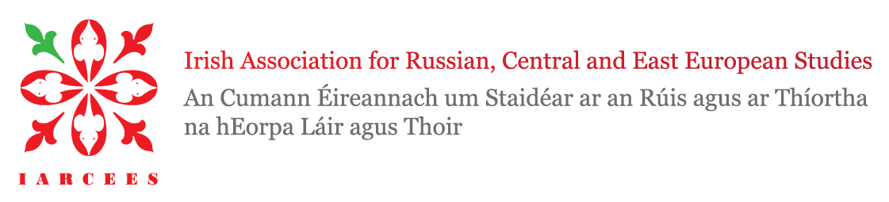
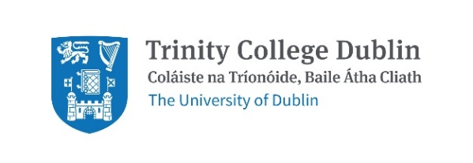

3rd IARCEES Workshop
Hosted by Trinity College Dublin
26 February 2021
Call for Papers
Following the success of the two previous workshops, the IARCEES (iarcees.org) invites early-career researchers based at third-level institutions on the island of Ireland and abroad to present their work on Russia (and its former republics), Central, Eastern and Southeastern Europe. This one-day event focuses on early career researchers based in (or visiting) Ireland. The workshop’s objective is twofold: to disseminate knowledge about the region from multiple disciplines and to continue to forge the network of emerging scholars on the island.
This year’s workshop theme is “(Re)Constructing Identities in Russia, Central, Eastern and Southeastern Europe.” We ask you how identities in Russia and East-Central Europe are imagined and subsequently performed. What informs these identities, what challenges them. With this in mind, this conference aims at discussing the key theoretical approaches and concepts that help us understand Russian and ECE identities throughout history. There are many iterations of identity and more emerging and shifting as a result of the pandemic.
We welcome individual abstracts and panels of three to four abstracts from different disciplines and fields addressing identity and (but not limited to): activism, arts, borders (geographic and symbolic), cultural studies, democracy, disaster (and response), diaspora, economy, history, migration, pandemic, polarisation, politics, popular culture, populism, and transnationalism.
The keynote speaker will be Dr Jac Hayden, Director of European Studies, Trinity College Dublin. Special guests Dr Balázs Apor (Trinity College Dublin) and Dr John Paul Newman (NUI) will showcase their edited volume Balkan Legacies: The Long Shadow of Conflict and Ideological Experiment in Southeastern Europe at the workshop.
We invite interested candidates, especially early career researchers from third-level institutions on the island of Ireland and abroad to send an abstract (max. 300 words) and an author bio (max. 100 words) by 1 December 2020 to bencekos@tcd.ie. Successful applicants will be notified by 15 December 2020 and will be asked to prepare a 15-minute presentation on their abstract topic.
The workshop will be hosted on 26 February 2021. Organisers will confirm closer to the date whether the event will take place in person at the Trinity Long Room Hub, virtually, or follow a hybrid model. We will endeavour to accommodate participant preferences. The organisers are fully committed to the safety of the participants and will adhere strictly to government guidance regarding Covid-19 measures.

For further information please contact workshop organisers:
Rebecca Carr, MPhil, carrreb@tcd.ie
Sara Bencekovic, MSc, bencekos@tcd.ie

