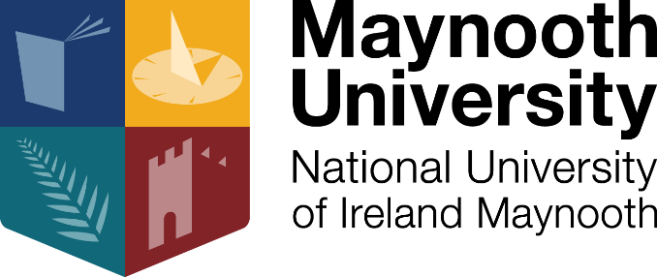

School of Business
Industry Speaker Series 2017-2018
‘Building Your Career Successfully’

Date: Wednesday, 7 February 2018
Time: 12.00pm
Venue: RHE01, School of Business Building (North Campus)

About the Event
We are delighted to announce the launch of the School of Business’ new Industry Speaker Series, which will be kicking off with an exciting panel discussion on Building Your Career Successfully. The event will feature industry experts from companies such as LinkedIn, Jameson and Clark Recruitment, who will be offering their tips and advice on

- Getting the most out of your LinkedIn profile to build your career
- Applying to graduate programmes
- Building a standout CV

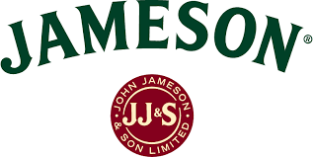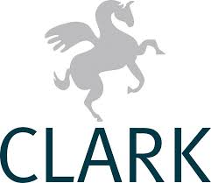

Get ahead of the competition and secure your place now at what promises to be a very informative career event!

To RSVP, please email business@mu.ie

