 | Personal Emergency Evacuation Plan  The purpose of this plan is to outline the options available to the Student concerned in responding to a fire alarm activation in their place of study.

Name: TBC
Contact Number: TBC
Faculty: TBC
Position: TBC
Designated assistance if applicable:
Locations: Bioscience and Electronic Engineering laboratories and Class halls

Date:

Student Details: TBC

Bioscience Building
Overview
The Bioscience Building was built in 2002 it is one of the main teaching and research buildings on the Maynooth University Campus with a significant number of laboratories and tutorial rooms located on the ground, first and second floors. There are lifts in the buildings that can transport personnel to all floors.

Emergency Evacuation Procedures
- If located on the ground floor exit the building via the nearest emergency exit see attached floor plan.
- If located on the 1st or 2nd floors classrooms you should make your way to the refuge area at one of the escape stairs – see attached floor plan.
- If you cannot safely exit the building you should contact the Maynooth University 24HR Emergency Line on 01 708 3929 to inform Security of your location.

Fire Marshals
Should check the stairwells as they exit to see if anyone is present at the building refuge areas during the evacuation. Fire Marshals should not put themselves in any danger in trying to establish anyone’s location. Location details of anyone in a refuge point should be provided to Security personnel responding to the alarm activation.

Security
- To liaise with building fire marshals to identify if any personnel are in refuge area(s).
- To provide the emergency services with students likely location in the event of a genuine fire.

Building Fire Alarm / Safety Details
The open areas and the exit routes from the building are fitted with automatic fire detection. It is unlikely that a fire will develop within the building to such an extent that you will be unable to exit the building or access a refuge area. However it is vital that you initiate your response to any alarm activation immediately.

Fire assembly Points: B – at the front entrance of Bioscience Building

Maps and Plans
See attachment

General
It is possible that the student will be in a different location than those mentioned above when an alarm activation takes place. Indeed they may be in a different building. In general the advice to students is that if they cannot safely exit a building in the event of a fire alarm activation they should seek refuge in a suitable area such as a designated refuge area, an area between two sets of fire doors or in an area close to a window with fire doors close by – and contact Security (01 708 3929) to report their location. Students should make them-self familiar with the layouts of the building areas that they regularly frequent. If required this document can be expanded to take account of additional locations and building by contacting access.office@mu.ie

Building Layout Maps
Bioscience Building Ground and First Floor
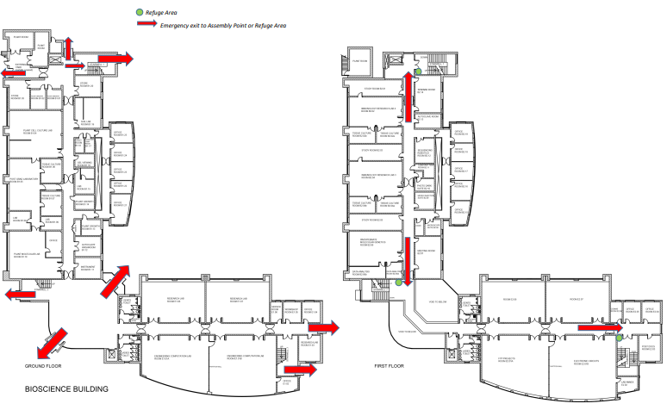
Bioscience Building Second Floor and Roof

