

**Core Expenses – Staff Manual**

**Approver 1 Manual**

**Table of Contents**

|  |  |
| --- | --- |
| **Details** | **Page Number** |
| Login | 2 |
| Forwarding to “Approver 2” | 2-5 |
| Car Approval | 6 |

**Login**

Navigate to the **Core Portal Login page** by copying below to your browser:

<https://www.maynoothuniversity.ie/ess>

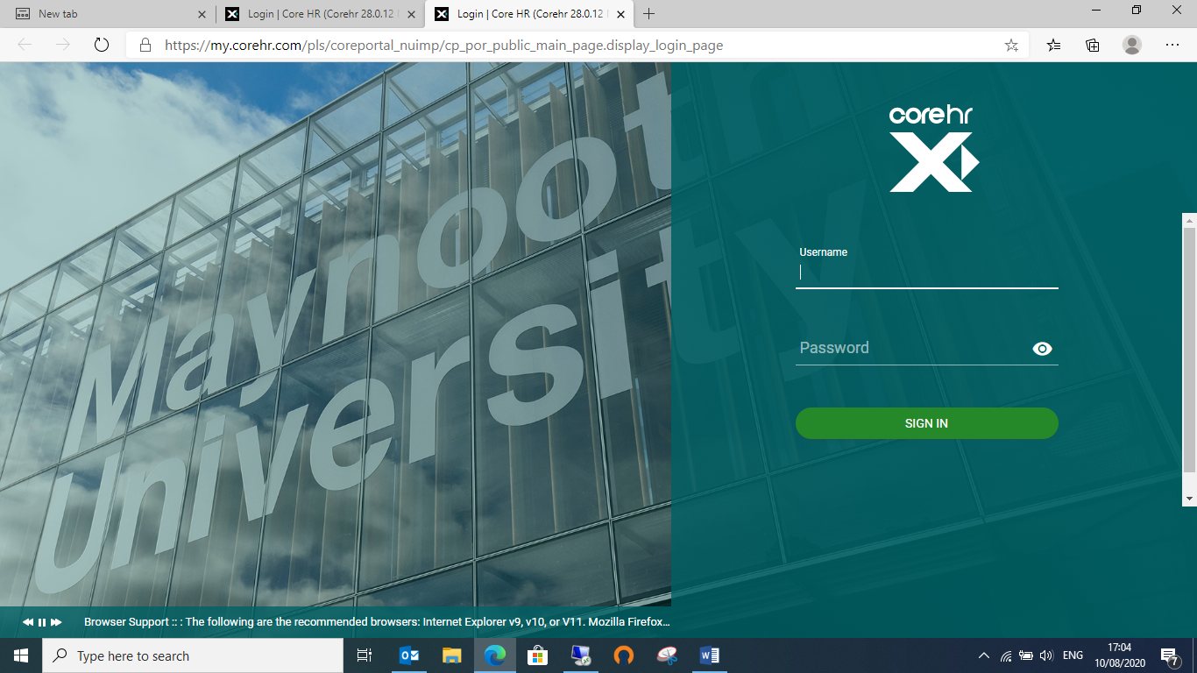To login, enter your **system** username and password in the corresponding fields and press enter on your keyboard or click on **Sign in**

Click on “Manager Dashboard” – top of screen on left

The following will appear for approval

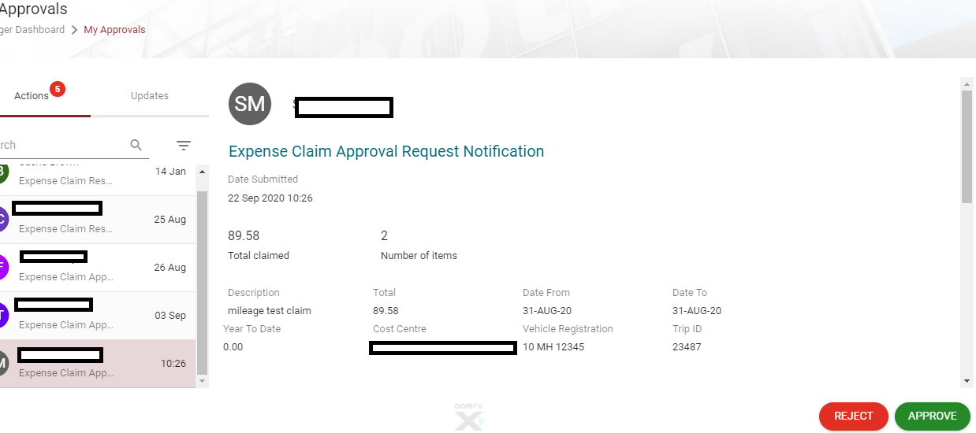

You can view each expense item individually to by clicking on the 3 dots

Here you can;

* View details
* View receipts
* Add approver notes

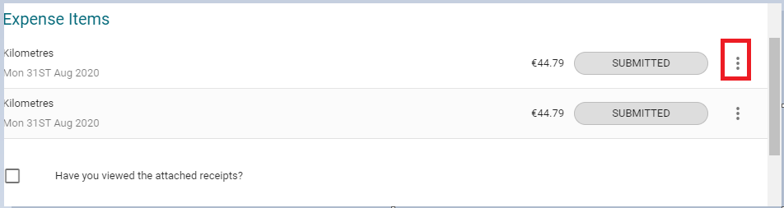

Once you are happy with the details you forward the claim to the appropriate approver 2.

**Forwarding an expense claim to the HOD for “approver 2”**

To forward the claim for “approvers 2” authorisation- scroll down until you see ‘have you viewed the receipts’

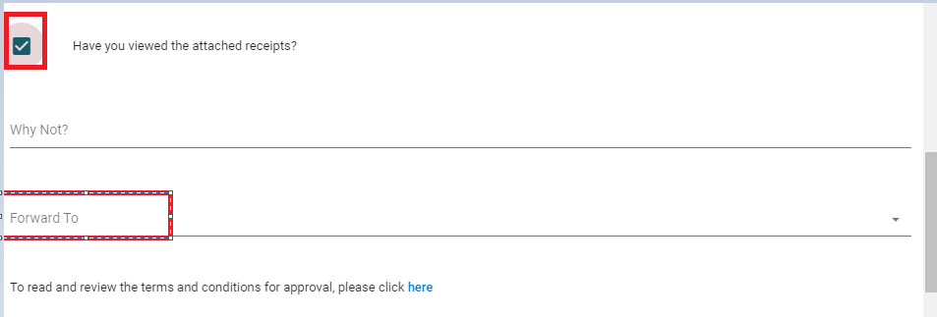

Tick – Have you viewed the attached receipts?

Forward to: Enter the name of the 2nd approver

Tick – I confirm the above details are correct

Click on the forward to “select forward approver” type the name of your approver here and there name will appear in the drop down list.

\***DO NOT CLICK APPROVE\***

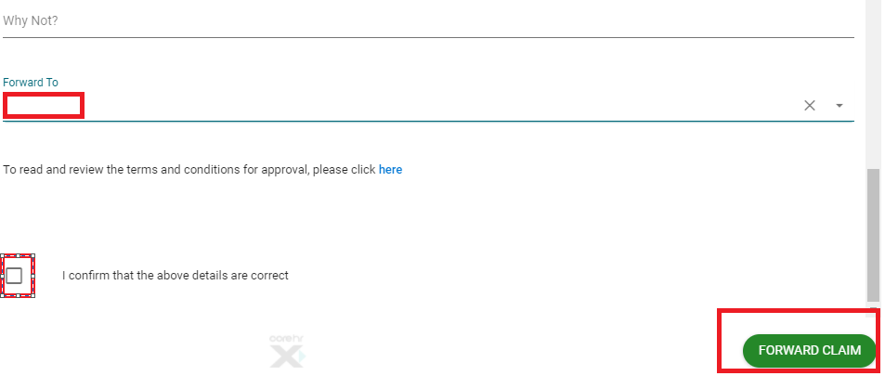

**FOR CAR APPROVAL PLEASE FOLLOW BELOW**

Click on “Manager Dashboard” – top of screen on left

The following will appear for approval

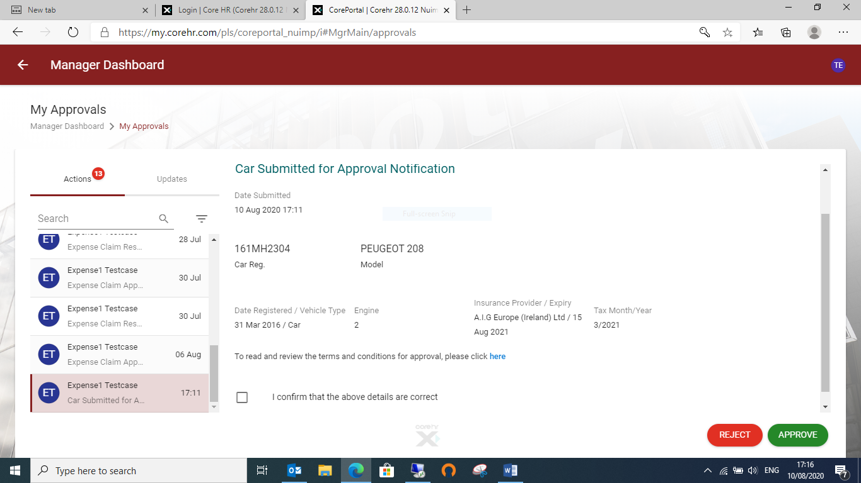

**Check the details –**

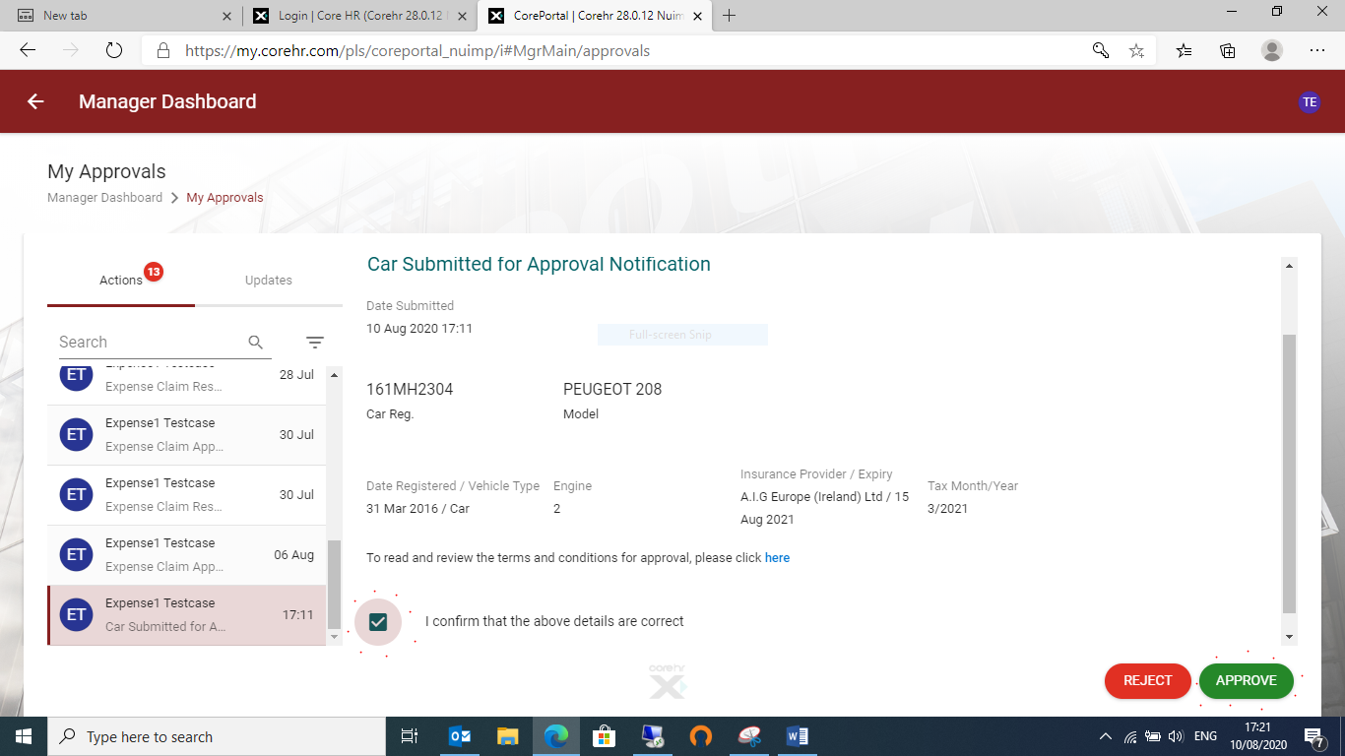

Please note insurance expiry date, insurance provider are mandatory fields.

Click the “I confirm that the above details are correct” tick box and press approve.

The car approval notification will no longer be visible in the approvals section.