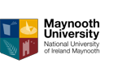

Maynooth University Master’s Scholarships Guide for Applicants

Important information for applicants

The purpose of this guide is to provide applicants with practical information in preparing and submitting an application for the Maynooth University Master’s Scholarships of €2,000.

Applicants are required to read carefully the terms and conditions of the scholarships and this guide before completing their application.

All applicants are required to apply for their chosen Master’s courses on www.pac.ie before submitting their completed application.

Eligibility criteria for the scholarship are outlined in the terms and conditions documents.

Applications that are incomplete or not submitted (i.e. remain as drafts) in the online system after the application deadline will be deemed ineligible.

Where text in the application form exceeds the specified limit, only the text within the limit will be considered.

Important dates

Deadline for applications | 17:00 (GMT), 30th June 2019
Outcome of the competition: | July/August 2019

Applicants are strongly encouraged to submit applications well in advance of the deadline. Late applications cannot be accepted.

How to apply

Applications are online via an online application system accessible from the following link:

https://app.hobsons.co.uk/AYApplicantLogin/fl_ApplicantConnectLogin.asp?id=nuim

Applicants do not have to complete and submit their application in one sitting; they can save the information in the online system and return to their application repeatedly. Please note that once an application is submitted, it is not possible to make any changes.

The application form consists of a number of fields. Many fields are mandatory and if left empty, the system will provide an error message as applicants save their work and progress to another section/check the application before submitting. Some fields are not specified as mandatory in the online system; however applicants still have to ensure that they provide information in fields relevant to their scholarship funding proposal.

Some fields require text to be entered into a box and some fields require documents to be uploaded into the system.

Where text is to be entered directly into a box, applicants can prepare their text outside of the online application system and simply cut and paste it into the online system once they are happy with it. Please note that the online system does not support any formatting such as bold, underlined or italics.

Where applicants are required to upload a document, they can upload a file in one of the formats supported by the online system: .pdf (preferred file format), .docx,
.doc, .rtf, .wpd, .txt, .xlsx, .xls, .jpg, .pict, .gif, .bmp, .tif or .png. The file name must include the appropriate three- or four-letter extension. Important: do not attempt to upload a document that is password protected or contains macros or some other active content; such files cannot be uploaded and the upload process will fail. It is recommended that applicants save their documents as .pdf, selecting “smallest file size” option when they create the .pdf file.

Content of the application
Table below provides applicants with information about the type of information required. Note that the table does not represent an exhaustive list of fields that will be available to applicants in the online system.

Information type | Comments
Application details | Please select the option ‘Taught Masters Scholarship’ from the drop down menu.
PAC no. | Please insert your Postgraduate Application Centre (PAC) number that you have received from www.pac.ie after submitting your master’s course(s) application online.
About You - Applicant’s personal details | Mandatory information. Please note that date of birth is required to ensure that duplicate records can be identified in the online system.
Applicant’s contact details | A number of fields are mandatory.
Applicant’s academic history | Details of academic qualifications, including results. Information about the applicant’s final undergraduate

 | honours level 8 degree or equivalent must be provided. Applicants are required to upload official transcripts for academic qualifications into the online application system. Applicants may enter a number of qualifications into the system but only level 8 honours Bachelor’s degrees or equivalent are considered.
Selecting your Department | Applicants may select up to three Departments from the drop down menu. Applicants may be considered for scholarships in Masters programmes in up to three Departments.
Taught Master’s Scholarship | This section provides the opportunity for applicants to declare if they have been in receipt of a higher education authority student grant/SUSI grant. Please see terms and conditions for further details. If an applicant has not been in receipt of a student grant for the final year of their undergraduate honours degree, this will not affect the assessment of their application. Applicants must also declare their acceptance of the scheme’s terms and conditions in this section.
Taught Master’s Access Scholarship | All applicants must indicate whether they wish to be considered for the taught master’s scholarship allocated under the Maynooth Access Programme. Please note this section is only relevant to the Taught Master’s Scholarship of €2,000 applications and to students currently registered with the Maynooth University Access Office. It is not considered for Alumni Scholarship applications. If this section is not completed it is assumed that the applicant does not wish to be considered.
Recommendations | Recommendations are not required for Taught Master’s Scholarship applications. References provided will not be considered.
Downloadable Forms | Downloadable forms are not required for Taught Master’s Scholarship applications. They are only relevant to Alumni Scholarship applications. If you are a graduate of Maynooth University and you are uploading an Alumni Scholarship personal statement form, please refer to the Alumni Scholarship guidance.
Check your application | This section will help you to identify incomplete sections of the application before you submit your application.

Applying “step by step”

Creating account
The first step is to register in the online system and create an account, including user name and password – see a screen snapshot below. To create your account, select the “Create Account” tab. Note instructions regarding password characteristics provided on the bottom of the screen.
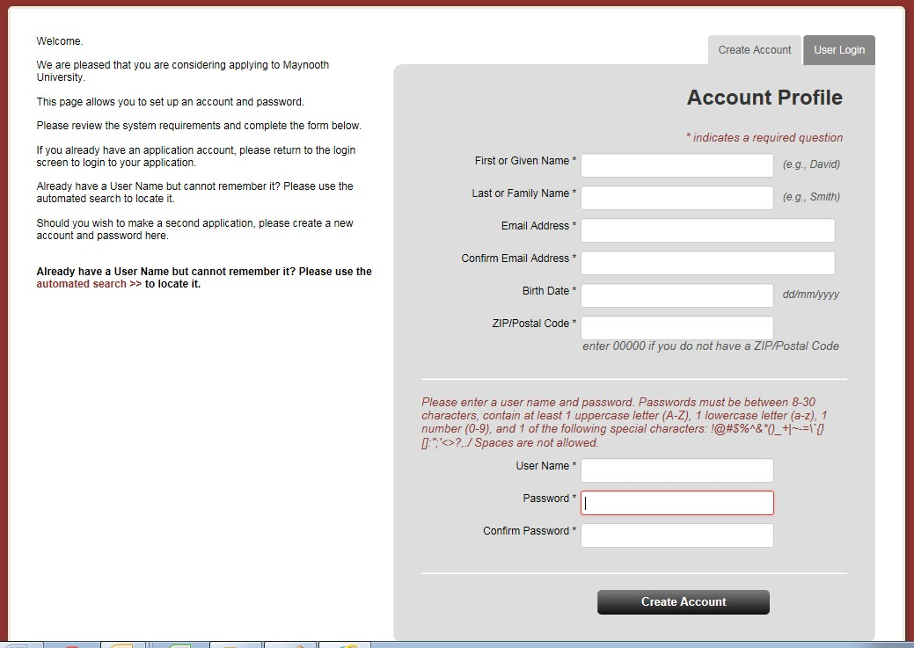

The online system will also send you an email confirming your account details.

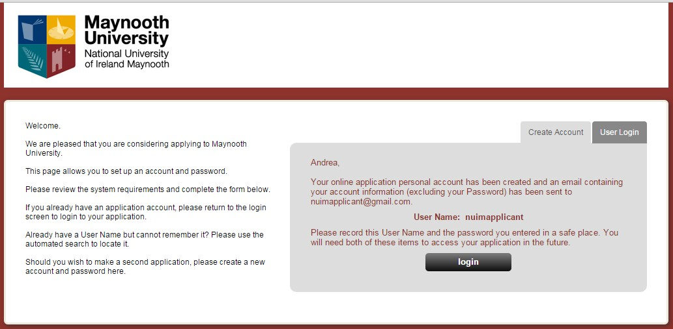

Before you can log into the system for the first time after creating your account, you need to confirm your acceptance of terms and conditions for use of the online system.

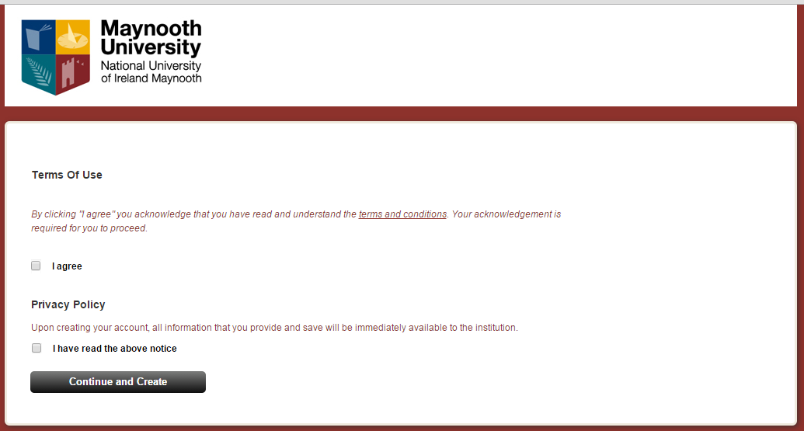

When you need to return to the online system to continue working on your application, you will select the “User Login” tab as highlighted on the screen snapshot below.

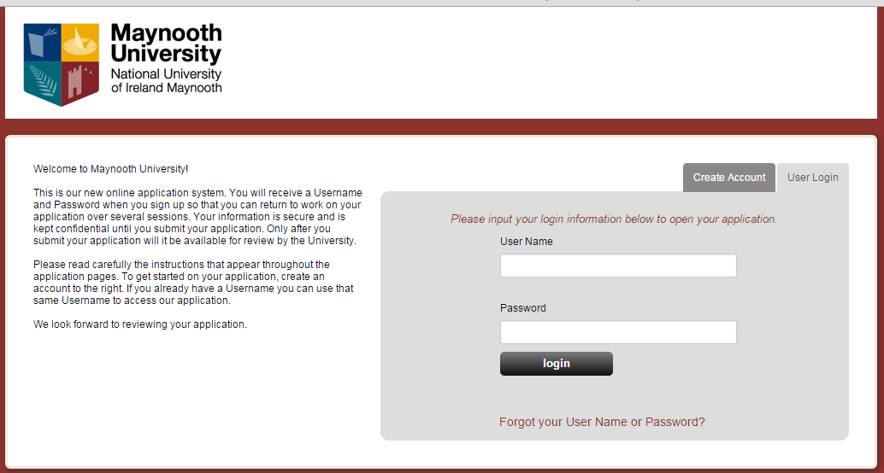

Note: If you forget/misplace your user name or password, click on “Forgot your User Name or Password?” at the bottom of the login screen and follow instructions provided by the system.

Starting application

The University uses the online application system to accept and process not only scholarship applications but also applications for certain type of courses. Applicant’s home screen therefore includes two main areas. “Application for Admission” and “Scholarship Application”. To start your scholarship application, click on the “Start Application” button in the “Scholarship Application” area. See screen snapshot below.

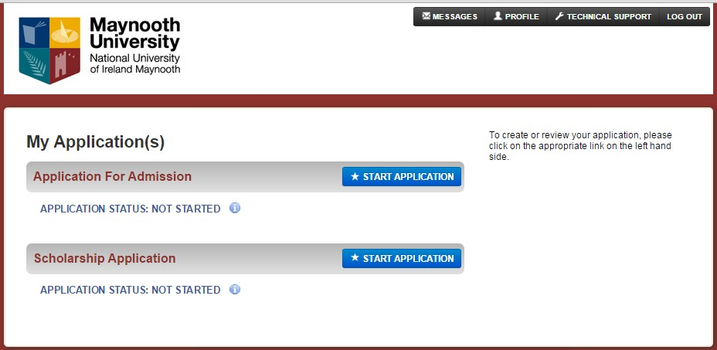

After you click on the relevant “Start application” button, the following screen will be displayed:

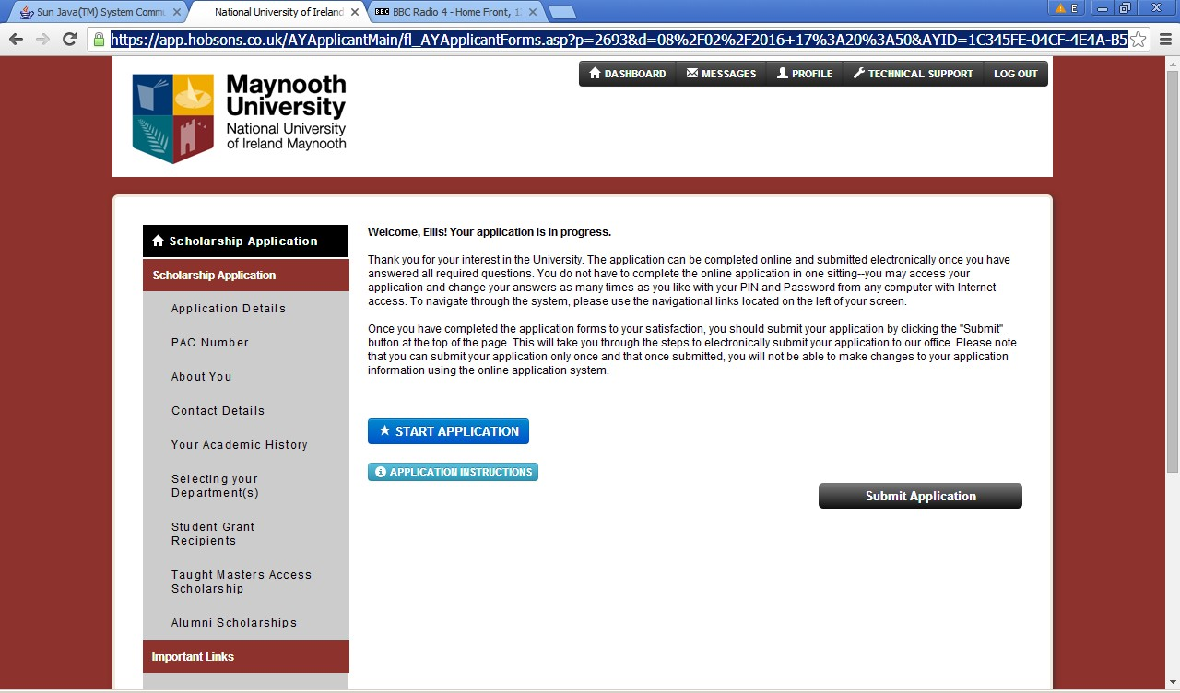

After you click on the “Start Application” button again, you will progress into the first section of the application.

“Application details” section
The online system can be used to accept applications for different scholarships depending on schemes currently available at the University. Please ensure that you select “Taught Master’s Scholarship” to indicate which scholarship you wish to apply for. If you select a different scholarship type, your application will NOT be considered as application for a Taught Master’s Scholarship or Alumni Scholarship, even if you submit details relevant for the scholarship competition.

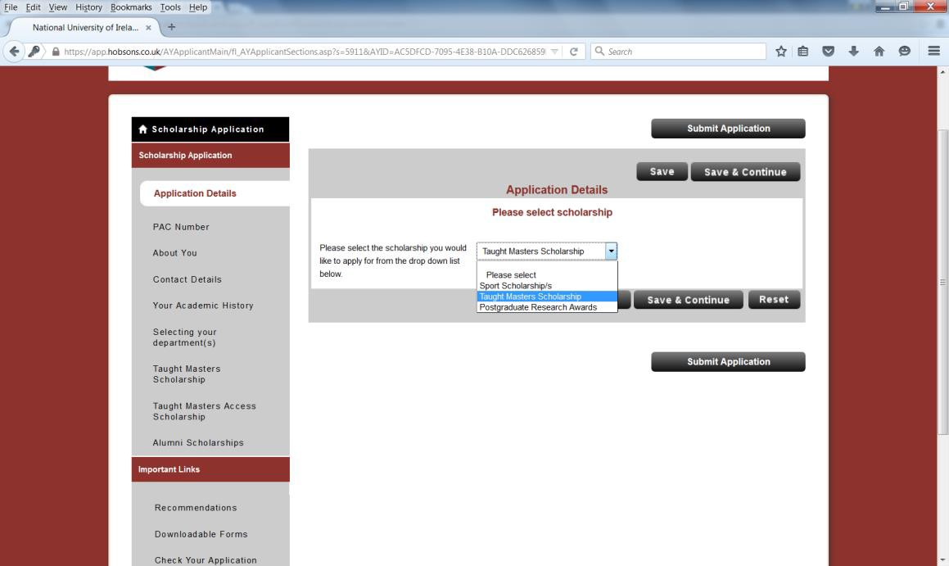

To save your scholarship selection and continue to the next section of your application, click on the “Save & Continue” button.

You can alternatively click on the “Save” button and select a section that you wish to populate from the list of sections available on the left hand side of the screen. Note that the list of sections changes dynamically depending on information saved in the system – you will notice that more sections will become available to you once you save your choice of scholarship.

iv) “PAC No.” section

All applicants must include a PAC application no. in this section. The PAC no. is provided after submitting an application for Maynooth postgraduate programmes via the www.pac.ie online course application process.

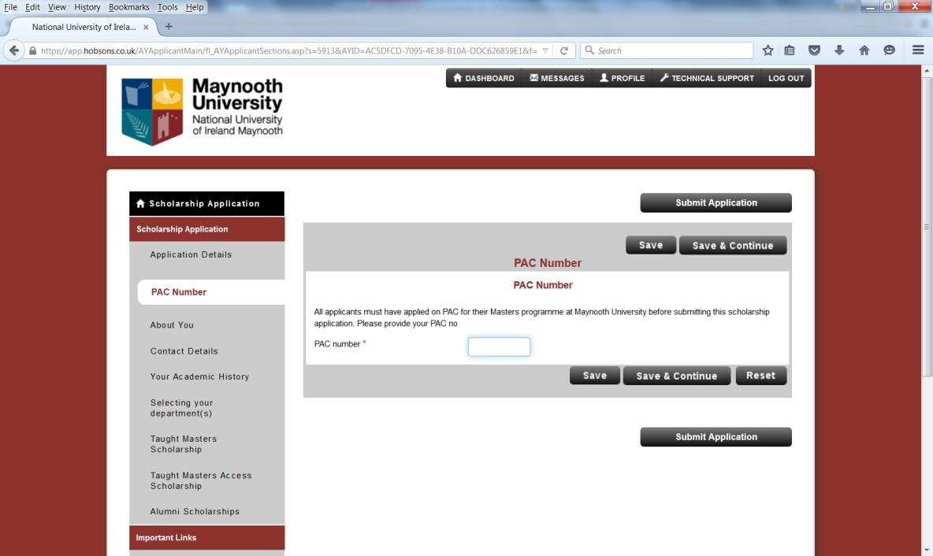

Insert PAC no.

“About you” section

Ensure that all fields marked with * are completed.
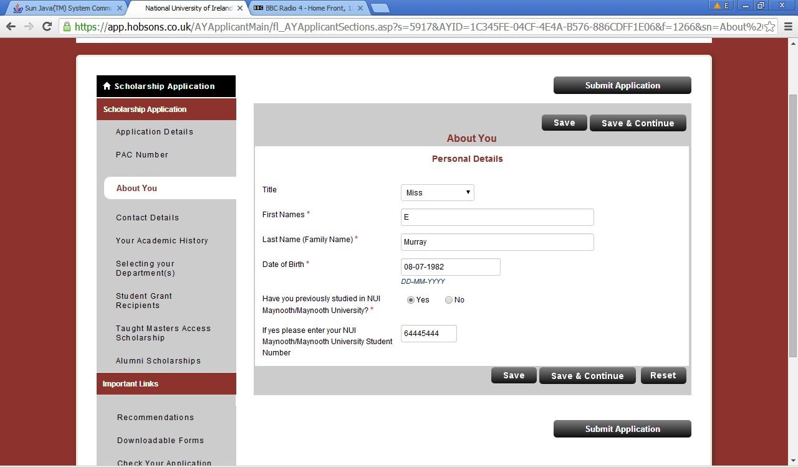

Important: if you do not save details entered before selecting another section from the list of sections on the left hand side of the screen, the data will be lost. Therefore you should always click on either “save” or “save & continue” if you wish to save the information entered.

“Contact details” section
Fields on the screen below are used to capture applicant’s contact details.

Note: “Home phone number” field is mandatory and cannot be left empty. If you are not in the position to provide a home phone number, enter an alternative phone number (work, mobile) instead.

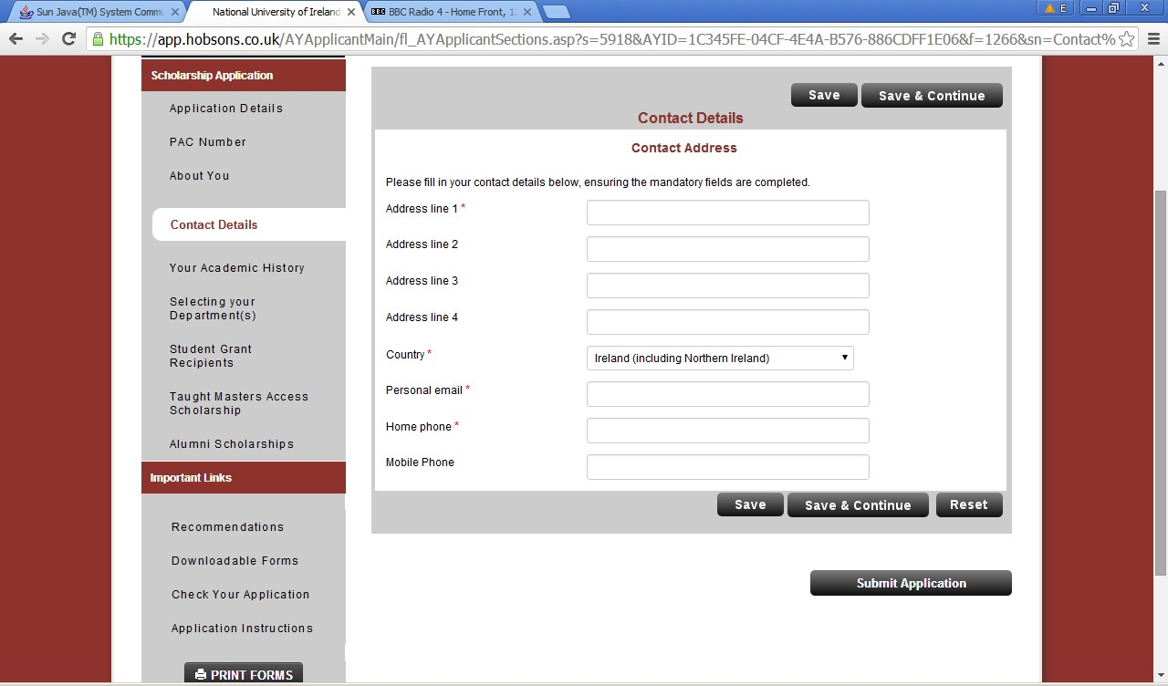

“Your Academic History” section
This section allows you to provide a summary of your academic history to date. Applicants are required to upload a scan of their official transcripts. In case of transcripts issued in languages other than English, applicants are required to upload an English translation together with the original transcript. Official translations are preferred where available; if providing an official translation at the time of application is not feasible, an unofficial translation can be uploaded into the online system instead. The University reserves the right to require official translations of transcripts at the time of scholarship offer, before awards are confirmed. Applicants may enter a number of qualifications into the system but only level 8 honours Bachelor’s degrees or equivalent are considered for Taught Master’s Scholarship applications.

Applicants should select the relevant qualification level) from a drop-down list. Qualification levels used are those specified within the Irish National framework of qualifications (NFQ). To find out more about the relevant levels in order to determine equivalency of non-Irish degrees, applicants are advised to consult the following sources: http://www.qqi.ie/Pages/National-Framework-of-Qualifications-
%28NFQ%29.aspx and http://www.qqi.ie/Pages/Active-NFQ-Standards-for-HE.aspx

Important: equivalencies of non-Irish qualifications as determined by applicants will be subject to confirmation by Maynooth University.

Highest qualification to date

Highest Qualification Awarded to date: Please specify your highest qualification awarded (i.e. fully completed) to date. Only honours level 8 degree or equivalent transcripts are required for Taught Masters Scholarship applications. If you have completed your undergraduate degree studies, please upload your honours level 8 Bachelor’s degree transcript or equivalent in this section. You can request a copy of your official transcript of your degree results (or equivalent) from your university.
Please note you will need to provide a translated copy if your transcript was not originally provided in English.

Current Studies: If you are currently studying/have not fully completed your most recent studies please select the relevant qualification level from the drop-down list. If this does not apply to you, select “Not Applicable”. If you have not yet completed your honours level 8 degree but will do so in 2019, you are required to provide details of your qualification ‘pending’. If the qualification has not yet been fully completed, please upload a copy of your penultimate summer results for the most recent year of your degree studies (or equivalent). You are then required to submit final degree transcripts by the 1st July 2019 to your www.pac.ie application form.

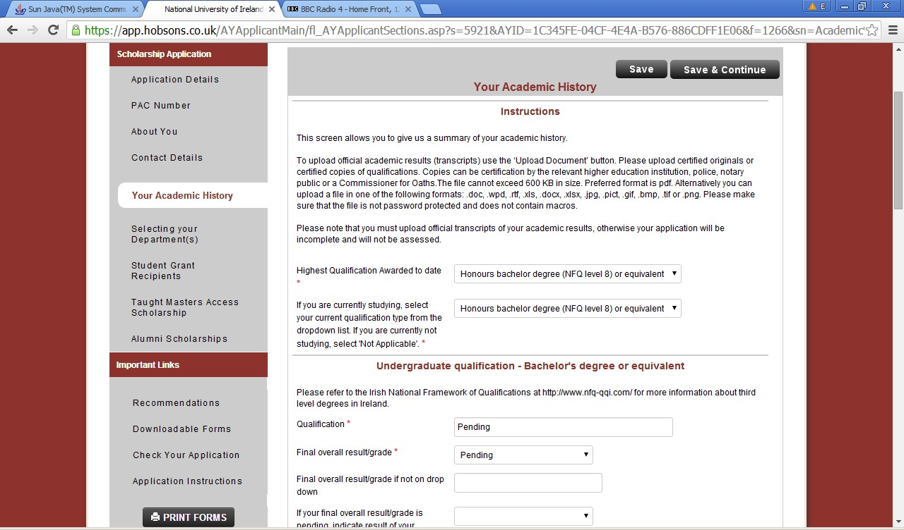

Note: information regarding supported formats and file size for documents to be uploaded. Once you upload your transcript, you can view the uploaded file by clicking on “View”. If you need to remove the uploaded file from the system, click on
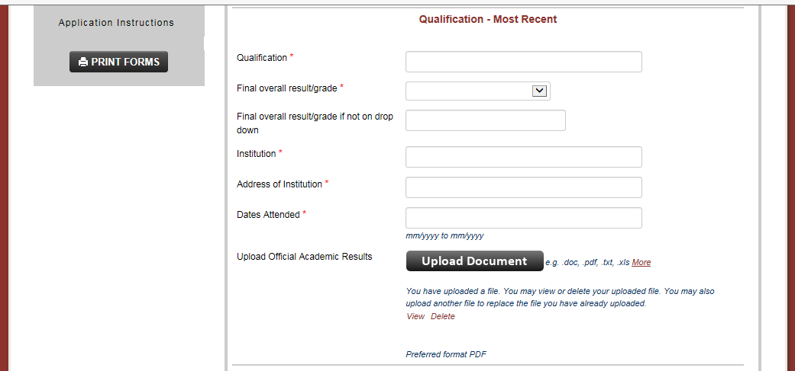

“D e le te ” . Both “View” and “Delete” are situated at the bottom of the section pertaining to the academic qualification as shown below.

“Selecting your Department(s)” section
Here you will use the drop down menus provided to indicate up to three Departments where you wish to study a Taught Master’s programme in 2019. You may choose 1, 2 or 3 Departments and these must correspond with the Departments running the Masters programmes selected in your www.pac.ie online course application. While it

is possible for an applicant to receive more than one offer of a scholarship, it is only possible to accept one scholarship award overall.

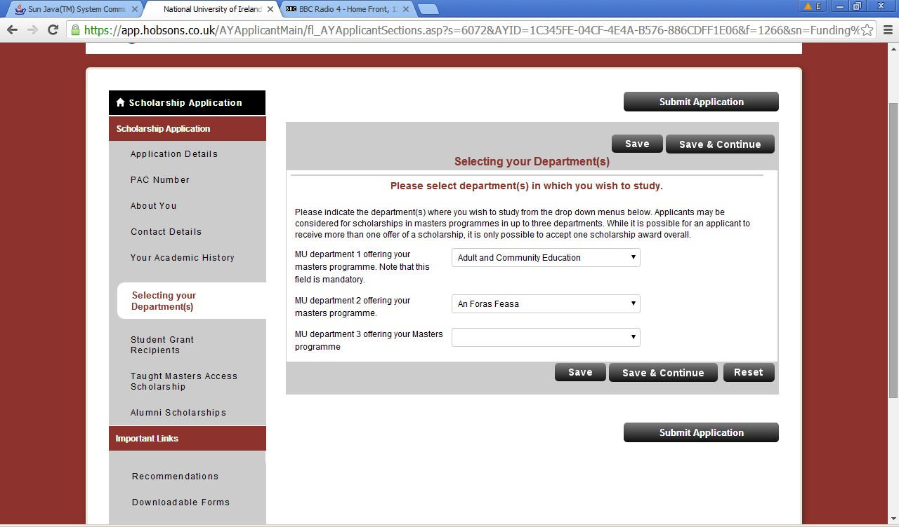

“Student Grant Recipients” section
Where a tie-break on academic results occurs at the top of the scholarship ranking, applicants who can provide evidence that they were in receipt of a student grant for their final year of degree study will be given preference for a scholarship. If an applicant has not been in receipt of a student grant for the final year of their undergraduate honours degree, this will not affect the assessment of their application other than in the event of two top-ranked applicants equal on academic results. Please ensure to upload evidence of an email or letter from the grant authority confirming your receipt of the grant following the onscreen instructions.
Applicants must also declare their acceptance of the scheme’s terms and conditions in this section.

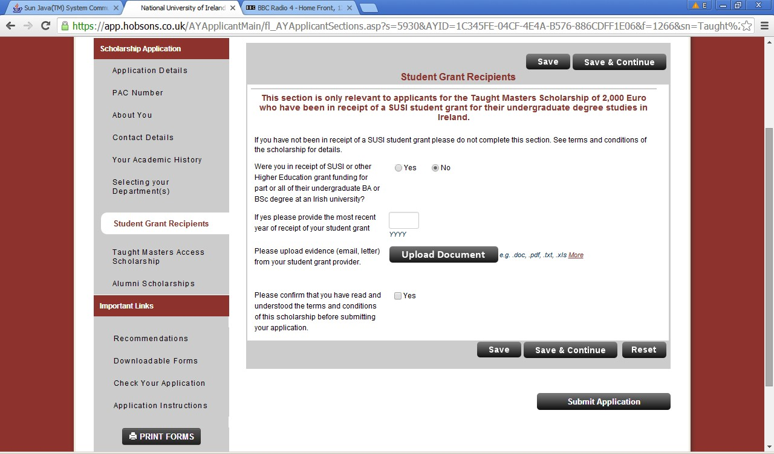

x) “Taught Master’s Access Scholarship” section

All applicants must indicate whether they wish to be considered for the taught master’s scholarship allocated under the Maynooth Access Programme. If you are not currently registered with the Maynooth University Access Office you should select ‘no’ as your answer in this section.

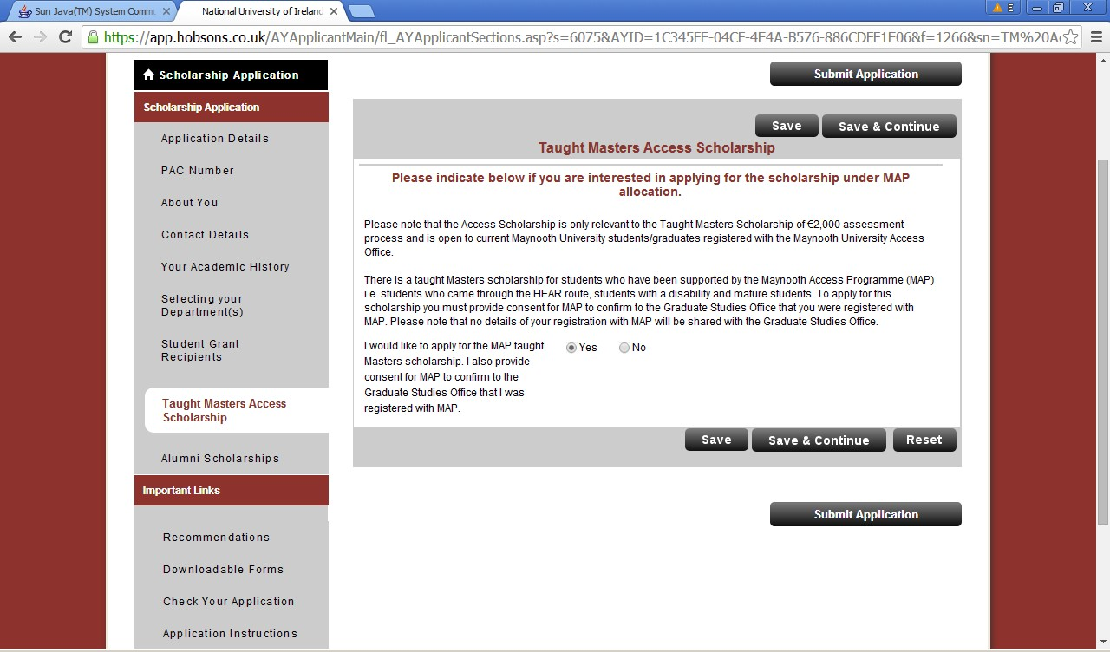

- “Recommendations” section
Recommendations are not required for Taught Master’s Scholarship applications. References provided will not be considered. Please ignore this section.

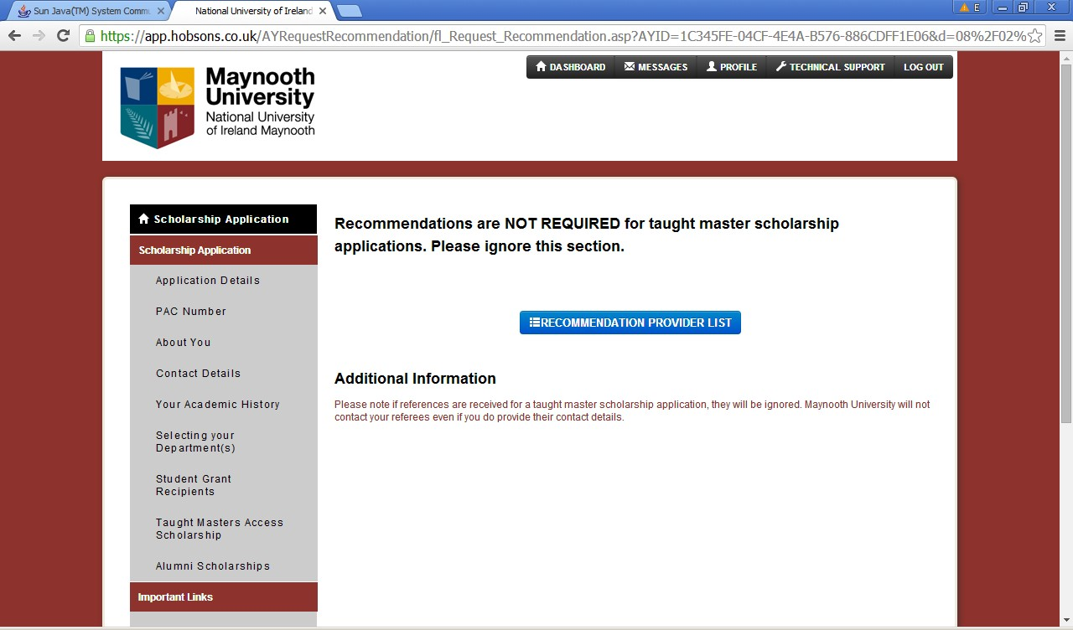

“Downloadable Forms” section

Downloadable forms are not required for Taught Master’s Scholarship applications. They are only relevant to Alumni Scholarship applications. If you are a graduate of Maynooth University and you are uploading an Alumni Scholarship personal statement form, please refer to the Alumni Scholarship guidance.
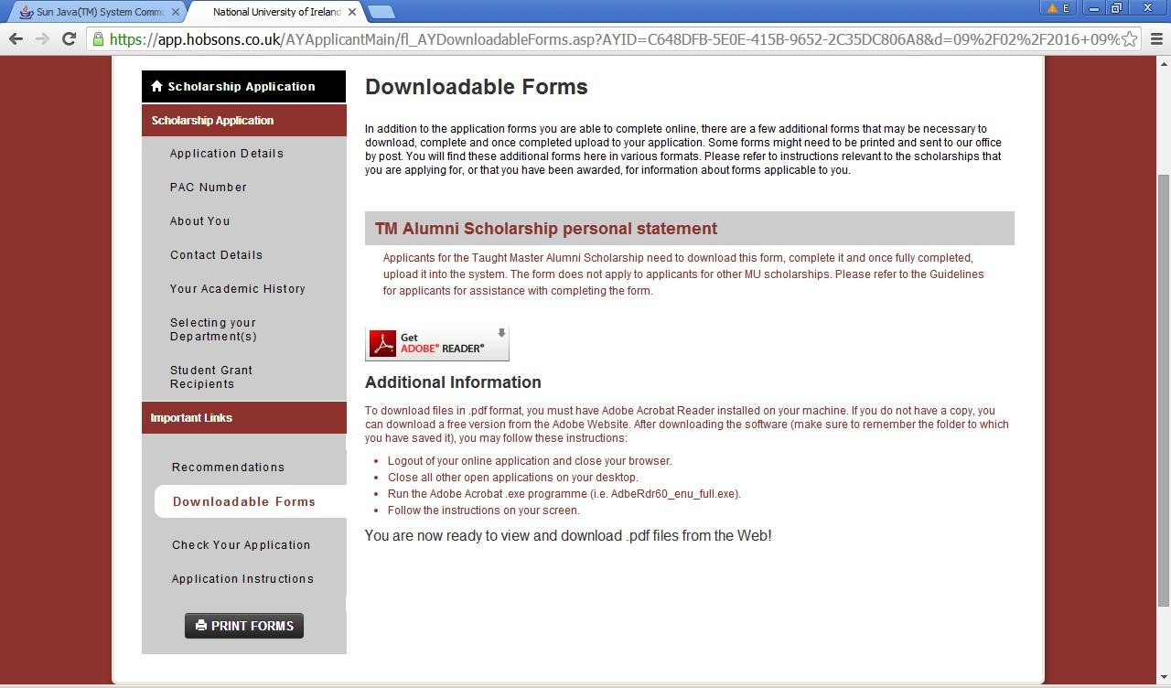

“Checking your application” section

It is not possible to submit an application if some of the mandatory fields is not completed. To check whether all mandatory fields have been populated, select “Check Your Application”. The screen snapshot below shows a result of the check where some of the mandatory fields are not populated. By clicking on the name of the question, in this case “Date of Birth”, you can access directly the relevant field.
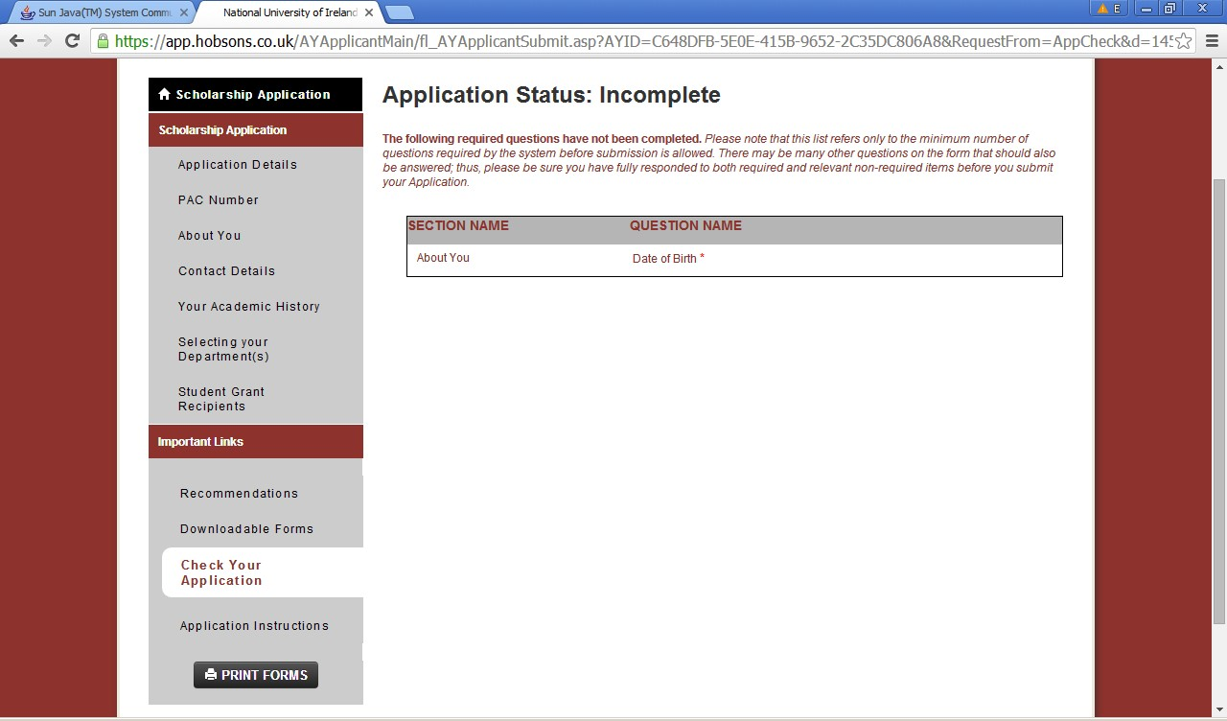

Applicants are encouraged to review their application before it is submitted, by clicking at the “Print Forms” button located in the bottom left corner of the screen.

When all mandatory fields are populated, the “Check Your Application” functionality returns the following screen:
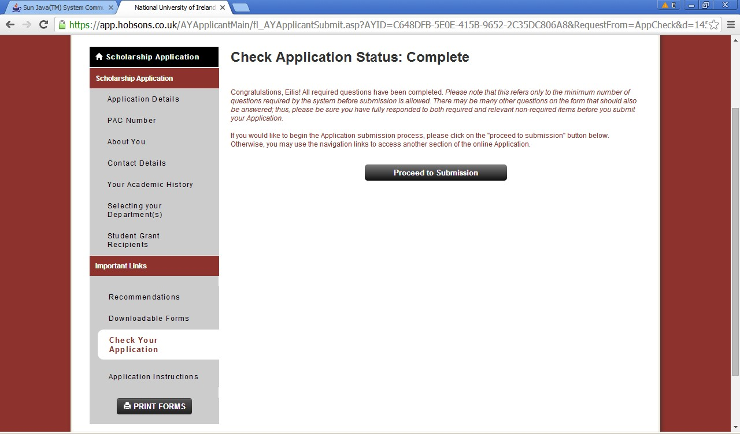

Remember, once you submit your application, it will not be possible to make any amendments in it. By clicking at the “Proceed to Submission” button, the submission process will be initiated and the following screen will appear:
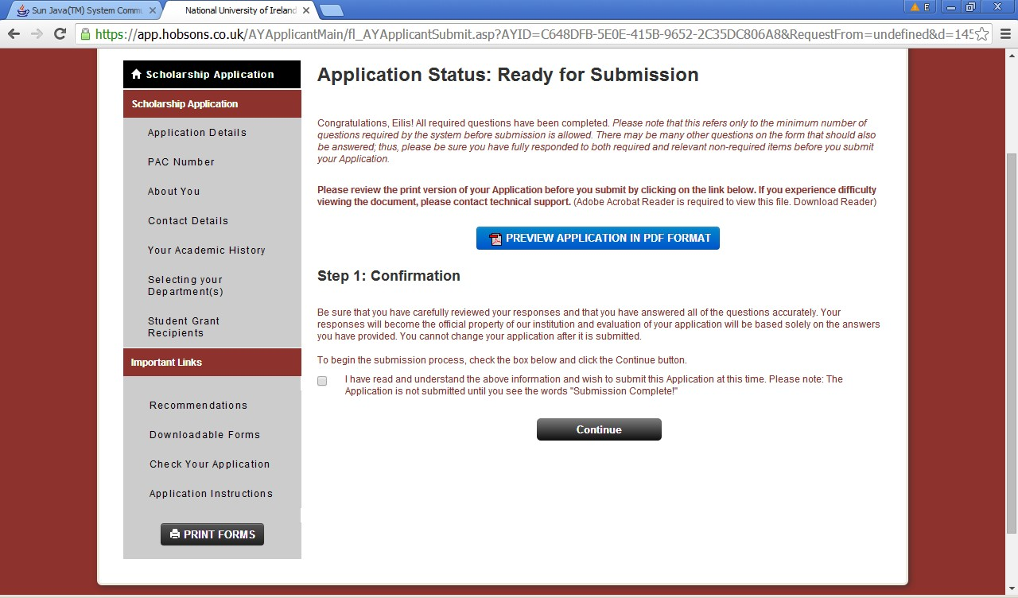

Applicants can at this stage preview and save their complete application including all uploaded documents in PDF format, by clicking at “Preview Application in PDF format”.

After applicants review their complete application and are ready to submit, by clicking at the “Continue” button they will progress to the final step in the submission process illustrated on the screen snapshot below:

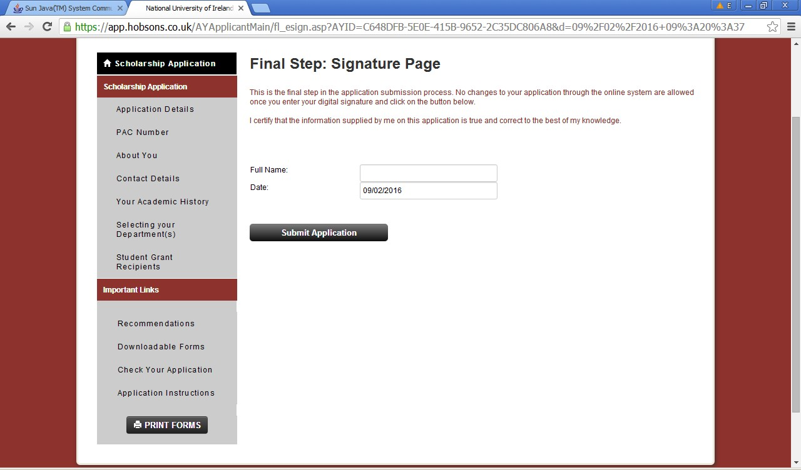

Following successful submission, the applicant’s home screen will indicate that the
application has been submitted and will allow viewing the application, see the

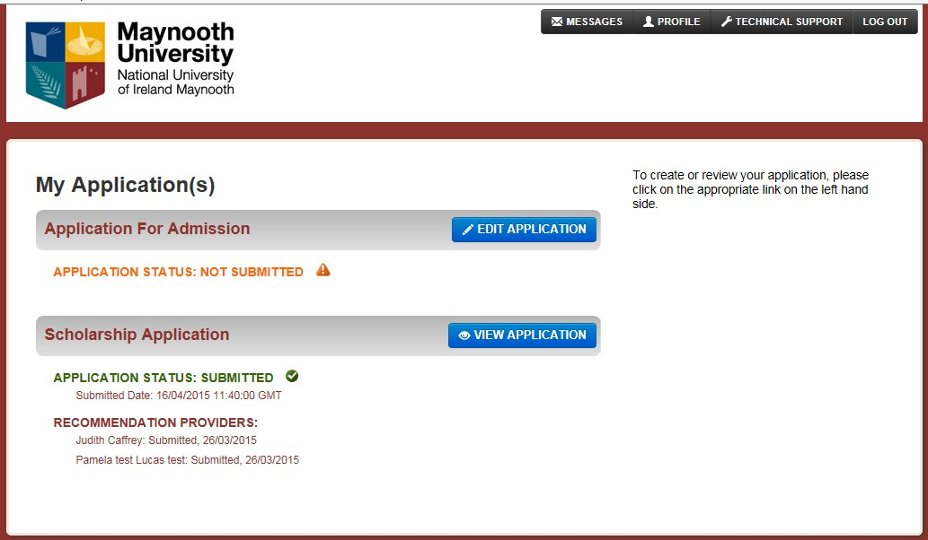

screen snapshot below:

Changing password, updating applicant’s profile
Password can be changed by clicking at “Profile” on the top of any screen within the online application system:
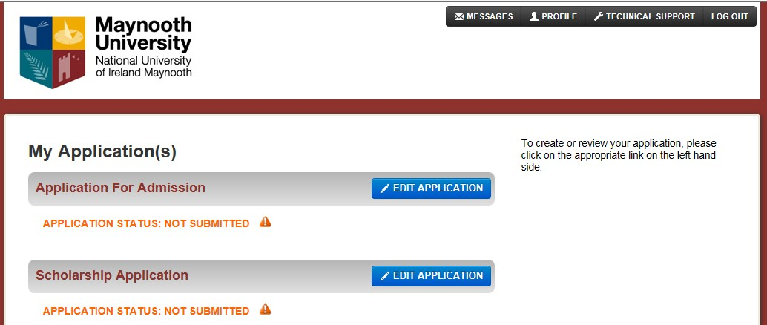

The following window opens which allows to change the password and to update some other details saved in the applicant’s profile, as indicated on the screen snapshot below:
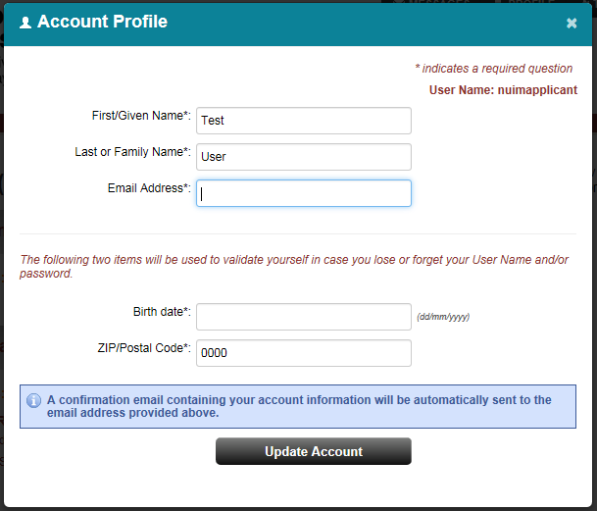

Recommended system requirements for using the online system

Maynooth University uses a third party service, therefore some email addresses and urls used are those of the service provider. All information provided by applicants and referees will only be used by Maynooth University in the process of collecting and processing scholarship applications. No third party will have access to the data.

Supported browsers include Internet Explorer 9 and 11, Firefox, Chrome and Safari.

While the majority of features will work with other browsers, full compatibility is guaranteed and support offered is for the browsers mentioned above.

If you are using one of the supported browsers and are experiencing problems, we encourage you to upgrade to the latest version. If you still experience problems after upgrading, please make sure that your browser is set to accept cookies. Also, make sure the following browser settings are enabled:

JavaScript must be enabled. Popup blockers must be disabled.
If your browser has a section for trusted sites, please enter these two URLs:

http://rec.hobsons.co.uk https://rec.hobsons.co.uk
You will need Adobe Reader 6.0 or higher to download, view and print PDF files. While PDF files should work with most other PDF viewers, we can only guarantee full compatibility and support for Adobe Reader 6.0 or higher.

If your email offers a whitelist, please add the following addresses:

support@campusmgmt.com

Enquiries

If you have any questions regarding the application process please consult documentation for applicants, such as this guide, Frequently asked questions (FAQ), and Terms and conditions of the scheme.

Should the documents available do not answer your question, please email masters.scholarships@mu.ie with “Master’s Scholarships” in the subject line.

For reasons of transparency and fairness, only email enquiries will be accepted and responses will be included in the FAQ document published at: www.maynoothuniversity.ie/postgradscholarships

The FAQ process will close on the 1st June 2019.

