Ollscoil Mhá Nuad
Maynooth University

2023 Promotion to Grade of Administrative Officer II

Application Form

SECTION 1: CANDIDATE DETAILS

Name:

Staff Number:

Email Address:

Department:

Date Appointed to SEA Grade:
Have you worked at SEA grade for a minimum of three years over the last five years: | Yes / No

Strict word limits apply within the application form. Applications exceeding word limits will have the additional words redacted.

SECTION 2: MAYNOOTH UNIVERSITY EMPLOYMENT HISTORY

Please document below your current and previous positions/roles in reverse chronological order. (Please add further rows if necessary).

 | Position / Role | From  (mm/yyyy) | To  (mm/yyyy)
Current
Previous

COMPETENCIES

Assessment is based on four core competencies and three additional non-core competencies. The three non-core competencies are the competencies, from the overall framework, that candidates consider most relevant to the AOII role.

The four Core University Competencies are:
- Service Orientation;
- Strives for Organisational Excellence;
- Collaboration; and
- Ethical Integrity.

The four Non-Core University Competencies are:
- Problem Solving & Decision Making;
- Resilience;
- Communicating & Influencing; and
- Analysis & Judgement.

Candidates are required to demonstrate that they are skilled in all four of the core competencies and skilled in three of the four non-core competencies, in order to be recommended for promotion. All competencies carry an equal weight.

Please also see Appendix 1 for a generic role profile, as agreed in the Memorandum of Understanding between the University and SIPTU.

Section 3: CORE COMPETENCY ASSESSMENT
Using the boxes below, please provide a summary and self-assessment of how you display each of the listed core competencies in your day-to-day role within the University and explain how each demonstrated competency helps you to make a more coherent contribution to your role, team and/or Department.
CORE COMPETENCY 1 | SERVICE ORIENTATION
Using the box below, candidates are required to illustrate how they contribute to a service-oriented culture by always seeking to put the individual first, aiming to continuously improve service quality, and proactively seeking to understand, uphold and respond to the service user’s needs.
Please state your word count here (no more than 600):

CORE COMPETENCY 2 | ORGANISATIONAL EXCELLENCE
Using the box below, candidates are required to illustrate how they promote and deliver quality and operational excellence, seek out & adopt best practice methods.
Please state your word count here (no more than 600):

CORE COMPETENCY 3 | COLLABORATION
Using the box below, candidates are required to illustrate how they build effective relationships & create partnerships internally and/or externally and demonstrate an interest in, respect for and understanding of others and promote an inclusive environment.
Please state your word count here (no more than 600):

CORE COMPETENCY 4 | ETHICAL INTEGRITY
Using the box below, candidates are required to illustrate how they uphold the University’s values of equality, diversity and inclusion and demonstrate integrity and display respect and honesty when dealing with others within the University and beyond.
Please state your word count here (no more than 600):

SECTION 4: NON-CORE COMPETENCY ASSESSMENT

Candidates must provide a summary and self-assessment of how they are skilled in three of the following four non-core competencies, in their day-to-day role within the University and explain how each demonstrated competency helps you to make a more coherent contribution to your role, team and/or Department..

- Problem Solving & Decision Making;
- Resilience;
- Communicating & Influencing; and/or
- Analysis & Judgement.

Candidates must indicate which of the three non-core competencies they have selected in this section (no more than three can be selected). | Problem Solving & Decision Making |  |  | ☐
 | Resilience |  |  | ☐
 | Communicating & Influencing |  |  | ☐
 | Analysis & Judgement |  |  | ☐
NON-CORE COMPETENCY 1
Name of selected first non-core competency:
Using the box below, candidates are required to illustrate how they meet the first of their selected non-core competencies.
Please state your word count here (no more than 600):
NON-CORE COMPETENCY 2
Name of selected second non-core competency:
Using the box below, candidates are required to illustrate how they meet the second of their selected non-core competencies.
Please state your word count here (no more than 600):
NON-CORE COMPETENCY 3
Name of selected third non-core competency:
Using the box below, candidates are required to illustrate how they meet the third of their selected non-core competencies.
Please state your word count here (no more than 600):

Completed applications should be emailed to promotionschemes@mu.ie by 11.59pm, Friday, 19th May 2023. Late applications will not be accepted under any circumstances.

Appendix 1
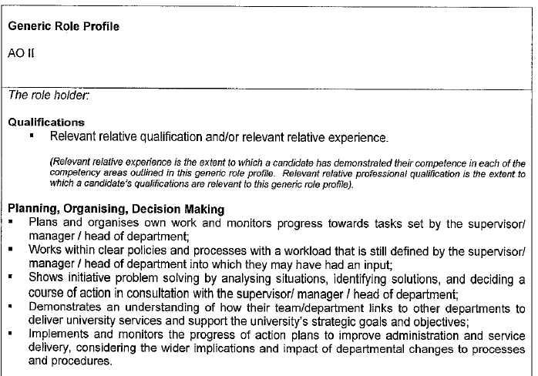
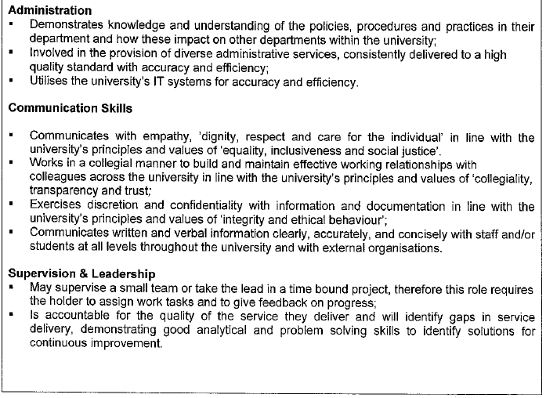

Please refer to the AOII Promotion Call document for definitions on the required competencies.

