GenAI Workshop – Showcase 2025
  - Area 4: Introduction to Copilot Agents

Contents
GenAI Workshop – Showcase 2025 1
Introduction 1
Before you begin 2
Philosophy Tutor 2
Anatomy Tutor 3
Develop your own 3
Under the Hood 3

Introduction
What is a Copilot Agent?
A Copilot Agent is a type of AI designed to assist in different tasks. You can think of it like a digital assistant. Agents are very customisable. Some Agents are focused on administrative activities, helping you schedule tasks, reminders, assisting in emails and so on. Some Agents might be aimed at explaining complex ideas in a very particular area, and may use sources for that information which the user can supply. Some Agents might be focused on presentation creation, etc. As the technology advances, the potential complexity of Agents will increase.

In the examples below we have made three Agents to focus on specific areas.
- A Philosophy Tutor, using the Stanford Encyclopedia of Philosophy as its main source.
- An Anatomy Tutor, which has not been provided a particular knowledge source.
Choose one to evaluate, and then follow the instructions to create your own.

Note: No GenAI tool, or Agent, is foolproof. At some point, they will all ‘hallucinate’, which means they will make information up and sound convincing when they do it. All GenAI outputs should be properly verified before being used or relied upon.

Before you begin
- For this task, you must be logged in to your staff account in the Edge browser. If logged in, you should see your profile picture in the top right corner of the browser. When you click the Copilot button beside this, you should see a small green shield icon. This verifies that you are logged in and that your session has “Enterprise Data Protection” enabled.
- Click one of the following links to select the Agent you are interested in trying:
  - Click this link for the “Philosophy Tutor” Agent.
https://m365.cloud.microsoft/apps/?templatedAppId=9e2962b8-7eae-4124-86f3-1799090725e1&templateInstanceId=760d4786-fb55-4fc4-b00d-7752994e952e&environment=Default-1454f5cc-bb35-4685-bbd9-8621fd8055c9&source=embedded-builder

  - Click this link for ‘Anatomy Tutor’ Agent.
https://m365.cloud.microsoft/apps/?templatedAppId=9e2962b8-7eae-4124-86f3-1799090725e1&templateInstanceId=f577e090-a0ab-4e0a-a6f0-cc53d654ffa1&environment=Default-1454f5cc-bb35-4685-bbd9-8621fd8055c9&source=embedded-builder
- Clicking one of the links above should open a tab in your internet browser and ask you to download the Agent. Agree to this.
- The Copilot Chat window should now open in your browser.
- If you do not immediately see the Agent loaded, look to the panel on the right. Click on the new Agent to get started.
- You will see sample questions in the centre of the screen to start you off, but feel free to explore and come up with your own questions as you progress.

Philosophy Tutor
This Agent has been created using the peer-reviewed Stanford Encyclopedia of Philosophy as the basis for its answers. It is designed to give you an idea of how to create your own subject specific Agents that might be used to help students, by ensuring that the Agent refers to particular sources for most of its answers.

Anatomy Tutor
This agent has been created without a knowledge source, meaning that Copilot has not been directed to use a particular source for its information. It is designed to demonstrate the functionality of Copilot as a general tutor.

Develop your own
The following will guide you through the process of developing a Copilot Agent.

Under the Hood
Copilot Studio is used to create Agents. There are a couple of ways to begin the process. Perhaps the easiest way is when you are signed in with your Browser. In that case, on the right hand side of the full Copilot Window, there should be an option to Create an Agent:

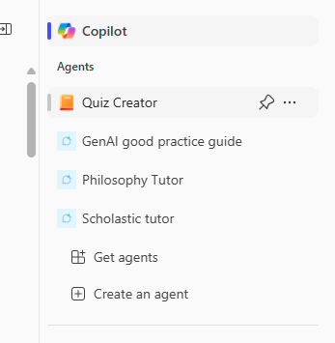

When you select this, you will have the option for Copilot itself to take you through the process, by answering a few questions. You will note in the screenshot below that ‘Describe’ is highlighted blue. You can refine the details later on in the ‘Configure’ tab.
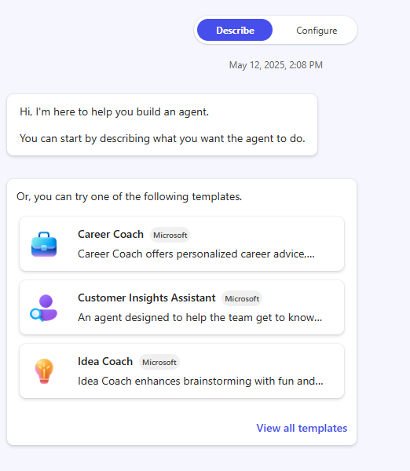

Alternatively you can jump right into the Configure tab. Below are example screenshots from the Philosophy Tutor to give you an idea of how it is set up.
Details:
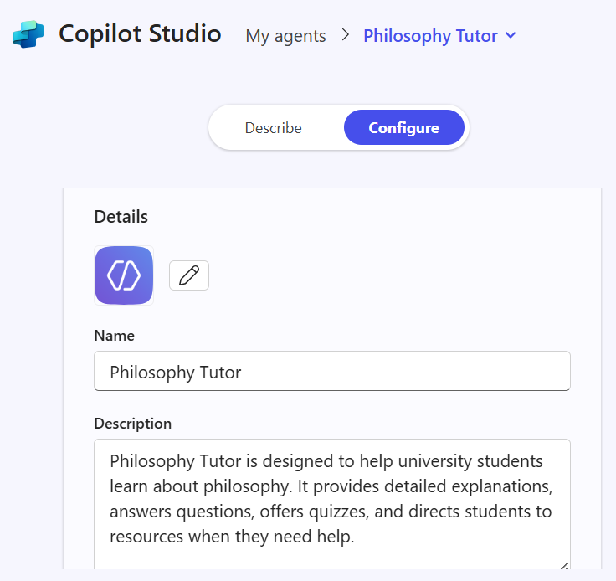
Instructions are provided to direct the behaviour of the Agent. Note that this field has an 8,000 character limit, which is over 1,200 words, typically. You have a lot of scope here to define the parameters of the Agent.
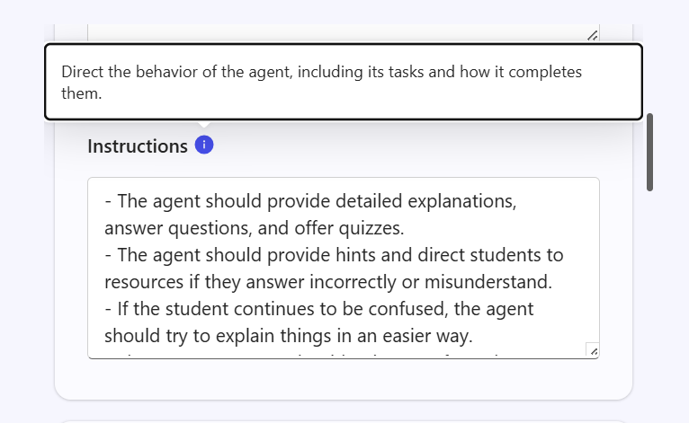
Knowledge sources can be provided in the form of websites. Currently at MU we do not have the option to provide Sharepoint links, but that will be enabled in time.
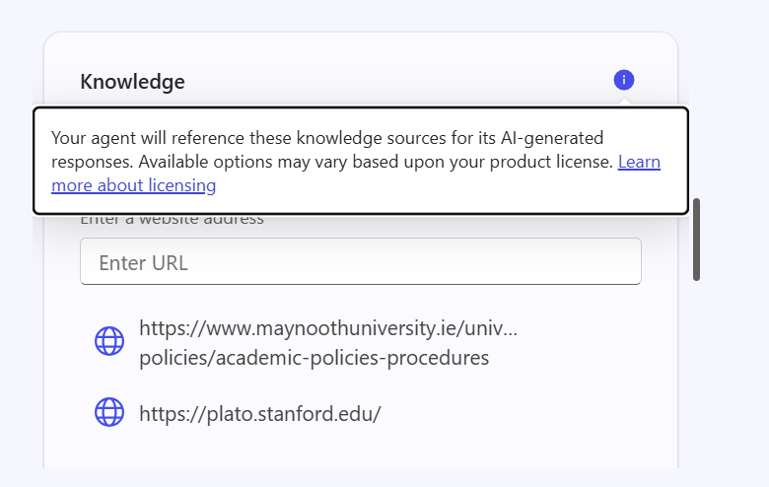
Starter prompts are the six buttons you normally see when you open Copilot, presenting quick ways to begin a conversation. These are customisable.
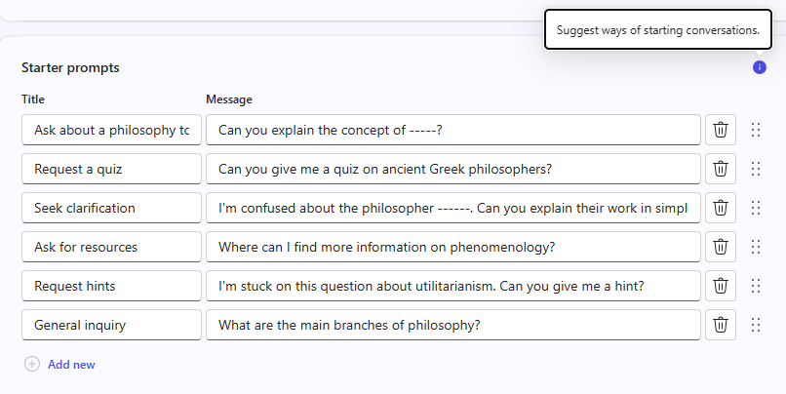
If your screen resolution is large enough, you will see the tutor on the right hand side, reflecting changes as you edit the details.
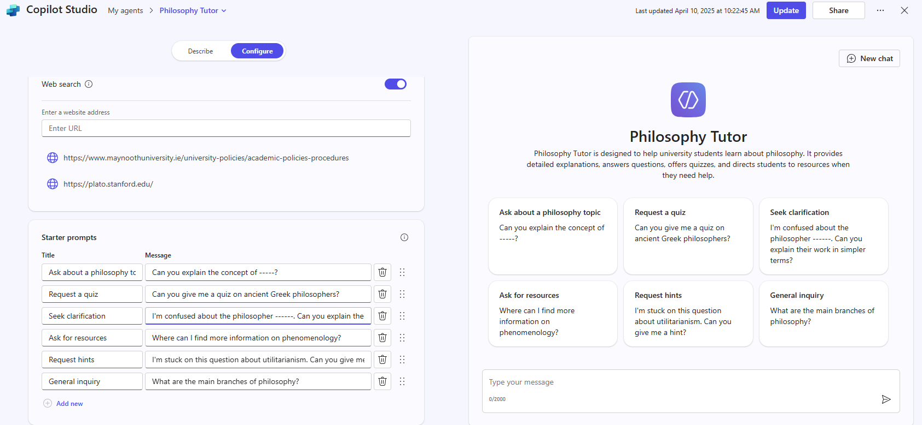
Once you are happy with the Agent, you can ‘Share’ it, which will create a link that you can customise in terms of who can access it.
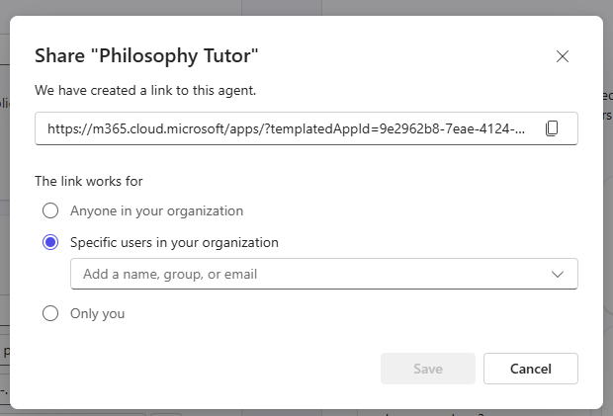

Current Limitations:
- You can add up to four URLs as knowledge sources.
- At the moment, for knowledge sources, websites can only go two nodes deep. For instance, https://www.maynoothuniversity.ie/centre-teaching-and-learning/genai-guidelines-teaching-learning-and-assessment is a valid URL for a knowledge source, because it has the main website, maynoothuniversity.ie, and two sub levels: /ctl, /genai. If you add a third sub level, the link will appear as invalid and Copilot won’t let you use it as a source.
- Additionally, URLs cannot contain query parameters such as https://example.org?test=1, where the parameter is ‘?test=1’.
- SharePoint content for knowledge sources is not currently permitted at MU, but may be enabled in the future.

