National University of Ireland, Maynooth
DEPARTMENT OF HISTORY

FLYERS FOR OPTIONAL MODULES

III ARTS SEMESTER 2 2021-22

PLEASE NOTE

Flyers provide information supplementary to that available in module descriptors, which may be viewed on the university database at www.maynoothuniversity.ie/courses.

Students are expected to consult both flyers and module descriptors in advance of registration.

Lectures will be delivered in accordance with the University’s guidelines for a safe campus. Should the need arise, modules may have to move to online delivery. Due notice will be given if this is the case.

national university of ireland, maynooth
department of history
third arts, 2021-22
Second Semester
Lecturer  DR ALISON FITZGERALD | Module code HY313 | Credits  5 | Lecture hours per week  Two
Module title:
ART, DESIGN AND SOCIETY IN SEVENTEENTH-CENTURY EUROPE

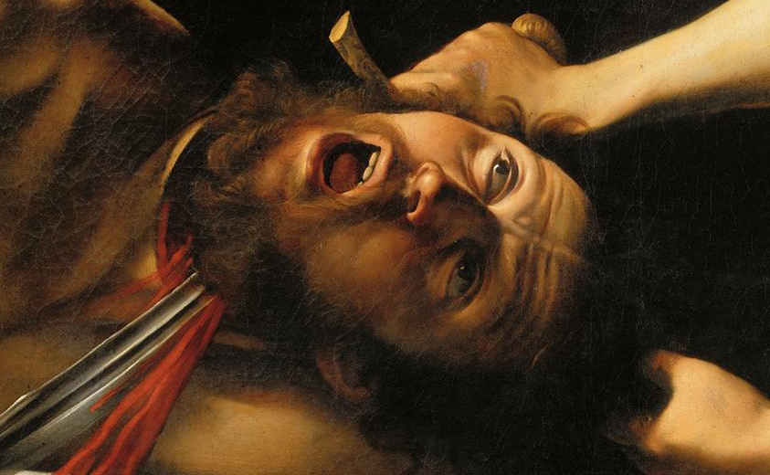

Module Content:
Why was Italian painter Caravaggio such an influential artist in seventeenth-century Europe? How did the sculptor Bernini dazzle his patrons and his rivals in seventeenth-century Rome? Why is the seventeenth century known as the Golden Age of Dutch painting? How did seventeenth-century artists use emblem books to communicate ideas that crossed geographic and linguistic boundaries? This module considers artistic developments in seventeenth-century Europe. It investigates the ways in which the socio-political and cultural background of the period shaped the production of art. From nepotistic papal patronage to the secular tastes of the Dutch bourgeoisie, it examines the context in which artists like Bernini, Caravaggio and Rembrandt worked, and locates their art in a historical and stylistic context using seventeenth-century city guides, artists’ biographies and Counter-Reformation literature. The module will include a seminar in the Russell Library providing an opportunity to explore primary sources on campus.

No previous knowledge of the History of Art is required to take this module.

Form of Assessment:
In-class assessment: 30%; Essay: 3,500 words: 70%
Deadline for submission of essay: Monday, 9 May 2022

Special requirements (e.g. field trips inc. costs, special sessions)
It may be possible to schedule a field trip to the National Gallery to support this module. If that is not viable a seminar will be organised focusing on highlights of the NGI’s collection of seventeenth-century art.
national university of ireland, maynooth
department of history
third arts, 2021-22
Second Semester
Lecturer  professor terence dooley | Module code HY 352 | Credits  5 | Lecture hours per week  Two

Module title
THE DECLINE AND RISE OF THE IRISH COUNTRY HOUSE,
1845 TO PRESENT

Module content
This module begins by providing an in-depth examination of the reasons for the decline of Irish country houses from the late nineteenth century onwards. It looks at the impact that the Great Famine, the Land War of the 1880s, the Land Acts from 1870 to 1909, the economic fallout from post—war global depression, the Great War 1914-18, and the revolutionary period 1919-23 all had on landed families and their homes.

The focus then turns to the struggle for survival that faced big house owners in independent Ireland. It considers questions of management, sustainability and public and political perceptions of these houses up to the present day. It also introduces comparative aspects with country houses in Britain and wider Europe.

Students will be familiarised with the primary sources which are available for the study of big houses and landed estates in Ireland, how to locate them and how to assess their strengths and weaknesses.

At the end of this module students should have an in-depth understanding of Irish country houses and their histories; be able appreciate the social, economic, political and cultural contexts which shaped their decline and rise in the 150 years or so from 1845; be able to identify primary sources relevant to the study of individual houses and families; and be able to analyse and critically assess primary and secondary historical sources and present cogent, coherent arguments.

Form of Assessment:

1,500 review [website/book/primary source]` 30%
Submission date: [mid-term]
Essay of c. 3,500 words: 70%
Submission date: Monday, 9 May 2022

national university of ireland, maynooth
department of history
third arts, 2021-22
Second Semester
Lecturer  PROFESSOR MARIAN LYONS | Module code HY 393 | Credits  5 | Lecture hours per week  Two

Module title
IRISH MIGRANTS IN THE EARLY MODERN WORLD

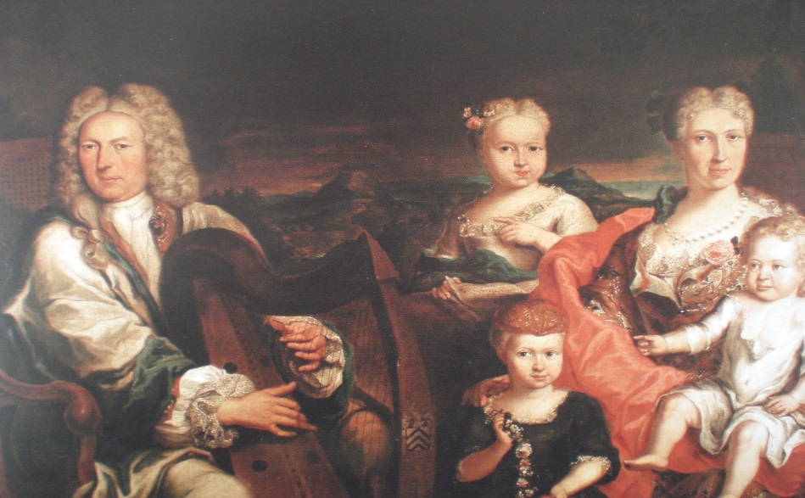

Module content
Between c.1600 and c.1820, a great variety of motives caused men and women to leave Ireland for Continental Europe and further afield. The lure of education, employment, prosperity and religious tolerance was especially strong, but so too was the desire for adventure and change, and a dislike of the isolation associated with living at the extreme periphery of Europe. By the mid-seventeenth century, the Irish had achieved unprecedented visibility on the Continent: on the battlefields, in the docks of major ports, in the university lecture halls, in royal courts, on the streets and even in the hospitals, prisons and galley ships. Between c.1600 and c.1820 many Irish made significant contributions to their host societies in Europe and through service in the overseas colonial administrations of Europe’s major powers, especially in the realms of war, politics, diplomacy, medicine, and trade (including slavery and the East India Company). Drawing upon secondary and primary source material, this module explores their diverse experiences in various parts of Europe and as far afield as the Caribbean.

Form of Assessment
Research project (4,500 words approx.), topic to be agreed upon in advance with lecturer 90%
Primary source analysis (500 words approx.) 10%
Deadline for submission of research project: Monday, 9 May 2022

national university of ireland, maynooth
department of history
third arts, 2021-22
Second Semester
Lecturer  DR JENNIFER REDMOND | Module code HY 395 | Credits  5 | Lecture hours per week  Two

THE IRISH IN BRITAIN: TWENTIETH CENTURY

Module Content
Historically, we know quite a bit about the successes, failures, and experiences of the Irish in North America, but what about those who went to places closer to home? Britain was a quicker, cheaper, less hazardous place to migrate to and became popular as a destination for Irish migrants in the twentieth century, but were they welcome? What did they do? Where did they live? This module examines the lives of the Irish in twentieth-century Britain, comparing the life opportunities offered in both countries and hence the reasons why so many thousands of young people left. Work experiences for men and women are analysed, including during the Second World War when Irish people worked in the British home front industries as well as the armed forces, a history that calls into question the idea of Irish neutrality. Irish experiences of discrimination are also examined, particularly in the context of the IRA campaigns in Britain during the years of the Troubles. More positive narratives of career success are also interrogated, in particular the differing career paths of Irish men and women in Britain. We will use personal accounts such as memoirs and oral histories as well as wider social historical material including newspapers and statistical information to examine issues of health, employment, identity and education for the second generation Irish.
Students will work independently and in groups throughout this course on a range of assessments that will expose them to the use of primary sources. They will also gain experience in choosing their own topic for research for the final essay.

Form of Assessment:

In-class presentation 20%
Participation grade 10%
Essay (3,500 words) 70%
Deadline for submission of essay: Monday, 9 May 2022

Special requirements (e.g. field trips inc. costs, special sessions)
Required text
Enda Delaney, Demography, State and Society (Liverpool University Press, 2000)
Available as an ebook from Maynooth Library

national university of ireland, maynooth
department of history
Third arts, 2021-22
second Semester
Lecturer  DR HUSSAM R. AHMED | Module code HY 3006 | Credits  5 | Lecture hours per week  Two

Module title
ANTI-COLONIAL RESISTANCE IN THE MODERN MIDDLE EAST

Overview

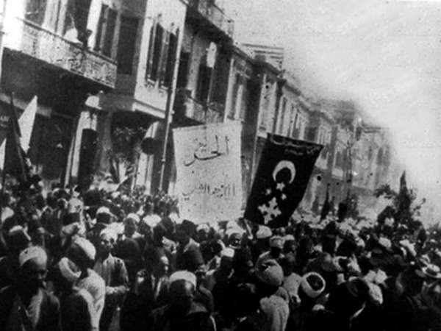
This module will focus on resistance to British and French colonialism in the Middle East in the 19th and 20th centuries. By taking an in-depth look at Egypt, Greater Syria and Algeria the module will cover the following themes: colonial government and bureaucracy, colonial education, mediating elites and colonial citizenship, preparation for self-rule, anti-colonial organisations, armed rebellion and decolonisation. The course will also look at the legacies of anticolonial resistance through some readings from the more contemporary period, including fiction and film.

Assessment

Participation 10%
Presentation and handout 20%
Final essay (3,500 words) 70%

Deadline for submission of essay: Monday, 9 May 2022

national university of ireland, maynooth
department of history
Third arts, 2021-22
Second Semester
Lecturer  MR JACK KAVANAGH | Module code HY 3013 | Credits  5 | Lecture hours per week  Two

Module title
IRISH POLITICAL HISTORY – TWENTIETH CENTURY

Module content

This module is an examination of the Irish civil war, with a specific emphasis upon the military developments of the period using primary sources from the Military Archives of Ireland. It will address key developments in military structures, political responses to violence and the creation of the security state from 1922-32.

Module aim

To enable students to understand and reflect upon the history and legacy of the Irish civil war.

Form of assessment

Assignment (1,000 words) based on selected document 20%
Assignment (1,000 words) based on selected document(s) 20%
Essay of 3,000 words based on primary research and on a
topic to be agreed with course director 60%

Deadline for submission of essay: Monday, 9 May 2022
national university of ireland, maynooth
department of history
Third arts, 2021-22
Second Semester
Lecturer  DR JONATHAN WRIGHT | Module code HY 3017 | Credits  5 | Lecture hours per week  Two

Module title
AFRICAN LIVES IN BRITAIN AND IRELAND, C. 1550-2018

Overview
This module will explore the history of Africans and African communities in Britain and Ireland from the sixteenth century to the second half of the twentieth century. Combining contextual discussion with a case study approach, it will explore the lives of individual Africans or people of African ancestry, setting them in their particular historical and social circumstances. In so doing it will highlight the ways in which Britain and Ireland were, from a very early point, bound into wider global processes of exploitation and exchange and will examine the ways in which 'big' historical processes and dynamics - slavery, empire, migration and decolonization - are experienced at the level of individual lives. Themes explored will vary from year to year, but might include the African presence in Tudor Britain; runaways and black loyalist refugees in the late eighteenth century; visual depictions of Britain’s black community; and the Windrush generation and the politics of race in modern Britain. Extensive use will be made of primary source material and a willingness to contribute to in-class discussion is essential.

Module Aim
Upon completing this module, you will have explored the lives of a number of Africans or people of African ancestry whose experiences shed light on important events and processes in British and Irish history. You will develop an understanding of the scale and significance of the African presence in Britain and Ireland and you will engage with a range of primary source material and a fascinating body of historiography. More broadly, you will develop your research and writing skills through the completion of written assignments and your presentation and communication skills through your contributions to in-class discussion.

Assessment
Analysis of primary source, 1 (c. 1,250 words) 25%
Analysis of primary source, 2 (c. 1,250 words) 25%
Essay (c. 2,500 words: due Monday 9 May 2022) 50%
Deadline for submission of essay: Monday, 9 May 2022

national university of ireland, maynooth
department of history
third arts, 2020-21

Second Semester
Lecturer  DR LEWIS DEFRATES | Module code  HY 3019 | Credits  5 | Lecture hours per week  Two

Module title

American History Elective (B): America in the World, 1865-1935
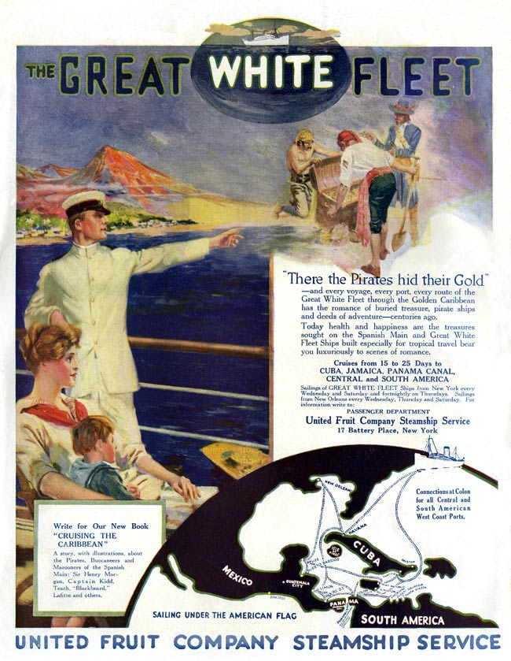
Module content
This module will explore the myriad of ways that the people, goods and ideas of the United States of America moved through the world in the seven decades following the end of the Civil War. ‘Isolationism’, that previously ubiquitous description of United States prior to its intervention in the Second World War, is now understood by most historians as either a limited descriptor or a useful fiction. Focusing primarily on cultural interaction, we will discuss how apparently exceptional American ideas regarding religion, race and gender were formed through transnational movement. We will pay particular attention to the vast array of non-state actors whose working and leisurely lives were bound up in global exchange: from missionaries to entertainers to middle class housewives.
The notion of American Empire will be a key theme of the module. Students will interrogate the extent to which the growing American presence around the world constituted a form of cultural ‘imperialism’, or if this term is best limited to the overseas territorial acquisitions it made in the 1890s. We will also examine the multidirectional nature of cultural transmission, exploring not just how Americans changed the world, but how these engagements transformed the United States. By the end of this module, students will have developed a strong understanding of America’s global history before the passage of President Roosevelt’s ‘Good Neighbor’ policy in 1935, as well as a grasp of the diverse methods and approaches of transnational history.

Module Aim and Objectives:
In addition to gaining a greater understanding of the United States’ multifarious engagements in the world in the decades between the Civil War and the New Deal, this module is intended to develop students’ skills as historians and researchers. Students will participate in class discussions, offer presentations on a particular topic using primary and secondary sources, and compose a long essay.

Module Structure:
24 contact hours in the form of one-hour seminars, delivered over 12 weeks.

Form of Assessment: In-class assignments/tests 40%
3,000 word essay, due Monday, 9 May 2022 60%
NATIONAL UNIVERSITY OF IRELAND MAYNOOTH
DEPARTMENT OF HISTORY
THIRD ARTS 2020-21

First Semester
Lecturer | Module code GC316 | Credits  5 | Lecture hours per week

Module title
A WORLD FULL OF GODS: RELIGIOUS LIFE IN THE ROMAN EMPIRE

Information as per Course Finder, July 2021

Overview
Neither Latin nor ancient Greek has a word which precisely corresponds to our concept of “religion”. However, what we might term “religion” is one of the most richly-evidenced areas of life in the Roman world: this truly was a world full of gods. This module involves a wide-ranging study of the religious life of the Roman world. We will study a broad variety of religious notions and experiences in antiquity, from the authoritative apparatus of traditional Roman religion to the gods of the wider world, worshipped by cities, voluntary associations and individuals across the empire. We will attempt to understand how the inhabitants of the Roman world understood the realm of the divine, and how it related to their daily-lived experience. We will look at the intersection of religion and imperial power, and consider how religion both bolstered imperial authority (as, for instance, in the case of emperor worship) and in some cases could come to challenge it (for instance, in the cases of Judaism and Christianity). We will also look at how gods are represented in Roman art and literature, at Roman philosophical approaches to questions of religion, and at modern sociological and anthropological approaches to the religious life of the period.

18 lecture hours, 3 workshops

Form of assessment
Assessment type | Weighting | Duration
Continuous Assessment | 40%
University scheduled written examination | 60% | 90 minutes

Please note that GC316 is timetabled by the Department of Ancient Classics and may clash with core lectures in other subjects.

