National University of Ireland, Maynooth
DEPARTMENT OF HISTORY

FLYERS FOR OPTIONAL MODULES

III ARTS SEMESTER 2 2020-21

PLEASE NOTE

Flyers provide information supplementary to that available in module descriptors, which may be viewed on the university database at www.maynoothuniversity.ie/courses.

Students are expected to consult both flyers and module descriptors in advance of registration.

national university of ireland, maynooth
department of history
third arts, 2020-21
Second Semester
Lecturer  DR ALISON FITZGERALD | Module code HY313 | Credits  5 | Lecture hours per week  Two
Module title:
ART, DESIGN AND SOCIETY IN SEVENTEENTH-CENTURY EUROPE

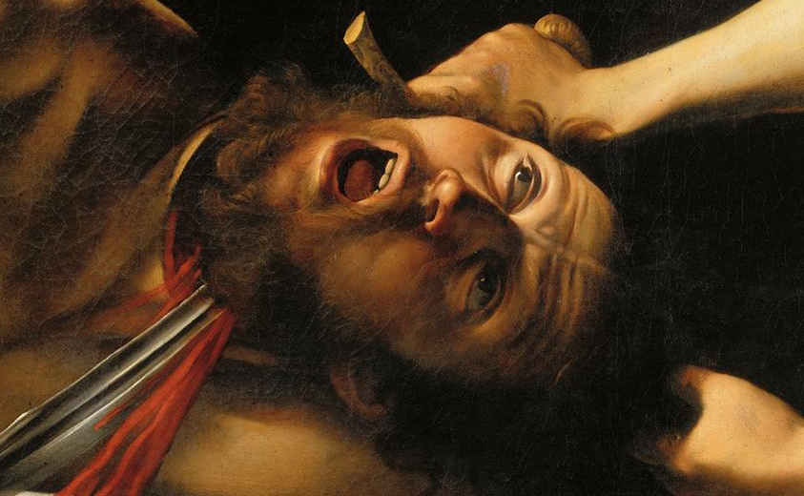

Module Content:
Why was Italian painter Caravaggio such an influential artist in seventeenth-century Europe? How did the sculptor Bernini dazzle his patrons and his rivals in seventeenth-century Rome? Why is the seventeenth century known as the Golden Age of Dutch painting? How did seventeenth-century artists use emblem books to communicate ideas that crossed geographic and linguistic boundaries? This module considers artistic developments in seventeenth-century Europe. It investigates the ways in which the socio-political and cultural background of the period shaped the production of art. From nepotistic papal patronage to the secular tastes of the Dutch bourgeoisie, it examines the context in which artists like Bernini, Caravaggio and Rembrandt worked, and locates their art in a historical and stylistic context using seventeenth-century city guides, artists’ biographies and Counter-Reformation literature. The module will include a seminar in the Russell Library providing an opportunity to explore primary sources on campus.

No previous knowledge of the History of Art is required to take this module.

Lectures will be delivered in accordance with the University’s guidelines for a safe campus. Should the need arise, this module might have to move to online delivery. Due notice will be given if this is the case.
Form of Assessment:
In-class assessment: 30%; Essay: 3,500 words: 70%
Deadline for submission of essay: Monday, 10 May 2021

Special requirements (e.g. field trips inc. costs, special sessions)
It may be possible to schedule a field trip to the National Gallery to support this module. If that is not viable a seminar will be organised focusing on highlights of the NGI’s collection of seventeenth-century art.
national university of ireland, maynooth
department of history
third arts, 2020-21
Second Semester
Lecturer  professor terence dooley | Module code HY 352 | Credits  5 | Lecture hours per week  Two

Module title
THE DECLINE AND RISE OF THE IRISH COUNTRY HOUSE,
1845 TO PRESENT

Module content

This module begins by providing an in-depth examination of the reasons for the decline of Irish country houses from the late nineteenth century onwards. It looks at the impact that the Great Famine, the Land War of the 1880s, the Land Acts from 1870 to 1909, the economic fallout from post—war global depression, the Great War 1914-18, and the revolutionary period 1919-23 all had on landed families and their homes.

The focus then turns to the struggle for survival that faced big house owners in independent Ireland. It considers questions of management, sustainability and public and political perceptions of these houses up to the present day. It also introduces comparative aspects with country houses in Britain and wider Europe.

Form of Assessment:
2 X 2,500 word essays on topics to be set by course director. Topics will be made available on Moodle on Week 1

Essay I, due end of week 6 50%
Essay II, due 10 May 2021 50%

Lectures will be delivered in accordance with the University’s guidelines for a safe campus. Should the need arise, this module might have to move to online delivery. Due notice will be given if this is the case.

Core Texts:
Terence Dooley, The Big Houses and landed estates of Ireland: a research guide (Dublin, 2007)
[Available from Four Courts Press: https://www.fourcourtspress.ie/books/archives/the-big-houses-and-landed-estates-of-ireland/ ].

Terence Dooley, The decline of the Big House in Ireland: a study of Irish landed families 1860-1960 (Dublin, 2001) [Chapters will be made available via Moodle].

national university of ireland, maynooth
department of history
third arts, 2020-21

Second Semester
Lecturer  DR DAVID LEDERER | Module code HY 354 | Credits  5 | Lecture hours per week  Two

Module title
THE HOLY ROMAN EMPIRE, 1648-1806

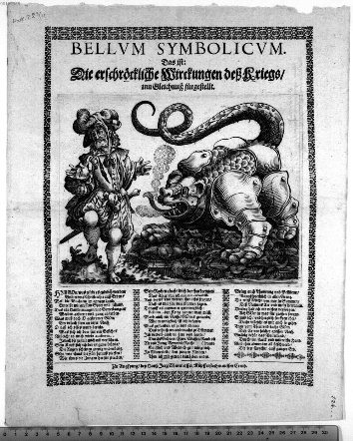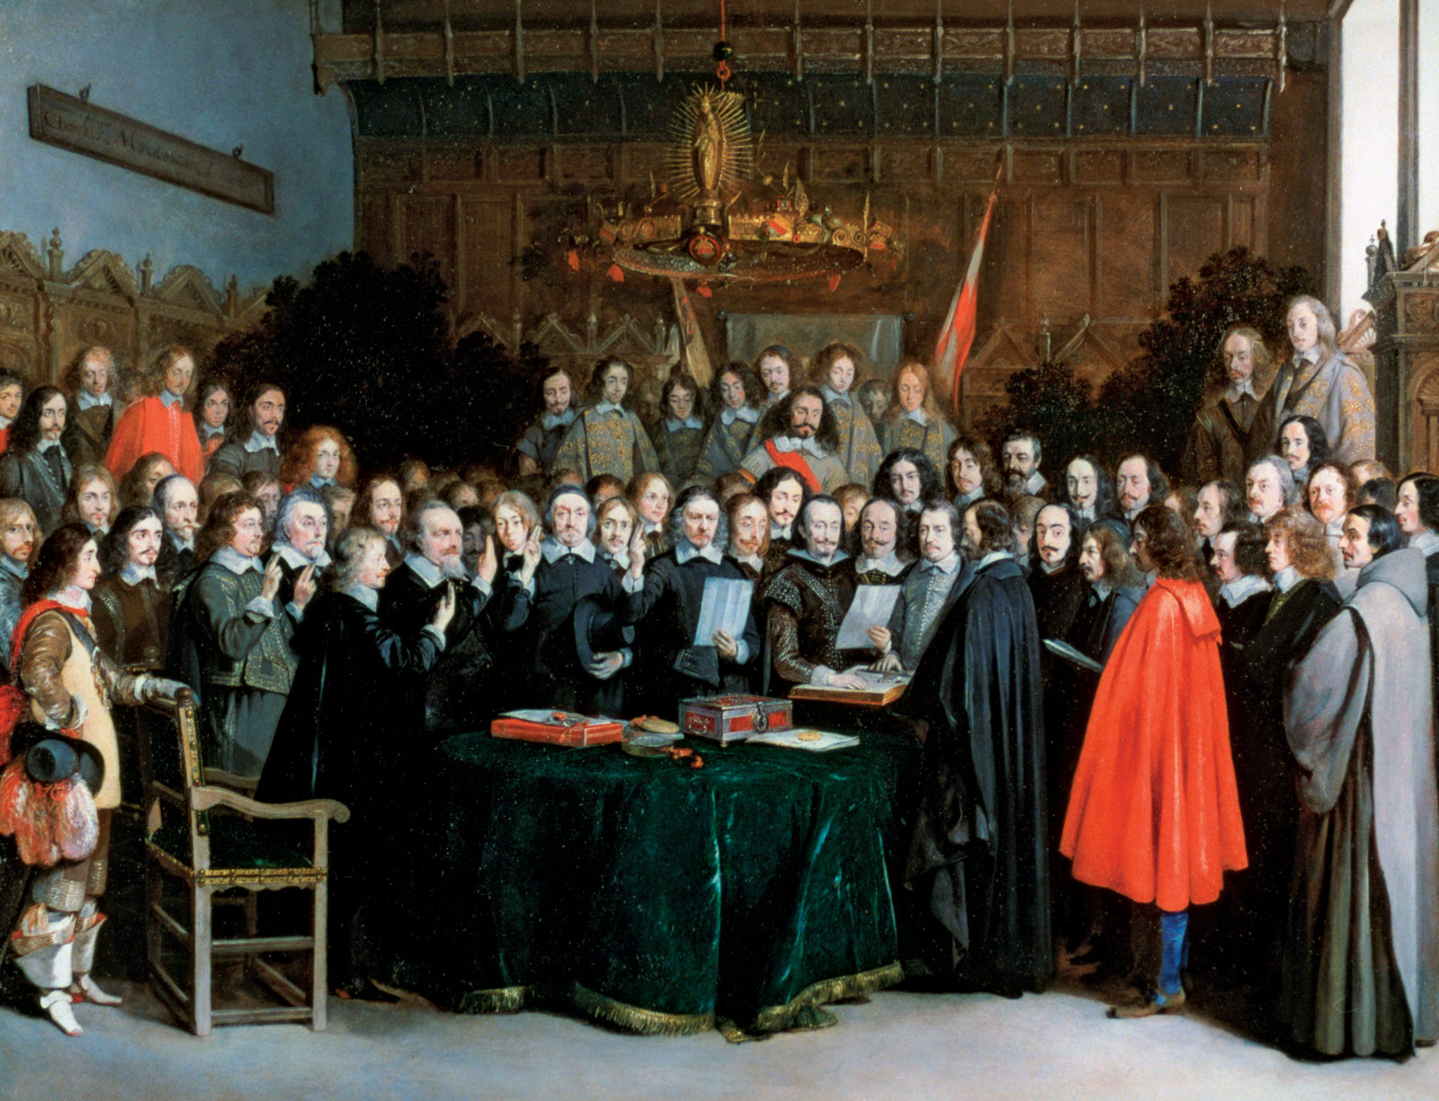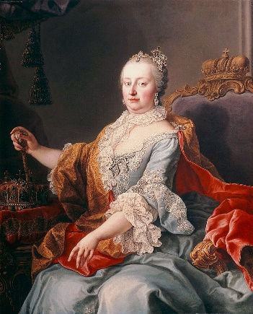

MODULE CONTENT

This is part two of the Holy Roman Empire super-elective, which follows on from HY353 in the first semester. It begins with an extended analysis of the Thirty Years War from political and social perspectives and the impact of the Peace of Westphalia on Europe. Subsequently, we examine mounting tension between Prussia and Austria and events leading to the final dissolution of the Empire in 1806. Finally, students are introduced to differing historical interpretations of the Empire from German, European and Global perspectives. Students participate actively in a series of in-class discussions, presentations of historical documents and oral book reviews, posting to a group website and composing an essay for submission at the end of the semester.

Lectures will be delivered in accordance with the University’s guidelines for a safe campus. Should the need arise, this module might have to move to online delivery. Due notice will be given if this is the case.

Form of Assessment

3,000 word essay 60%
In-class assignments/tests 40%
Deadline for submission of essay is Monday, 10 May 2021

NATIONAL UNIVERSITY OF IRELAND, MAYNOOTH
DEPARTMENT OF HISTORY
THIRD ARTS, 2020-21

Second Semester
Module Co-ordinator  DR DYMPNA MC LOUGHLIN | Module code  HY 390 | Credits  5 | Lecture hours per week  Two

Module title:

SOCIAL HISTORY OF HEALTH IN NINETEENTH AND TWENTIETH CENTURY IRELAND

Overview
The module will introduce students to the key aspects of the social history of medicine in nineteenth century Ireland. It will document the journeys of ordinary Irish men, women and children through ill health, and how they negotiated their way through various medical institutions. The medical profession will also be documented, as well as how the profession interpreted and treated various illness and diseases, not always successfully.

Course Themes
- The nineteenth century medical world
- Medical institutions in the nineteenth century.
- Illness with stigmas attached to them such as aids, tuberculosis and syphilis.
- Smallpox in Ireland
- Cholera in Ireland 1832 and 1847-52.
- Mental health and the and the implications of the Dangerous Lunatics Act 1838
- The adulteration of alcohol and its devasting impact on human health- case studies of whiskey, poteen and ether.

LECTURES WILL BE DELIVERED IN ACCORDANCE WITH THE UNIVERSITY’S GUIDELINES FOR A SAFE CAMPUS. SHOULD THE NEED ARISE, THIS MODULE MIGHT HAVE TO MOVE TO ONLINE DELIVERY. DUE NOTICE WILL BE GIVEN IF THIS IS THE CASE.

Form of Assessment

Template – brief analysis of a primary source (1000 words) 20%
Essay of 4,000 words on primary source 80%
Deadline for submission of essay is Monday, 10 May 2021

national university of ireland, maynooth
department of history
third arts, 2020-21
Second Semester
Lecturer  DR SARAH RODDY | Module code HY 396 | Credits  5 | Lecture hours per week  Two

HISTORIOGRAPHY – LEVEL 3

Module content

How have historians written about the lives of ordinary people in the past? This module will deepen students’ engagement with historiography and historical theory in the realm of what has variously been termed ‘social history’, ‘history from below’ or ‘people’s history’. Focusing both on the emergence and development of the field more widely from the mid-twentieth century, and on its application in writing about modern Ireland, students will gain an understanding of the unique insights, heated debates and methodological challenges that social history has to offer.

Lectures will be delivered in accordance with the University’s guidelines for a safe campus. Should the need arise, this module might have to move to online delivery. Due notice will be given if this is the case.

Assessment

Two-hour university scheduled examination at end of semester

national university of ireland, maynooth
department of history
Third arts, 2020-21
Second Semester
Lecturer  DR HUSSAM AHMED | Module code HY 3006 | Credits  5 | Lecture hours per week  Two

Module title
ANTI-COLONIAL RESISTANCE IN THE MODERN MIDDLE EAST

Overview

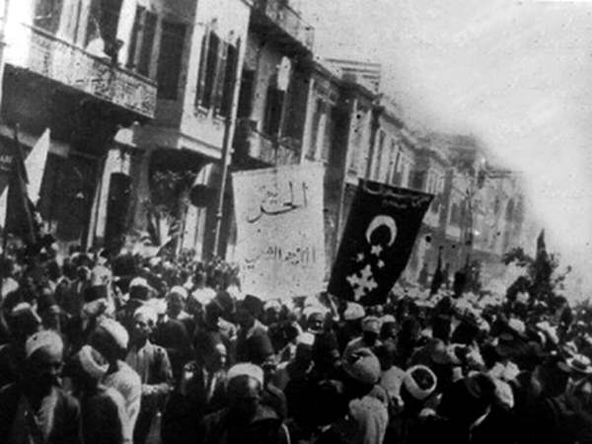
This module will focus on resistance to British and French colonialism in the Middle East in the 19th and 20th centuries. By taking an in-depth look at Egypt, Greater Syria and Algeria the module will cover the following themes: colonial government and bureaucracy, colonial education, mediating elites and colonial citizenship, preparation for self-rule, anti-colonial organisations, armed rebellion and decolonisation. The course will also look at the legacies of anticolonial resistance through some readings from the more contemporary period, including fiction and film.

Lectures will be delivered in accordance with the University’s guidelines for a safe campus. Should the need arise, this module might have to move to online delivery. Due notice will be given if this is the case.

Assessment

Participation 10%
Presentation 20%
Final essay (3,500 words) 70%

Deadline for submission of essay: Monday, 10 May 2021

national university of ireland, maynooth
department of history
Third arts, 2020-21
Second Semester
Lecturer  DR BEATRICE SCUTARU | Module code HY 3015 | Credits  5 | Lecture hours per week  Two

Module title
TRENDS IN INTERNATIONAL HISTORY

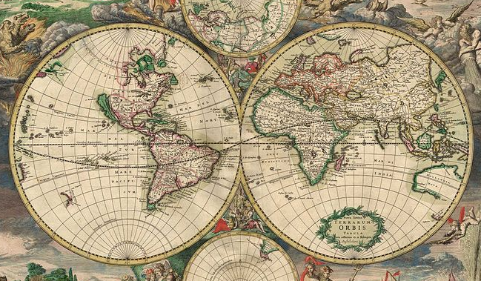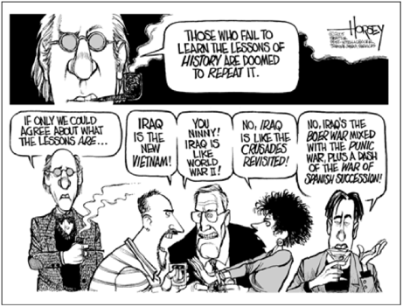

Module content:
This module will introduce students to the varieties of focus, methods and analytical scope in the dynamic field of international history. The field of international history has undergone substantial changes in the past half century. We will consider how cooperation between history and other disciplines, as well as advances in the fields of transnational, global and world history influence the ways in which international histories are conceptualised and written. We will engage in critical thinking, analysis and discussions, examining key texts covering theory and methodology, as well as practical examples of historical research produced using these approaches. Through general overviews and empirical case studies, we will explore the kinds of questions international historians ask and the methods they use to answer them. The goal is both to broaden the student’s general historical understanding and to encourage them to reflect critically on the merits of different approaches available to international historians.
Module Structure:
This module will combine general overviews (lecture style) with empirical case studies and discussions of historical research. Assigned readings underpin each session; it is essential that students carry out these readings in advance of the respective lecture. The module will be delivered in accordance with the University’s guidelines for a safe campus. Should the need arise, this module might have to move to online delivery. Due notice will be given if this is the case.
Form of assessment | Deadline | % of final grade
Participation | Weekly in-class assignments | 10%
Oral presentation | Assigned date to be decided with module coordinator | 30 %
Essay (3,500 words) | Monday, 10 May 2021 | 60 %

NATIONAL UNIVERSITY OF IRELAND MAYNOOTH
DEPARTMENT OF HISTORY
THIRD ARTS 2020-21

First Semester
Lecturer  TBC | Module code GC316 | Credits  5 | Lecture hours per week

Module title
A WORLD FULL OF GODS: RELIGIOUS LIFE IN THE ROMAN EMPIRE

Information as per Course Finder, July 2020

Overview
Neither Latin nor ancient Greek has a word which precisely corresponds to our concept of “religion”. However, what we might term “religion” is one of the most richly-evidenced areas of life in the Roman world: this truly was a world full of gods. This module involves a wide-ranging study of the religious life of the Roman world. We will study a broad variety of religious notions and experiences in antiquity, from the authoritative apparatus of traditional Roman religion to the gods of the wider world, worshipped by cities, voluntary associations and individuals across the empire. We will attempt to understand how the inhabitants of the Roman world understood the realm of the divine, and how it related to their daily-lived experience. We will look at the intersection of religion and imperial power, and consider how religion both bolstered imperial authority (as, for instance, in the case of emperor worship) and in some cases could come to challenge it (for instance, in the cases of Judaism and Christianity). We will also look at how gods are represented in Roman art and literature, at Roman philosophical approaches to questions of religion, and at modern sociological and anthropological approaches to the religious life of the period

18 lecture hours

Form of assessment
Continuous Assessment detail(s): 40% Optional CA
An optional coursework essay will be available for 40% of the total mark. The essay mark will be applied only if it is to the student's advantage.
Assessment type | Weighting | Duration
Continuous Assessment | 40%
University scheduled written examination | 60% | 90 minutes

Please note that GC316 is timetabled by the Department of Ancient Classics and may clash with core lectures in other subjects.

