National University of Ireland, Maynooth
DEPARTMENT OF HISTORY

FLYERS FOR OPTIONAL MODULES

III ARTS SEMESTER 2 2018-19

PLEASE NOTE

Flyers provide information supplementary to that available in module descriptors, which may be viewed on the university database at www.maynoothuniversity.ie/courses.

Students are expected to consult both flyers and module descriptors in advance of registration.

national university of ireland, maynooth
department of history
third arts, 2018-19

Second Semester
Lecturer  DR RICHARD ANSELL | Module code HY 302 | Credits  5 | Lecture hours per week  Two

Module title
EUROPE 1770-1870

Module content

Between 1770 and 1870, Europe was transformed by far-reaching change. In political terms, the module moves through the origins and fall-out of French Revolution, periods of global war, the varying ‘successes’ of the 1848 revolutions, widespread calls for popular representation and the unifications of Germany and Italy. All the while, however, we afford equal prominence to powerful economic, social, cultural and intellectual forces. Many of these political movements traced their origins to the eighteenth-century Enlightenment, while the spread of industrialisation from the middle of the eighteenth century brought wide-ranging consequences for the lives of working people. We move from the Ancien Régime to a period in which modern European science and industry subjugated large parts of the world, justified by scientific theories of racial superiority. The story of this period is in some senses one of Europe turning outwards, a development accompanied by unprecedented violence as well as intellectual progress, and of the transformative effects of communication and travel on ordinary Europeans.

Form of Assessment:
In- class assessment 20%
4,000 word essay 80%

Deadline for submission of essay: Monday, 13 May 2019
Module conditions apply. See relevant descriptor at www.maynoothuniversity.ie/courses.

Special requirements (e.g. field trips inc. costs, special sessions)

national university of ireland, maynooth
department of history
third arts, 2018-19
Second Semester
Lecturer  DR ALISON FITZGERALD | Module code HY313 | Credits  5 | Lecture hours per week  Two
Module title:
ART, DESIGN AND SOCIETY IN SEVENTEENTH-CENTURY EUROPE

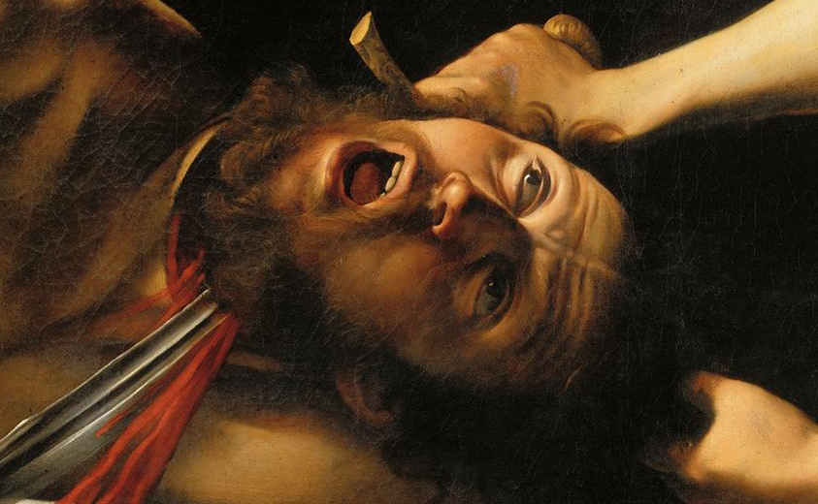

Module Content:

This module considers artistic developments in seventeenth-century Europe. It explores how, in the wake of the Counter Reformation, painting was used as a form of religious propaganda. More broadly, it investigates the ways in which the socio-political and cultural background of the period shaped the production of art. From nepotistic papal patronage to the secular tastes of the Dutch bourgeoisie, it examines the context in which artists like Bernini, Caravaggio and Rembrandt worked, and locates their work in an historical as well as stylistic context. No previous knowledge of the History of Art is required.

Form of Assessment:
In-class assessment: 30%
Essay: 3,500 words: 70%
Deadline for submission of essay: Monday, 13 May 2019
Module conditions apply. See relevant descriptor at www.maynoothuniversity.ie/courses.

Special requirements (e.g. field trips inc. costs, special sessions)
Site visits will be a component of this module. Dates and details will be provided at the outset of the course. Site visits where scheduled, will take place on Friday afternoons or Saturday mornings.

national university of ireland, maynooth
department of history
third arts, 2018-19
Second Semester
Lecturer  DR JOANNE MANCINI | Module code HY 341 | Credits  5 | Lecture hours per week  Two

Module title
AMERICAN HISTORY ELECTIVE

Module content

This module offers an introduction to the cultural history of the United States (including aspects of colonial American and Indigenous history). It will employ a seminar format, with in-depth discussions of primary sources including art and visual culture, literary texts, music, and other works, as well as explorations of online repositories for primary sources. We will also examine current secondary literature (primarily journal articles), both in history and, because of the interdisciplinary nature of the subject matter, in related disciplines such as literature, history of art, musicology, American Studies, and/or anthropology. The module will take a chronological approach, but we will also consider various themes. Students must come to class meetings having completed the assigned readings and other exercises, and participate fully in these discussions.

Form of Assessment:
Participation 10%
Group Presentation 20%
3500-word essay 70%
Deadline for submission of essay: Monday, 13 May 2019
Module conditions apply. See relevant descriptor at www.maynoothuniversity.ie/courses.

Special requirements (e.g. field trips inc. costs, special sessions)

national university of ireland, maynooth
department of history
third arts, 2018-19
Second Semester
Lecturer  DR RICHARD ANSELL | Module code  HY 346 | Credits  5 | Lecture hours per week  Two

Module title
IRISH FRENCH RELATIONS, 1580-1800

Module content
Thousands of people left Ireland for France between the late sixteenth and late eighteenth centuries, but they did not leave Irish history. This module explores the strong links that they created between Ireland and France in the early modern period, following soldiers, merchants, students, seminarians and economic migrants to the Continent. Irish soldiers serving in the French army provided the backbone of attempts to reinstall the Catholic James II and his descendants on the British and Irish thrones, thriving merchant communities in the French Atlantic ports sustained vital links for the Irish economy and students at colleges in Paris, Bordeaux, Toulouse and elsewhere help historians to establish how Catholic Ireland survived the long Protestant reformation. Towards the end of our period, these links helped to transmit French republican ideals that inspired the Irish rebellion of 1798, ‘The Year of the French’. The module uses recent historiography on the Irish in Europe, alongside plentiful primary sources, to explore the vibrant communities that Irish migrants created in France and their integration into French society. It also recognises, however, that the movement of people went both ways: French Protestant migrants (Huguenots) began to arrive in Ireland from 1685 onwards, fleeing persecution at home and transforming aspects of Irish social and cultural life. This two-way relationship between Ireland and France would play several important roles in the political and intellectual history of early modern western Europe, but it also offers a timely case study of migration and its place in international relations.

Form of Assessment:
In- class assessment 20%
4,000 word essay 80%
Deadline for submission of essay: Monday, 13 May 2019
Module conditions apply. See relevant descriptor at www.maynoothuniversity.ie/courses.

Special requirements (e.g. field trips inc. costs, special sessions)

national university of ireland, maynooth
department of history
third arts, 2018-19
Second Semester
Lecturer  professor terence dooley | Module code HY 352 | Credits  5 | Lecture hours per week  Two

Module title
THE DECLINE AND RISE OF THE IRISH COUNTRY HOUSE,
1845 TO PRESENT

Module content

This module begins by providing an in-depth examination of the reasons for the decline of Irish country houses from the late nineteenth century onwards. It looks at the impact that the Great Famine, the Land War of the 1880s, the Land Acts from 1870 to 1909, the economic fallout from post—war global depression, the Great War 1914-18, and the revolutionary period 1919-23 all had on landed families and their homes.

The focus then turns to the struggle for survival that faced big house owners in independent Ireland. It considers questions of management, sustainability and public and political perceptions of these houses up to the present day. It also introduces comparative aspects with country houses in Britain and wider Europe.

Form of Assessment:
4,000 word essay 80%
In- class assignment 20%
Deadline for submission of essay: Monday, 13 May 2019
Module conditions apply. See relevant descriptor at www.maynoothuniversity.ie/courses.

Special requirements (e.g. field trips inc. costs, special sessions)

national university of ireland, maynooth
department of history
third arts, 2018-19
Second Semester
Lecturer  DR JENNIFER REDMOND | Module code HY 395 | Credits  5 | Lecture hours per week  Two

THE IRISH IN BRITAIN: TWENTIETH CENTURY

Module Content
Historically, we know far more about the successes, failures and experiences of the Irish in North America, but what about those who went to places closer to home? Britain was a quicker, cheaper and less hazardous place to migrate to and became popular as a destination for Irish migrants in the twentieth century, but were they welcome? What did they do? Where did they live? This module examines the lives of the Irish in twentieth-century Britain, comparing the life opportunities offered in both countries and hence the reasons why so many thousands of young people left. Work experiences for men and women are analysed, including during the Second World War when Irish people worked in the British home front industries as well as the armed forces, a history that calls into question the idea of Irish neutrality. Irish experiences of discrimination are also examined, particularly in the context of the IRA campaigns in Britain during the years of the Troubles. More positive narratives of career success are also interrogated, in particular the differing career paths of Irish men and women in Britain. We will use personal accounts such as memoirs and oral histories as well as wider social historical material including newspapers and statistical information to examine issues of health, employment and identity and education for the second generation Irish.

Form of Assessment:
5,000 word essay or shorter essay combined with class assignments/tests.
Deadline for submission of essay: Monday, 13 May 2019
Module conditions apply. See relevant descriptor at www.maynoothuniversity.ie/courses.

Special requirements (e.g. field trips inc. costs, special sessions)
Required text
Enda Delaney, Demography, State and Society (Liverpool University Press, 2000).
national university of ireland, maynooth
department of history
third arts, 2018-19
Second Semester
Lecturer  PROFESSOR FILIPE R. DE MENESES | Module code HY 397 | Credits  5 | Lecture hours per week  Two

DEFYING THE WIND OF CHANGE: PORTUGAL, RHODESIA AND SOUTH AFRICA, 1960-1980

Module content:
This module examines the political, military, intelligence and economic ties between Portugal, Rhodesia (before and after its Unilateral Declaration of Independence in 1965) and apartheid-era South Africa as the three countries resisted calls for equal political representation for men and women of all races. It considers how the three countries exploited their growing financial muscle as well as the circumstances of the Cold War to pursue these ends. The bloc was undone by the Portuguese revolution of April 1974, which led to the independence of Angola and Mozambique and left Rhodesia’s borders exposed. After 1980 only South Africa remained under minority white rule, but it would take until the end of the Cold War for its leadership to abandon apartheid and begin the transition to a one-person, one-vote system. Extensive use is made of recently declassified material gathered in Lisbon and Pretoria.
Module aim and objectives:
Aim:
- This module will enable students to understand and reflect critically the final stages of the decolonization process in Africa and their relationship to both local conflicts and the wider Cold War.
Objectives:
- To allow students to gain a thorough understanding of southern African politics, European (notably Portuguese) involvement in the region, and the Apartheid regime and similar experiences.
- To familiarize students with the most up-to-date historiography on the subject, allowing them to engage critically with it.
- To allow students to handle recently declassified archival material and to incorporate it into their projects.
- To encourage students’ ability to deliver their findings in a variety of formats.

Format:
Each class is divided into two sections. In the first, the instructor will provide an outline of the historical events covered, as well as of their historiographical coverage. In the second, selected readings and original documents (translated, in some cases) will be presented and analyzed by the lecturer and the students, and student presentations will be made.
Form of Assessment:
Oral presentation (10 minutes) and 4,000 word essay.
Deadline for submission of essay: Monday, 13 May 2019
Module conditions apply. See relevant descriptor at www.maynoothuniversity.ie/courses

national university of ireland, maynooth
department of history
third arts, 2018-19

Second Semester
Lecturers  DR COLMÁN ETCHINGHAM | Module code SG354 | Credits  5 | Lecture hours per week  Two

Module title
THE VIKING WORLD II - IRELAND

Module content

The Vikings were a major factor in Irish history from the late eighth century until the early eleventh, and had a continuing influence until the later twelfth century. This module studies the Viking impact in Ireland during this period.

Form of assessment

100% continuous assessment

Special requirements (e.g. field trips inc. costs, special sessions)
None

Please note that SG354 is timetabled by Sean-Ghaeilge and may clash with core lectures in other subjects.

