National University of Ireland, Maynooth

DEPARTMENT OF HISTORY

FLYERS FOR OPTIONAL MODULES

III ARTS SEMESTER 1 2023-24

PLEASE NOTE

Flyers provide information supplementary to that available in module descriptors, which may be viewed on the university database at www.maynoothuniversity.ie/courses.

Students are expected to consult both flyers and module descriptors, as well as the academic timetable, in advance of registration.

national university of ireland, maynooth
department of history
Third arts, 2023-24

First Semester
Lecturer  PROFESSOR FILIPE RIBEIRO DE MENESES | Module code HY 314 | Credits  5 | Lecture hours per week  Two

Module title

Hitler’s Europe, 1939-1945 (A)

Module Content
This module is the first part of a year-long examination of the European continent during the Second World War. Its focus is on Nazi plans for the future of Europe once a German military victory had been secured, and how these evolved during the conflict. As such it considers the often contradictory political, economic and racial aims of the Nazis and how they proposed to bring them to fruition. Special attention is paid to the origins and implementation of the Final Solution and its relationship with the course of the war. It is recommended that students also sign up for HY 315 in the second semester.

Module Aim and Objectives:
Aim:
- To acquire a deeper understanding of the nature of Nazi plans for the future of Europe, enabling students to discuss this period with greater certainty and clarity.
Objectives:
- To familiarize students with the historiography of the period 1939-1945, including that of the Final Solution;
- To deepen students’ ability to engage critically with key primary and secondary sources relating to a crucial period of contemporary European history;
- To stimulate and reward students’ willingness to participate in class discussion

Module Structure:
This module will be seminar-based, with an emphasis on the reading, and discussion, of primary documents and key secondary texts.

Form of assessment
This module is entirely based on continuous assessment, including a short oral presentation, a review and an essay. Great importance is placed on class participation as well as critical engagement with sources.

national university of ireland, maynooth
department of history
third arts, 2023-24
First Semester
Lecturer  professor terence dooley | Module code HY 352 | Credits  5 | Lecture hours per week  Two

Module title
THE DECLINE AND RISE OF THE IRISH COUNTRY HOUSE,
1845 TO PRESENT

Module content
This module begins by providing an in-depth examination of the reasons for the decline of Irish country houses from the late nineteenth century onwards. It looks at the impact that the Great Famine, the Land War of the 1880s, the Land Acts from 1870 to 1909, the economic fallout from post—war global depression, the Great War 1914-18, and the revolutionary period 1919-23 all had on landed families and their homes.
The focus then turns to the struggle for survival that faced big house owners in independent Ireland. It considers questions of management, sustainability and public and political perceptions of these houses up to the present day. It also introduces comparative aspects with country houses in Britain and wider Europe.
Students will be familiarised with the primary sources which are available for the study of big houses and landed estates in Ireland, how to locate them and how to assess their strengths and weaknesses.
At the end of this module students should have an in-depth understanding of Irish country houses and their histories; be able appreciate the social, economic, political and cultural contexts which shaped their decline and rise in the 150 years or so from 1845; be able to identify primary sources relevant to the study of individual houses and families; and be able to analyse and critically assess primary and secondary historical sources and present cogent, coherent arguments.

Form of Assessment:
In-class presentation 20%
Field trip journal 10%
Essay of c. 3,500 words on a topic of your choice to be agreed
in advance with Prof Dooley: 70%
Essay deadline: Monday, 8 January 2024

Special requirements (e.g., field trips inc. cost; special sessions; books):
Students will be expected to partake in one field trip which may have to be arranged for a Saturday morning. The cost is not likely to exceed €10.
national university of ireland, maynooth
department of history
third arts, 2023-24

First Semester
Lecturer  DR DAVID LEDERER | Module code HY 353 | Credits  5 | Lecture hours per week  Two

Module title
THE HOLY ROMAN EMPIRE, 1495 TO 1618

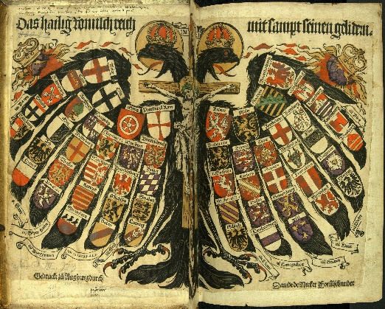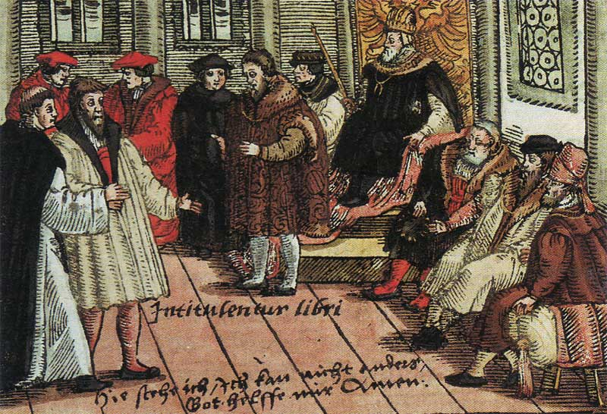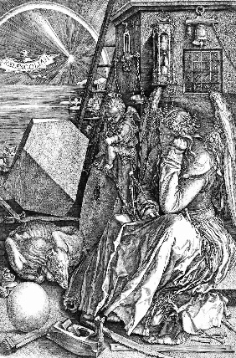

MODULE CONTENT
Voltaire jokingly disparaged this loose conglomeration as ‘... neither holy, nor Roman, nor an empire". In 1848, revolutionaries debated Greater- and Lesser-German solutions to replace it. Nazi propagandists drew historical parallels between the first Reich (which lasted over 1,000 years) and their short-lived racist vision of an Aryan Third Reich. Post-War Austrian historian Friedrich Heer promoted the ethnically diverse Empire as a traditional model of European integration. In the 1990s, debate raged over Germany’s ‘special path’ (Sonderweg) from Martin Luther to unification under Bismarck and, ultimately, two world wars. Was the Holy Roman Empire a failed state? Or the direct antecedent of the Danubian Monarchy? Or Imperial Germany? the EU? the Holocaust?

HY353 is part one of the Holy Roman Empire super-elective, which continues in semester two with HY354, introduces this enigmatic Empire from its medieval origins under Charlemagne to the political constitution set out in the Golden Bull and imperial reforms. Then, we focus on the Reformations and German Peasants’ War. Students participate in class discussions, presentations of primary and secondary sources, post to a group website and compose an essay for the end of the semester.

Form of Assessment
3,000 word essay 60%
In-class assignments/tests 40%
Deadline for submission of essay is Monday, 8 January 2024

national university of ireland, maynooth
department of history
third arts, 2023-24

First Semester
Lecturer  DR MICHAEL POTTERTON | Module code  HY 387 | Credits  5 | Lecture hours per week  Two

Module title

TOWNS IN MEDIEVAL IRELAND

Module content
Ireland has a very significant urban tradition stretching back well over a millennium. The earliest stages of town development can be traced at a few of the larger early medieval monastic sites such as Armagh and Kildare. A new wave of urban growth was instigated by Scandinavian settlers – several of Ireland’s largest towns and cities were founded primarily as trading ports at strategic locations by the Vikings in the ninth and tenth centuries. The arrival of the Anglo-Normans in the second half of the twelfth century initiated another crucial phase of urban generation, with more than fifty towns being founded. A further stage of town creation was the plantation era of the late sixteenth and early seventeenth centuries. Through archaeological, documentary and other sources, this module will trace the development of urban Ireland from the early medieval period through to the seventeenth century.

Module aim
The main aim of this module is to familiarise students with the tradition of town life in medieval Ireland. Upon successful completion of the module, students will

• be familiar with the origins and main phases of town development in Ireland;
• be aware of the range of sources available for the study of Ireland’s historic towns;
• be able to recognise various surviving medieval components in the modern streetscape;
• have a good idea of what daily life was like in a medieval Irish town.

Form of Assessment
There are three parts to the assessment for this module:
a. one in-class test 25% of module marks
b. one illustrated project (3,000 words) due Monday, 8 January 2024 65% of module marks
c. participation in class 10% of module marks

Special requirements
Participants are expected to attend a Saturday fieldtrip (10am–5pm), which will depart via coach from Maynooth and will cost students €20 each. Further details will be provided in class and on Moodle.

national university of ireland, maynooth
department of history
third arts, 2023-24
First Semester
Lecturer  DR JOHN PAUL NEWMAN |  | Module code  HY 3007 | Credits  5 | Lecture hours per week  Two
Module title

EASTERN AND CENTRAL EUROPE UNDER COMMUNISM

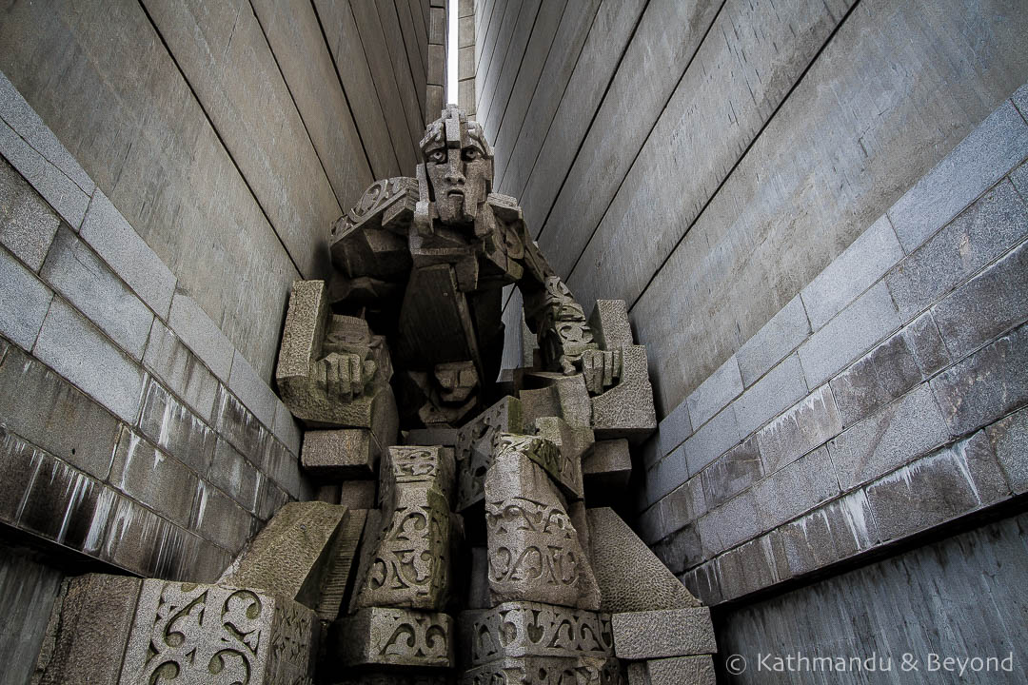
From the ‘Monument to 1300 Years of the Bulgarian State’, put up in 1981 in the city of Shumen, a prime example of the communist appropriated national history (this statue depicts a ‘Khan’ of the medieval Bulgarian empire)

This module covers the history of eastern and central Europe under communism, that is, from 1945-1989. Due attention is to the role of the interwar period and the Second World War in creating the conditions necessary for the rise of the communist regimes in the region. We will explore the part played by personalities, leaders, the (communist) party, intellectuals, and the ordinary people in the establishment, maintenance, and eventual downfall of the communist system. In addition to the political history of communism we will look at movies, television, consumption (shopping), and leisure time and how they shaped the communist experience. What was the lived experience of communism really like for the average person? Why did the system last so long? Why did it end when it did? And what are the long-term implications of this time for the future integration of Europe?

Assessment
1,000 word assignment (25%)
Class quiz (10%)
3,000 word final project (65%)
Deadline for submission of project: Monday, 8 January 2024
national university of ireland, maynooth
department of history
Third arts, 2023-24
First Semester
Lecturer  DR JONATHAN WRIGHT | Module code HY 3017 | Credits  5 | Lecture hours per week  Two

Module title
AFRICAN LIVES IN BRITAIN AND IRELAND, C. 1550-2018

Overview
This module will explore the history of Africans and African communities in Britain and Ireland from the sixteenth century to the second half of the twentieth century. Combining contextual discussion with a case study approach, it will explore the lives of individual Africans or people of African ancestry, setting them in their particular historical and social circumstances. In so doing it will highlight the ways in which Britain and Ireland were, from a very early point, bound into wider global processes of exploitation and exchange and will examine the ways in which 'big' historical processes and dynamics - slavery, empire, migration and decolonization - are experienced at the level of individual lives. Themes explored will vary from year to year, but might include the African presence in Tudor Britain; runaways and black loyalist refugees in the late eighteenth century; visual depictions of Britain’s black community; and the Windrush generation and the politics of race in modern Britain. Extensive use will be made of primary source material and a willingness to contribute to in-class discussion is essential.

Module Aim
Upon completing this module, you will have explored the lives of a number of Africans or people of African ancestry whose experiences shed light on important events and processes in British and Irish history. You will develop an understanding of the scale and significance of the African presence in Britain and Ireland and you will engage with a range of primary source material and a fascinating body of historiography. More broadly, you will develop your research and writing skills through the completion of written assignments and your presentation and communication skills through your contributions to in-class discussion.

Assessment
1,250 word assignment 25%
1,250 word assignment 25%
2,500 word essay 50% (deadline Monday 8 January, 2024

national university of ireland, maynooth
department of history
Third arts, 2023-24
First Semester
Lecturer  PROFESSOR ROISÍN HIGGINS | Module code HY 3021 | Credits  5 | Lecture hours per week  Two

Module title
THATCHER’S BRITAIN: A POLITICAL AND SOCIAL HISTORY OF BRITAIN IN THE 1980s

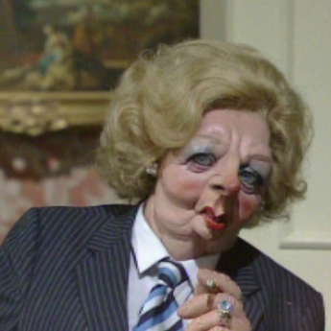
Overview
British politics and society were transformed in the 1980s. It was a decade that saw an acceleration of deindustrialisation; changes to economic orthodoxies; ideological clashes; high unemployment; affluence and optimism; racism and riots. At the helm in Downing Street was Margaret Thatcher who was elected three times as Prime Minister. She was the first woman to hold this position: a divisive and dynamic figure. This module examines the contradictions and complexities of Thatcher’s Britain. It explores the economic changes that underpinned the politics of the period and their repercussions across the society. The response to Thatcher was often intense because the stakes were high. The ideological shifts of the 1980s had long-reaching consequences. By taking this module students will not only gain knowledge of Thatcher’s Britain, they will have a better understanding of British society today and the issues that remain contested and unresolved.

Module Aims
Students will gain a critical understanding of the main political, economic and social developments in Britain in the 1980s and of the role Margaret Thatcher played in shaping British politics and society while she was Prime Minister.

Assessment
Participation 10%
In-class presentation 20%
3,500-word essay (deadline Monday 8 January 2024) 70%

NATIONAL UNIVERSITY OF IRELAND MAYNOOTH
DEPARTMENT OF HISTORY
THIRD ARTS 2023-24

First Semester
Lecturer | Module code GC313 | Credits  5 | Lecture hours per week

Module title
FIRE FROM HEAVEN: THE RISE OF MACEDONIA & ALEXANDER THE GREAT

as per Course Finder, July 2023
To explore the historical facts and literary constructions concerning Philip II and Alexander the Great.
This module explores the extraordinary careers of the Macedonian kings Philip II and, to a greater extent, his son Alexander the Great. It examines their rise to power, and attempts to explain the reasons for their military successes, by which in a short space of time Philip had conquered the Greek world and, Alexander, subsequently, moved the boundaries of that Greek world eastwards to the borders of India. Though Alexander's life met a premature end, the consequences of his conquests were far-reaching both politically and culturally, as various local cultures blended with the Greek; analysis of the nature and significance of these changes is central to the investigation.
18 lectures, 3 tutorials

Form of assessment
Assessment type | Weighting | Duration
Continuous Assessment | 40%
University scheduled written examination | 60% | 90 minutes

Please note that GC313 is timetabled by the Department of Ancient Classics and may clash with core lectures in other subjects.

