National University of Ireland, Maynooth

DEPARTMENT OF HISTORY

FLYERS FOR OPTIONAL MODULES

III ARTS SEMESTER 1 2020-21

PLEASE NOTE

Flyers provide information supplementary to that available in module descriptors, which may be viewed on the university database at www.maynoothuniversity.ie/courses.

Students are expected to consult both flyers and module descriptors in advance of registration.

national university of ireland, maynooth
department of history
third arts, 2020-21

First Semester
Lecturer  DR FRANCES NOLAN | Module code HY 306 | Credits  5 | Lecture hours per week  Two *

Module title
WOMEN IN EIGHTEENTH-CENTURY IRELAND

Module content
This module will explore the various roles and experiences of women in eighteenth-century Ireland. Students will be asked to consider the position of women in the Protestant ascendancy and in the declining Catholic elite, as well as women among the emergent middle class and the ‘lower orders’. Particular attention is given to women's legal status, religious identity, political engagement, economic activity, social and cultural engagement and expressions of status, work and property ownership. Engaging with the extant historiography, students will be encouraged to contextualise primary source material within wider historical debates to consider the issues that attend the study of women, with a particular focus on the methodologies used in women's and gender history in Ireland, Britain and Europe.

Module aim

Through this module, students will be
- able to identify and analyse appropriate primary source material
- able to engage in original analyses of the history of women and gender in eighteenth-century Ireland
- able to formulate research questions for the purposes of essay writing and presentations
- familiar with the historiography of women's and gender history in eighteenth-century Ireland, Britain and Europe

Form of assessment
Mid-term assessment (PowerPoint presentation) 20%
Essay of 3,500-4,000 words based on primary research and on a
topic to be agreed with course director 80%
Deadline for submission of essay: Monday, 4 January 2021

* Lectures will be delivered in accordance with the University’s guidelines for a safe campus. Should the need arise, this module might have to move to online delivery. Due notice will be given if this is the case.

national university of ireland, maynooth
department of history
Third Arts: 2020-2021

First Semester
Lecturer  DR IAN SPELLER | Module code HY 316 | Credits  5 | Lecture hours per week  Two *

Module title
MILITARY HISTORY (methodologies and contexts):

MARITIME STRATEGY AND NAVAL WARFARE IN THE 20th CENTURY

Module content:

This Elective will explore a sub-discipline within the wider discipline of military history, examining maritime strategy and naval warfare in the twentieth century. It will introduce students to the theory and practice of naval warfare and will provide a thematic exploration of the subject area, using relevant historical case studies to explore ideas about maritime strategy and naval warfare.

The module will require students to engage with concepts and theories of military history and maritime strategy and to employ these in order to explore the conduct and consequences of war at sea (and from the sea) in the twentieth century – with a particular focus on the period 1900-1945.

The module does not attempt to provide a comprehensive history of the entire period but instead uses selected case studies to explore ideas about naval warfare. These case studies will include an analysis of war at sea during the Russo-Japanese War, the First World War, the Second World War and in a range of other conflicts.

Students are required to attend ALL lectures and to undertake additional reading in their own time.

Form of Assessment
Two x 2500 word essays, each weighted 50%.
Essay 1 to be submitted towards the middle of the semester
Essay 2 to be submitted by Monday, 4 January 2021

Module Structure:
This module is based on two x one-hour lectures each week plus recommended reading undertaken in the student’s own time.
* Lectures will be delivered in accordance with the University’s guidelines for a safe campus. Should the need arise, this module might have to move to online delivery. Due notice will be given if this is the case.

national university of ireland, maynooth
department of history
third arts, 2020-21

First Semester
Lecturer  DR DAVID LEDERER | Module code HY 353 | Credits  5 | Lecture hours per week  Two

Module title
THE HOLY ROMAN EMPIRE, 1495 TO 1618

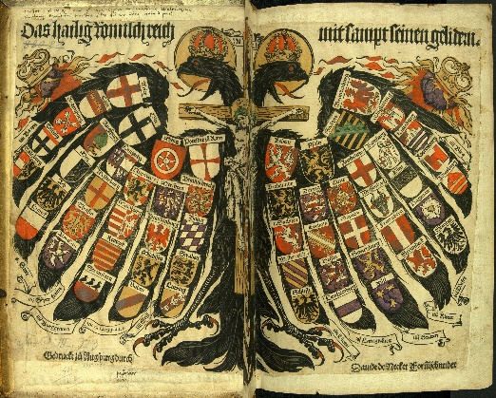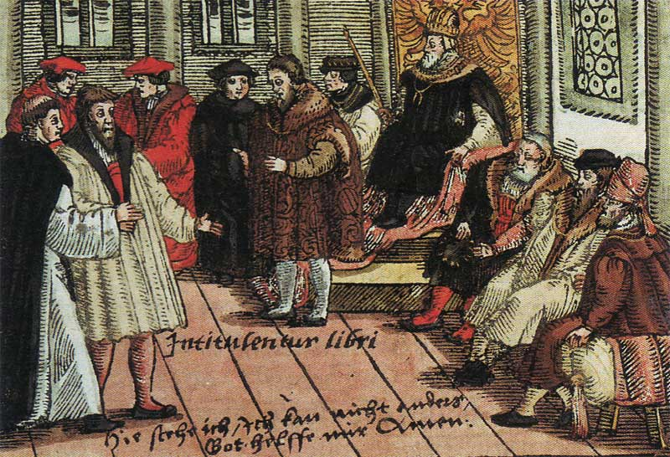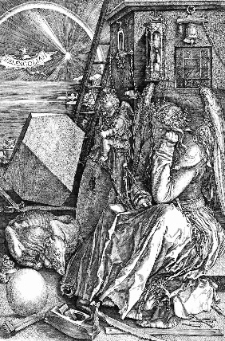

MODULE CONTENT
Voltaire jokingly disparaged this loose conglomeration as ‘... neither holy, nor Roman, nor an empire". In 1848, revolutionaries debated Greater- and Lesser-German solutions to replace it. Nazi propagandists drew historical parallels between the first Reich (which lasted over 1,000 years) and their short-lived racist vision of an Aryan Third Reich. Post-War Austrian historian Friedrich Heer promoted the ethnically diverse Empire as a traditional model of European integration. In the 1990s, debate raged over Germany’s ‘special path’ (Sonderweg) from Martin Luther to unification under Bismarck and, ultimately, two world wars. Was the Holy Roman Empire a failed state? Or the direct antecedent of the Danubian Monarchy? Or Imperial Germany? the EU? the Holocaust?

HY353 is part one of the Holy Roman Empire super-elective, which continues in semester two with HY354, introduces this enigmatic Empire from its medieval origins under Charlemagne to the political constitution set out in the Golden Bull and imperial reforms. Then, we focus on the Reformations and German Peasants’ War. Students participate in class discussions, presentations of primary and secondary sources, post to a group website and compose an essay for the end of the semester.

Lectures will be delivered in accordance with the University’s guidelines for a safe campus. Should the need arise, this module might have to move to online delivery. Due notice will be given if this is the case.

Form of Assessment
3,000 word essay 60%
In-class assignments/tests 40%
Deadline for submission of essay is Monday, 4 January 2021
national university of ireland, maynooth
department of history
third arts, 2020-21

First Semester
Lecturer  DR MICHAEL POTTERTON | Module code  HY 387 | Credits  5 | Lecture hours per week  Two

Module title

TOWNS IN MEDIEVAL IRELAND

Module content
Ireland has a very significant urban tradition stretching back well over a millennium. The earliest stages of town development can be traced at a few of the larger early medieval monastic sites such as Armagh and Kildare. A new wave of urban growth was instigated by Scandinavian settlers – several of Ireland’s largest towns and cities were founded primarily as trading ports at strategic locations by the Vikings in the ninth and tenth centuries. The arrival of the Anglo-Normans in the second half of the twelfth century initiated another crucial phase of urban generation, with more than fifty towns being founded. A further stage of town creation was the plantation era of the late sixteenth and early seventeenth centuries. Through archaeological, documentary and other sources, this module will trace the development of urban Ireland from the early medieval period through to the seventeenth century.

Module aim
The main aim of this module is to familiarise students with the tradition of town life in medieval Ireland. Upon successful completion of the module, students will

• be familiar with the origins and main phases of town development in Ireland;
• be aware of the range of sources available for the study of Ireland’s historic towns;
• be able to recognise various surviving medieval components in the modern streetscape;
• have a good idea of what daily life was like in a medieval Irish town.

NB: Lectures will be delivered in accordance with the University’s guidelines for a safe campus. Should the need arise, this module might have to move to online delivery. Due notice will be given if this is the case.

Form of Assessment
There are two parts to the assessment for this module:
a. one mid-term assignment (1,000 words; due November; 25% of module marks).
b. one illustrated project (3,000 words; due Monday, 4 January 2021; 75% of module marks).

national university of ireland, maynooth
department of history
third arts, 2020-21
First Semester
Lecturer  DR JOHN PAUL NEWMAN | Module code  HY 3007 | Credits  5 | Lecture hours per week  Two *

Module title

EASTERN AND CENTRAL EUROPE UNDER COMMUNISM
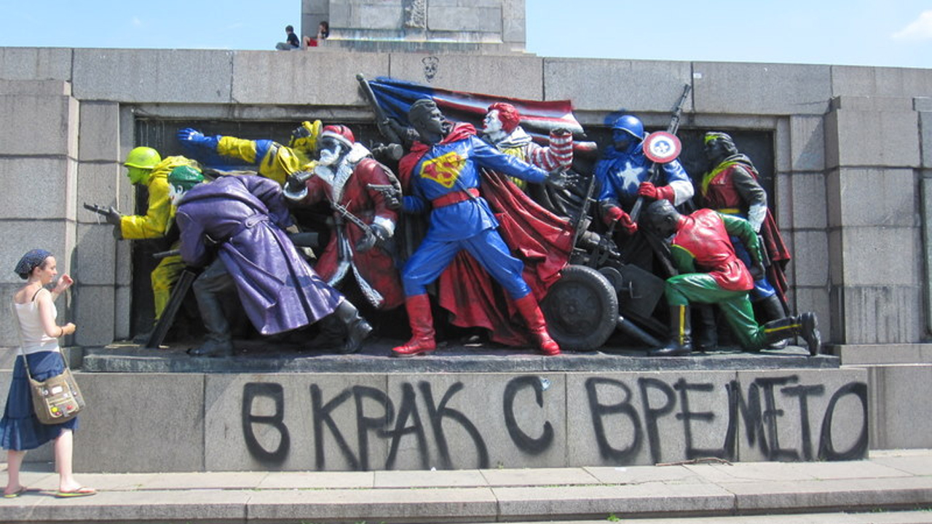
An artist in Bulgaria paints American cultural icons onto a Soviet Red Army monument. The caption reads ‘In step with the times’
Module content
This module charts the history of eastern and central Europe under communism, that is, from 1945-1989. Due attention is to the role of the interwar period and the Second World War in creating the conditions necessary for the rise of the communist regimes in the region. We will explore the part played by personalities, leaders, the (communist) party, intellectuals, and the ordinary people in the establishment, maintenance, and eventual downfall of the communist system. In addition to the political history of East European communism we will look at the part played by intellectuals, movies, television, consumption (shopping), and leisure time in shaping the communist experience. What was the lived experience of communism really like for the average person? Why did the system last so long? Why did it end when it did? And what are the long-term implications of this time for the future integration of Europe?

Form of assessment
Mid-term essay (1,500 words) 30%
Final 3,500 words project 70%
Deadline for submission of final project: Monday, 4 January 2021
* Lectures will be delivered in accordance with the University’s guidelines for a safe campus. Should the need arise, this module might have to move to online delivery. Due notice will be given if this is the case.
national university of ireland, maynooth
department of history
third arts, 2020-21

First Semester
Lecturer  NIALL Ó SÚILLEABHÁIN | Module code  HY 3009 | Credits  5 | Lecture hours per week  Two

Module title

IRELAND AND THE WIDER WORLD IN THE LATE MIDDLE AGES

Module content
Ireland was deeply and inextricably tied to Western Europe in the late medieval period (c. 1000 – c. 1450) and the waves of social, economic and cultural change which engulfed Latin Christendom did not spare the Irish. Just like Britain and the Continent, and accelerated by establishment of the English colony after 1169, Ireland in the later middle ages saw the arrival of reforming monks, crusading knights, economic transformations and deadly pandemics. This module will examine the major trends which shaped the societies of medieval Europe and their continued relevance in the modern world, as well as Ireland’s unique responses and reactions to these continent-wide events. Just as religion was at the heart of the medieval understanding of the world, it will be a key thematic lens for this course. Using a wide range of primary sources from across Europe, students will explore the ways medieval Christianity framed the worldviews and attitudes of medieval people. Topics covered will include the growth of the state, religious reform, family structures, heath and disease and medieval slavery, giving students a comprehensive understanding of medieval society, in Ireland and across the medieval world.

Lectures will be delivered in accordance with the University’s guidelines for a safe campus. Should the need arise, this module might have to move to online delivery. Due notice will be given if this is the case.

Module aims
Upon completion of this module, students will have developed a broad knowledge of the major developments in Irish and European social, cultural and religious history in the period AD 1000 – 1450.

Form of assessment
Critical Review of Secondary Literature (1,000 words) 25%
Primary Source Commentary (1,000 words) 25%
Essay (3,000 words) 50%
Deadline for submission of essay: Monday, 4 January 2021

NATIONAL UNIVERSITY OF IRELAND MAYNOOTH
DEPARTMENT OF HISTORY
THIRD ARTS 2020-21

First Semester
Lecturer  TBC | Module code GC313 | Credits  5 | Lecture hours per week

Module title
FIRE FROM HEAVEN: THE RISE OF MACEDONIA & ALEXANDER THE GREAT

Overview as per Course Finder, July 2020
To explore the historical facts and literary constructions concerning Philip II and Alexander the Great.
This module explores the extraordinary careers of the Macedonian kings Philip II and, to a greater extent, his son Alexander the Great. It examines their rise to power, and attempts to explain the reasons for their military successes, by which in a short space of time Philip had conquered the Greek world and, Alexander, subsequently, moved the boundaries of that Greek world eastwards to the borders of India. Though Alexander's life met a premature end, the consequences of his conquests were far-reaching both politically and culturally, as various local cultures blended with the Greek; analysis of the nature and significance of these changes is central to the investigation.
18 lectures, 3 tutorials

Form of assessment
- Continuous Assessment detail(s): An optional coursework essay will be available for 40% of the total mark; the essay mark will be applied only if it is to the student's advantage.
Assessment type | Weighting | Duration
Continuous Assessment | 40%
University scheduled written examination | 60% | 90 minutes

Please note that GC313 is timetabled by the Department of Ancient Classics and may clash with core lectures in other subjects.

NATIONAL UNIVERSITY OF IRELAND MAYNOOTH
DEPARTMENT OF HISTORY
THIRD ARTS 2020-21

First Semester
Lecturer  TBC | Module code SG354 | Credits  5 | Lecture hours per week  Two

Module title
THE VIKING WORLD II - IRELAND

Overview as per Course Finder, July 2020

The Vikings were a major factor in the history of Europe from the late eighth century until the eleventh. This module studies the Viking impact in Britain, Continental Europe and the North Atlantic.

Form of assessment
50% continuous assessment
50% university scheduled examination (60 minutes)

Special requirements (e.g. field trips inc. costs, special sessions)
None

Please note that SG354 is timetabled by the School of Irish and may clash with core lectures in other subjects.

